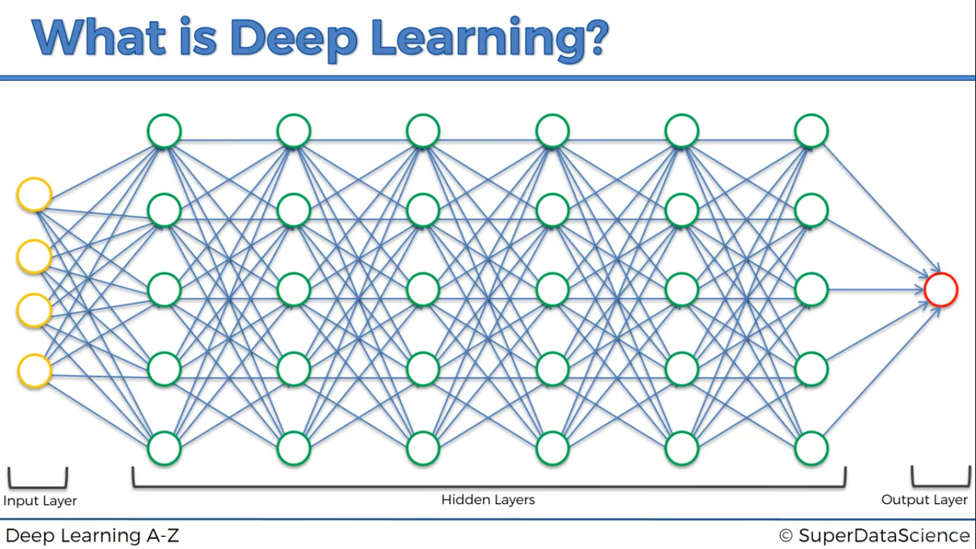
Deep Learning

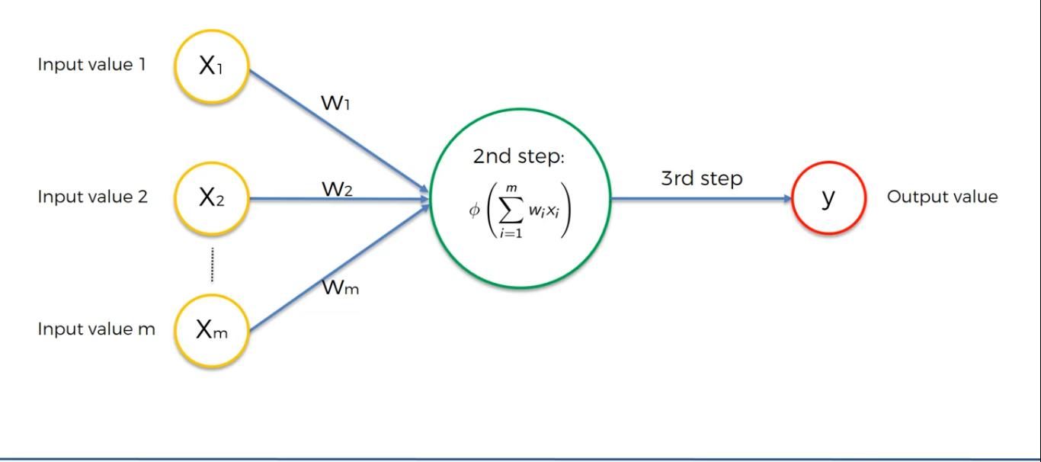
The neuron

- Here X1, X2, X3 .....Xn are the inputs. Here X is an independent variable. Here all the input values are from the same observation or same row.

- W1, W2, W3 .....Wn are the weights of a input X1, X2, X3 .....Xn respectively which is contributing to the next neuron.

- Then we calculate the weighted sum which is sumof(WiXi).

- For that we apply Activation Function
- And after that if any hidden layer is present then the value will be transmitted to the next neuron.

- Or else the result is taken as the Output.

Different kind of Activation Function
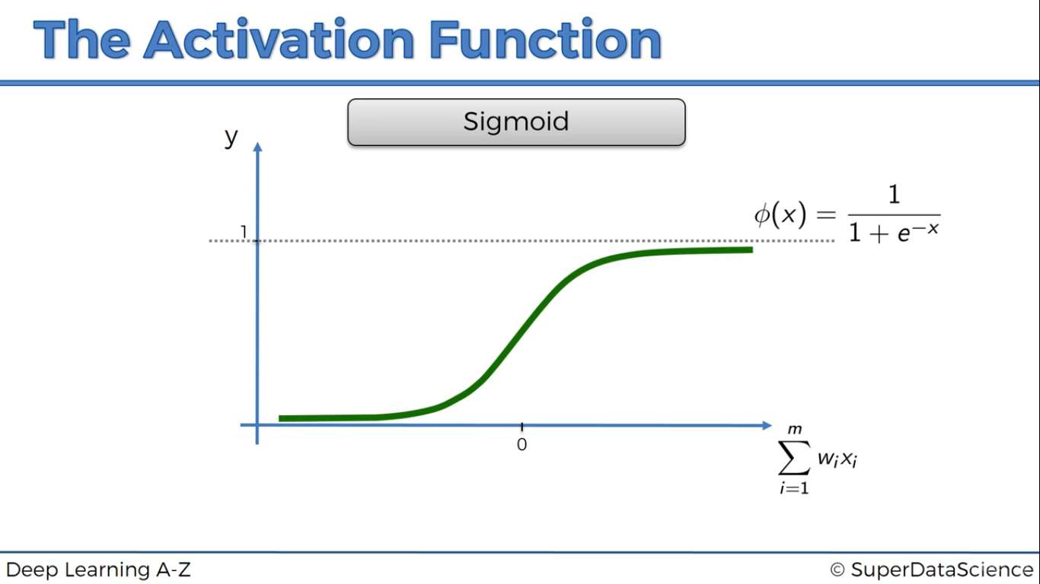
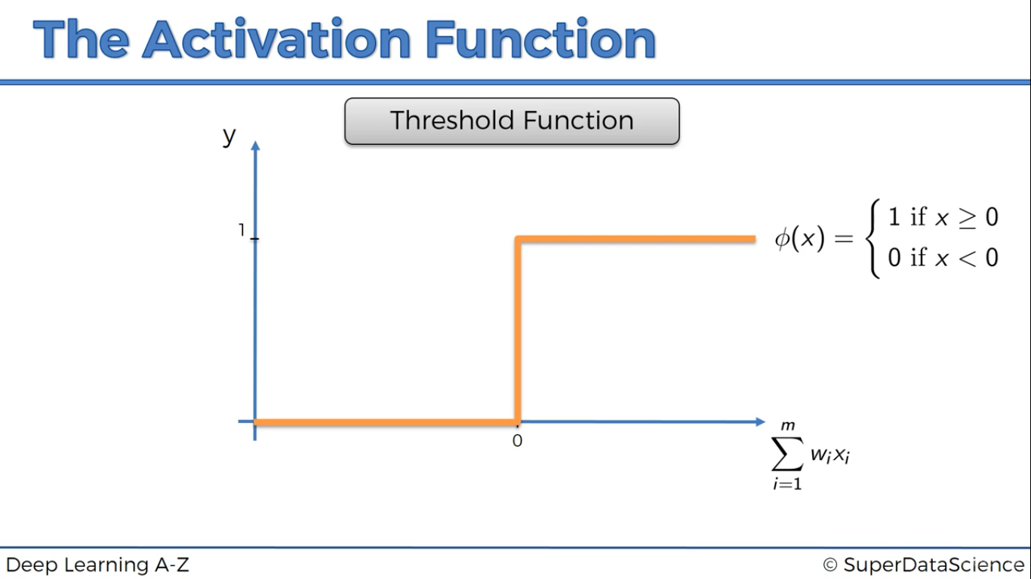

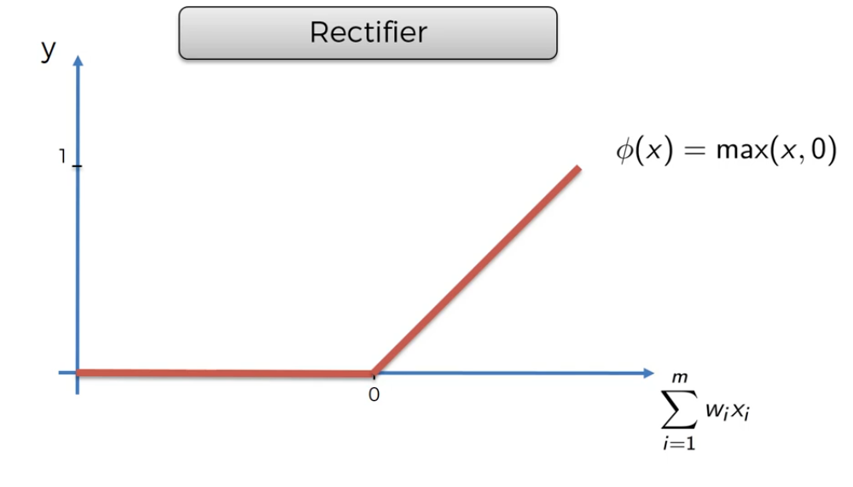
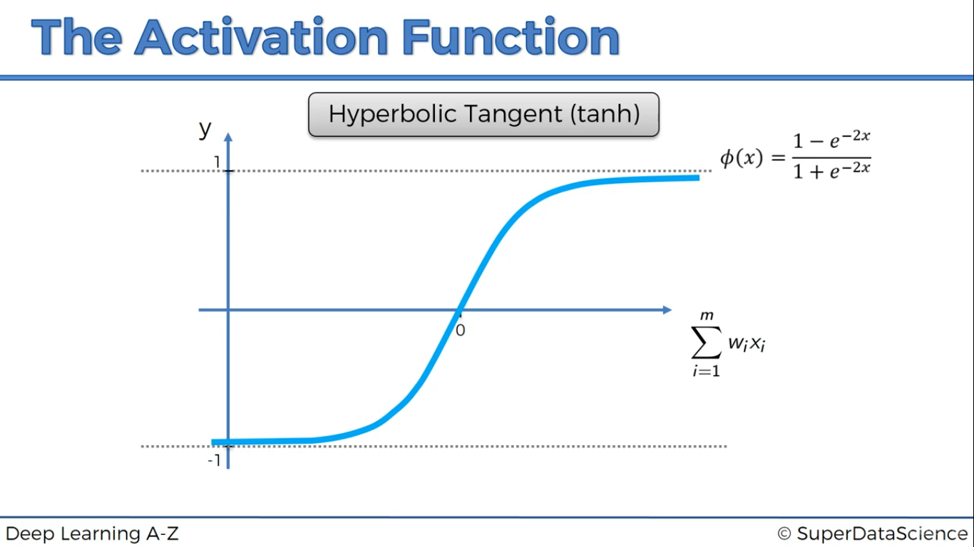

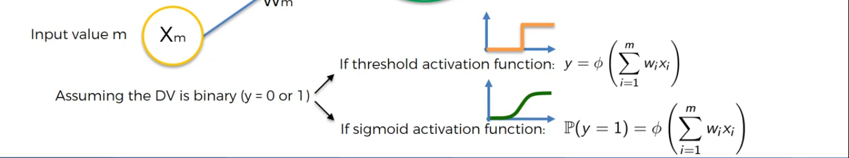

Learning of Neural Networks

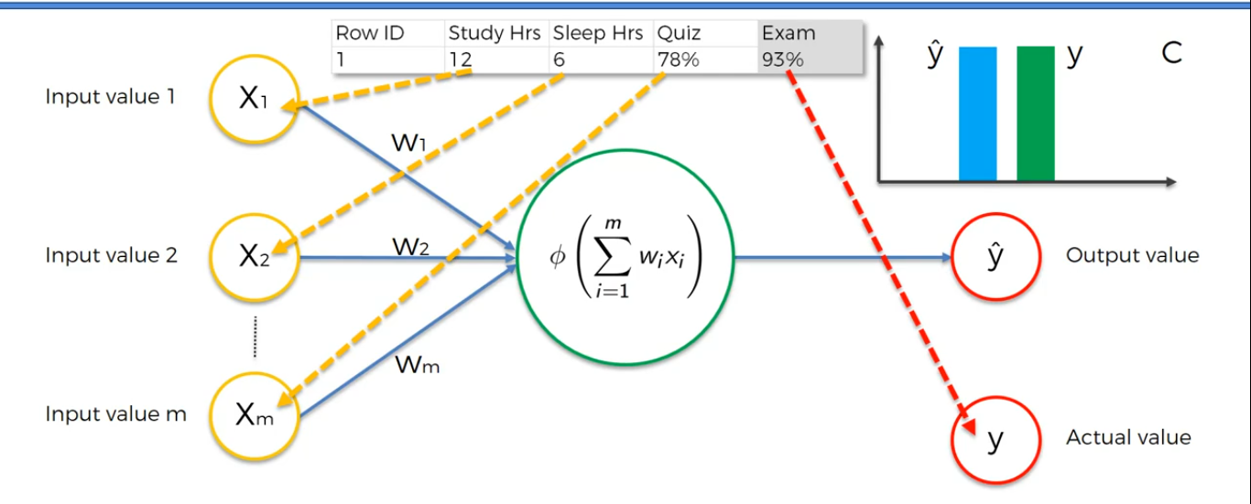

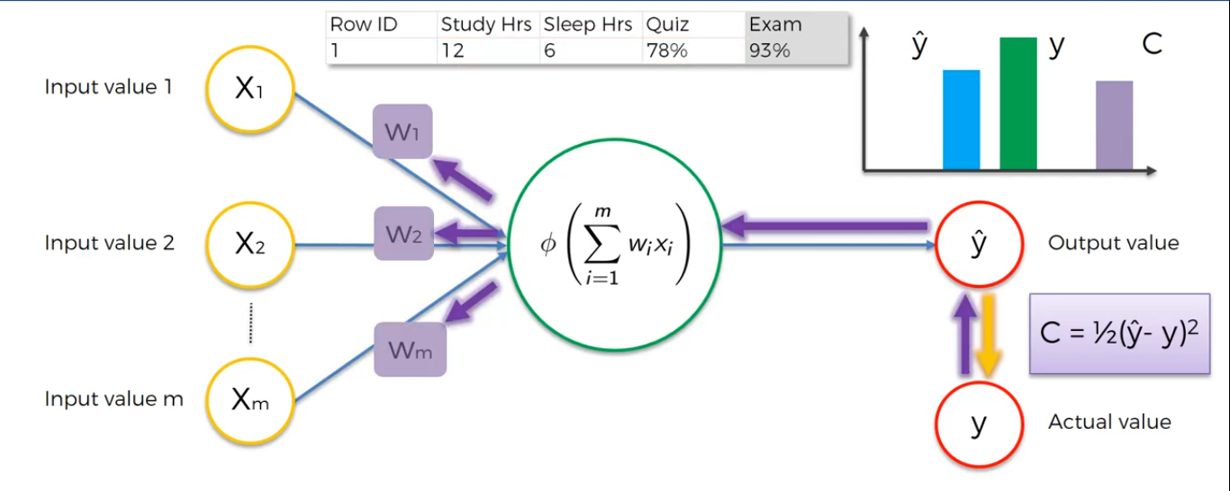

Here C is the cost function which calculates the mean sqaure error in the actual and the predicted value.

- Untill the value of C is minimized we change the weights W. After several tuning we can achieve minimum C value.

- Changing of Weights according to the C is known as Backpropogation because we go back and change the weights.

Gradient Descent
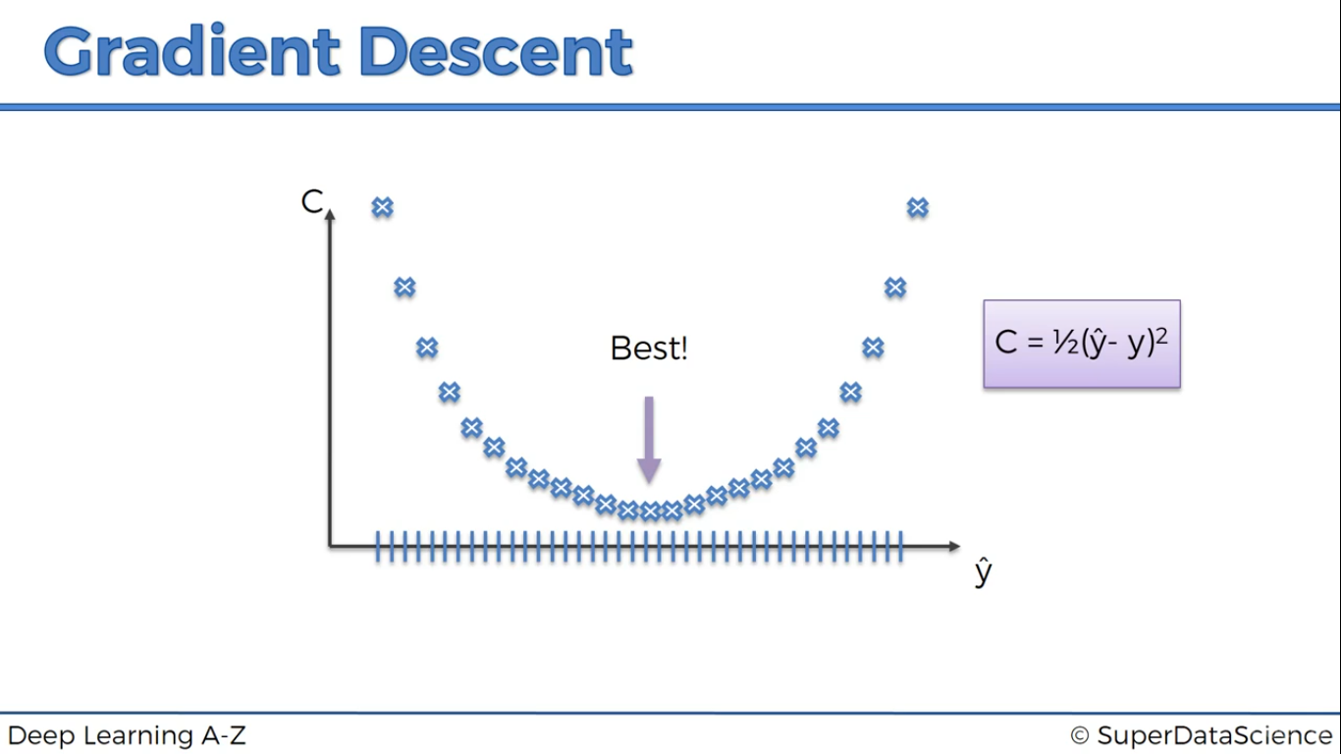
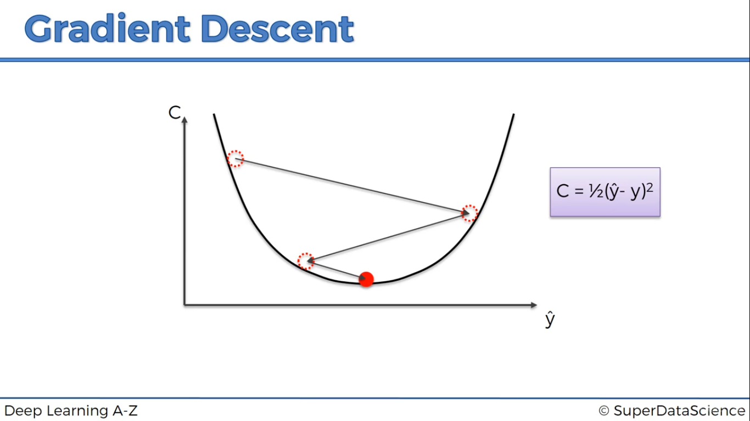

While finding the cost function we cannot find all the best possible things in the real life situation. Bruteforce approach is possible for only for one neuron. So we come up with the technique of gradient descent. In which we find the slop of a random point and if the slop is negetive then it is a downhill. If the slop is positive then it is a uphill. As in the above image we come to the efficient solution.

Stochastic Gradient Descent

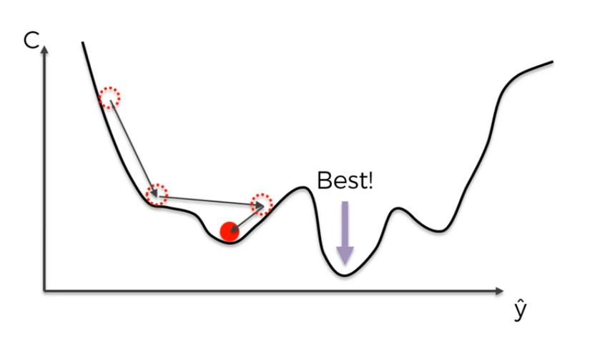
This image shows the drawback of gradient descent.

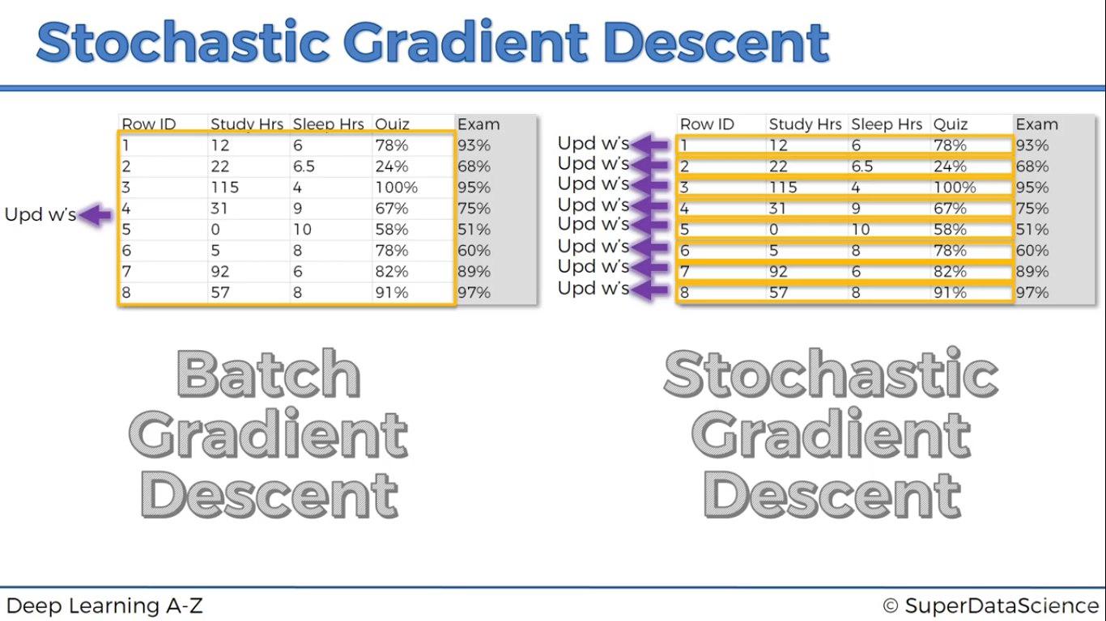

In Batch gradient descent after the completion of batch, cost function is calculated. And based on that using backpropogation we end up at a optimised weights.

In Stochastic after every row is passed we calculate the weights and this method is called is called reinforcement learning.

Summary

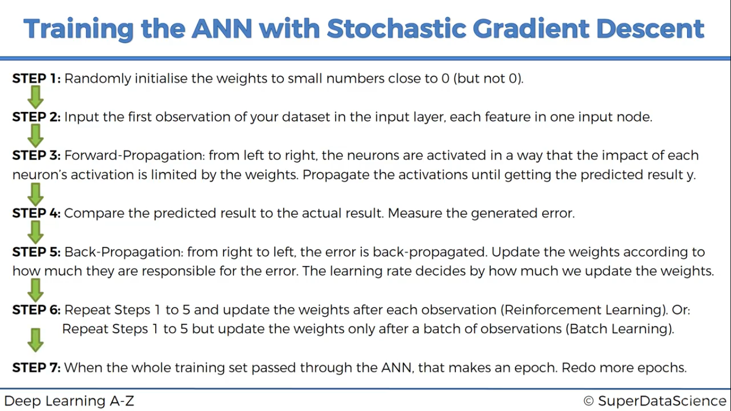

Recurrent Neural Networks

Conversion of ANN to RNN
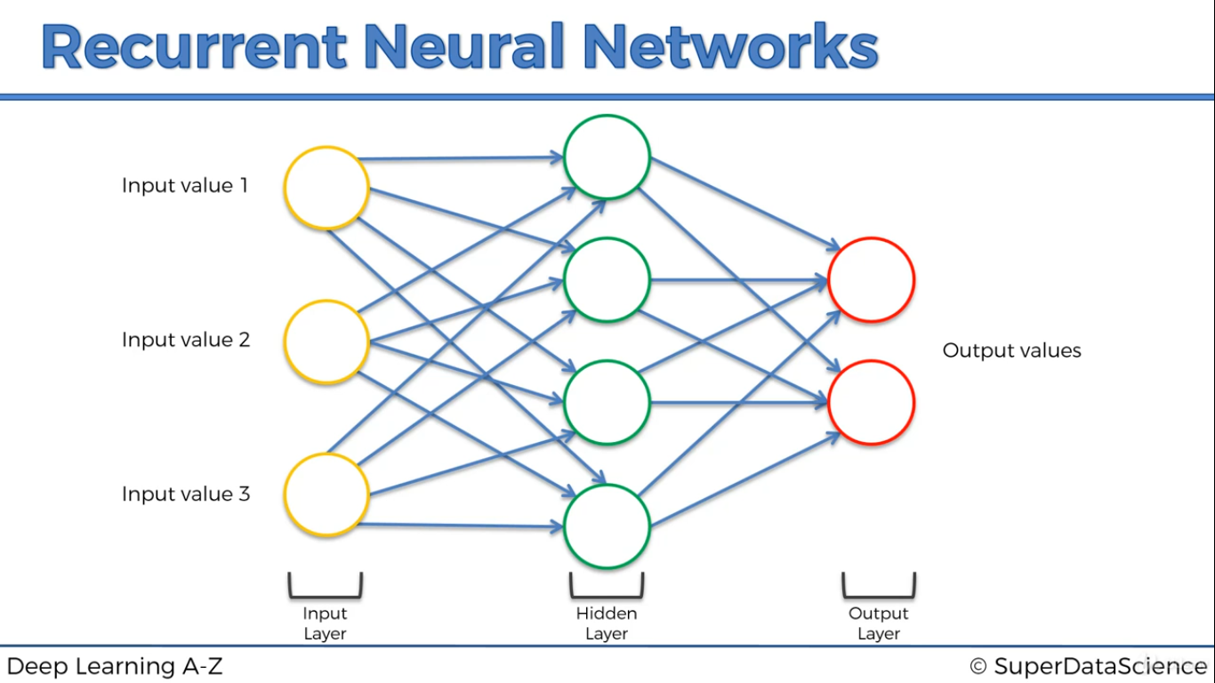
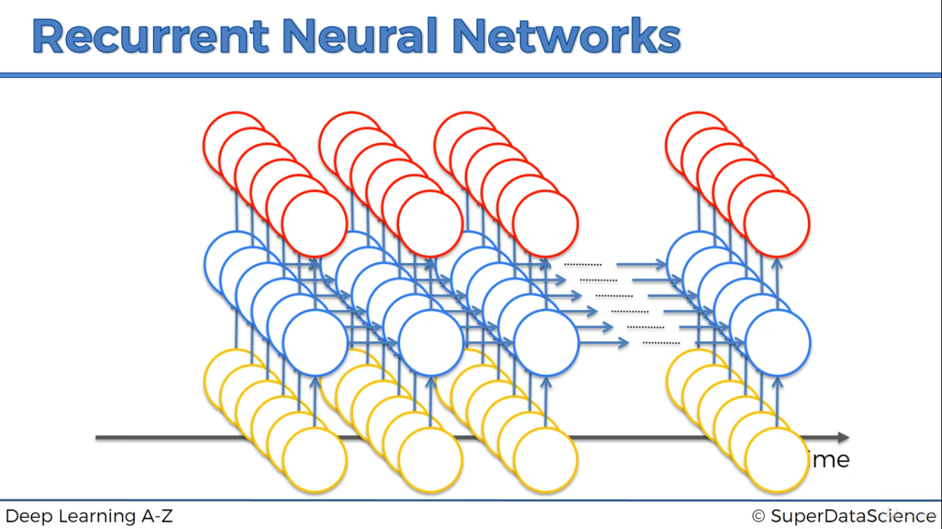

Steps
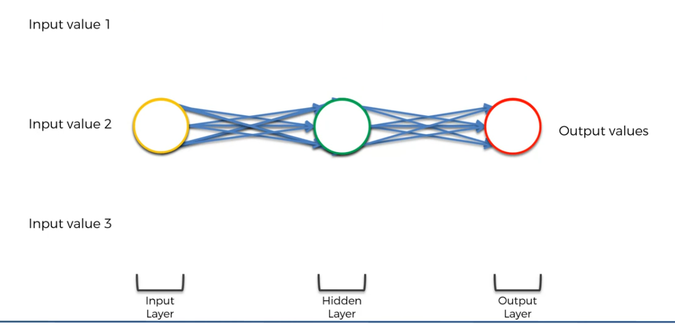

Step 1

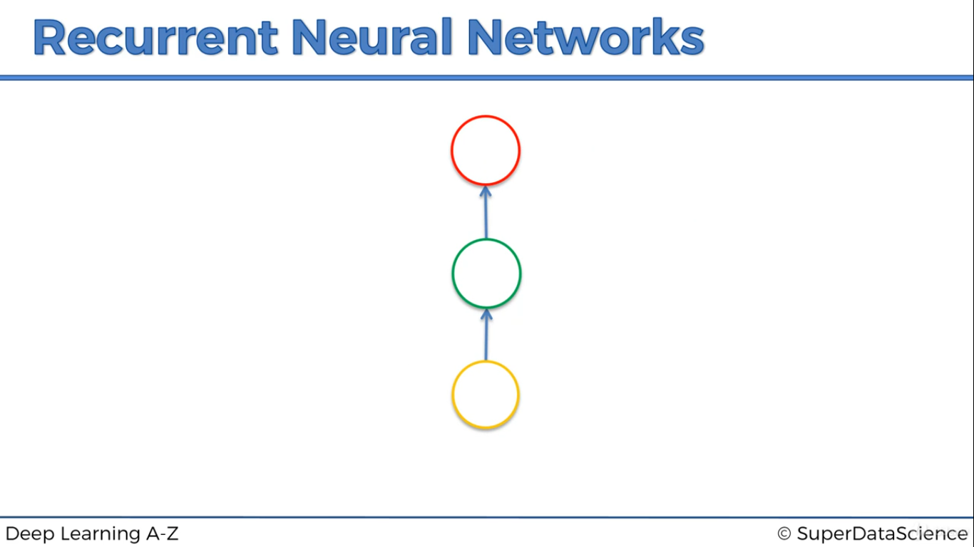
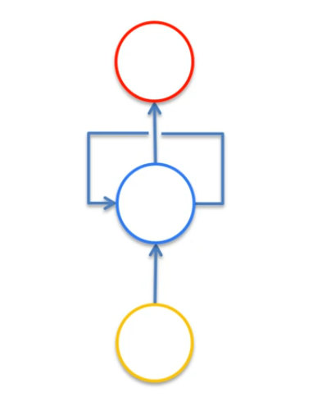

Step 2 and Step 3

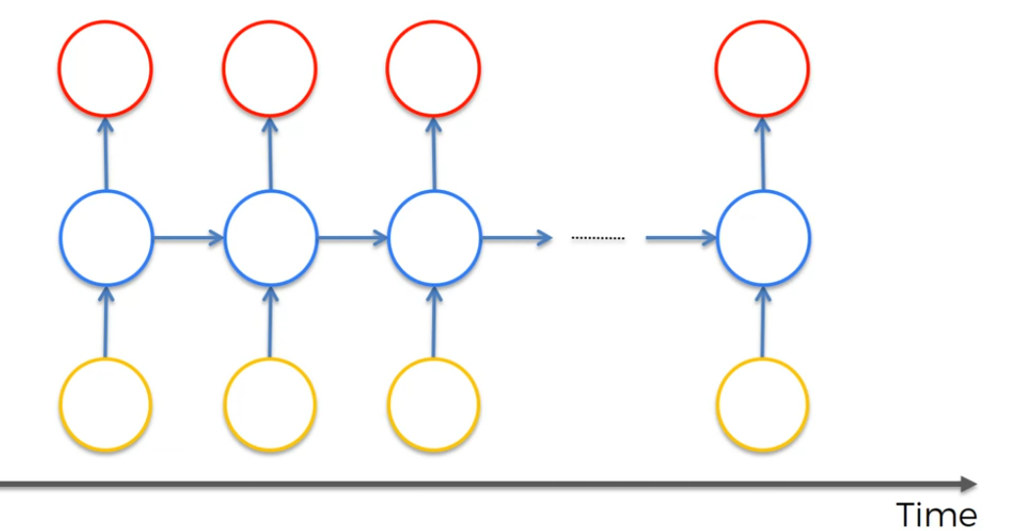

Step 4

Recurrent Neural Network(RNN) are a type of Neural Network where the output from previous step are fed as input to the current step. In traditional neural networks, all the inputs and outputs are independent of each other, but in cases like when it is required to predict the next word of a sentence, the previous words are required and hence there is a need to remember the previous words. Thus RNN came into existence, which solved this issue with the help of a Hidden Layer. The main and most important feature of RNN is Hidden state, which remembers some information about a sequence.

Different kinds of RNN
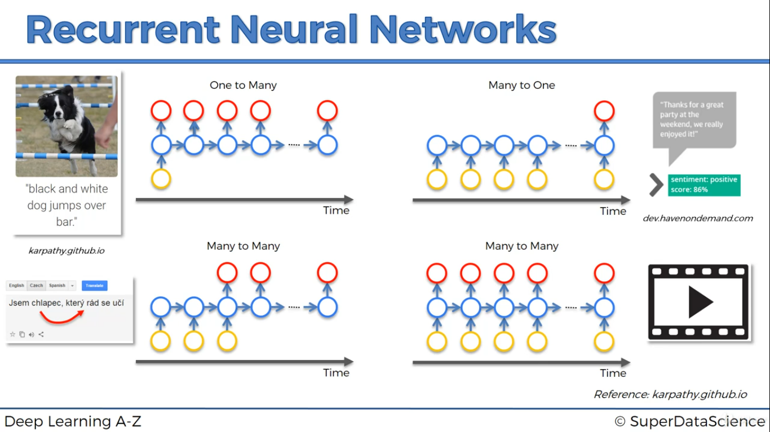

Basics of Tenserflow
https://www.guru99.com/tensor-tensorflow.html

Overfitting and Underfitting

Overfitting and underfitting are the two biggest causes for poor performance of machine learning algorithms
In statistics, a fit refers to how well you approximate a target function.
This is good terminology to use in machine learning, because supervised machine learning algorithms seek to approximate the unknown underlying mapping function for the output variables given the input variables.

Overfitting refers to a model that models the training data too well.
Overfitting happens when a model learns the detail and noise in the training data to the extent that it negatively impacts the performance of the model on new data. This means that the noise or random fluctuations in the training data is picked up and learned as concepts by the model. The problem is that these concepts do not apply to new data and negatively impact the models ability to generalize.

Underfitting refers to a model that can neither model the training data nor generalize to new data.
An underfit machine learning model is not a suitable model and will be obvious as it will have poor performance on the training data.

Droput Technique

Simply put, dropout refers to ignoring units (i.e. neurons) during the training phase of certain set of neurons which is chosen at random. By “ignoring”, I mean these units are not considered during a particular forward or backward pass.

More technically, At each training stage, individual nodes are either dropped out of the net with probability1-p or kept with probability p, so that a reduced network is left; incoming and outgoing edges to a dropped-out node are also removed.

Droput is a technique for reducing overfitting.

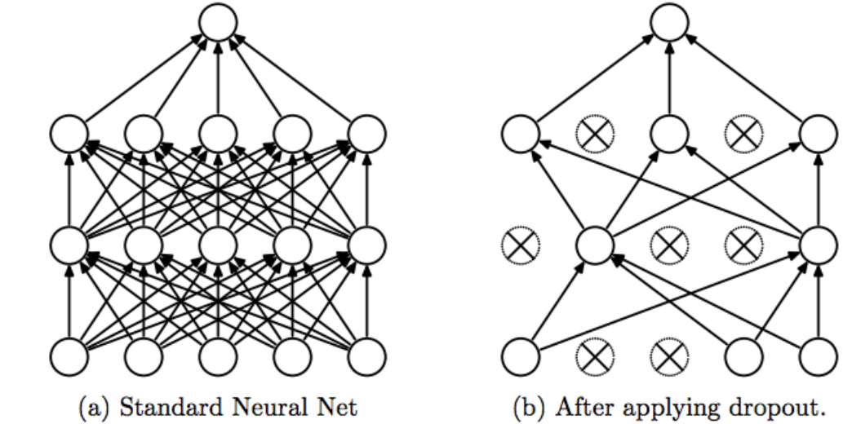

Embedding in LSTM Network

if you think about how to provide a word as an input to LSTM which is basically a network/model of matrix multiplications and additions and floating functions, you would realize that you need some integer/float based representation of words to feed into your network.
The most logical representation would then be to represent each word by an integer and since vocabulary of your dataset is finite, you would have a finite set of integers representing the words. For the purposes of matrix algebra we represent these integers as an array indices of a 1–0 array where each word is represented by a 1 at an array index of its designated integer. All other indices are 0s.
If you are getting confused, let me give you an example:
Let us say that you dataset consist of only two sentences:
- I love coffee.
- I like dogs.
Vocab: {I, love, coffee, I, like, dogs}
Integers assigned:
I: 0, love: 1, coffee: 2, like: 3, dogs: 4
Vector representations:
I: [1,0,0,0,0]
love: [0,1,0,0,0]
coffee: [0,0,1,0,0]
like: [0,0,0,1,0]
dogs: [0,0,0,0,1]
This type of word representation is called one-hot vector representation.
But, as you can see similar words do not share any kind of information.
For example, if you take euclidian distance between “coffee” and “love” and “like” and “love” you would get the same result.
In order to have a representation where similar words have smaller euclidean distance than the ones which are not similar at all. Here, similarity is based upon context of the word i.e. what conditions or surroundings is the word used in.
This representation is called word embedding.
And they may look like:
I: [0.02, 0.08, 0.14, 0.16, 0.60] etc…
However, most of the time these embeddings are learnt during the bigger training task that you are already doing.
Hence, using an embedding layer which has a size equal to the vocabulary size of your dataset has become really popular.
This layer is interface between your input layer (matrix of word’s indices in the vocabulary) and the LSTM layer.

Bidirectional RNN
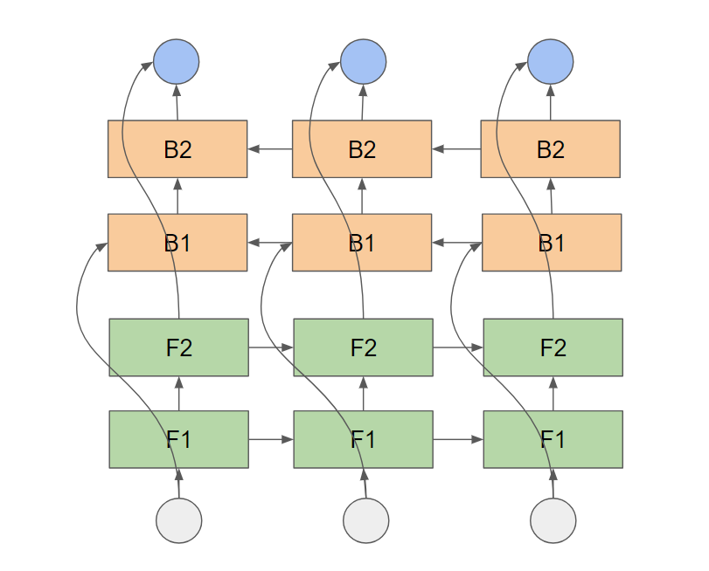
LSTM in its core, preserves information from inputs that has already passed through it using the hidden state.
Unidirectional LSTM only preserves information of the past because the only inputs it has seen are from the past.
Using bidirectional will run your inputs in two ways, one from past to future and one from future to past and what differs this approach from unidirectional is that in the LSTM that runs backwards you preserve information from the future and using the two hidden states combined you are able in any point in time to preserve information from both past and future.
What they are suited for is a very complicated question but BiLSTMs show very good results as they can understand context better, I will try to explain through an example.
Lets say we try to predict the next word in a sentence, on a high level what a

unidirectional LSTM will see is
The boys went to ....

And will try to predict the next word only by this context, with bidirectional LSTM you will be able to see information further down the road for example

Forward LSTM:
The boys went to ...

Backward LSTM:
... and then they got out of the pool

You can see that using the information from the future it could be easier for the network to understand what the next word is.

