**Data Analytics Cohort 01(gray)**

**Abdullah Owais**

**Project-SQL  
🡺 Query Explanations:**

1. **Considering the top 5 groups with the highest**

**average monthly charges among churned customers,**

**how can personalized offers be tailored based on age,**

**gender, and contract type to potentially improve**

**customer retention rates?**

**🡺** select

CASE

WHEN Age between 18 and 25 then '18-25'

WHEN Age between 26 and 35 then '26-35'

WHEN Age between 36 and 45 then '36-45'

WHEN Age between 46 and 55 then '46-55'

WHEN Age between 56 and 65 then '56-65'

else '66+'

END as AgeGroup,

Gender,

avg(`Monthly Charge`) AS AvgMonthlyCharges

from

churnData

where

`Churn Label` = 'Yes'

Group by

AgeGroup,

Gender

Order by

AvgMonthlyCharges DESC

limit 5;

**Explanation:**

What I understood by the “groups” is distributing the data by its demographics. The most viable and appropriate metric here is the age column. I used the case keyword and temporarily made the age group column where I split the ages into said groups. Took out the average of the monthly charges by each group and displayed it in descending (top 5). All this was done for the churned customers.

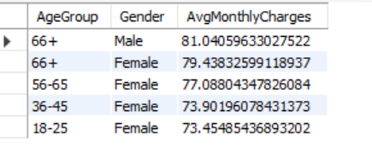

1. **What are the feedback or complaints from**

**those churned customers?**

**🡺** select

`Customer ID`,

Age,

Gender,

`Internet Type`,

`Monthly Charge`,

`Churn Reason`,

`Churn Category`

from

churnData

where

`Churn Label` = 'Yes'

and `Churn Reason` IS NOT NULL;

**Explanation:**

The customers that churned must’ve given some sort of complain or reasoning to leave the telecom company’s data packages. There’s not a specific column for “Feedback” but we do have a churn reason column which states the same meaning. I also added the churn category for a better understanding.

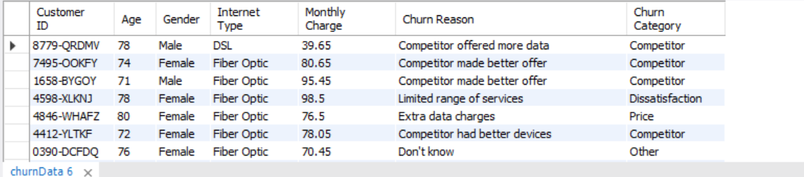

1. **How does the payment method influence**

**churn behavior?**

**🡺** **select**

**`Payment Method`,**

**count(`Customer ID`) as Total_Customers,**

**SUM(CASE WHEN `Churn Label` = 'Yes' THEN 1 ELSE 0 END) as Churned_Customers,**

**(SUM(CASE WHEN `Churn Label` = 'Yes' THEN 1 ELSE 0 END) / count(`Customer ID`)) * 100 AS Churn_Rate**

**from**

**churnData**

**group by**

**`Payment Method`**

**Order by**

**Churn_Rate desc;**

**Explanation:**

What I inferred from this question is how the methods of payment effect the rate of the customer churn for the telecom company. We have total 3 methods of payment. We find the churned customers rate by dividing the total customers by the customers that churned by using the specific payment method. This query wouldn’t be solved alone with the Where clause i.e where churn_label=’yes’( Because we have aggregated data, best we use having clause). I used the case and the sum keywords for this purpose.

**SUM(CASE WHEN `Churn Label` = 'Yes' THEN 1 ELSE 0 END) as Churned_Customers,**

**(SUM(CASE WHEN `Churn Label` = 'Yes' THEN 1 ELSE 0 END) / count(`Customer ID`)) * 100 AS Churn_Rate //count(customerID) gets all customers**

