Diabetes Health Indicators Machine Learning Project

1. Introduction
Diabetes is one of the most common chronic diseases worldwide, and early detection can significantly improve patient outcomes. With the availability of healthcare data and modern machine learning techniques, predictive models can be developed to help identify individuals at risk.
The aim of this project is to explore the Diabetes Health Indicators dataset and build machine learning models that can predict different diabetes-related outcomes. The project focuses on three main prediction tasks:
- Binary classification to predict whether a person has been diagnosed with diabetes.
- Multiclass classification to predict the stage of diabetes.
- Regression to estimate a diabetes risk score.
The overall workflow of the project follows a standard machine learning pipeline that includes data exploration, preprocessing, model training, evaluation, hyperparameter tuning, and deployment through a Streamlit application.

2. Dataset Overview
The dataset used in this project contains various clinical, lifestyle, and demographic indicators related to diabetes. These features provide useful information that can help identify patterns associated with the disease.
Some of the important variables in the dataset include:
- Fasting glucose level
- Postprandial glucose level (blood sugar after meals)
- HbA1c level
- Insulin level
- Body Mass Index (BMI)
- Cholesterol levels
- Physical activity levels
- Sleep duration
- Family history of diabetes
- Lifestyle indicators such as diet score and alcohol consumption
These features represent both medical measurements and lifestyle factors, which together provide a comprehensive view of an individual's health status.
The dataset also contains the following target variables:
- diagnosed_diabetes – binary indicator of whether a person has diabetes
- diabetes_stage – multiclass label representing the stage of diabetes
- diabetes_risk_score – a continuous score representing overall diabetes risk

3. Exploratory Data Analysis (EDA)
Before building machine learning models, the dataset was explored to better understand its structure and identify patterns within the data.
The following steps were performed during exploratory data analysis:
- Inspecting dataset shape and data types
- Checking for missing values
- Generating summary statistics
- Visualizing feature distributions
- Creating a correlation heatmap
The correlation heatmap revealed strong relationships between diabetes-related outcomes and several metabolic indicators. In particular, the following features showed relatively strong correlations:
- Fasting glucose
- Postprandial glucose
- HbA1c
- Insulin level
- BMI
These results align with medical knowledge, since elevated glucose levels and high HbA1c values are commonly used as diagnostic indicators for diabetes.
Exploring these relationships helped guide the feature selection process used later during model training.

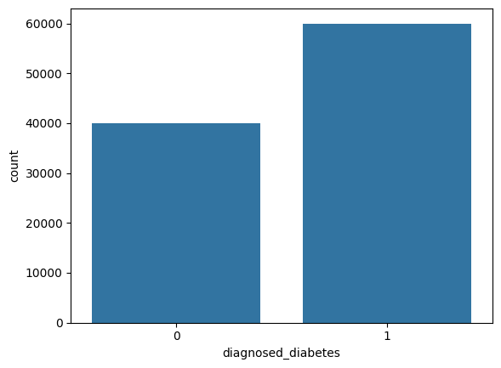
*Patient distribution

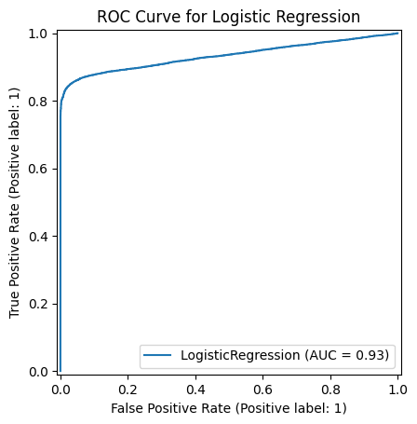
*ROC Curve

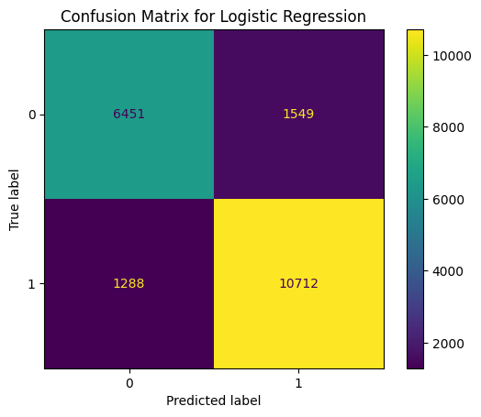
*Confusion matrix

4. Feature Selection
Based on the insights from the exploratory analysis, a subset of important features was selected for initial model experimentation.
The selected features include:
- Glucose fasting
- Glucose postprandial
- HbA1c
- Insulin level
- BMI
These variables are widely recognized as important indicators of metabolic health and showed meaningful correlations with the diabetes-related target variables.
Used a smaller set because these 5 features were the most correlated with the target variable .

5. Model Development
Three different machine learning tasks were addressed in this project.

Binary Classification
The first task was to predict whether an individual has been diagnosed with diabetes.
Several models were tested:
- Logistic Regression
- Decision Tree Classifier
- K-Nearest Neighbors (KNN)
These models were trained using an 80/20 train-test split, with stratified sampling to maintain the class distribution.

Multiclass Classification
The second task involved predicting the stage of diabetes, which contains multiple categories.
Similar classification algorithms were used, including:
- Logistic Regression
- Decision Tree
These models attempted to learn patterns that distinguish different stages of diabetes based on health indicators.

Regression
The third task was to predict the diabetes risk score, which is a continuous value representing an individual's overall risk level.
For this task, a Linear Regression model was implemented.
The regression model attempts to estimate the risk score based on clinical indicators such as glucose levels, HbA1c, insulin levels, and BMI.

6. Model Evaluation
Different evaluation metrics were used depending on the type of task.

Classification Metrics
For binary and multiclass classification models, the following metrics were used:
- Accuracy
- Precision
- Recall
- F1-score
A confusion matrix was also generated to visualize how many predictions were correct and where the model made mistakes.
Additionally, an ROC curve was used for the binary classification model to evaluate its ability to distinguish between diabetic and non-diabetic cases.
The best performing classification models achieved an accuracy of approximately 86%, indicating that the models were able to capture meaningful patterns within the dataset.

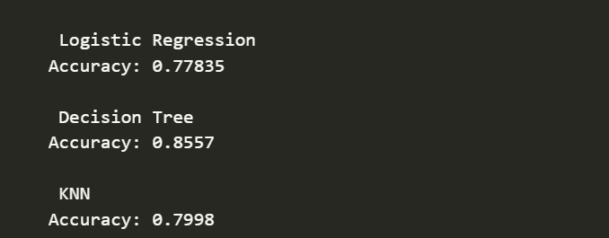

Regression Metrics
For the regression task, model performance was evaluated using:
- Root Mean Squared Error (RMSE)
RMSE measures how far the predicted risk scores are from the actual values.
Lower RMSE values indicate better model performance.

7. Model Saving
Once the final models were trained and evaluated, they were saved as serialized files using the joblib library.
Saving models allows them to be reused later without retraining.
The following model files were generated:
- binary_model.pkl
- multiclass_model.pkl
- regression_model.pkl
These files were stored inside the models directory of the project.

8. Streamlit Application
To make the models interactive and easier to demonstrate, a Streamlit application was developed.
The Streamlit interface allows users to input health-related features such as:
- Fasting glucose
- Postprandial glucose
- HbA1c
- Insulin level
- BMI
The application then uses the trained models to generate predictions for:
- Diabetes diagnosis (binary classification)
- Diabetes stage (multiclass classification)
- Diabetes risk score (regression)
This provides a simple and intuitive way to interact with the machine learning models.

9. Conclusion
This project demonstrates how machine learning techniques can be applied to healthcare-related datasets to predict diabetes outcomes.
Through data exploration, feature selection, and model training, several predictive models were developed to estimate diabetes diagnosis, stage, and risk score.

