Intro to DBS
Lec 5
Multiple buffer pools:
Either organize through: -
- ObjectID
Use unique objectIDs in record metadata to ensure a physical page only exist in one bufferpool at a time and fetch it through that id
- Hashing
Hash the page id by the number of bufferpools to get it
Prefetching:
For Sequential access database can prefetch pages to make processing time lower. Consider page 1 is called. Then page 2. Then page 3 and 4 are prefetched because the database understands sequential access happening. Even the OS can do this for us.
For index based access database differs from OS. OS cannot do this it only does sequential but Database can specify what files it needs to prefetch consider page 1->2->3->5.
Scan sharing / Synchronized Scans:
Low level operation that allows multiple queries to attach to a single cursor that scans a table. Essentially piggybacks on the first query and checks what pages it accesses to determine which pages we might need to access for the latter queries
CONSIDER
Two queries
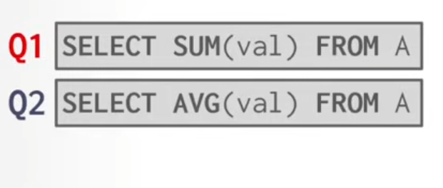
Q1 exectues from page 0 to page 3.
Q2 executes piggybacking on Q1 and starting from page 3 then scans ahead
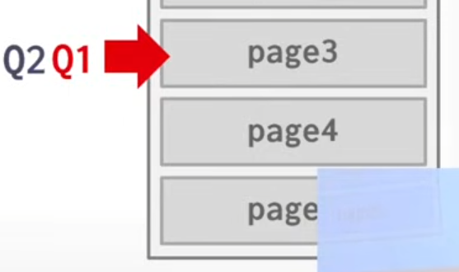
Both proceed forward
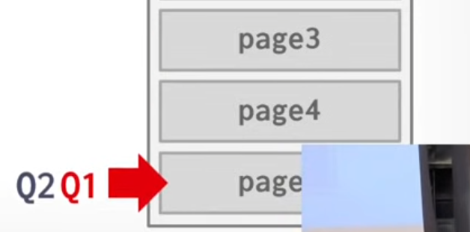
Q2 checks pages 0->2 because it hasn’t before
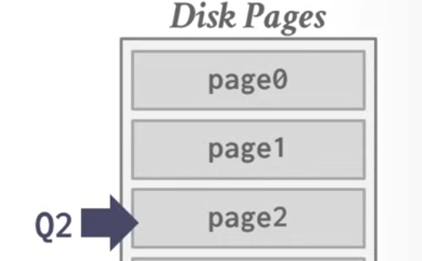
Tuple oriented storage: Reads:
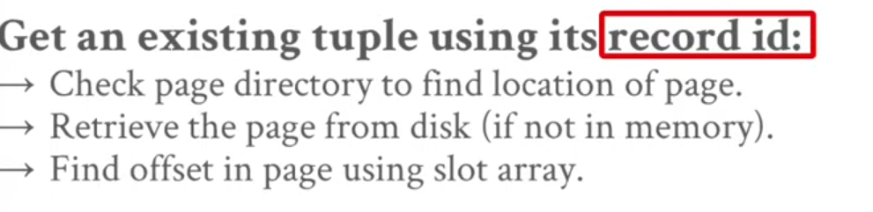
How about instead of doing it like this using the table heap we lookup using the indexes of the tuples?
Page Layout:
We studies tuple oriented storage now move onto index organized and log structured storage
Index Organized Storage:
Stores the tuple itself in the leaf node of a tree instead of recordid ( as in tuple oriented )
Still uses somewhat of a slotted page interface
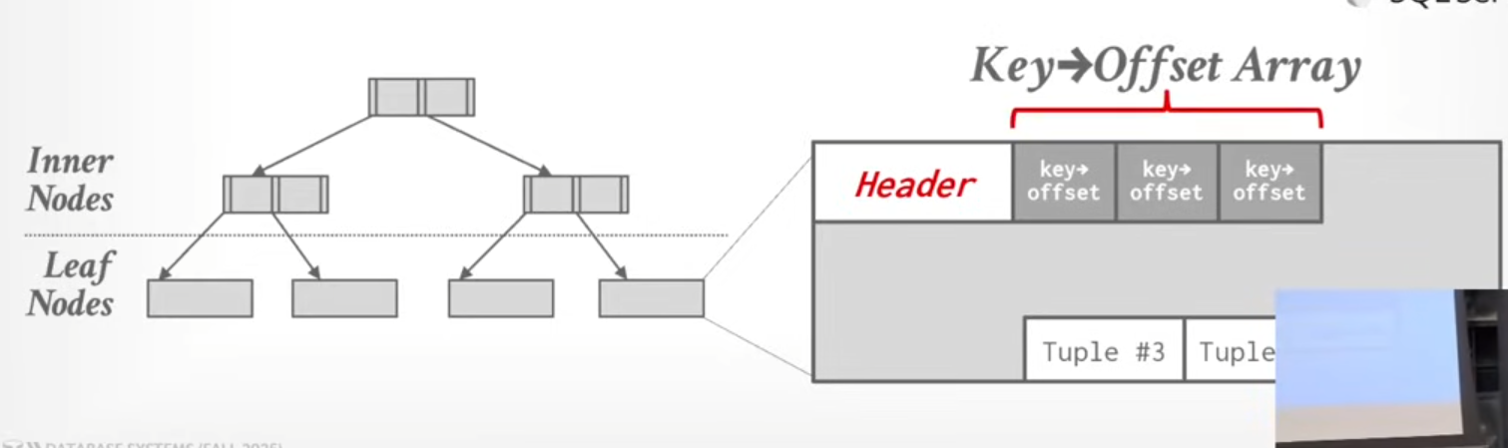
Updates in Tuple oriented storage:
very expensive
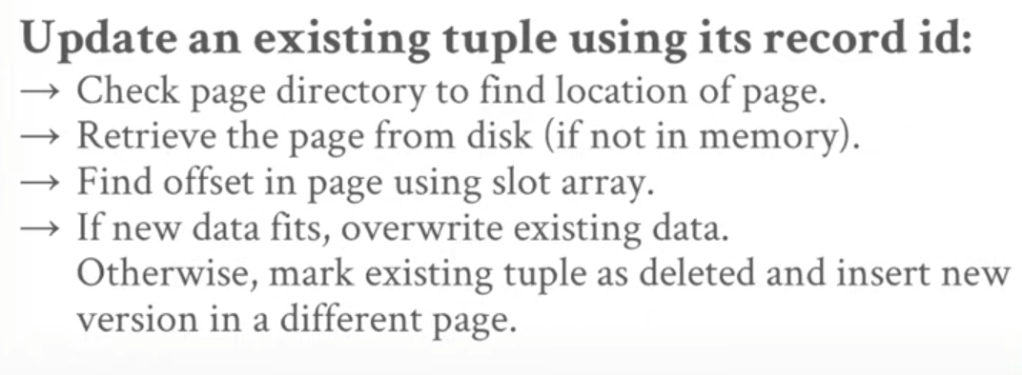

The problems with tuple oriented storage are
- Fragmentation
Pages not fully utilized (unusable space and empty slots)
- Useless disk i/o
DBMS must fetch whole page to update one tuple
- Random disk i/o
Searching for multiple tuples can take much work because they can all be on different pages
Log Structured Storage:
Instead of storing tuples in pages and updating them in-place , just append new records to datapages.
Makes updates for efficient might not be the same case for read.
Components:
- MemTable – an in memory data structure. We can make writes here and inplace updates
- SSTable – Sorted Stream Table an immutable file. Contains sequentially stores changed made to data. Stored in Disk.
FOR PUTS AND DELETES
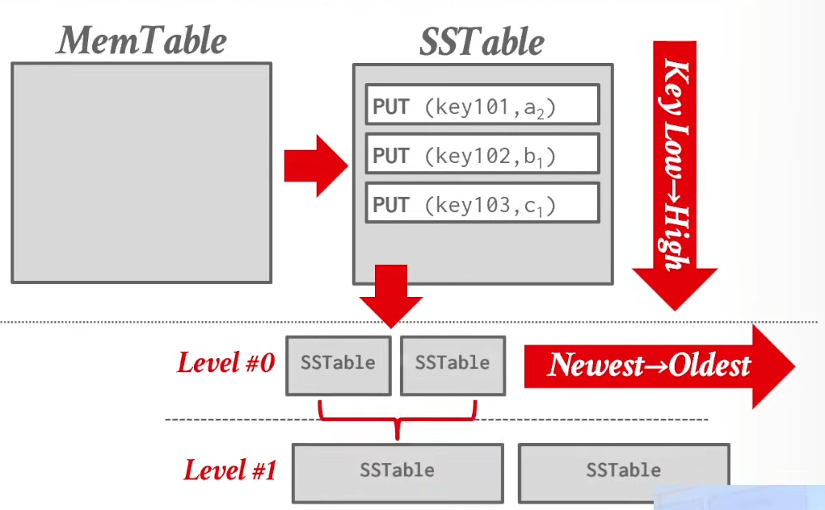
Changes made in mem table stored in SStable from lowest to highest key order then send to disk. Disk stores at level 0 with the newest SStable being stored first. Level 1 combines both SStables.
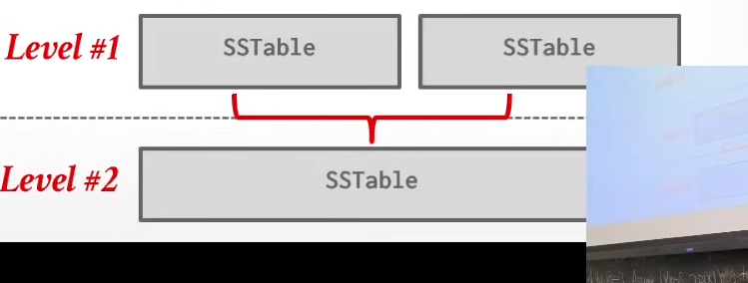level 2 does similar

FOR GETs
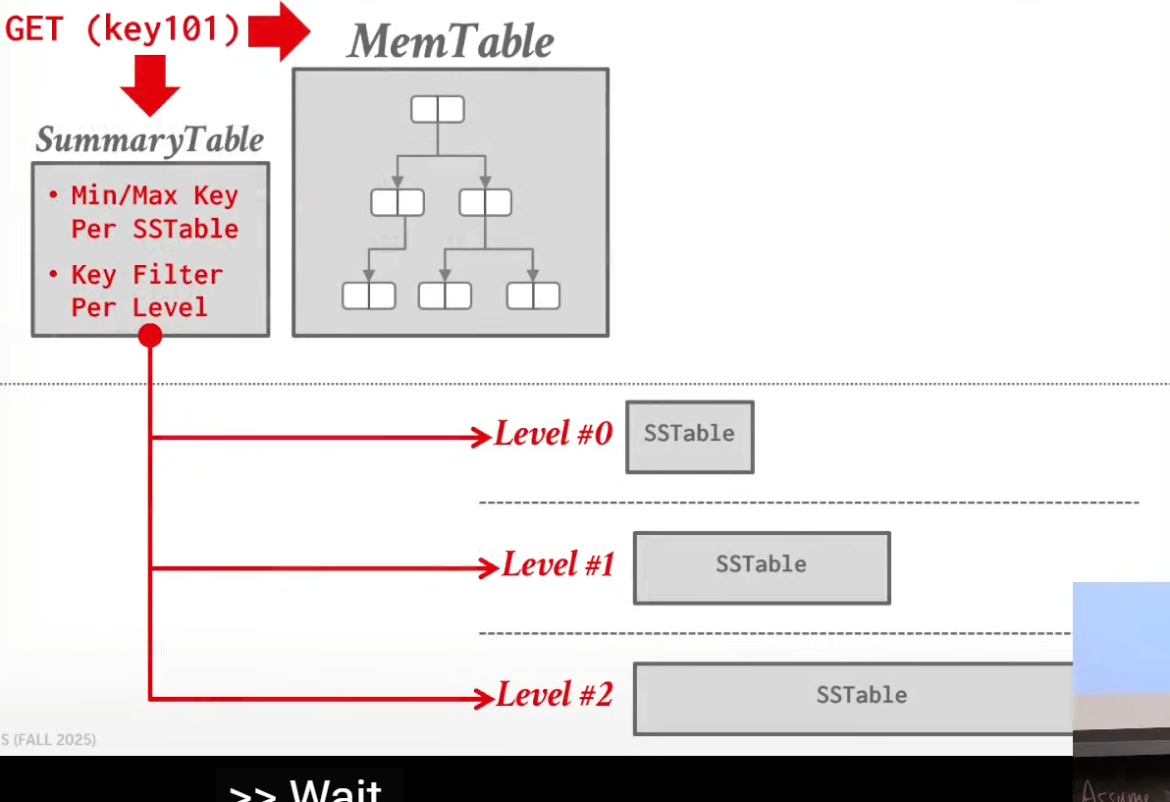
Summary table has functions to optimize getting data from sstables like checking if the value even exists. Always takes the lowest level SStable holding the value as it is the most recently modified.
Compaction:
Periodically compact data files to reduce wasted space and speedup reads
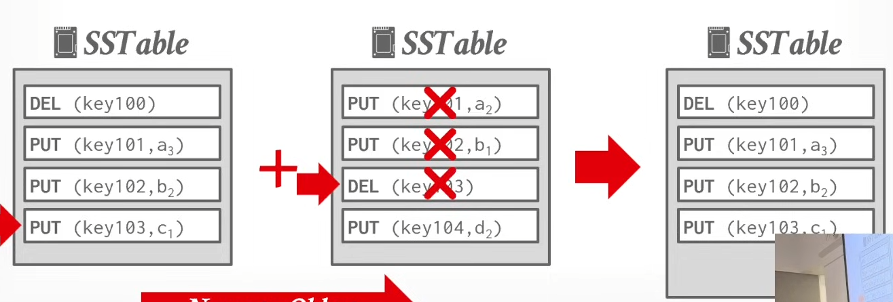
Priority goes to newer(left) sstable

