In real databases, the data is usually much bigger than RAM.
That means we can't load the whole table into memory and sort it using std::sort().
Instead, we sort the data a little at a time and keep storing temporary results on disk.
Sorting is used for:
• ORDER BY
• GROUP BY
• Building B+ Trees faster
• SortMerge Joins
External Merge Sort
Two phases:
1. Create Sorted Runs
Read as much data as RAM can hold.
Sort it.
Write it back.
Each sorted chunk is called a run.
2. Merge Runs
Merge the sorted runs until only one sorted run remains.

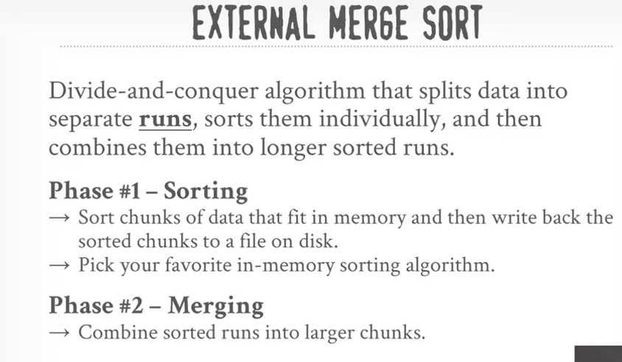
2Way Merge Sort
Uses 3 buffer pages (2 input, 1 output).
Init Pass: Sort each page individually.
Every later pass merges 2 runs into 1 larger run.
Total passes = Pass 0 + number of merge rounds.
Each pass reads every page once and writes every page once.
Total Cost = 2 × N × No. of Passes.
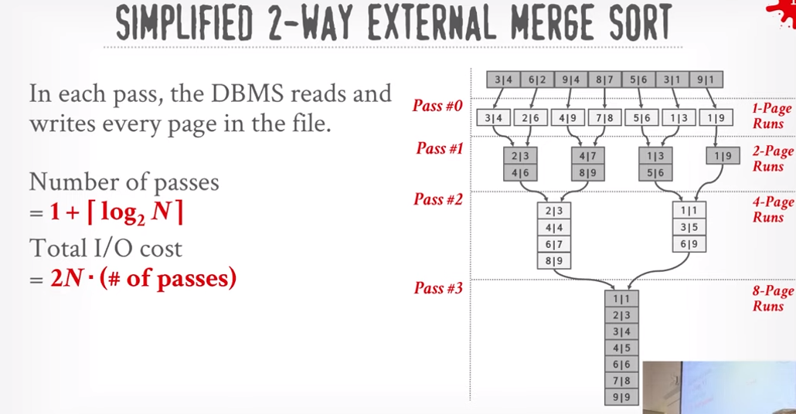
GROUP BY
Method 1: Sorting
Sort by the grouping column.
Scan once and compute aggregates.
Pros:
Output is sorted.
Cons:
Sorting is expensive.
Method 2: Hashing
Store groups in a hash table.
Update the aggregate whenever a matching key is found.
Usually faster.
Grace Hash Aggregation
Phase 1:
Partition data using a hash function.
Same keys always go to the same partition.
Phase 2:
Load one partition into RAM.
Build a hash table and compute aggregates.
If still too large, partition again.
