The purpose of the Architecture Centric Delivery is to describe practices that enable supporting system delivery within architectural overview of the system, different architectural views may be used to depict different aspects of the system. Architecture Centric Delivery is meant to assist the delivery team and processes necessary to capturing and conveying any significant architectural decisions.

Develop (and Document) in an Agile Fashion
In order to keep the software development process agile and not overburdened by excess documentation an Agile development process recommend that modeling activities be focused on 2 aspects of the system; the business domain, and the system architecture, it is these two aspects of the system that are the major source of complexity , and require the most attention. The steps taken to modeling and prototyping the business domain model in parallel are discussed in the "Business Domain Modeling Guidelines ".
The important point here is to note is that it is often overkill, and even wasteful to create detailed design documentation for every aspect of the system. Frequently, this type of extensive documentation is not even referred to by the people who would require it most, the application developers. A significant amount of work is required to keep this document up to date, so it increasingly becomes more and more irrelevant with time.
In order to keep system documentation both useful and relevant it should be focused clearly on architecturally significant aspects of the system, which leads to the next principal.

Architecture centric and User Story Centric
An important concept of the development process is that requirements are organized using descriptive behavior to tell how various actors may interact with the system. Other non-behavioral requirements are captured in the context of one or more of these User Stories. It is because of this reliance on scenario driven requirements that the process is said to be User Story centric.

The process is also said to be architecture centric because there is an emphasis on designing, developing, and testing the architecture before full-blown construction iterations begin. The focus of Discovery is to develop and validate an executable architecture prototype. Subsequent construction phase iterations may than reuse this architecture in a template driven development approach.
Architecture is developed and validated in Discovery by selecting a subset of functional requirements (User Stories) and realizing them with Architecture modeling activities. The proposed architecture is then validated through implementation and testing activities. By the end of Discovery a comprehensive software architecture document should have been documented, reviewed by the appropriate stakeholders, and validated with executable code that is able to operate under the appropriate nonfunctional requirements such as user load, availability, and security.
It is important to note that a combination of a robustly documented application architecture and documented business domain model validated by executable code is usually sufficient for most projects to initiate construction activities without the need to heavily document the remaining aspects of the system.

Model Visually
Even when using an agile approach, software/application architecture is an important concept to model/document. Another key principle of an Agile processes is that modeling be done visually. Visual representations of the system allow understanding at a higher level of abstraction than browsing through source code and other implementation artifacts. However, many aspects of system code are best left described in the system code.
UML is an excellent tool for diagramming models, and will probably be used for the majority of business model diagram efforts. The focus of diagrams should be to facilitate brainstorming, and not necessarily try to capture all aspects of the proposed architecture. Attempt to do so will create a model that overwhelm the reader with detail and lack meaning. Remember that the purpose of documenting any model is to convey knowledge to a particular audience, not to capture the detail of every relationship and field type. Models are not diagrams; rather diagrams are used to help communicate a model to a specific audience.
When designing significant components of software architecture during Discovery a good approach is to use modeling tools to create initial sketch/ blueprint of a proposed component and use this blueprint as a discussion piece with whoever is responsible for implementing the component. An even better approach is to have the developer participate in the design/modeling process. Only when an architecturally significant component has been implemented and validated should more comprehensive documentation begin.

Developing in an Iterative Fashion
An Agile development process recommends an approach where system architecture is modeled and documented, but is also continually refactored from information discovered during implementation activities. Discoveries made during implementation must be allowed to flow back into architecture and design documents. Documentation is both selective and geared towards illustrating architecturally significant components of the system.

In the Discovery phase architectural analysis is dedicated towards creating a conceptual model that partitions application responsibility, and refines the candidate architecture developed during the initiation phase. This is not focused on developing heavy documentation, but rather getting a high level overview of how the system will conceptually interact with itself and other systems. Key mechanism requirements (technology enablers) such as persistence, error handling and security are defined in candidate architecture.

Architecture Description
System Context
System Context Diagrams are diagrams used to define the system boundaries (i.e. system under discussion) and represent interactions between the system under discussion and external systems/interfaces. These diagrams usually picture the system at the center, with no details of its interior structure, surrounded by all of its interacting systems, environment and activities. Often, the System Context Diagram can be supplemented with Domain Driven Design interaction patterns (e.g. Anti-corruption layer). Below is an example of a system context diagram:
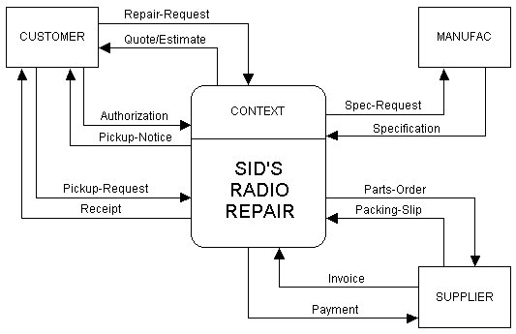
Platform Architecture
The platform architecture describes the software and application platforms that realize the architecture for the system. This view of the architecture communicates the technology choices and specific software packages/frameworks that will be used for developing the solution. Typically, a conceptual/logical architecture of capabilities is defined to guide the platform architecture that should be selected to meet the requirements of the overall solution capabilities.
Sample platform architecture for a multi-channel integration service:
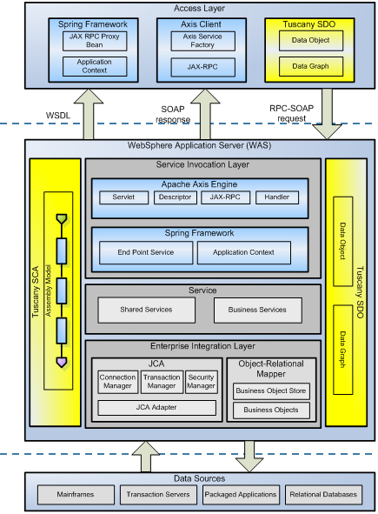
Layered Architecture
The purpose of this step is to organize the system architecture into layers and cohesive components. The number of layers is not fixed, but varies from situation to situation.
During architectural analysis, the focus is on modeling the application and business layers of the system. However if specific architectural patterns or reference architectures are used then they may also be incorporated into the model as well.
Sample layered architecture:
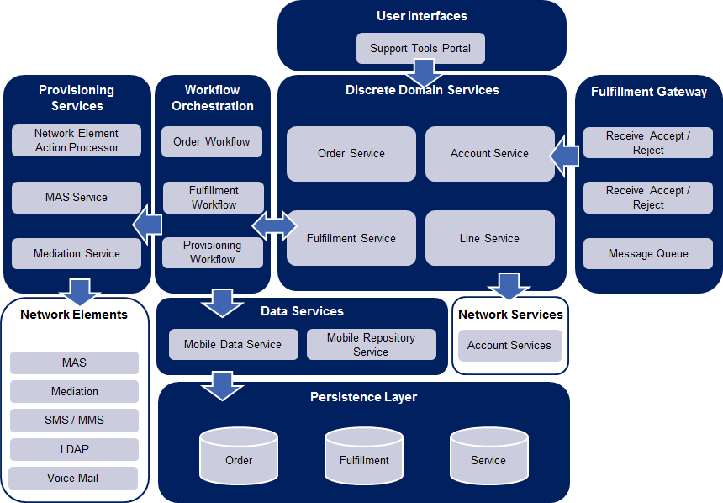
Deployment Architecture
Using a combination of deployment and or infrastructure diagrams, describe the deployment topology of the proposed solution.

Example:
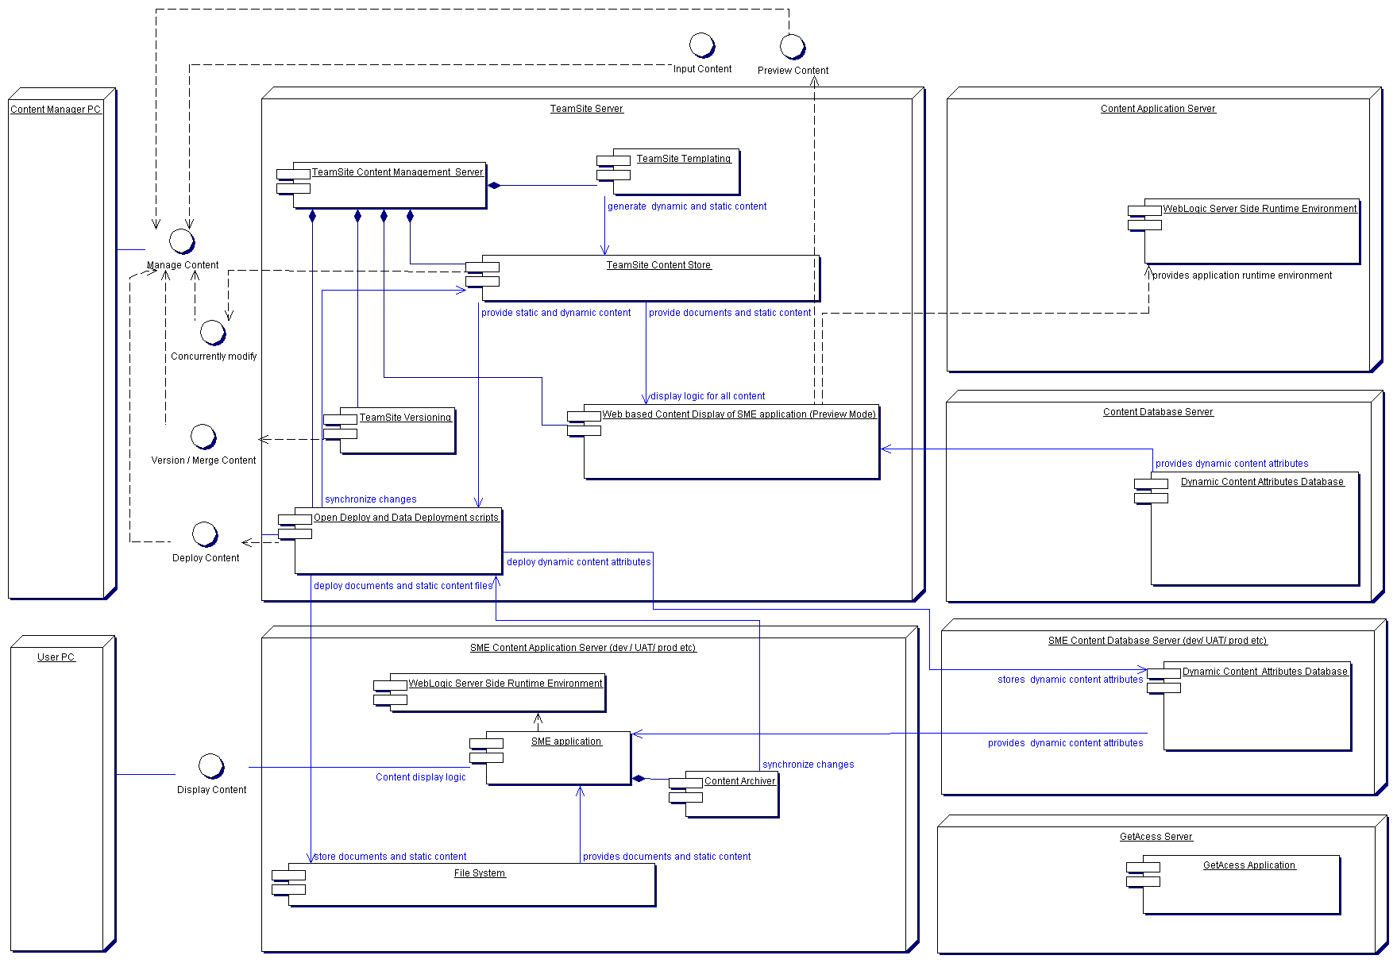

Architecture Risks
For complex systems, there is often significant risk that the architecture may not be technically feasible or meet the needs of the requirements upon implementation. Architecture centric delivery strives to mitigate these architecture risks by identifying them early in the project to inform the approach in addressing these risks. Common risks tend to fall into integration, performance, scalability, security or new unproven technologies. A number of strategies for mitigating these risks are available and include proof-of-concepts (POC), spikes, delaying irreversible decisions or applying set based thinking.
Architecture Constraints
Architecture constraints typically represent architecturally significant non-functional requirements that constrain the solution options. That means these requirements have a significant impact on the functional requirements themselves or solution. It is important to consider this category of requirements early on in the process to avoid making irreversible decisions in the solution and mitigating architecture risks. This category of requirements also often constrain the universe of features that the customer may want to a smaller set due to complexity, effort, time, risk and maintenance trade-offs. Examples of architecture constraints may be a requirement for 5 nines reliability or uptime (99.999%), response times of 1 second or less, or high security. As a result of these architecture constraints, a particular solution option may be a better choice than others.

