Homepage & Country Landing Pages – Requirements
The website itself must be entirely in German. All headings, filters, buttons, labels and customer-facing content should therefore be displayed in German.
1. Homepage
Directly below the header, the first section should be:
„Beliebte Reiseziele“
The following destinations should be displayed:
Österreich, Deutschland, Italien, Kroatien, Griechenland, Ägypten, Spanien, Südtirol, Städtereisen
On desktop, 5 destinations should be visible in one row. The remaining destinations can be accessed via a horizontal slider/carousel.
The complete destination card/image should be clickable.
There should be no search box or large search section above the destinations.

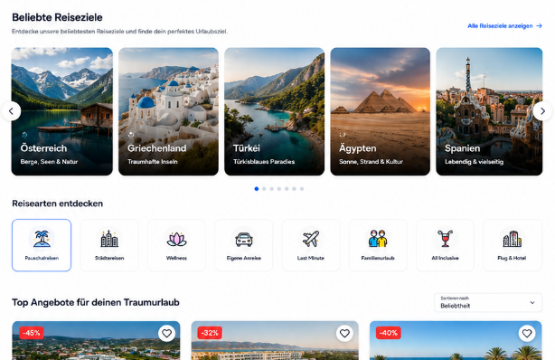

Mobile:
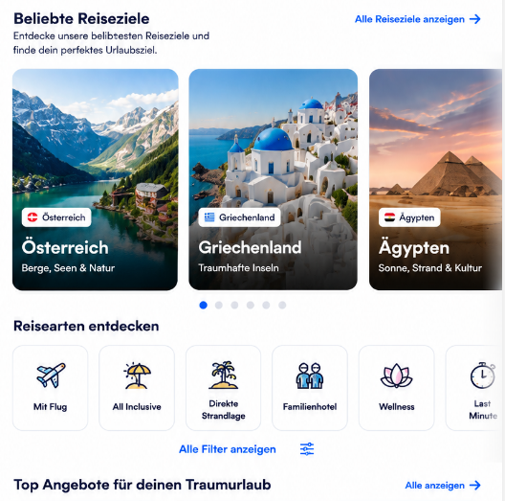

2. Homepage Filters
Below the popular destinations, there should be a modern filter section.
There should be no filter sidebar.
Instead, all filters should be displayed as modern clickable icon buttons/chips.
Since the homepage displays deals from all destinations, it should contain all available filters:
- Mit Flug
- All Inclusive
- Direkte Strandlage
- Adults Only
- Familienhotel
- Thermenurlaub
- Wellness
- Urlaub am See
- Urlaub am Meer
- In den Bergen
- Skiurlaub
- ab 85 % Weiterempfehlung
- Frühbucher
- Last Minute
Each filter should have a suitable icon.
Multiple filters
Users must be able to select multiple filters at the same time.
For example:
Mit Flug + All Inclusive + Direkte Strandlage + ab 85 % Weiterempfehlung
Selected filters should be visually highlighted, preferably using our blue brand color with white text/icon.
There should also be a simple way to remove individual filters or reset all selected filters.

3. Filters must be reflected in the URL
This is an important technical requirement.
Whenever a user selects one or multiple filters, the selected filters must be reflected in the URL.
For example:
/angebote?flug=1&all-inclusive=1&strandlage=1
This means a user should be able to copy and share the URL, and when another person opens that link, exactly the same filters should automatically be active and the corresponding deals should be displayed.
The filter state should also remain correct when:
- refreshing the page
- opening the URL directly
- using the browser Back button
- using the browser Forward button
The URL should therefore be the source of truth for the active filter state.
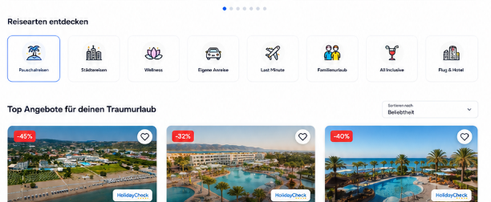

Mobile:
4. Country Landing Pages
Each major destination should have its own dedicated landing page.
For example:
Urlaub in Österreich
Urlaub in Deutschland
Urlaub in Italien
Urlaub in Kroatien
Urlaub in Griechenland
Urlaub in Ägypten
Urlaub in Spanien
Urlaub in Südtirol
The page should start with an H1 such as:
„Urlaub in Österreich“
Directly underneath the heading, there should be a short introduction about the respective destination.
This text should be individually editable for every country and suitable for SEO.
After the introduction, display the icon-based filters, followed by the available deals.

5. Filters by Destination
The landing pages should only display filters that are relevant to the respective destination.
Österreich
- Thermenurlaub
- Wellness
- Familienhotel
- Urlaub am See
- In den Bergen
- Skiurlaub
- ab 85 % Weiterempfehlung
- Frühbucher
- Last Minute
Deutschland
- Thermenurlaub
- Wellness
- Familienhotel
- Urlaub am See
- Urlaub am Meer
- In den Bergen
- Skiurlaub
- ab 85 % Weiterempfehlung
- Frühbucher
- Last Minute
Italien, Kroatien, Griechenland, Ägypten & Spanien
- Mit Flug
- All Inclusive
- Direkte Strandlage
- Adults Only
- Familienhotel
- ab 85 % Weiterempfehlung
- Frühbucher
- Last Minute
Südtirol
- Wellness
- Familienhotel
- Urlaub am See
- In den Bergen
- ab 85 % Weiterempfehlung
- Frühbucher
- Last Minute
Städtereisen
- Mit Flug
- ab 85 % Weiterempfehlung
- Zentrale Lage / Nähe zum Zentrum
- Frühbucher
- Last Minute
Multiple filters must also be selectable simultaneously on all landing pages, and every filter combination must be reflected in and shareable through the URL.

6. Deal Grid
Below the filters, all matching deals should be displayed using the deal card design we have already defined.
Desktop
Display exactly:
3 deal cards per row
The cards should have enough width and whitespace and should not be compressed to fit four or more cards into one row.
Filtering should ideally happen dynamically without a full page reload.

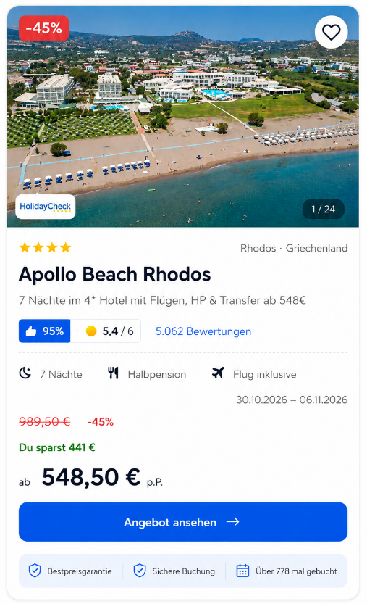
Der Should be a silder to see the Pictures before click on the offer.

7. Overall Page Structure
Homepage
Header
↓
Beliebte Reiseziele
↓
Icon Filters
↓
Deals – 3 per row on desktop
↓
Additional content / Footer
Country Landing Page
Header
↓
H1 – e.g. „Urlaub in Österreich“
↓
Short destination introduction
↓
Destination-specific Icon Filters
↓
Deals – 3 per row on desktop
↓
Additional SEO content / Footer
Important
The interface itself must remain German.
This document is written in English only to explain the requirements to the developer.

Offer Detail Page – Additional Requirements
Desktop Version
The right-hand booking / price column must be sticky.
When the user scrolls down the offer page, the price card including the CTA button should remain visible on the right side of the screen.
The sticky element should contain the main booking information, especially:
- Old price
- Current price
- Saving / discount
- Main CTA button: „Termine & Preise anzeigen“
The sticky behaviour should stop naturally before the footer or other page elements so it never overlaps content.
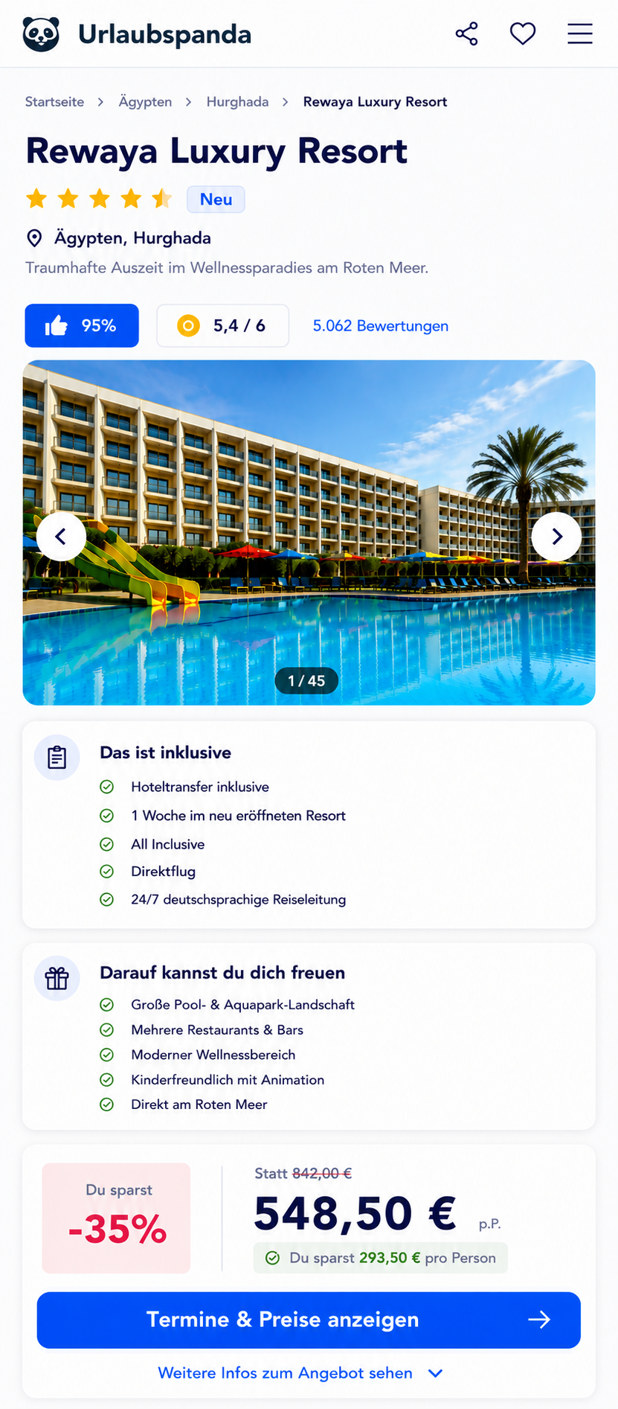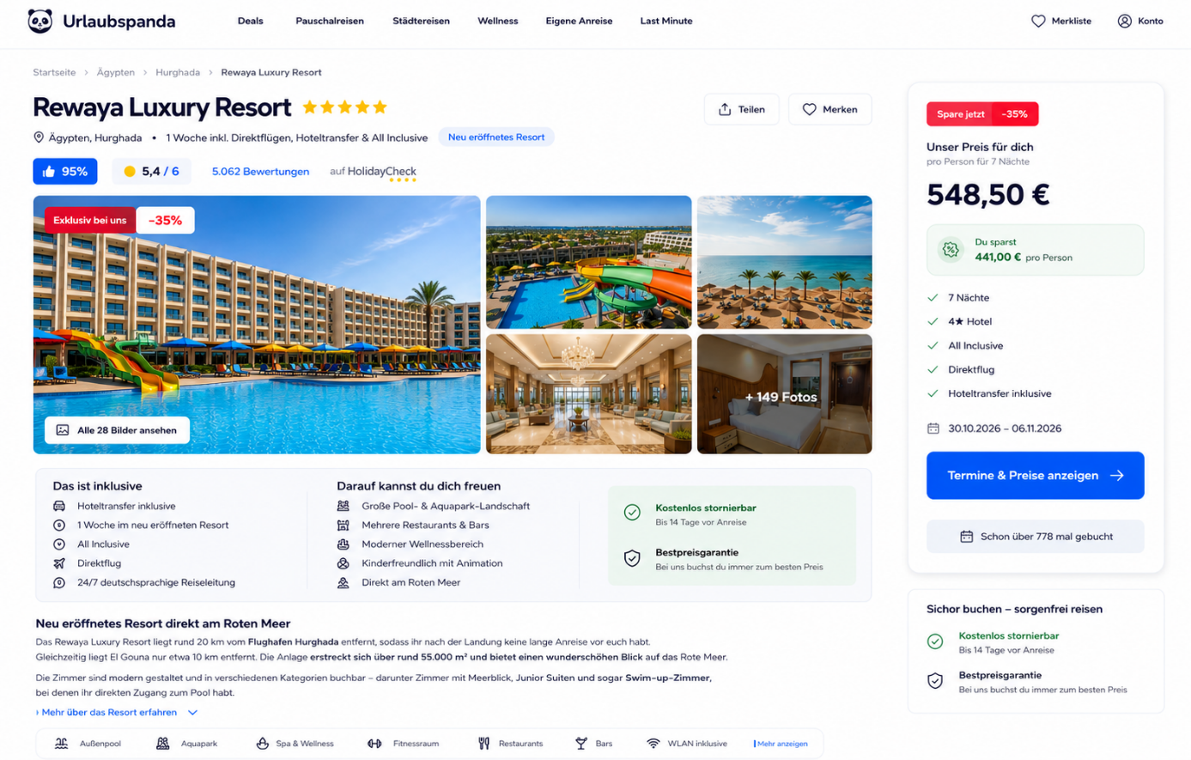

Mobile Version
On mobile, the normal CTA button should first appear inside the page content in the price section.
Once the user scrolls far enough that this original button is no longer visible, a sticky CTA bar/button should appear at the top of the screen.
The sticky version should remain visible while the user continues scrolling.
Important:
- Do not show both buttons at the same time.
- The sticky CTA should only appear once the original CTA has left the viewport.
- When the user scrolls back up and the original button becomes visible again, the sticky version should disappear.
- The CTA should be visually prominent and slightly thicker/taller than in the current example.
- Button text: „Termine & Preise anzeigen“
- Urlaubspanda blue background
- White bold text
- Large tap area
- Rounded corners
A button height of approximately 60–64 px on mobile would work well.

„Mehr Infos zum Angebot ansehen“
Directly below the normal CTA button on mobile, display the text link:
„Mehr Infos zum Angebot ansehen“
Optionally include a small downward chevron.
When clicked, the page should smooth-scroll directly to the written offer description further down the page.
For example:
Mehr Infos zum Angebot ansehen ↓
This is not a second primary CTA and should therefore visually remain a simple text link.

Share Button
There should be a share button next to the hotel name / hotel heading area.
On mobile, it should be easy to reach and clearly visible near the top of the offer page.
When the user clicks the share icon, open a small modal, bottom sheet or native share dialog with the following options:
- Link kopieren
- WhatsApp
- SMS
- Messenger
- E-Mail
Where supported, the browser's native Web Share API can be used on mobile.
If native sharing is not supported, use our own share modal as fallback.
The shared URL must always point directly to the current offer.

CTA Destination Behaviour
The CTA „Termine & Preise anzeigen“ needs to support two possible behaviours on a per-offer basis.
This should ideally be configurable in the backend.
Option A – Direct Redirect
For offers that use only one destination link:
User clicks:
„Termine & Preise anzeigen“
→ User is immediately redirected to the configured booking / affiliate link.
No additional popup is shown.

Option B – Country Selection Before Redirect
For some offers, different booking links may exist depending on the customer's country of residence.
When the user clicks:
„Termine & Preise anzeigen“
open a clean modal or bottom sheet asking:
„Wo wohnst du?“
Subtitle:
„Wähle dein Land, damit wir dir das passende Angebot zeigen können.“
Then display three large selectable options:
🇦🇹 Österreich
🇩🇪 Deutschland
🇨🇭 Schweiz
After selecting a country, immediately redirect the customer to the corresponding configured booking link.
For example:
Austria → affiliate_url_at
Germany → affiliate_url_de
Switzerland → affiliate_url_ch
The country selection should not be hardcoded into the frontend. Each offer should be able to have its own destination URLs.
If an offer only has one booking URL, the modal should not appear at all.

Backend Logic
Each offer should ideally support something like:
cta_mode:
- direct
- country_selection
For a direct offer:
cta_mode: direct
booking_url: ...
For country-specific offers:
cta_mode: country_selection

booking_urls:
AT: ...
DE: ...
CH: ...
This will allow us to decide separately for every deal whether the visitor should be redirected immediately or first select their country.

Recommended Mobile Behaviour
The mobile flow should therefore be:
Hotel information
↓
Reviews
↓
Large image slider
↓
Das ist inklusive
↓
Darauf kannst du dich freuen
↓
Price / discount
↓
Large blue „Termine & Preise anzeigen“ button
↓
„Mehr Infos zum Angebot ansehen ↓“
When the user scrolls further:
Sticky CTA appears at the top
If the CTA requires country selection:
CTA → Country modal → Austria / Germany / Switzerland → correct external link
If not:
CTA → immediate redirect
This behaviour should be identical whether the user clicks the normal CTA or the sticky CTA.

Future Booking Flow & Technical Requirements
At a later stage, the website will be expanded with a fully integrated booking flow directly on Urlaubspanda.
Instead of redirecting users to an external partner after clicking:
„Termine & Preise anzeigen“
the user should eventually be able to:
select dates → choose room / package → enter traveller details → complete the booking directly on our website.
The exact booking process and API requirements will be specified later.
For the current rebuild, the important point is that the architecture should not block this future development.
The CTA and offer data model should therefore be built in a flexible way so that the current behaviour:
External Redirect / Country Selection
can later be replaced or extended with:
Internal Booking Flow
without having to rebuild the entire offer page.
For example, the offer model could later support different CTA types such as:
cta_mode:
- direct_redirect
- country_selection
- internal_booking
The frontend components should therefore be reusable and not tightly coupled to external affiliate links.
SEO Requirements
The entire website must be built with SEO as a core requirement, especially the country landing pages and individual offer pages.
Important requirements include:
- Server-rendered / indexable HTML content
- Clean semantic HTML structure
- Correct H1 / H2 / H3 hierarchy
- Unique SEO title and meta description for every landing page and offer
- Clean, human-readable URLs
- Canonical URLs
- Open Graph metadata for sharing
- Structured data / Schema.org where appropriate
- Breadcrumb structured data
- Hotel / Offer structured data where applicable
- Image alt texts
- Internal linking between destinations, categories and offers
- Sitemap generation
- robots.txt support
- Avoid duplicate content caused by filters
- Filter URLs must be handled carefully for SEO
The filter system should remain shareable via URL as described earlier, but we should be able to control whether specific filter combinations are indexable or noindex. We do not want Google indexing thousands of low-value filter combinations.
Important destination/category landing pages can instead have dedicated SEO-friendly URLs and content.
For example:
/oesterreich/
/oesterreich/wellness/
/oesterreich/thermenurlaub/
/griechenland/all-inclusive/
/aegypten/direkte-strandlage/
while temporary combinations such as multiple filters can use query parameters and usually remain non-indexable.
Performance
The site needs to be very fast, especially on mobile.
Performance should be considered from the beginning, including:
- Optimized responsive images
- Modern image formats such as WebP / AVIF
- Lazy loading for images below the fold
- Preloading of important above-the-fold images
- Avoid unnecessary JavaScript
- Code splitting
- Fast server response times
- CDN / caching strategy
- Efficient API calls
- Pagination or incremental loading of offers
- No loading of hundreds of deals at once
- Stable layouts without content jumping
The goal should be excellent Core Web Vitals and a fast experience even on mobile connections.
General Architecture Goal
The new website should be built as a modern, scalable travel platform, not just as a visual redesign of the current site.
The foundation should support:
Current phase:
Landing pages → filters → offer pages → affiliate redirects
Later phase:
Landing pages → filters → live availability → internal booking flow → booking completion directly on Urlaubspanda
So the priorities from day one are:
SEO-friendly + very fast + mobile-first + modern + scalable + prepared for direct booking later.
Diesen Punkt würde ich wirklich ausdrücklich dazuschreiben, weil er beeinflusst, wie der Entwickler Datenmodell, Routing und Komponenten von Anfang an aufbaut.

