PULSE INSPECTION SUITE
Master Test Plan
Portfolio Edition
Document No: PIS-QA-MTP-01
Version 1.3
Prepared by: Abdelrahman Ali — SQA Engineer
Abyssal Systems — Sample QA Documentation (Portfolio Version)
Names, versions, and client references in this document have been fictionalized for public presentation. The testing approach, structure, and technical content reflect real production QA work.

Revision History
Version | Date | Summary of Changes | Author
1.0 | 2026-04 | Initial Master Test Plan — scope, approach, environment, entry/exit criteria. | QA Engineer
1.1 | 2026-06 | Added Test Procedures as a tracked deliverable; expanded risk register. | QA Engineer
1.2 | 2026-09 | Corrected database architecture description (historical baseline tables); added DVE overlay-recording rule. | QA Engineer
1.3 | 2026-10 | Added Section 16, Test Schedule. | QA Engineer
Portfolio | 2026-11 | Redacted for public portfolio — names and client references fictionalized; content otherwise unchanged. | QA Engineer

1. Introduction
This Master Test Plan defines the testing approach, scope, responsibilities, and release-readiness criteria for the Pulse Inspection Suite — a three-application package (DataLink, MissionHub, StreamCap) used during live ROV subsea pipeline and structure inspections. It is the top-level QA document: detailed step-by-step execution lives in the companion Test Procedures document, and per-application strategy and coverage live in the companion Test Strategy document.

1.1 Purpose
To give every stakeholder — QA, engineering, and release management — a single, shared definition of what “tested” means for a Pulse Inspection Suite release: what is covered, how it is covered, what environment it is covered in, and what has to be true before a build ships.

1.2 Document Control
This is a living document. It is revised with every major release rather than reissued from scratch, so that test coverage grows with the product instead of lagging behind it. See the Revision History above.

2. System Overview

2.1 Suite Composition
The Pulse Inspection Suite consists of three applications that run on separate machines and communicate over IP:
- DataLink — captures live readings from every connected sensor (navigation, depth, cathodic protection, DMS, and others), each sensor on its own dedicated port or socket, and streams them to MissionHub and to the project database in real time.
- MissionHub — the control and orchestration layer. Operators log in, connect to DataLink, set up the project/pipe or structure context, remotely initialize one or more StreamCap machines, design and push video overlays, drive recording, and log inspection events.
- StreamCap — runs on each video-capture machine (one per camera). Captures and displays live video from an industrial capture card or IP camera, burns in the overlay MissionHub configures, and records locally — entirely under remote command from MissionHub.

2.2 Operating Modes
MissionHub supports two operating modes that are materially different workflows, not a relabeling of the same one:
- Pipeline Mode — organized around a pipe and distance-along-pipe (KP) position. Events are logged against KP and can be checked against a historical baseline (“Old Event” matching, see 2.3) as the current position approaches a previously-recorded event.
- Structure Mode — organized around a Workpack of components, each tracked against a 3D model with traffic-light progress coloring (red = no task started, yellow = in progress, green = complete). Work is logged as Component Tasks, in either Single-Task (auto-start) or Multi-Task mode.

2.3 Database Architecture
Two tiers of database are in play, and the test strategy treats them differently:
- A project catalog database (ProjectCatalogDB) holds project, pipe/structure, and reference-code (event code library) metadata shared across the whole suite.
- Each pipe or structure has its own pair of databases — a Logging DB and a Processing DB — built from a shared template (PipeTemplateDB), so their schemas are identical at creation time.
- Within a pipe's databases, raw “Log” tables are written in real time by DataLink; “Proc” tables hold the processed/reprocessed version of the same data.
- “Old”–prefixed tables (e.g. a historical position or event log) are not an automatic archive. They hold historical data supplied by the client and imported before the project starts, specifically so the current survey can be compared against it — this is the data source behind Pipeline Mode's Old Event matching.
- “Design”–prefixed tables similarly hold client-supplied design or as-built baseline data, imported the same way, for comparison rather than generated by the suite itself.

3. Scope

3.1 In Scope
- DataLink: sensor string capture, per-port/socket handling, and database write-through.
- MissionHub: login and session setup, project/pipe/structure setup, remote initialization of StreamCap instances, overlay design, recording control, and event logging in both operating modes.
- StreamCap: capture-card and IP-camera initialization, overlay rendering and recording sync, recording start/stop/split/pause/resume, and local ASF export.
- Cross-application integration: multi-machine orchestration, time synchronization, and database consistency.
- Functional, regression, smoke, negative/edge, combination, database-validation, and stability testing across all of the above.

3.2 Out of Scope
- Internal driver-level behavior of third-party capture cards and GPUs, beyond the interface the suite uses.
- Operating-system issues unrelated to the suite's own behavior.
- Network infrastructure beyond the configured test environment.

4. Test Levels
Level | Purpose
Smoke | Fast pass/fail check that the core workflow — connect, initialize, overlay, record, log an event — works at all on a new build.
Regression | Full re-verification of previously working functionality after a change, to catch anything the change broke.
Manual Functional | Feature-level verification against expected behavior, run manually release over release.
Negative / Edge | Invalid input, boundary conditions, and failure-path behavior (disconnects, invalid IPs, out-of-range values).
Combination | Interactions between features that are not safe to test in isolation — multiple cameras, multiple overlays, mode switches.
Stress / Stability | Extended-duration and failure-recovery runs — crash/reconnect, long recordings, repeated reinitialization.
Database Validation | Direct verification that what lands in the database matches what the application displays and records.
Structure-Mode-Specific | Coverage unique to Structure Mode — Workpack, 3D model, Component Tasks — not exercised by Pipeline Mode cases.

5. Test Approach by Component

5.1 DataLink
No physical sensors are available in the test environment, so sensor strings are generated with a lightweight simulator tool that sends fake readings to DataLink's configured ports/sockets. Coverage focuses on: per-sensor port/socket configuration, string parsing, forwarding to MissionHub, and write-through to the database.

5.2 MissionHub
Coverage spans login and session setup, database/project/pipe (or structure) selection, remote initialization of one or more StreamCap instances by IP, overlay design, recording control, and event logging — including Old Event matching in Pipeline Mode and Component Task workflows in Structure Mode.

5.3 StreamCap
Coverage spans capture-card and IP-camera initialization, overlay burn-in, and recording control, all driven remotely from MissionHub rather than operated directly. One rule shapes a large part of this suite:
- Recording cannot start without an overlay configured on that camera.
- The overlay cannot be edited while a recording is active on that camera — recording must be stopped, the overlay adjusted, and a new recording started to pick up the change.

5.4 Cross-System Integration
Covers everything that only shows up when the three applications run together: multi-machine time synchronization (all machines take their time from MissionHub), consistent event/overlay state across multiple simultaneous StreamCap instances, and database consistency when multiple components write to the same pipe/structure database concurrently.

6. Test Environment
Baseline test environment — 5 machines, all Windows 10:
Machine | Role | Notes
Machine 1 | MissionHub | Orchestration application; also hosts the database connection.
Machine 2 | DataLink | Receives simulated sensor strings; forwards to MissionHub and the database.
Machine 3–5 | StreamCap (one per camera) | One capture machine per physical camera — 3 in the baseline environment, more for larger jobs.

Consolidated alternates (fewer physical machines, roles combined on shared hardware) are supported for smaller test passes, with the trade-off that cross-machine issues — time-sync drift and network-path behavior in particular — are not exercised the same way as on the full baseline environment. The full baseline is required before sign-off on a major release.
Database: SQL Server. All releases under this plan are treated as major releases.

7. Roles & Responsibilities
Role | Responsibility
QA Engineer | Owns test planning, execution, defect logging/triage, and release sign-off recommendation.
Engineering / R&D | Fixes defects, clarifies expected behavior, reviews edge cases flagged by QA.
Release Manager | Schedules releases, confirms exit criteria are met, authorizes the release.

8. Entry Criteria
- Build installed on all machines in the test environment.
- Database schema created or migrated to match the build under test.
- Sensor-simulation tooling available and able to reach DataLink.
- No outstanding Critical/Blocker defects from the previous cycle left unresolved without a documented waiver.

9. Exit Criteria
- All Critical- and High-priority test cases executed, with results recorded.
- No open Critical or Blocker defects; any open High-priority defect has a documented triage decision.
- Full regression suite executed with no unexplained new failures.
- Release sign-off obtained per Section 14.

10. Test Deliverables
Deliverable | Status
Master Test Plan (this document) | Maintained
Test Procedures | Maintained
Test Strategy | Maintained
Test Case Repository | Maintained — living document, extended every release
Bug Retest / Regression Sequence | Maintained — regenerated each release cycle
Requirements Traceability Matrix | Planned
Defect Report Template | Planned
Release Sign-off Report | Planned

11. Risk Assessment
Risk | Likelihood | Impact | Mitigation
No physical sensors available in the test environment | High | Medium | Dedicated simulator tool generates realistic sensor strings for every sensor type.
Multi-machine time drift affects overlay/event timestamps | Medium | Medium | Periodic time sync from MissionHub to all connected machines; verified in the stability suite.
StreamCap crash during active recording can corrupt the output file | Medium | High | Dedicated stress/stability cases around crash-and-reinitialize during active recording.
Historical-baseline data accuracy depends on a client-supplied import | Low | Medium | Database validation cases confirm imported baseline data matches the supplied source before go-live.
Consolidated (fewer-machine) test environments under-exercise cross-machine behavior | Medium | Medium | Full 5-machine baseline required before major-release sign-off, regardless of environment used for interim testing.

12. Test Procedures
Full step-by-step execution instructions live in the companion Test Procedures document. Each procedure maps to one stage of the real workflow, so a tester works through the application once per release rather than hunting for the right steps:
- 1. Sensor Simulation Setup
- 2. DataLink Configuration
- 3. MissionHub Login and Session Setup
- 4. StreamCap Camera Initialization
- 5. Overlay Design and Verification
- 6. Recording Control Verification
- 7. Event Logging
- 8. Database Verification
- 9. End-to-End Smoke Check

13. Defect Management

13.1 Lifecycle
New → Open → (Blocked, if waiting on something external) → Closed. Every defect carries a Priority and a Severity, set independently.

13.2 Traceability
Every defect is linked back to the test case that should have caught it, and every defect is tagged with the workflow stage it belongs to (the same stage taxonomy used in the Test Procedures document). This is what makes the Bug Retest / Regression Sequence possible: instead of retesting defects in the order they were filed, a tester works stage by stage through the application, confirming open defects and regressing closed ones in a single pass.

14. Release & Sign-off Process
- Engineering hands off a release-candidate build with release notes.
- QA installs the build across the baseline test environment and confirms entry criteria.
- Smoke suite is run first; a failure here stops the cycle and returns the build to engineering.
- Full regression, plus any suites targeted at the release's specific changes, are executed.
- Defects are triaged daily with engineering; Critical/Blocker defects are fixed and retested within the cycle.
- Once exit criteria are met, QA records a sign-off recommendation and the Release Manager authorizes the release.

15. Open Items
Standing items tracked for clarification as the product evolves:
- Authoritative source for the event-code (PCode/SCode) legend when a project's code library is incomplete.
- Confirming the unit-matching assumption between live navigation position and the historical-baseline KP unit.
- Confirming the directionality of time synchronization across machines (which machine is authoritative).
- Confirming the exact mechanism by which a dive/task must be started before certain actions are permitted.

16. Test Schedule

16.1 Release Cycle Overview
Every release is treated as major. A full cycle runs from build handoff through sign-off, with smoke testing gating entry into the full regression pass.

16.2 Phase Breakdown
Phase | Focus | Maps to
1 | Entry check & smoke | Smoke suite
2 | Core regression | Regression suite
3 | Database validation | DB Validation suite
4 | Negative / edge | Negative/Edge suite
5 | Combination scenarios | Combination suite
6 | Stress & stability | Stress/Stability suite
7 | Structure-mode-specific | Structure Mode suite
8 | Defect retest & regression | Bug Retest / Regression Sequence
9 | Exit review | Exit criteria checklist
10 | Sign-off | Release sign-off

16.3 Milestones
Milestone | Target
Build handoff | Day 0
Smoke complete | Day 1
Regression complete | Day 4
Full suite complete | Day 7
Defect retest complete | Day 9
Sign-off | Day 10

16.4 Visual Timeline
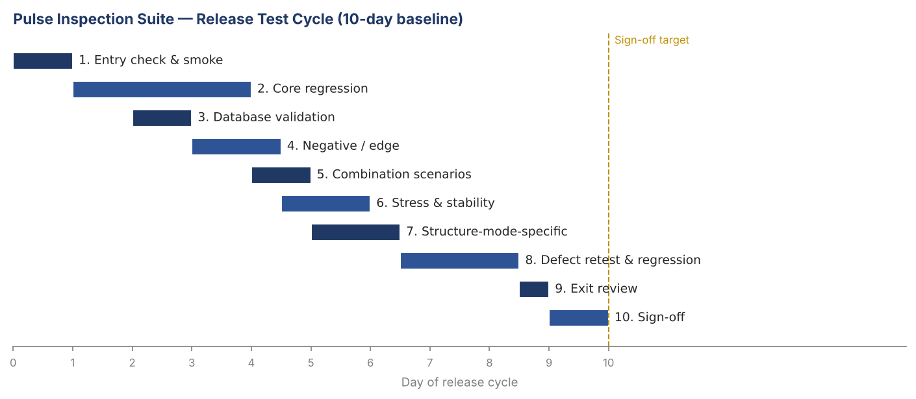

16.5 Assumptions & Scaling
The 10-day cycle assumes one QA engineer, the full 5-machine baseline environment available for the whole cycle, and a defect rate in line with recent releases. A release with significant new functionality extends Phases 2–7 proportionally; the schedule is a planning baseline, not a fixed commitment.

17. Approval
Role | Name | Signature | Date
QA Engineer | Abdelrahman Ali
Engineering Lead
Release Manager

— End of Document —

