Module 1:
Task1:
Firstly I’ve installed ubuntu ISO from the official website the i saved it in my USB drive then i inserted the USB drive and retstarted the computer.
Then iv’e accessed the boot menu in the BIOS to boot the USB drive ,
then i used website instructions till i reached “install ubuntu alongside windows”.

Task 2:
ls command :
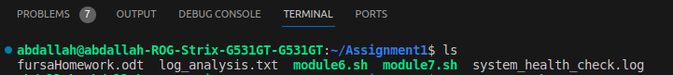
cd command :
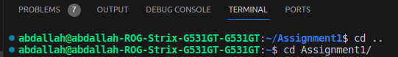

pwd command :
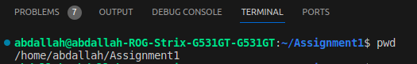

mkdir command :
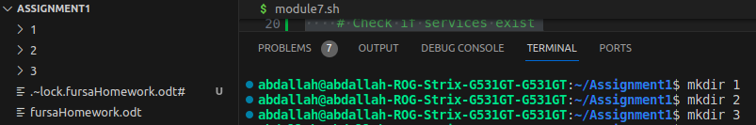
touch command :
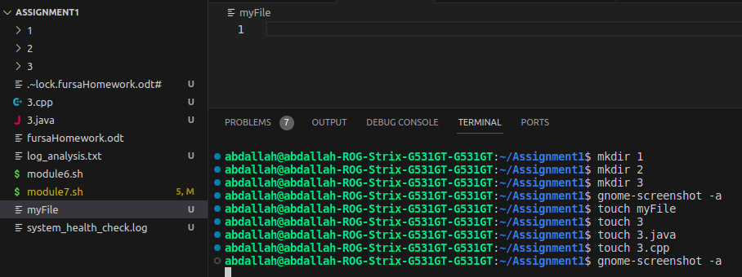

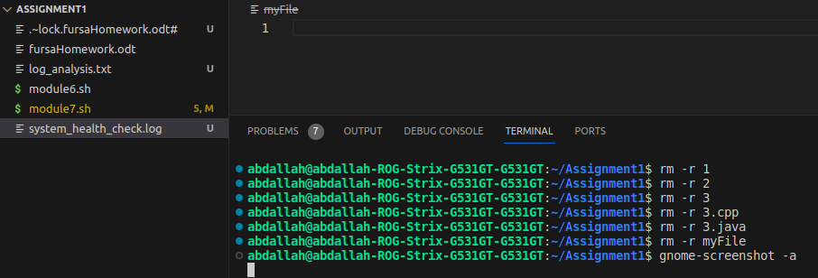
rm command :

man command :
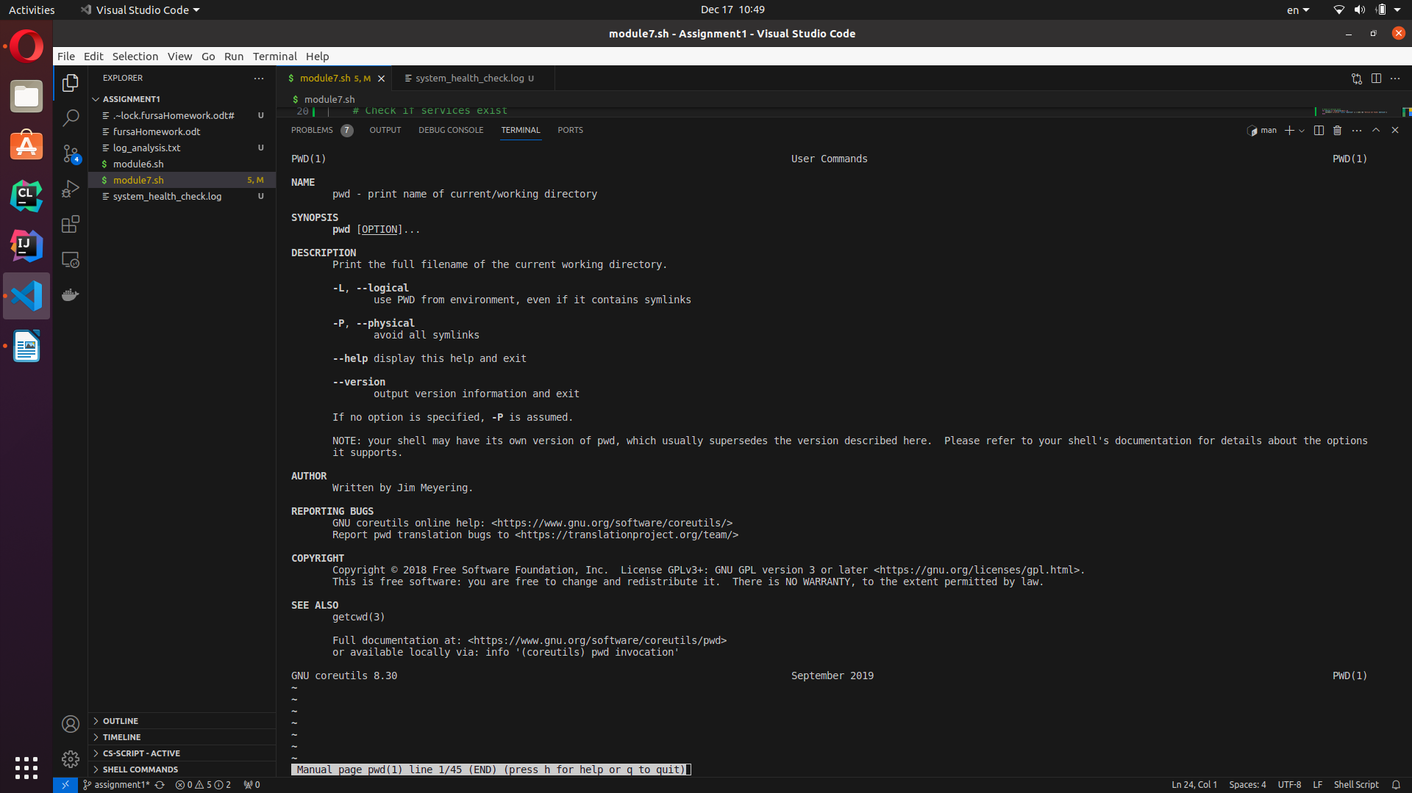

ncal command :
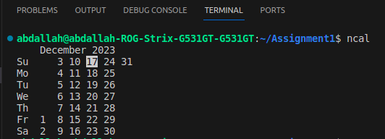

mv command :
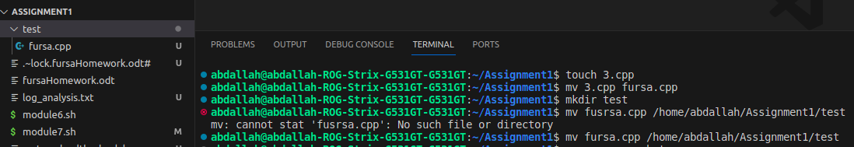

grep -option command :
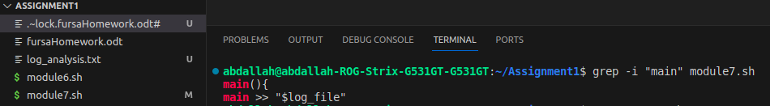
wc command :
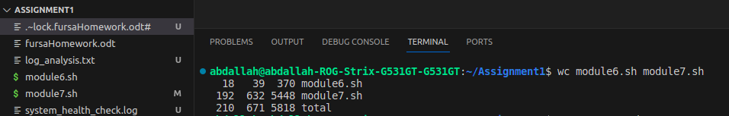

cat command :
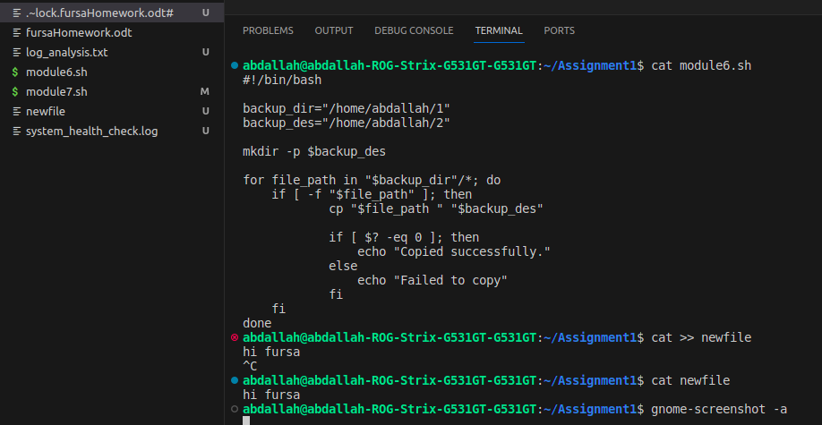

echo command:
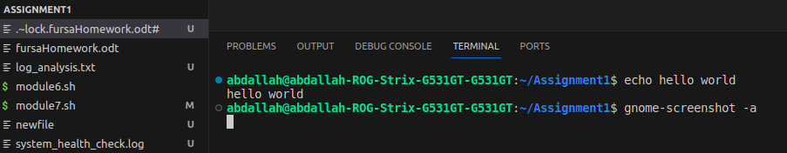

cp command :
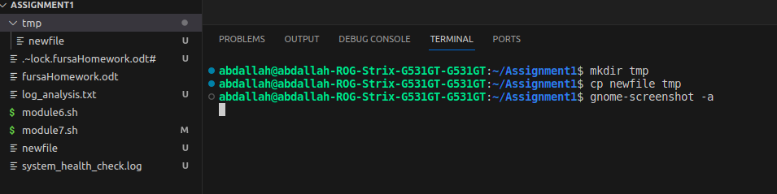

date command :

module 2:
Task3 :
- done in module 1 task 2
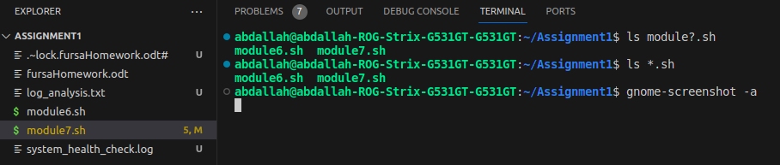
- wildCards:
- done in module 1 task 2
Task4 :
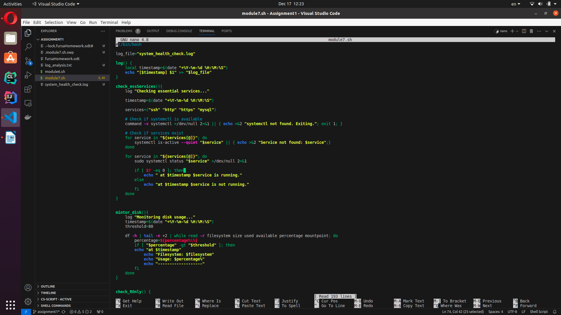

module 3:
Task5 :
