**Assignment-2**

**Name:** Abhishek Tongale

**Reg.No :** 2020BIT002

1. **Binary Search**

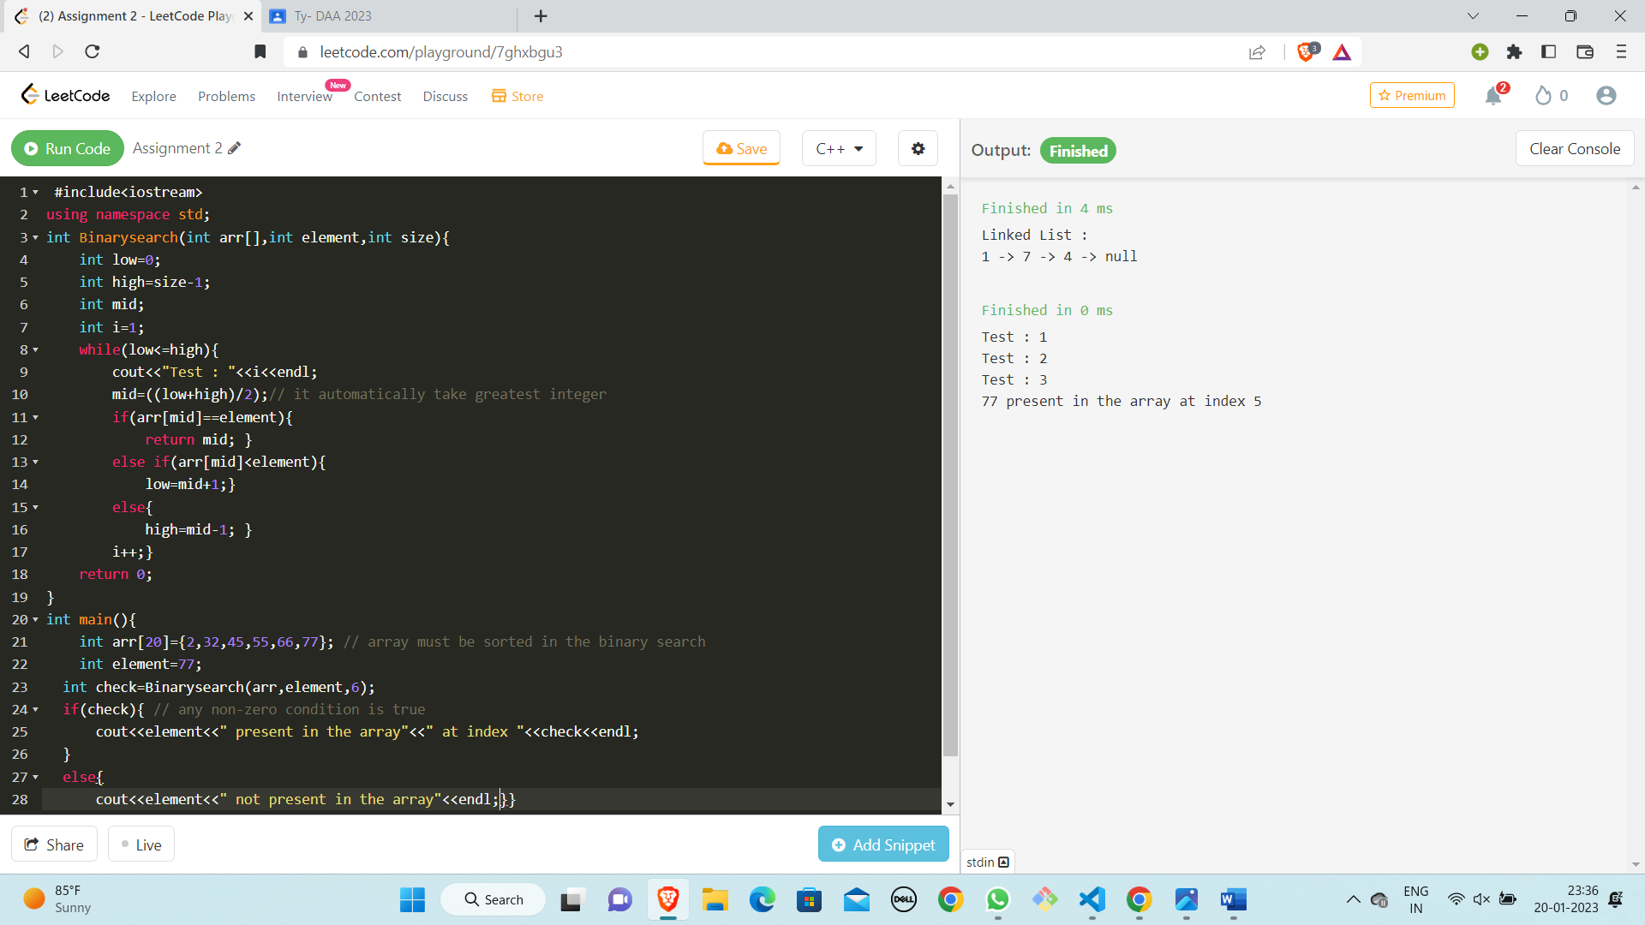

1. **Linear Search**

