DMZ: in normal if someone create a cyber to give access public to use his website or server then a hacker can easily enter the firewall then enter his server and he can attack his all devices and get information from the whole networt

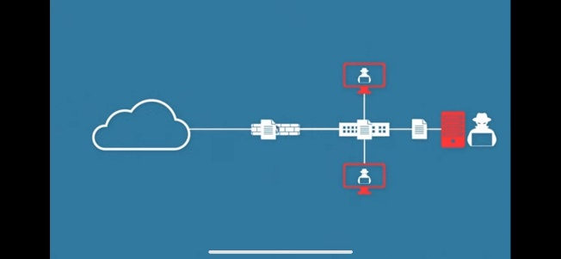But DMZ add extra firewall and server on this network so public and hackers everybody has permission to enter the extra sub and farewell but nobody is allowed to enter the main server and firewall and there’s how DMC helps to secure server information

Before:

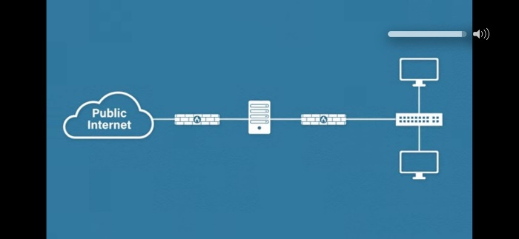after