Vlan : it helps to manage the traffic and increase the security within a network as an example:

If in office there have three floors and in every floors there have mixture of different department computers so when they sent something on switch the network become so much busy but vlan.. separate each department networks

Example: it helps to send IP department data to switch in a separate way and then sociology department data to switch in a separate way so it keeps data separate in a separate way so the traffic becomes so much easy

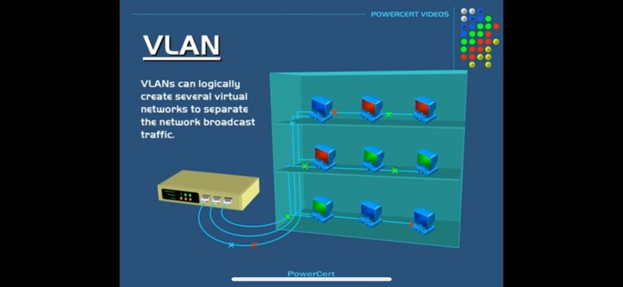Before

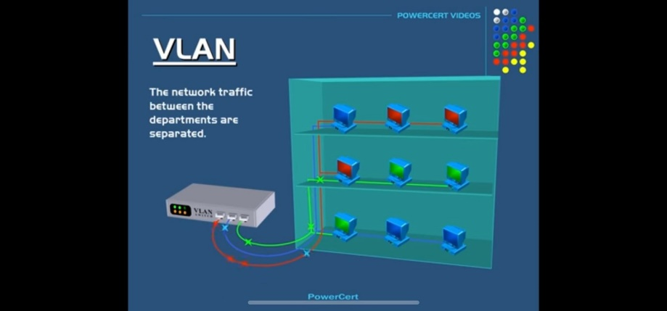

After: