**Video link:** [**https://youtu.be/p3vaaD9pn9I?si=NkAVWk7fmY8JKDEN**](https://youtu.be/p3vaaD9pn9I?si=NkAVWk7fmY8JKDEN)

**IP ADDRESS**: every device has ip address which indicate their name

**NAT : it convert device ip address to usable for the internet by adding a new ip address for this device on the network**

**The NAT device is placed at the router or gateway, between the private network and the public internet.** **When one device need to connect NAT device creat a table with local ip and request ip address and e use this adderss to send and receive the packets the Internet the net device sent a request at the Internet and the Internet reply with the address**

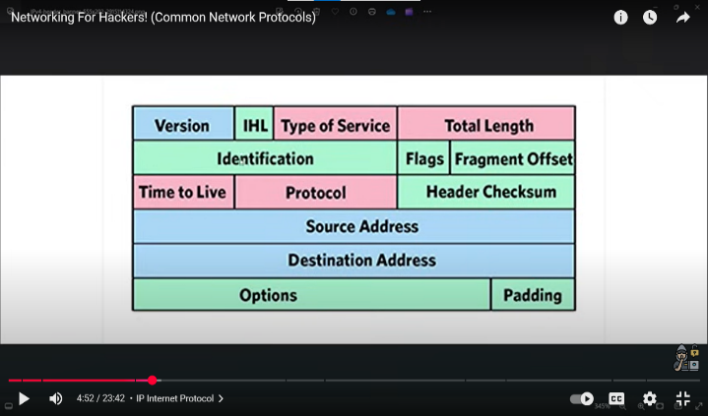**DHCP: It give ip address to each device by lease if the time is up it assign another ip for the device**

**FIELDS OF IP:**

**VERSION: tell what kind of barons is he used IP4 or IP6**

**IHL: it indicates the length of headers**

**TYPE OF SERVICE: this section indicate that the service is cost-effective or speed focused or reliability**

**TOTAL LENGTH: it shows the total length of the packets including its data**

**IDENTIFICATION: each packet has his unique ID. It helps to put fragments into packets in order.**

**Flags: it indicates that the packet is splitting or not**

**FRAGMENT OFFSET: if the packet is split, then it tells where from to start accordingly(split means they have a lot of letters in a mail(which have to organise in order)**

**SOURCE ADDRESS :it shows where from the packets is coming**

**DESTINATION ADDRESS: it shows where will be the packet gone it’s destination location**

**OPTION:not important**

**PADDER: this fields complete any space in the packets**

**tcp: source port number,destination port number(i know)**

**sequance number: it insures packts has arrive in order**

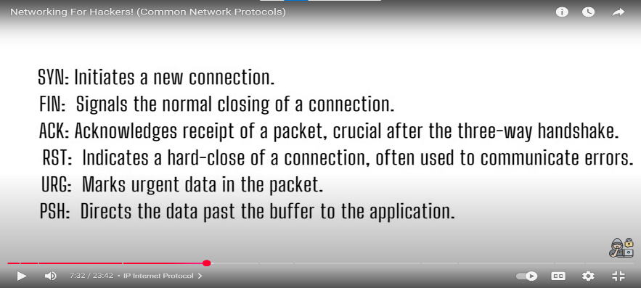**ackowledgement number: it acklowledge packet sent is successful**

**ARP: when a device connct with network newly then it set an ip and mac address with it**

**It important for switch,router to send traffic at exact location**

**DNS: Will you first buy a device which is a system then we turn on mobile data option and there are always assign a IP address for my device so when we turn on mobile data option by using DNS my IP address convert into public IP address to enter in Internet then Internet have a lot of apps available then we go in internet and search a domain for a website when we search a website we search the name but DNS help us to convert the name into IP address automatically so the Internet understand where I actually want to go that finally I enter apps and the further activities I do is actually become available because the app developer has make it**

**FTP: BY USING THIS PROTOCOL client request file from server then server give file to client such as we download a file from website**

**SMB: if we use this then one server act as a server who have files to share and other pc act like client it use when we share file**

**SMTP: IT USE TO SENT EMAIL FROM ONE DESTINATION TO ANOTHER**

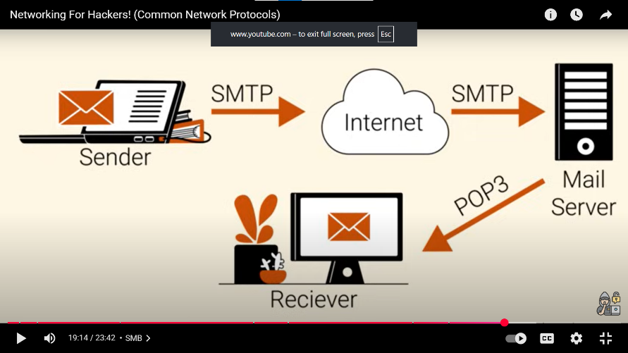

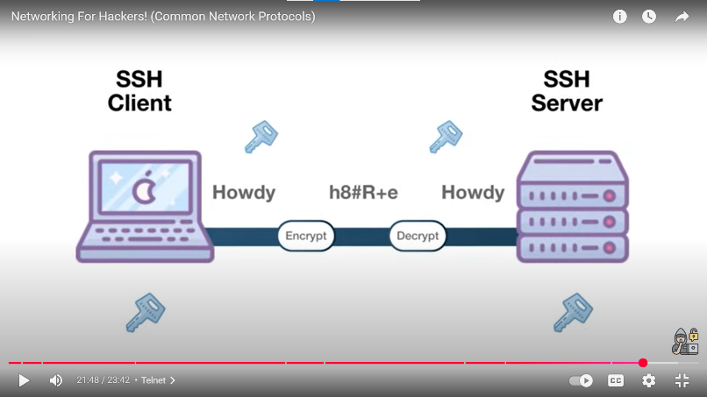**SSH: sent data by encryption**

**HTTP:** 