Product Line Profitability & Margin Performance
Executive Summary — Nassau Candy Distributor
This summary presents the headline findings of a profitability analysis covering 10,194 order line items, 8,549 orders, and 15 products sold by Nassau Candy Distributor between January 2024 and December 2025. The full methodology, supporting data, and detailed recommendations are available in the accompanying research paper and live Streamlit dashboard.
$141,784  Total Revenue | $93,443  Total Gross Profit | 65.9%  Overall Margin | 15  Active Products

Headline Finding: Extreme Profit Concentration
Just 5 of the company's 15 products — all Chocolate-division Wonka Bars — generate 92.9% of total revenue and 95.1% of total gross profit. This is not a gradual long tail; the drop-off after the fifth product is a cliff. The remaining ten products across the Sugar and Other divisions are catalog-breadth items, not meaningful profit drivers.
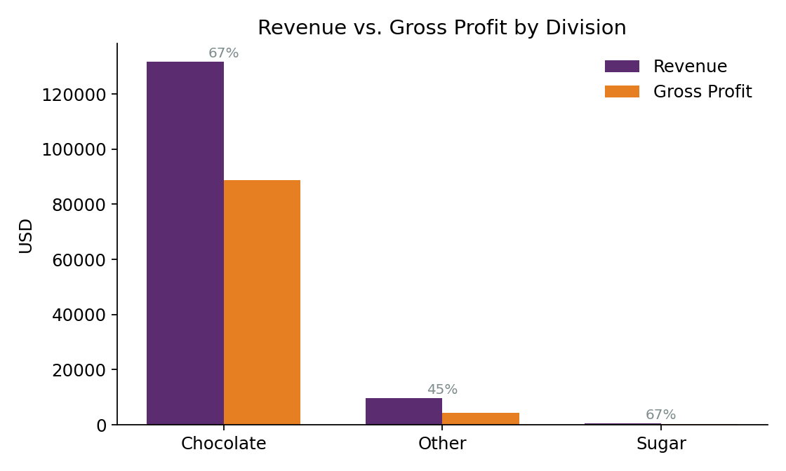
Revenue vs. gross profit by division. Chocolate drives the business at a 67.5% margin.

Three Products Flagged for Margin Risk
Lickable Wallpaper, Wonka Gum, and Kazookles (all Other division) combine above-average sales with below-average margins. Kazookles is the most urgent: a 7.7% margin, the lowest in the catalog, sourced from The Other Factory — which also has the weakest blended margin (11.9%) of any supplying factory.
Product | Sales ($) | Margin % | Action Needed
Kazookles | 1,205.75 | 7.7% | Urgent repricing / discontinuation review
Lickable Wallpaper | 7,860.00 | 50.0% | Margin review (largest non-core revenue line)
Wonka Gum | 597.50 | 52.0% | Monitor

Data Quality Note
During validation, we found the Ship Date field does not reflect genuine shipping timing relative to Order Date (computed lead times average ~1,300 days, with no meaningful difference between Same Day and Standard shipping). We recommend the data engineering team audit this field's source pipeline before it is used in any delivery SLA reporting. All financial findings in this summary are unaffected, as they do not depend on Ship Date.

Recommendations
- Protect the core: prioritize supply continuity for the 5 Wonka Bar products and their factories (Lot's O' Nuts, Wicked Choccy's), which together drive ~95% of profit.
- Fix the outlier: launch an immediate pricing/cost review of Kazookles and its supplying factory, The Other Factory.
- Right-size the catalog: decide whether the six lowest-volume Sugar/Other products are worth retaining for catalog breadth.
- Fix the data pipeline: resolve the Ship Date issue before building any delivery-performance reporting.

Deliverables Provided
- Research paper: full methodology, 11-section findings, and supporting tables/charts.
- Streamlit dashboard: live, filterable analytics covering product, division, cost-diagnostic, Pareto, and factory/logistics views.
- This executive summary: a one-page-equivalent briefing of the findings above.

