Product Line Profitability & Margin
Performance Analysis
Nassau Candy Distributor
Research Paper
Prepared as an independent data analytics study
Analysis period: January 2024 – December 2025

Table of Contents

Executive Summary
Nassau Candy Distributor sells across three product divisions — Chocolate, Sugar, and Other — through 8,549 orders placed by 5,044 customers between January 2024 and December 2025. This study analyzes 10,194 order line items to determine which products and divisions truly drive profitability, where margin risk is concentrated, and how shipping logistics support (or strain) the business.
The headline finding is that the business is heavily concentrated: five Chocolate-division Wonka Bar products generate 92.9% of total revenue and 95.1% of total gross profit, while ten other products across Sugar and Other divisions contribute the remaining single-digit share. Overall gross margin sits at a healthy 65.9%, but three products — Lickable Wallpaper, Wonka Gum, and Kazookles, all in the Other division — combine above-median sales with below-median margins and represent identifiable margin risk.
A separate, important finding emerged during data validation: the Ship Date field does not behave as a genuine shipment record relative to Order Date, which limits how far the logistics analysis can be taken with confidence. This is documented in Section 7 along with a recommendation.
Recommendations focus on protecting the five core Wonka Bar products, conducting a pricing/cost review of the three flagged Other-division products, and evaluating whether the long tail of low-volume Sugar-division products is worth retaining on the catalog.

1. Background and Context
For distributors like Nassau Candy, sales volume alone is a misleading indicator of business health. Some products sell in high volume but generate low profit, consume disproportionate manufacturing or operational cost, or appear successful on a revenue basis while quietly weakening overall margins.
To remain competitive, the organization needs visibility into which products truly drive profit, which divisions underperform financially, and where pricing, sourcing, or product-line rationalization is needed.

2. Problem Statement
Prior to this analysis, the organization lacked visibility into four key questions:
- Which product lines deliver the highest gross margin, as opposed to simply the highest sales volume.
- Whether high-sales products are actually profitable once cost is accounted for.
- How profitability varies across the three product divisions (Chocolate, Sugar, Other).
- Which specific products represent margin risk and warrant a pricing or sourcing review.

3. Data Overview and Methodology

3.1 Dataset Description
The dataset contains 10,194 order line items spanning January 2024 to December 2025, covering 8,549 unique orders, 5,044 unique customers, 15 products, and 59 state/province-level markets across 4 U.S. regions (Pacific, Atlantic, Interior, Gulf). Each row records an Order Date, Ship Date, Ship Mode, customer location, Division, Product, Sales, Units, Cost, and Gross Profit.

3.2 Data Cleaning and Validation
The following validation steps were applied before analysis:
- Removed duplicate Row IDs and any record with non-positive Sales, Units, or negative Cost.
- Dropped records with missing values in any core financial or categorical field.
- Standardized text fields (Division, Region, State, Ship Mode, Product Name) by trimming whitespace.
- Parsed Order Date and Ship Date (DD-MM-YYYY format) and validated Gross Profit reconciles to Sales − Cost for every row.
- Result: zero rows required removal — the dataset reconciled cleanly (Sales − Cost = Gross Profit for all 10,194 rows, no nulls, no duplicate Row IDs).

3.3 Key Performance Indicators
The following KPIs were computed for every product and rolled up to the division and factory level:
KPI | Definition
Gross Margin % | Gross Profit ÷ Sales
Profit per Unit | Gross Profit ÷ Units
Revenue Contribution % | Product Sales ÷ Total Sales
Profit Contribution % | Product Profit ÷ Total Profit
Avg. Ship Distance | Haversine distance, factory → customer state centroid
Table 1. KPI definitions used throughout this analysis.
Products were further classified into four risk/performance quadrants using the median sales, median gross profit, and median margin across the 15-product catalog as cutoffs: Star (high profit, high margin), Risk (high sales, low margin), Tail (low sales, low profit), and Average.

4. Product-Level Profitability Analysis
Ranking all 15 products by total gross profit reveals an extreme concentration: the top five products — all Chocolate-division Wonka Bars — account for 92.9% of revenue and 95.1% of profit. Every other product in the catalog is a minor contributor by comparison.
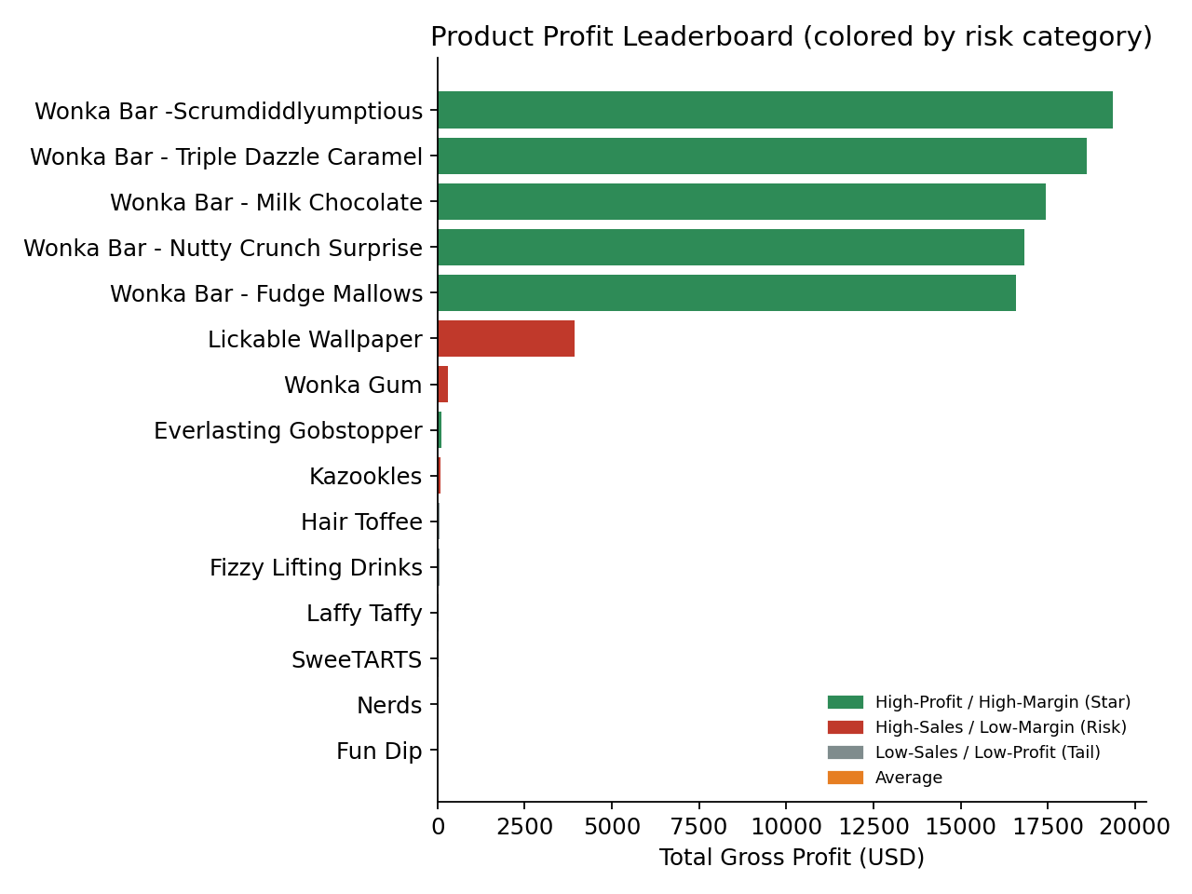
Figure 1. Product profit leaderboard, colored by performance quadrant. Green = Star, Red = Risk.

4.1 Star Products
Six products qualify as Star performers (gross profit and margin both at or above the catalog median): the five core Wonka Bars (margins ranging 64.9%–71.4%) plus Everlasting Gobstopper, a low-volume Sugar product with an exceptional 80% margin. These six products should be the explicit priority for marketing, inventory allocation, and supply continuity.
Product | Division | Sales ($) | Gross Profit ($) | Margin %
Wonka Bar - Scrumdiddlyumptious | Chocolate | 27,874.80 | 19,357.50 | 69.4%
Wonka Bar - Triple Dazzle Caramel | Chocolate | 28,485.00 | 18,610.20 | 65.3%
Wonka Bar - Milk Chocolate | Chocolate | 26,867.75 | 17,443.37 | 64.9%
Wonka Bar - Nutty Crunch Surprise | Chocolate | 23,574.95 | 16,819.95 | 71.4%
Wonka Bar - Fudge Mallows | Chocolate | 24,890.40 | 16,593.60 | 66.7%
Everlasting Gobstopper | Sugar | 130.00 | 104.00 | 80.0%
Table 2. The six Star products.

4.2 Margin-Risk Products
Three products combine above-median sales with below-median margin — meaning they move volume but erode blended profitability relative to what the catalog could otherwise deliver:
Product | Division | Sales ($) | Margin % | Concern
Lickable Wallpaper | Other | 7,860.00 | 50.0% | Largest non-Chocolate revenue line, but 17-21pp below Chocolate margins
Wonka Gum | Other | 597.50 | 52.0% | Moderate margin, modest volume
Kazookles | Other | 1,205.75 | 7.7% | Severe margin compression — near break-even
Table 3. The three margin-risk products.
Kazookles is the standout concern: a 7.7% margin is far below every other product in the catalog and suggests either a pricing error, an unfavorable cost structure, or a product that needs renegotiation with its supplying factory.

4.3 Long-Tail Products
Six products (largely in the Sugar division — Laffy Taffy, SweeTARTS, Nerds, Fun Dip, Fizzy Lifting Drinks — plus Hair Toffee) each contribute under $80 in total sales over the two-year window. Collectively they represent 0.18% of revenue. These are catalog-breadth items rather than meaningful profit drivers.

5. Division-Level Performance Analysis
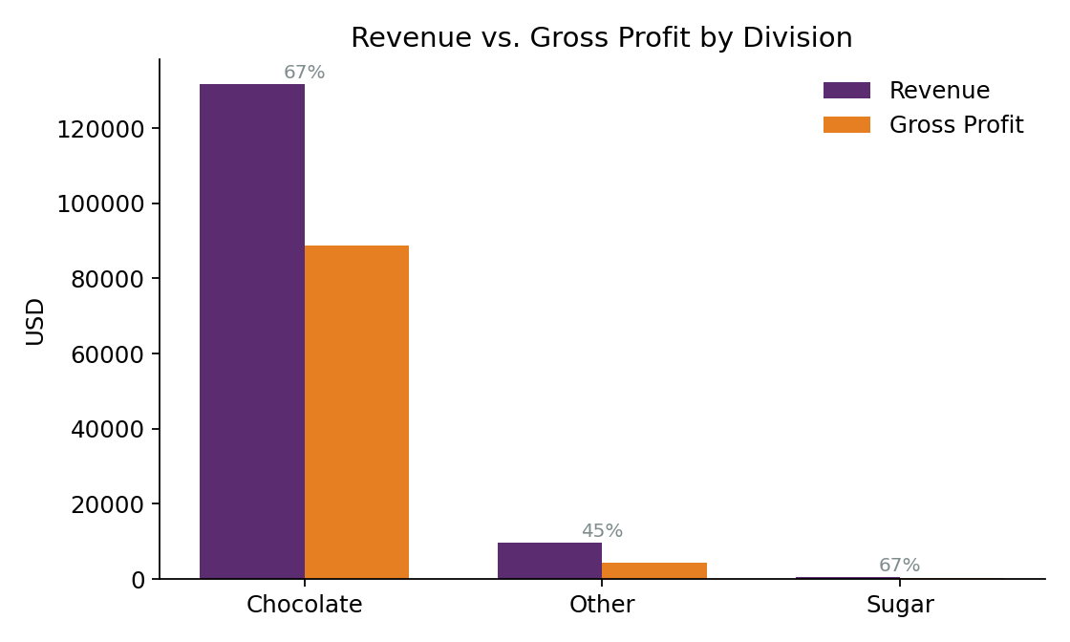
Figure 2. Revenue vs. gross profit by division, with margin % annotated.
The Chocolate division is the business: 92.9% of revenue, 95.1% of profit, and the highest margin of the three divisions (67.5%) despite having only 5 SKUs. The Other division contributes 6.8% of revenue at a noticeably weaker 44.8% margin — pulled down primarily by Kazookles. The Sugar division is immaterial in dollar terms (0.3% of revenue) but posts a respectable 66.6% average margin across its 7 SKUs, driven by Everlasting Gobstopper and Hair Toffee.
Division | Orders | Sales ($) | Gross Profit ($) | Margin % | Revenue Share | Profit Share
Chocolate | 8,205 | 131,692.90 | 88,824.62 | 67.5% | 92.9% | 95.1%
Other | 304 | 9,663.25 | 4,333.45 | 44.8% | 6.8% | 4.6%
Sugar | 40 | 427.48 | 284.73 | 66.6% | 0.3% | 0.3%
Table 4. Division-level summary.
The structural takeaway: Chocolate is not just the largest division, it is also the most efficient. The Other division's lower margin is a margin-management issue, not a volume issue — exactly the kind of finding the Pareto and cost-diagnostic sections below quantify further.

6. Profit Concentration (Pareto) Analysis
A Pareto analysis was run on both revenue and profit to quantify how concentrated the catalog is.
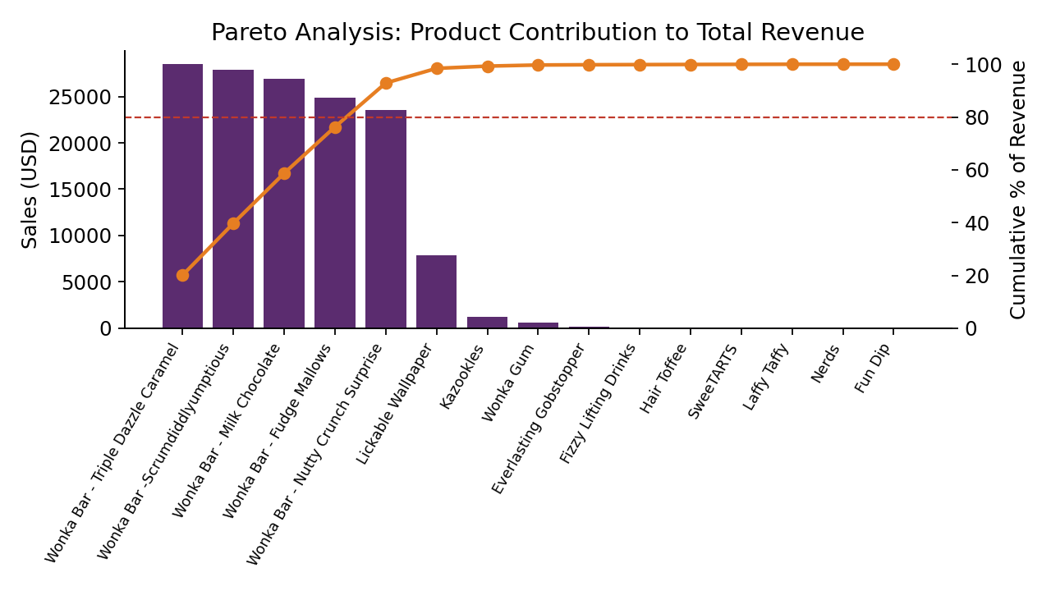
Figure 3. Cumulative revenue contribution by product, ranked largest to smallest.
- Just 5 of 15 products (33%) generate 80%+ of total revenue (92.9% cumulative at exactly 5 products) — there is no gradual long tail; the drop-off after the fifth product is a cliff, not a slope.
- The same 5 products generate 95.1% of total profit, confirming the concentration is not a revenue-only artifact of low-margin bulk sales.
- This level of dependency is a real operational risk: any disruption to Wonka Bar production (the Lot's O' Nuts or Wicked Choccy's factories) would impact the overwhelming majority of company profit.

7. Cost Structure Diagnostics
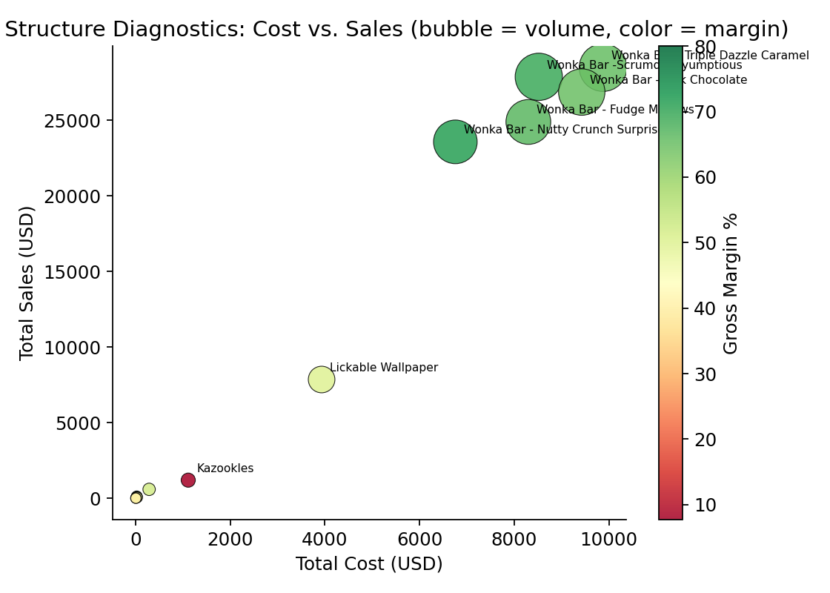
Figure 4. Cost vs. sales by product. Bubble size = unit volume, color = gross margin.
Plotting total cost against total sales for every product highlights the same three risk products identified in Section 4.2 from a different angle: Kazookles sits well below the margin line formed by the rest of the catalog relative to its cost base, and Lickable Wallpaper, while higher-volume, sits at a visibly lower margin band (yellow-green) than the Chocolate cluster (dark green).
Recommended next steps for these products: a cost renegotiation conversation with the supplying factory (The Other Factory and Secret Factory respectively — see Section 8), a repricing test, or, for Kazookles specifically, a discontinuation review if repricing isn't viable given its 7.7% margin floor.

8. Factory and Logistics Analysis

8.1 Data Quality Finding: Ship Date Field
Before drawing logistics conclusions, a validation check was run on shipping lead time (Ship Date − Order Date). The result was a clear data-quality flag: average computed lead time was approximately 1,300 days, and — critically — Same Day shipments showed effectively the same average “lead time” as Standard Class shipments (1,333 vs. 1,314 days). A real shipping process would show Same Day consistently near zero and a clear ordering across Ship Modes.
This pattern indicates Ship Date was populated independently of Order Date in the source system (e.g., both fields may have been generated relative to different reference points during data creation), rather than reflecting genuine fulfillment timing. As a result, this report does not use raw lead-time or delay metrics as a finding, and we recommend the data engineering team audit the ETL pipeline that populates Ship Date before it is used for SLA or carrier-performance reporting.
What remains valid and is used below: which factory supplies which product (and therefore its profit contribution), and the approximate geographic distance between each factory and its customer base, computed via state-centroid coordinates.

8.2 Factory Profit Contribution
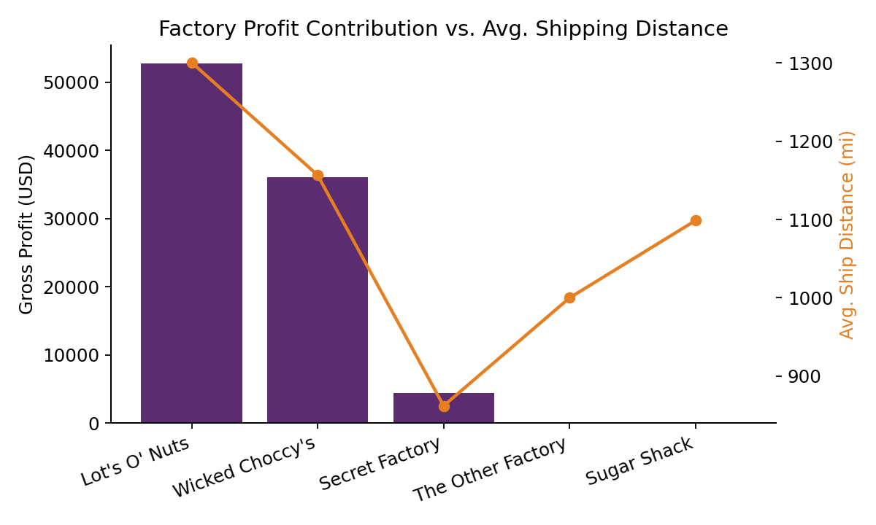
Figure 5. Gross profit by factory (bars) vs. average shipping distance (line).
Factory | Sales ($) | Gross Profit ($) | Margin % | Avg. Distance (mi)
Lot's O' Nuts | 76,340.15 | 52,771.05 | 69.1% | 1,300.5
Wicked Choccy's | 55,352.75 | 36,053.57 | 65.1% | 1,156.7
Secret Factory | 8,587.50 | 4,344.70 | 50.6% | 862.1
The Other Factory | 1,282.25 | 152.25 | 11.9% | 1,000.0
Sugar Shack | 220.98 | 121.23 | 54.9% | 1,098.8
Table 5. Factory-level financial and distance summary.
Lot's O' Nuts and Wicked Choccy's together account for roughly 95% of company gross profit — unsurprising given they supply the five Star Wonka Bar products. The Other Factory stands out for the wrong reason: an 11.9% margin, by far the weakest of any factory, and it supplies Kazookles and Hair Toffee — directly corroborating the product-level risk finding in Section 4.2.
Average shipping distances cluster around 850–1,300 miles for all factories, reflecting Nassau Candy's broad national customer base rather than any single factory being a geographic outlier.

9. Key Findings Summary
- Finding 1 — The business is highly concentrated: 5 of 15 products (33%) generate 92.9% of revenue and 95.1% of profit, all from the Chocolate division.
- Finding 2 — Three products — Lickable Wallpaper, Wonka Gum, and Kazookles, all Other division — combine above-median sales with below-median margin. Kazookles' 7.7% margin is a severe outlier.
- Finding 3 — The Other division's blended margin (44.8%) trails Chocolate (67.5%) and Sugar (66.6%) by 20+ points, driven almost entirely by the three flagged products rather than the division as a whole.
- Finding 4 — The Other Factory has the weakest margin profile of any supplying factory (11.9%) and is the sole or primary source for the two lowest-margin products in the catalog.
- Finding 5 — The Ship Date field cannot currently be used to assess delivery performance — a data engineering issue, not a logistics issue, but one that should be fixed before any SLA reporting is built on top of it.

10. Recommendations
- Recommendation 1 — Protect supply continuity for the five Star Wonka Bar products and their two supplying factories (Lot's O' Nuts, Wicked Choccy's) — they represent the large majority of company profit; any disruption here has outsized impact.
- Recommendation 2 — Initiate a pricing and cost review for Kazookles specifically; at a 7.7% margin it is barely above break-even and is the single clearest candidate for repricing, cost renegotiation with The Other Factory, or discontinuation.
- Recommendation 3 — Review sourcing terms with The Other Factory more broadly — its 11.9% blended margin is far out of line with every other factory in the network.
- Recommendation 4 — Decide deliberately whether to retain the six long-tail Sugar/Other products (under $80 total sales each over two years) as catalog-breadth items, or simplify the SKU list — they are not material to profit either way.
- Recommendation 5 — Have the data engineering team audit the ETL process populating Ship Date before building any shipping-performance or SLA dashboard on top of this dataset.

11. Conclusion
This analysis establishes a clear, data-driven view of where Nassau Candy's profitability actually comes from: a small, high-margin core of Chocolate products, with the rest of the catalog playing a minor financial role. By transforming raw order and shipment data into product-, division-, and factory-level profitability intelligence, the organization can prioritize its strongest products, address the specific margin-risk products and supplier identified above, and build future reporting (including delivery-performance tracking, once the Ship Date issue is resolved) on a reliable analytical foundation.

