regmods-008-project-workspace

Dennis Barger

Thursday, November 20, 2014

# Course Project Overview

## Scenario

You work for Motor Trend, a magazine about the automobile industry. Looking at a data set of a collection of cars, they are interested in exploring the relationship between a set of variables and miles per gallon (mpg)(outcome). They are particularly interested in the following quesions:

* Is an automatic or manual transmission better for MPG?
* Quantify the MPG difference between automatic and manual transmissions.

## Approach

Use the "mtcars" data set in R and writ up an analysis to answer the questions. The analysis should use regression models and exploratory data analysis techniques.

The report deliverable should include the following:

* Written as a PDF printout of a compiled (using knitr) R markdown document.
* Brief. Roughly the equivalent of 2 pages or less for the main text. Supporting figures in an appendix can be included up to 5 total pages including the 2 for main report. The appendix can only include figures.
* Include a first paragraph executive summary.
* Upload the PDF document to Coursera.

## Peer Grading

The report will be graded based on the following criteria:

* Constructive feedback. Overall strengths and weaknesses in the submission. Provide advice how the work could be improved in the future.
* Did the report interpret the coefficients correctly?
* Did the report included exploratory data analysis?
* Did the report fit multiple models and detail the strategy for model selection?
* Did the report answer the questions?
* Did the report do a residual plot and some diagnositics?
* Did the report quantify the uncertaintiy in conclusions and perform inference correctly?
* Was the report brief (2 pages max) for the main body and no longer than 5 pages of supporting appendix figures?
* Was the report done in Rmd (knitr)?

## MTCARS Data Set Overview

### Description

The MTCARS dataset was extracted from teh 1974 Motor Trend US magazine and comprises fuel consumption and 10 aspects of automobile design and performance for 32 automobiles (1973-74 models).

### Usage

mtcars

### Format

A data frame with 32 observations on 11 variables.

|  |  |  |
| --- | --- | --- |
| Position | Element | Description |
| 1 | mpg | Miles/(US) gallon |
| 2 | cyl | Number of cylinders |
| 3 | disp | Displacement (cu.in.) |
| 4 | hp | Gross horsepower |
| 5 | drat | Rear axle ratio |
| 6 | wt | Weight (lb/1000) |
| 7 | qsec | 1/4 mile time |
| 8 | vs | V/S |
| 9 | am | Transmission (0 = automatic, 1 = manual) |
| 10 | gear | Number of forward gears |
| 11 | carb | Number of carburetors |

### Source

Henderson and Velleman (1981), Building multiple regression models interactively. Biometrics, 37, 391-411.

# Workspace

## Exploratory Data Analysis

data(mtcars)  
auto <- mtcars[mtcars$am==0,]  
manl <- mtcars[mtcars$am==1,]  
auto_mean <- round(mean(auto$mpg),2)  
manl_mean <- round(mean(manl$mpg),2)  
inc_pctg <- round((manl_mean - auto_mean)/auto_mean * 100,2)  
paste("Mean mpg for automatic: ",auto_mean)

## [1] "Mean mpg for automatic: 17.15"

paste("Mean mpg for manual: ",manl_mean)

## [1] "Mean mpg for manual: 24.39"

paste("Difference in mpg for manual: ",inc_pctg,"%")

## [1] "Difference in mpg for manual: 42.22 %"

## Use boxplot to compare MPG by automatic and manual transmission  
boxplot(manl$mpg,col="lightyellow")  
abline(h=auto_mean,col="red")

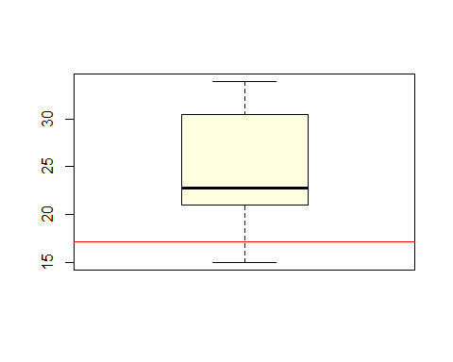

quantile(manl$mpg)

## 0% 25% 50% 75% 100%   
## 15.0 21.0 22.8 30.4 33.9

quantile(auto$mpg)

## 0% 25% 50% 75% 100%   
## 10.40 14.95 17.30 19.20 24.40