We have been thinking about the addins capability and this is what we have come up with.
Both involve specifying the desired add-ins in the RegistryRecord xml definiton, at the corresponding object level (analog to ValidationRuleLists).

Example xml snippet:

<AddIns>
<AddIn Assembly="RegistrationAddins" class="RegistryRecordAddIn">
<Event eventName="OnLoaded" eventHandler="OnLoadedHandler">
<Event eventName="OnInserting" eventHandler="OnSavingHandler">
<Event eventName="OnUpdating" eventHandler="OnSavingHandler">
</AddIn>
<AddIn Assembly="ThirdPartyAddins" class="RegistryRecordAddIn">
...
</AddIn>
</AddIns>

The naming of our own events should follow the .NET convention. Instead of using words such OnBefore , OnAfter , OnPre, OnPost… we should use the verb ending like “ing” and “ed”

OnInserting OnInserted
OnUpdating OnUpdated
OnLoading OnLoaded

I think this is how ELN 11 is standardadizing event naming, but you could check with Kevin. I think the user of Before and After in event names is no longer recommended.

No problem with this, we’ll consult with Kevin

This xml snippet shows a list of classes containing the add ins. Every class can register to several events on the object.
Every AddIn would have access to an IRegistryRecord: the whole purpose of the AddIn is to modify this object according to its needs.
The idea is that we can register to events of RegistryRecord objects, but of other objects as well. For example, it would also be possible to subscribe to events of the structure or a particular property of compounds, etc. In order to achieve this, the xml snippet should be inserted in the corresponding xml hierarchy, analog to ValidationRuleLists.
This seems like a good way to handle the configuration, but what’s the advantage versus having the configuration at the top object level?
If we put the all the xml at top level, the manager should re-parse the xml for extracting the hierarchy (that should be embedded in the xml).
That is: we want to have an add-in for compounds. We found no easy way to specify that we want to add it to all compounds. At first we thought of using a binding expression. But a binding expression refers to a particular object, not all the objects inside a list.
Besides, we think that the events are subscribing to a particular object delegates, and so are very tightly related to it.
This may need further clarification.

Also note that we can register to any delegate the object exposes, whether we provide it explicitly or is inherited from other classes. For example we would be able to register to Property class OnPropertyChanged event.
Yes, registering to other existing delegates is great!

The implementation of this involves new classes
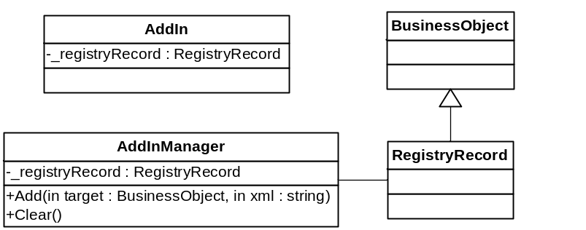

Every Add-In should implement the AddIn interface, which consists of a Registry Record. This is because we accept any delegate with any method signature, and we must make a registry record accessible to it.
What is involved in implementing the AddIn interface? When we create addins for other objects (not for the RegistryRecord Object) those addins will have to implement a different interface, corresponding to the Object they are extending. Right? Basically, this are AddIns to our CSLA business objects. The implement the interface published by the object and can then fire code at any published event. Right?

Here we see two things:
Firstly, as we are supporting any delegate, it’s possible that the add in doesn’t get in touch with a registry record. This breaks the add-ins purpose. That’s why the add-ins have to implement the interface that guarantees they have a registryRecord reference.

Secondly, we don’t clearly see how general should this be. Should it be prepared for registration objects as well as other applications? We have been thinking some alternatives for avoiding the RegistryRecord object, but none satisfied us.

So when loading the xmls every object is responsible for retrieving its add-ins xml portion and using it as a parameter to the AddInManager Add method. This method is responsible for retrieving the method handler and registering it into the delegate. No more work on this is needed, as .NET delegates will handle the rest.
This sounds simple and clean, but what is the advantage of making each sub object handle its own addin registrations? Why not have the top level object do all the work on behalf of its subobjects? I do kind of see the advantage of having the xml nested within the subobjects because this conveys information of which object we are adding to w/o having to introduce additional xml tags or attributes. However, I don’t see the advantage of making the subobjects responsible for reading the xml and registering the addins. Implementing that task at the top object level may avoid having to edit multiple objects.
We think this approach is similar to ValidationRuleLists, that are handled by each sub-object. In this case, all the sub-object should do is extract the xml portion and forward it to the add-in manager add method.
Given that the events belong to every sub-object, we believe that it should manage this functionality.
Besides, this is the simplest alternative, as giving the root object the responsibility of loading all the add-ins would be difficult with the current business object loading implementation.

Here’s an example registry record which has add-ins at the compound->structure level and at the registry record level.

<MultiCompoundRegistryRecord>
<RegNumber/>
<ComponentList>
<Component>
<ID/>
<ComponentIndex>0</ComponentIndex>
<Compound>
<CompoundID/>
<PropertyList/>
<RegNumber/>
<BaseFragment>
<Structure>
<StructureID/>
<StrucureFormat/>
<Structure molWeight="" formula="">
<ValidationRuleList>
<ValidationRule name="RequiredField"/>
<ValidationRule name="OnlyChemicalContentAllowed"/>
</ValidationRuleList>
<AddIns>
<AddIn Assembly="RegistrationAddins"class="RegistryRecordAddIn">
<Event eventName="OnPropertyChanged" eventHandler="NormalizedStructureHandler"/>
</AddIn>
</AddIns>
</Structure>
<NormalizedStructure/>
</Structure>
</BaseFragment>
</Compound>
</Component>
</ComponentList>
<BatchList/>
<AddIns>
<AddIn Assembly="RegistrationAddins" class="RegistryRecordAddIn">
<Event eventName="OnLoaded" eventHandler="OnLoadedHandler"/>
<Event eventName="OnInserting" eventHandler="OnSavingHandler"/>
<Event eventName="OnUpdating" eventHandler="OnSavingHandler"/>
</AddIn>
<AddIn Assembly="ThirdPartyAddins" class="RegistryRecordAddIn">
...
</AddIn>
</AddIns>
</MultiCompoundRegistryRecord>

At the right moment in the object life-cycle, the delegate will be triggered and the add-in will modify the business object accordingly.

Is there something to keep track of the order in which addins are called? Since it is possible to have multiple addins hoocke to a single event, they should be called in a predictable order.

We haven’t considered this. At first sight we think they should be called by .NET delegate in the order they were added. That is, the order in which they were in xml.

