Coming tasks for China team to work on

- GUI task for Fragment Grid
This is to provide GUI form element that support the fragment selection and editing feature. It could be an extended DataGrid or a Infragistic DataGrid.
Existing form element may already be able to handle this feature, but need to investigate.

The proposed GUI grid is something like below. The GUI element will be embedded to the form.

The Fragment structure and property will show here when a fragment is selected 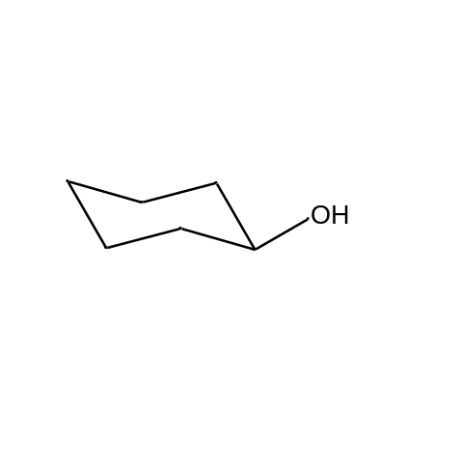
  Other properties of the fragment goes here
A drop down list of the available fragments | Equavelant | A drop down list of Fragment Type | OK
A drop down list of the available fragments | Equavelant | A drop down list of Fragment Type | Edit

- GUI task to do the table management for Fragments and more.
This is to utilize table editor to do table management. The Fragment table management needs to be able to populate the fragments table with structures and other information. It also needs to performe duplicate checking when a new fragment is entered. Duplicate resolving is simple because it shouldn’t allow same fragment to
be entered twice, unless it is different fragment type?

- GUI task of implementing the work flow for duplicate resolution, the work flow is stated in C:\Informatics\Team\.net\ChemOfficeEnterprise\Registration\Documents\Design\FragmentManagement.doc

Basically different buttons needs to show up based on the configuration and the work flow. I am putting the work flow diagram here for easy reference.

Case 1: AllowCompoundForm = True

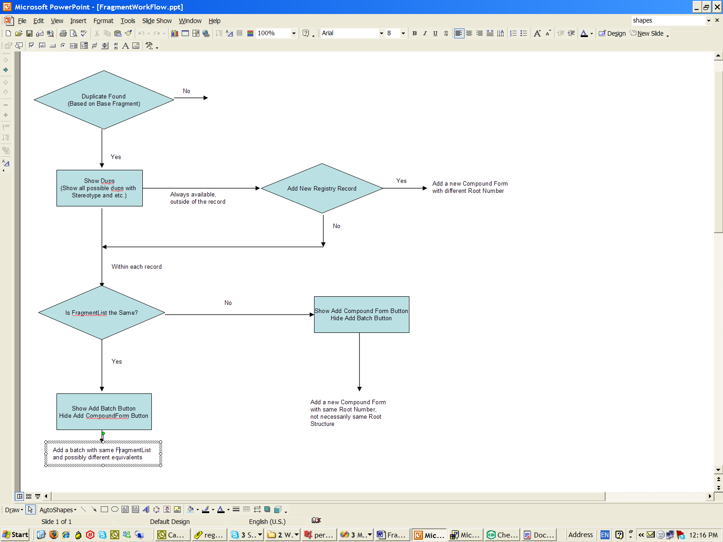

Case 1: AllowCompoundForm = False

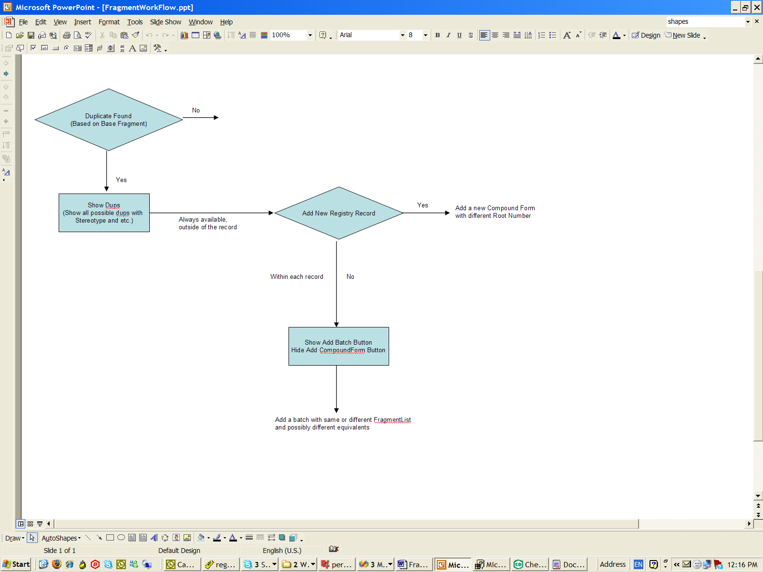

- Business Object extension such that it understands Mauricio’s returning of duplicate list. The returned duplicate list should contain information of what options to provide in the work flow, stated in 3.

The duplicate list returned by Mauricio will be extended to have information of how to proceed with the work flow based on the configuration and the duplicate checking. The business objects need to be able to understand it and be able to communicate with UI of what to display and what not to display.

