Inventory Enterprise DFCI Requirements Specification

Date Printed: 8-Nov-26

Publication Record
Version | Date Revised | Primary Author | Description
1 |  | Patrick Donovan | Initial version

Table of Contents
Publication Record 2
Table of Contents 3
1. Introduction 5
1.1. Purpose 5
1.2. Scope 5
1.3. Document Conventions 5
1.4. Document References 5
2. Standard System Overview 5
3. Data Model 6
3.1. Summary 6
3.2. Substance Data Requirements 6
3.2.1. Commercial 6
3.2.2. Investigational 7
3.2.3. Solution 7
3.2.4. Configuration 8
Invconfig.ini 8
3.3. Container Data Requirements 8
3.3.1. Transactions 8
3.3.2. Solution 8
3.4. Drug representation in Inventory containers 9
3.4.1. Commercial containers 9
3.4.1.1. Requirements Addressed 9
3.4.1.2. Proposed Solution 9
3.4.2. Investigational Containers 9
3.4.2.1. Requirements Addressed 9
3.4.2.2. Proposed Solution 9
3.5. Additional Data Requirements 10
3.5.1. Protocol Table 10
3.5.2. Forecasting Table 10
3.5.2.1. INV_FORECAST 10
3.5.2.2. Forecast Data Management 10
Proposed Solution 11
An excel file upload interface will allow spreadsheets of a specified format to be uploaded in the tables. The excel spreadsheet will consist of three columns, and look like the data in Table 3 Format for Par Level import. 11
FUNCTION INSERTUPDATEFORECAST 11
DFCI requires a mechanism to populate the Forecast data. 11
Input: 11
Input 11
Description 11
pLocation IN inv_locations.location_barcode%TYPE 11
Barcode of the location 11
pNDC IN inv_compounds.CAS%TYPE, 11
NDC code of the drug 11
pAmount IN INV_forecast.amount%TYPE 11
Par level for the location, in the default units of the drug 11
4. Functional Areas 15
4.1. Managing Substances 15
4.1.1. Requirements 15
4.1.2. Proposed Solution 15
4.2. Par Level Management 17
4.2.1. Requirements Addressed 17
4.2.2. Proposed Solution 18
4.3. Managing Drug Containers 18
4.3.1. One-off Drug shipments to pharmacies 18
4.3.1.1. Requirements Addressed 18
4.3.1.2. Proposed solution 18
4.4. Transactions 18
4.4.1. Inventory Updates 18
5. Reporting 18
5.1. Site Par Level Report 18
5.2. Central par Level Report 21
5.3. Master Inventory Report 21
5.4. Usage Rate Report 21
5.5. Accountability Reports 21

- Introduction
  - Purpose
The purpose of this document is to describe the enhancements to Inventory Enterprise to meet project requirements for DFCI. The FRS will address the following:
- Data model for DFCI

  - Scope
The scope of this document is to detail the changes to Inventory Enterprise required for DFCI implementation.
  - Document Conventions
Italicized text – if found in the Requirements section refers to standard functionality in Inventory 9SR3
  - Document References
Document Title | Filename | Description
<Original Proposal>
Gen Requirements description

- Standard System Overview
Inventory Enterprise is a ChemOffice WebServer based application designed to manage the reagent tracking needs of chemical and pharmaceutical research centers. The system manages data associated with both commercially and internally produced chemical substances.Inventory Enterprise can be tightly integrated with CambridgeSoft’s Registration Enterprise and chemical procurement ChemACX DATABASE. Inventory Enterprise is designed for a range of sizes large workgroups to enterprises, and captures both stockroom and reagent needs as well as high - throughput discovery data.
- 21CFR11 Audit Trails - Each change to the database is documented in the Inventory Enterprise audit trails. Electronically filter the data to see all changes made by a particular user, or only the changes made in a particular location between two dates.
- Barcode Generation and Scanning - Inventory Enterprise creates unique barcodes for each container in the system. Simply print the barcode and attach it to the container. Use your wireless scanner to rectify location contents by scanning the barcodes of the appropriate containers.
- Customized Report Generation/Creation - Built-in report generator. Use a wizard to rapidly generate new report templates. Customize report templates specific to your site's needs. Create reports (with sorted data) for search results or location contents. Reports can be exported to a variety of formats including PDF, HTML, Excel, RTF and JPEG. Email reports on the fly.
- Duplicate Checking/Substance Conflict Resolution - When a duplicate is detected, according to stereochemistry preferences set by the user, the user is asked if the new substance should be skipped, a duplicate record created, or if one of the duplicate records should be edited. Duplicates are detected according to the key fields the user defines (e.g. structure, CAS number, and Substance Name).
- Flexibility - Inventory Enterprise can be adapted to fit any organization's workflow and procedures. Administration tools give high level users the ability to customize the user interface. The software's open architecture allows the application to be easily integrated with additional onsite software (e.g. purchasing systems).
- Integration with Registration Enterprise and ChemACX - Search over the Registration Enterprise, ChemACX, and Inventory Enterprise databases simultaneously. Link directly to compounds in Registration Enterprise and ChemACX in inventory containers. Sharing data between applications limits the possibility of data entry error. If a change is made to the record in database of origin, it is reflected in Inventory Enterprise.
- Oracle Role Based Security - Usernames and passwords are linked to predefined roles in Oracle. These roles control which buttons are available after login, limiting the abilities of lower level users. Application administrators are permitted full control, while another user may only be able to search over the registration database.

- Data Model
  - Summary
DFCI requires specific data to be stored on the compound and the substance level for their implementation. In addition, different required fields will be necessary depending on the substance type. In addition, specific fields will need to be added to containers to cover DFCI data requirements. These fields can be added through configuration and through front end customization.

  - Substance Data Requirements
    - Commercial
The principal identifier used for commercial drugs is the NDC code. This code is unique to a manufacture, drug, dose and packaging. The drug name must also be stored, in addition to the the drug type, in this case defaulting to “Commercial”. Also, the BDPP, a 5 digit number associated to similar drugs (brand and generic, different manufacturers) should also be stored for each commercial drug.

Table 1 Fields for Commercial Drugs
Required Field | Description | Data type | Map to | Comments
NDC | Identifier for drug. | 10 Digit number | CAS | Will require CAS validation in gui to be removed
Drug Type |  |  | ALT_ID_1 | Will always be “Commercial” for this drug type.
Drug Name | Description of Drug | Text | Substance_Name
BDPP | DFCI identifier of family of drugs | 5 Digit number | ALT_ID_2
ABC # | Catalog Number |  | ACX_ID | Links to catalog number in ABC catalog

    - Investigational
Investigational drugs are primarily identified by the BDPP number, which is unique to a drug used in a particular protocol. An investigational drug may also have an NDC code associated to it in cases where a commercial drug is used in a protocol for a different indication. Finally, some drugs may be a placebo, in which case an additional field is required.

Table 2 Fields for Investigational Drugs
Required Field | Description | Data type | Map to | Comments
BDPP | Identifier for drug. | 5 Digit Number | CAS | Will require CAS validation in gui to be removed
Drug Type |  |  | ALT_ID_1 | Will always be “Investigational”
Drug Name | Description of Drug | Text | Substance_Name
NDC | Optional identifier of commercial drug used in protocol | 10 Digit number | ALT_ID_3
Protocol Id | Protocol identifier | 5 Digit number | ALT_ID_4
Is placebo? | Determines if a drug is a placebo | Boolean | IsPlacebo | True = Is Placebo  False = Not Placebo

    - Solution
The data fields can be handled through configuration. Front end management of substances will require customization to be detailed in a later section.

ALT_IDs can be linked to picklists, allowing data to be normalized and searchable. Boolean fields can also be added to the substance tab, allowing additional fields to be added. These field types combine to allow Inventory to capture all necessary substance information for the inventory system. See figure *** for a table showing the field mapping.

Field Name | Mapping | Comments
NDC | CAS | NDC if commercial, BDPP if investigational
BDPP | ALT_ID_1 | REQUIRED FOR BOTH.
Drug Type | ALT_ID_5 | Picklist with “Investigational” and “Commercial” options
Drug Name | Substance Name
NDC for Investigational | Alt_ID_2 | For commercial drugs in investigational studies only.
Protocol Id | Alt_ID_3 | Links to protocol identifier
Is placebo | IsPlacebo Boolean | Identifies placebos in investigational studies. When placebo, it is marked as True.

    - Configuration
Invconfig.ini
ALT_IDS=inv_compounds.ALT_ID_1:BDPP;1,ALT_ID_2:NDC for Investigational;0,ALT_ID_3:PROTOCOL ID;0,ALT_ID_5:Drug Type;1
  - Container Data Requirements
    - Transactions
To allow for accountability reports to be produced, decrements to containers must be recorded along with additional information, depending on the whether the drug is commercial or investigational. These fields can be populated by updating the custom fields at the container level.

In the case of commercial, a transaction id and lot number must be captured when a supply is decremented. The lot number may or may not be passed for this transaction.

In the case of investigational drugs, additional fields that are required are: Dose, MRN, Patients initials, dispensing pharmacist, and protocol id.

    - Solution
The following container level fields have been reserved to capture the required transaction data.

Field Name | Map to | Comments
Transaction Id | FIELD_10 | Captures the transaction id of the decrement. Required for ALL.
Lot Number | FIELD_9 | Captures the lot number of a decrement. Optional for Commercial, REQUIRED for investigational.
Dose | FIELD_4 | Dose. REQUIRED for investigational
MRN | FIELD_5 | Medical record number. REQUIRED for investigational
Patients Initials | FIELD_6 | Initials of patient. REQUIRED for investigational
Dispensing Pharmacist | FIELD_7 | Dispensing pharmacist. REQUIRED for investigational

  - Drug representation in Inventory containers
    - Commercial containers
      - Requirements Addressed

Currently, DFCI has no need to track drugs down to the container level. Expiration date and lot number are not available during updates, so drug supplies do not need to be tracked to the container, only the total supply. Drugs past expiry date will be retired during manual inventory steps, and the inventory will be updated accordingly.

      - Proposed Solution
Since drugs do not need to be tracked on the container level, orders can be consolidated into single containers. Along with the total drug quantity in the order, the container will also reflect the total price for that particular order is accurately reflected. This bulk container can be allotted out when supplies are distributed to the network of pharmacies. Drug information will be available since the container is linked to a single NDC code in the Drug (Substance) table.
This solution will require that decrementing logic take into account that a single drug order may cross several of these virtual containers, rather than a single container. Once a virtual container has been emptied, it should be retired from inventory.

Figure: Drug lifecycle in Virtual Inventory Containers
    - Investigational Containers
      - Requirements Addressed
Investigational drugs are handled in one of several ways. Bulk supplies, individually tracked containers and kits with containers all must be tracked, and dispensation information must be captured as described in 3.3.1.

      - Proposed Solution

First, they can be handled much like commercial drugs, where a patient is distributed an amount from a bulk supply, which is in turn associated to a single BDPP number representing the study drug. The only difference in this case is that additional data must be recorded with the transaction, and the drug dispensation must have a lot number associated with it at the container level (see 3.3.1. ).

Second, they can be tracked to individual containers, distributed in a specific series. In this case, the same transaction information is captured, but a specific container is decremented rather than a bulk supply.

Finally, some bottles have kit numbers associated with them. The kit number can be stored at the container level in the *** field. Since this field is searchable, bottles associated to kit numbers can be searched for and located in the inventory. These containers are decremented in the same way as an individually tracked container.

Due to the irregular ordering procedures for Investigational drugs, investigation drug containers must be manually entered into the system using the create container functionality.

Figure *** Investigational drug container lifecycle figure
  - Additional Data Requirements
    - Protocol Table
DFCI requires a table to store protocol data for their audit reports.

    - Forecasting Table
DFCI requires an additional table to store par level information for specified drug/location combinations.
      - INV_FORECAST
Table | INV_FORECAST
COLUMN NAME | DATATYPE | NULL | FK | UNIQUE INDEX | DESCRIPTION
LOCATION_ID_FK | INV_LOCATIONS.LOCATION_ID%TYPE | N | LOCATION_ID_FK | INV_FORECAST_IDX | Location_Id of par level
COMPOUND_ID_FK | INV_COMPOUNDS.COMPOUND_ID%TYPE | N | COMPOUND_ID_FK | INV_FORECAST_IDX | Compound_Id of par level
AMOUNT | NUMBER(10) | N |  |  | Par level amount, of default drug units
      - Forecast Data Management
Requirements Addressed
DFCI requires a mechanism to load and update forecast data for individual drugs as their par levels are refined. A spreadsheet can be uploaded to populate the data. Existing rows will be updated with new data. Extra rows can only be deleted through the manage tables menu in the Tasks pane.
Proposed Solution
An excel file upload interface will allow spreadsheets of a specified format to be uploaded in the tables. The excel spreadsheet will consist of three columns, and look like the data in Table 3 Format for Par Level import.
Table 3 Format for Par Level import
Location Barcode | NDC | Amount
PH1000 | 1234567890 | 1000

Where the first row will be header information, and the forecast data will be stored in the second row on. The Location Barcode corresponds to the barcode given to each pharmacy. The NDC code is specific to a drug, and the Amount specifies the number of units required at that location (Par Level).

The upload will call a function to check to see if a row already exists, and either updates that row with new data, or adds a new row in the case where no existing row is found.

FUNCTION INSERTUPDATEFORECAST
DFCI requires a mechanism to populate the Forecast data.
Input:
Input | Description
pLocation IN inv_locations.location_barcode%TYPE | Barcode of the location
pNDC IN inv_compounds.CAS%TYPE, | NDC code of the drug
pAmount IN INV_forecast.amount%TYPE | Par level for the location, in the default units of the drug

The output will be 0 in the case of success, and -1 in the case where an exception has occurred.

    - ChemACX Data
      - Requirements Addressed
DFCI requires that the ChemACX catalog be populated with data from their internally stored drug database and the commercial Amerisource Bergin data. These datasets are available as CSV files, and contain a variety of specific information describing the products, quantities, prices, and other drug specific information. Specifically the requirements include:
- Store drug catalog based on Drug Database and Amerisource Bergen catalog
- Take updates to the catalog
- Create containers in Inventory based on the container data from the catalog and drug database
- Allow searches for drugs on brand name, generic name and NDC code.
- Allow orders to be associated to a Global and Daily purchase order, and containers to be traceable to that purchase order.
- Create containers as bulk containers, where the totals of several identical containers are summed and grouped in a single virtual container.

      - Proposed solution:
Some database changes will be required for the oracle version of ChemACX. The Drug database and AB catalog can be stored in two new tables. These tables can be used to create views that will mimic the existing ChemACX table structure, or in certain cases, to populate tables that cannot be replaced with a view. These changes will be put into the chemACX Oracle setup scripts so that the admin simply needs to run the setup scripts to create all necessary objects in the database.

The ABC can be wiped out and reloaded. This will be handled via an import screen allowing a tab delimited file to be uploaded. The insert will be mediated by an insert function, which will check to be sure that no duplicate rows exist during the upload.

Drug Database will be loaded initially, and added as needed via the Manage Substances interface.

      - Changes to Database Objects:
      - Tables:
Remove:
ACX_SYNONYM
PRODUCT
PACKAGE

Create (for catalog)
ABC_CATALOG
ECITEMNUM VARCHAR2(15) CONSTRAINT pk_ecitemnum PRIMARY KEY,
ECDESC VARCHAR2(255),
ECUI VARCHAR2(255),
ECNAME VARCHAR2(255),
ECNDC VARCHAR2(13),
PRPRICE NUMBER,
ECAWP NUMBER,
PRCONT VARCHAR2(10)

PHDOUT (For Drug Database)
Name VARCHAR2(255),
DSG_FORM VARCHAR2(255),
ROUTE VARCHAR2(255),
BDPP VARCHAR2(255),
BRAND VARCHAR2(255),
STRENGTH VARCHAR2(255),
D_SIZE VARCHAR2(255),
DUP NUMBER,
COST NUMBER,
INVST_FLG Varchar2(255),
PCN Varchar2(25),
PROT VARCHAR2(25),
SUI VARCHAR2(25),
NDC VARCHAR2(13),
ORDER_NO VARCHAR2(255),
BARCODES VARCHAR2(255),
FDB_NAME VARCHAR2(255),
FDB_ROUTE VARCHAR2(255),
FDB_GCN VARCHAR2(255),
FDB_DSG_FORM VARCHAR(255),
FDB_BRAND VARCHAR(255),
FDB_STRENGTH VARCHAR(255),
FDB_SIZE VARCHAR(255)

Triggers:

TRG_PHDOUT to eliminate “-“ from NDC codes when inserting (uniform NDC codes)
TRG_ABC_CATALOG to eliminate “-“ from NDC codes when inserting (uniform NDC codes)
TRG_ABC_CATALOG to insert a row in “Substance” when data is inserted

Views
Created
PACKAGE
SELECT to_number(abc_catalog.ecitemnum) AS packageid,
supplier.name AS suppliername,
supplier.supplierid AS supplierid,
to_number(abc_catalog.ecitemnum) AS productid,
REPLACE(abc_catalog.ecui,' ','') AS "SIZE",
phdout.dsg_form AS container,
null as catalog2num,
to_string(abc_catalog.prprice) AS price,
'dollars' AS currency,
'$' AS csymbol,
null AS price_url,
null AS datecreated,
0 AS IsPriceCd,
0 AS IsPriceWWW,
0 AS IsEComm,
null AS discprice,
null AS savings,
abc_catalog.ecname AS Name,
ecitemnum As catalognum
FROM abc_Catalog, phdout, supplier where abc_catalog.ecndc=phdout.ndc and supplier.supplierid=1;

PRODUCT
to_number(abc_catalog.ecitemnum) AS productid,
supplierid AS supplierid,
abc_catalog.ecname AS prodname,
abc_catalog.ecdesc AS proddescrip,
abc_catalog.ecitemnum as catalognum,
null as concentrationpct,
null as concentrationtag,
null as datecreated,
null as mol_id,
to_number(abc_catalog.ecitemnum) as csnum,
null as productclaimedmw,
null as productlaimedformula,
null as chemclassid,
null as numtoskip,
0 as iswww,
null as picture,
0 as ispicture,
abc_catalog.ecdesc as extended_description,
abc_catalog.ecitemnum as acx_id,
0 as hasmsds

FROM abc_Catalog, phdout, supplier where abc_catalog.ecndc=phdout.ndc and supplier.supplierid=1;

acx_synonym
select 100000000 + to_number(abc_catalog.ecitemnum) as synonymid,
abc_catalog.ecname as name,
'Chemical' as synonymtype,
supplierid as supplierid,
to_number(abc_catalog.ecitemnum) as csnum,
null as datecreated,
supplier.name AS suppliername,
abc_catalog.ecitemnum as acx_id
FROM abc_Catalog, phdout, supplier where abc_catalog.ecndc=phdout.ndc and supplier.supplierid=1
union
select 200000000 + to_number(abc_catalog.ecitemnum) as synonymid,
phdout.brand as name,
'Chemical' as synonymtype,
supplierid as supplierid,
to_number(abc_catalog.ecitemnum) as csnum,
null as datecreated,
supplier.name AS suppliername,
abc_catalog.ecitemnum as acx_id
FROM abc_Catalog, phdout, supplier where abc_catalog.ecndc=phdout.ndc and supplier.supplierid=1 and phdout.brand is not null;

Interfaces:
Upload template to load/update new files
- ASP Page
- Back end function for data insert for ABC

- Functional Areas
  - Managing Substances
    - Requirements
Different fields are required depending on the substance type. See Table 1 and Table 2 for Commercial and Investigational requirements, respectively.

When a substance is added to the INV_COMPOUNDS table, a should be run to ensure that a row exists in PHDOUT in the ChemACX db corresponding to that compound in the case of commercial items.
    - Proposed Solution
The substance and manage substance web pages will be changed so that the fields displayed and required will depend on the substance type. In addition, CAS validating functionality must be removed to allow non-CAS numbers to be included in the CAS field in the Inventory substance table.

The CAS field will be relabeled “NDC” or “BDPP” depending on whether the drug is investigational or not. Additional fields will be relabeled as necessary, and logic will be added to show different required fields.

Affected screens and changes are below:

Manage Substances screens:

Figure 1 Substance Search Screen Changes
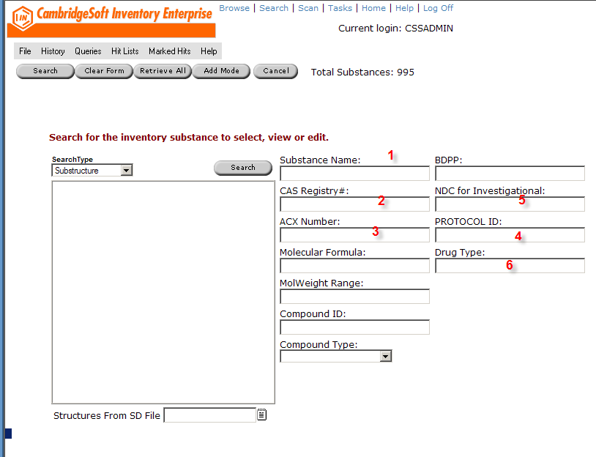

- Re-label substance name as Drug Name
- Re-label CAS as NDC,
- Re-label ACX Number as ABC Number
- No changes
- No changes
- Drop down to include Commercial and Investigational

Remove ChemDraw window.

Figure 2 Add Substance Screen Changes
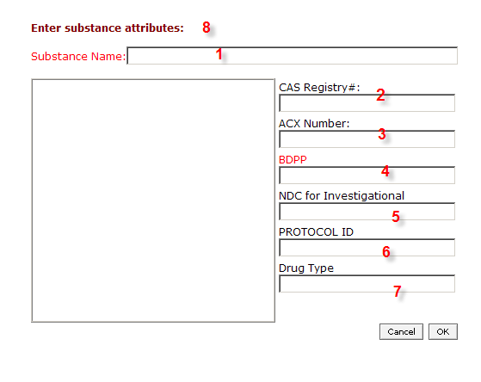
- Change “Substance Name” to “Drug Name”
- Change CAS Registry # to NDC, require for Drug Type=”Commercial”
- Change ACX to ABC
- Required for all drug types
- Optional for Investigational only
- Required for Investigational, no value for Commercial
- Drop down including “Investigational” and “Commercial”
- Change “substance” to “drug”

Database Object changes:
Functionality to check to ensure row exists in PHDOUT in ChemACX, otherwise add a new row there.
  - Par Level Management
    - Requirements Addressed
DFCI requires that par levels be stored for key drugs for each pharmacy location. This level is the approximate level of a two day supply, and will allow DFCI to manage their drug stocks

    - Proposed Solution
  - Ordering Drugs
    - Manual Orders
    - Automated Orders
  - Receiving Drugs (Supply Pharmacies)
  - Replenishment
    - Manual Replenishment - One-off Drug shipments to pharmacies
      - Requirements Addressed
While an order can be used to move a single container to a specified pharmacy location, in certain circumstances, it may be easier to create an aliquot from the drug supply and move it to the new pharmacy manually.
      - Proposed solution
No custom development is needed for this action. A user can simply use the “Create Sample” to create a virtual container containing the desired transfer amount, and then use the “Move Container” functionality to transfer the container to the new location. The container will immediately be added to the stock available at the destination pharmacy. Alternatively, this container can be added to an Order and the order can be tracked. No changes will be required for this workflow.
    - Automated Replenishment
    - Workflow For Replenishment
    - Receiving at Pharmacies
  - Restocking of supply pharmacies
  - Managing Drug Containers
    - One-off Drug shipments to pharmacies
      - Requirements Addressed
While an order can be used to move a single container to a specified pharmacy location, in certain circumstances, it may be easier to create an aliquot from the drug supply and move it to the new pharmacy manually.
      - Proposed solution
No custom development is needed for this action. A user can simply use the “Create Sample” to create a virtual container containing the desired transfer amount, and then use the “Move Container” functionality to transfer the container to the new location. The container will immediately be added to the stock available at the destination pharmacy.
  - Transactions
    - Inventory Updates
      - Requirements Addressed
DFCI will adjust inventory according to dispensations and other amount adjustments through the use of the pharmacy front end. The pharmacy system will pass a stored procedure request to the EGATE system, which in turn handles request queuing and connecting to the database. If any connectivity problems exist, EGATE maintains the queue until the connection can be established.

A common stored procedure should be created to validate dispensation input, ensure adequate stock exits and update the proper drug containers with the dispensation. In addition, extra data should be updated on a container to allow details of the transaction to be entered into the audit tables. That data, in turn can be used to populate the accountability reports.

- Capture transaction data
- Decrement supplies based on data passed in from the transaction
- Record changes in the audit report
- Maintain transaction and error records for failed transactions.

      - Proposed Solution

A unified stored procedure to handle the different scenarios will be developed. This stored procedure will take parameters passed, validate them, and either insert an error into the Transaction_Error table or decrement the specified stock. In either case, the transaction record will be recorded in a TRANSACTION_RECORD table. This procedure will handle all the different decrementing scenarios, including commercial drugs, bulk investigation drugs, and investigational drugs tracked in individual containers.

      - Database Changes
New tables:
TRANSACTION_RECORD
TRANSACTION_ERROR
New stored procedures:

New functions:

- Reporting
  - Site Par Level Report
This report compares the currently available amount at each location with the data stored in the INV_FORECAST table. If the availability is less than the par level, the report will include the NDC, location and quantity required to bring the supply back up the par level.
Figure 3 Workflow for Unified Decrementing Stored Procedure
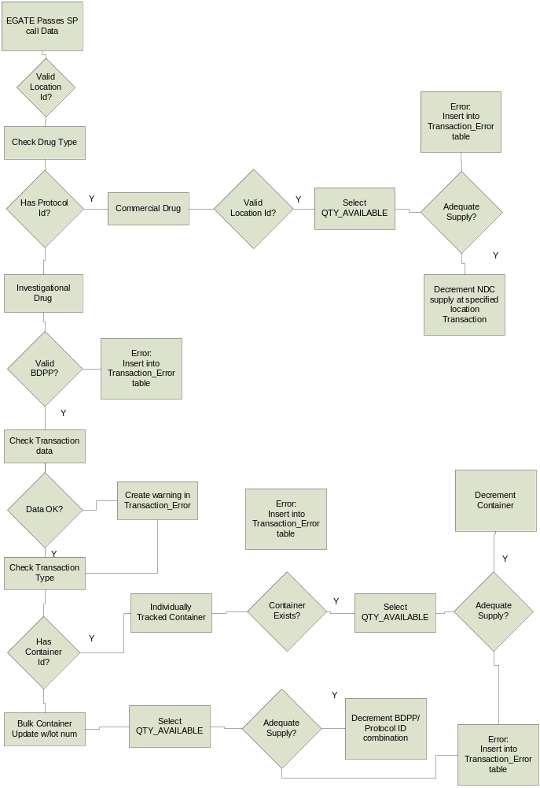This report can be printed and used in restocking pharmacies from the central pharmacy. A parameter may be added to determine the par level situation at a particular pharmacy.
  - Central par Level Report
This report compares the currently available amount at the primary pharmacy with the data stored in the INV_FORECAST table. If the availability is less than the par level, the report will include the NDC and quantity required to bring the supply back up the par level. This report can be printed and used when the drugs are reordered from ABC.
  - Master Inventory Report
This report will include the total drug inventory broken down by NDC and location across the entire system. A parameter may be added to view the inventory in a particular pharmacy.
  - Usage Rate Report
This report will tabulate drug usage rates grouped by NDC codes and Location Id.
  - Accountability Reports
This report will represent the same data and same format as found in the investigational drug signout sheets.

