DrugDeg app feature test
Tester: Date: Time finished:
Logged in as: drugdeg_t1
Test type | Done | Parameters | Results
View all parents:  Structures |  | N.A.
View all parents:  No structures |  | N.A.
View all parents:  No structures,  printer-friendly |  | N.A.
View all parents:  Structures,  printer-friendly |  | N.A.
View all parents:
Change # of parents
displayed
View parent detail |  | CJ-011974
View linked document |  | DocManager test 09.doc
View experimental detail |  | Thermal / Humidity
View some other expt. (without first returning to parent compound) |  | Oxidation
View a degradant |  | CP-102,706
Return to experiment |  | N.A.
View a mechanism |  | CP-102,706 mechanism
Return to experiment |  | N.A.
Return to parent |  | N.A.
Return to parent list |  | N.A.

Any “Add”, “Modify”, or “Delete” buttons appear (aside from “Edit query”, etc.)? ____________

DrugDeg app feature test
Tester: Date: Time finished:
Logged in as: drugdeg_t1
Test type | Done | Parameters | Results
New Query: ID prefix |  | UK | 12 hits
Refine (over current records found) |  | Salt: Mesylate | 1 hit: UK-033274
Undo Refine |  | N.A. | 12 hits
New Query: ID number |  | 11974, then 011974 | 1 hit: CJ-011974
New Query: mol weight |  | 434 | 1 hit: CJ-017493
New Query: mol weight |  | “430-440” | 3 hits: CJ-017493  CP-019106  CP-056636
New Query: formula |  | O3 | 19 hits
Edit query |  | Add mol weight: “< 315” | 4 hits: CP-045634  CP-052043  CP-063748  CP-069242
New Query: name |  | Trovafloxacin | 1 hit: CP-099219
Edit Query |  | Change the case of some letters in “Trovafloxacin” | 1 hit: CP-099219
New Query: salt |  | Sodium | 11 hits
New Query: conditions |  | Acid | 25 hits
New Query: parent info +  parent info +  parent info |  | Condition: Acid  Salt: Mesylate  Formula: N6 | 2 hits: CP-116517  CP-597396

DrugDeg app feature test
Tester: Date: Time finished:
Logged in as: drugdeg_t1
Test type | Done | Parameters | Results
Search parent substruct |  | 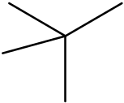 | 6 hits
Search parent substruct +  parent info |  | 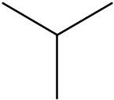 and Salt: HCl | 14 hits
Search degradant  substruct |  | 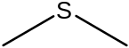 | 5 hits: CJ-013610,  CP-448187, CP-670648,  UK-116044, and UK-287074
Search degradant  substruct +  parent info |  | and Pfizer prefix: UK | 2 hits: UK-116044  UK-287074
Search parent substruct +  degradant substruct +  parent info |  | 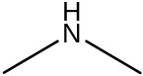  Salt: HCl | 3 hits: CJ-011974  CP-051974  CP-095946
Search parent exact  structure |  | 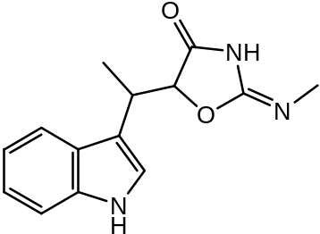 | 2 hits: CP-004781  GS-004781

DrugDeg app feature test
Tester: Date: Time finished:
Logged in as: drugdeg_t2
Test type | Done | Parameters | Results
Add parent |  | 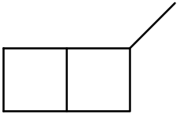ZT-201  Name: AqSqMe  Salt: Hydrobromide
Search parent compounds |  | Pfizer prefix: ZT  Pfizer number: 201
Show details |  | ZT-201
Add document link |  | DocManager test 05.doc
Add experiment |  | ZT-201: Thermal,  “expt conds”, “notes”, “refs”
Click experiment link |  | Thermal
Add degradant |  | 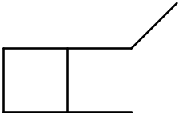ZT-2011,  AqSqMe deg
View degradant (click  “Degradant” button) |  | ZT-2011
Return to experiment |  | N.A.
Add mechanism |  | 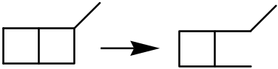
View mechanism (click  “Mechanism” button) |  | Mechanism for the degradant ZT-2011
Return to experiment |  | N.A.

DrugDeg app feature test
Tester: Date: Time finished:
Logged in as: drugdeg_t2
Test type | Done | Parameters | Results
Modify parent |  | Start with ZT-201:  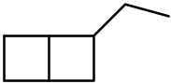 ZD-202  Name: AcSkMe  Salt: hydrobromide, citrate
View experiment |  | Thermal
Modify experiment |  | Start with thermal:  Fluorescence  “expt conds 2”, “notes 2”, “refs 2”
View degradant |  | ZT-2011
Modify degradant |  | Start with ZT-2011:  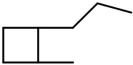 ZD-2021  Name: AcSkMe deg
View mechanism |  | Mechanism for ZD-2021
Modify mechanism |  | Change the mechanism so the parent and degradant are as modified above.
View mechanism |  | Mechanism for ZD-2021
Edit mechanism |  | (Same one, setting up for the next step.)
Delete mechanism

View degradant |  | ZD-2021
Edit degradant |  | ZD-2021 (again, setting up for next step)
Delete degradant

Edit experiment |  | ZD-202, Fluorescence
Delete experiment

Delete document link |  | Any one will do.
Edit parent |  | ZD-202
Delete parent

DrugDeg app feature test
Tester: Date: Time finished:
Logged in as: drugdeg_t2
Test type | Done | Parameters | Results
Add salt |  | 32 – Barium zzx
Modify salt text |  | Barium
Add condition |  | Marathon
Modify condition |  | Sprint
Delete condition |  | Sprint

