CambridgeSoft ChemOffice DOCManager 10.0 Installer Design Specification

Date Printed: 8-Nov-26

Publication Record
Version | Date Revised | Primary Author | Description
1 |  | Vikas Bhatti | Initial version

Table of Contents
Table of Contents 2
1. Scope 4
2. Functional Description 4
3. DocManager 10.0 System Requirements 4
4. Installation Requirements and Steps 5
4.1. Outline 5
4.1.1. Basic File Structure 5
4.1.2. IIS Configuration 5
4.1.3. Additional Requirements 6
➢ Com+ Application Installation 6
➢ Editing the INI Files 7
➢ Selecting an Administrative User 8
➢ Pre-Defined System Search 8
➢ Short Cuts 9
4.1.4. Build Versioning 9

- Scope
This document covers the detailed steps and installation requirements to help facilitate creation of DocManager 10.0 Installation. The Document is divided into different sections showing various aspects of Installation e.g. Basic File Structure, Advanced Requirements, Com+ Application Setup, Installing services and Configuring IIS.
  - Document Conventions
<INSTALLDIR> - This variable refers to the Installation Directory selected by the user while running the installation
[BUIDVERSION] – This property is widely used in the Installation and refers to the Current buildVersion . The first two octets are static i.e. 10.0. The third octet would be automatically incrementing based on the label generated by CruiseControls .Net
[WindowsFolder] – Refers to the location Windows is installed under e.g. C:\Windows
[WindowsVolume] – Refers to the Drive the operating system in installed on i.e. C:, D: etc.
- Functional Description
Web browser based, DocManager Enterprise extends the capability of standard search engines to include full free text searching and chemically intelligent structure searching of electronic documents including Text, Microsoft Word, Excel, PowerPoint, and Adobe PDF. The DocManager Enterprise interface allows users to easily submit documents through a series of simple-to-navigate web forms. When a new document is submitted, DocManager builds a free text index of the document, and extracts chemical information into a chemically-aware, substructure searchable database.
- Installation Requirements and Steps
  - Outline
    - Basic File Structure
This section includes transferring files on to the target system. The default installation directory is determined based on the Installation Directory set by the user while installing ChemOffice Core 10. While installing Core, a Key Value pair for COWS_DIR is populated in COWS.ini which helps determine the default value for installing Application Installers. The default value for ChemOffice would be <Inetpub>\WWWRoot\ChemOffice. Some Dlls would also be copied at the following path:
<ProgramFilesFolder>\CambridgeSoft\Informatics2008\Common\Dlls
.

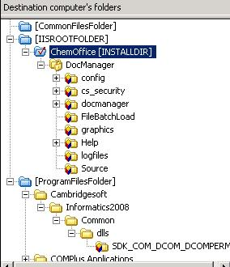

    - IIS Configuration
The installer would give the End User a List of WebSites available on the local IIS Server. User can choose the WebSite he wants to Install the ChemOffice under. All the Virtual Directories should be created under that WebSite.. The default document for this WebSite would be set to ChemOffice.asp.. The pre IIS 6.0 Version Virtual Directories would be marked to run under High Application Protection Option. The IIS 6.0 verison Virtual Directories would be associated with the New Application Pool (ChemOfficeAppPool) that would be created with this installation. The Virtual Directory created by the Docmanager Installer would be DocManager and would be mapped to where DocManager is installed on the local machine.
The Authenticated Users Group on the Target Machine would be given full control access on all files in this website.
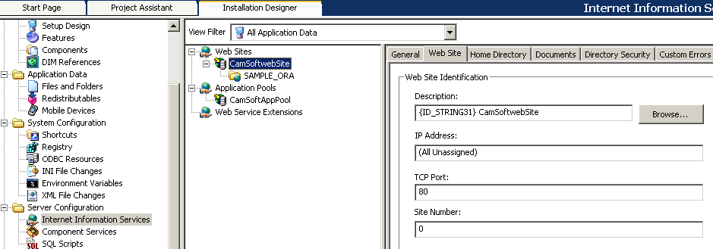

    - Additional Requirements
- Installer Pre-Requisite
This installer would have a dependency on Core 10 Installer. Unless Core 10 is installed this installation wouldn’t continue.
- Oracle Service Name
User would be required to pass in the Oracle Service name he wish to use with the application. This Service Name would be appended in the all the UDL files installed by the installer.
- Com+ Application Installation
The Installer would also be installing Five Com Components using the Same User Credentials passed in by the End User at the time of Installation. The Components that would be installed are:
BLOB
MolParser

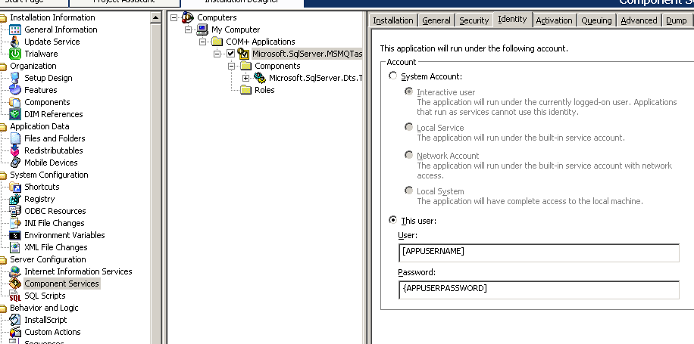
- Editing the INI Files
The installer would be editing the INI Files as well. The INI Files and the key Value Pairs that would be edited by the Installer are:
File Name | Section Name | Key Name | Value
<INSTALLDIR>\DocManager\Config\DocManager.ini | GLOBALS | ABOUT_WINDOW | DocManager [BUILDVERSION]
<INSTALLDIR>\DocManager\Config\cfserver.ini | GLOBALS | TEMP_DIR_PATH | [INSTALLDIR]cfwtemp\
 | DOCUMENT_MANAGER | ORA_SERVICENAME | ORACLESERVICE
 | CS_SECURITY | CS_SECURITY_UDL_PATH | [COWSDIR]Cs_Security\config\cs_security.udl
<INSTALLDIR>\Config\ChemOffice.ini | GLOBALS | AppName | DocManager

- Selecting an Administrative User
A user would be given the list of Admin Users available on the local box. He would need to choose the Admin User he wants to install DocManager with and put in the correct password for the selected account else the Installation shouldn’t proceed.
- Pre-Defined System Search
A Pre-Defined System Search would be initiated before the installation starts to check the version of Windows, IIS and User Privileges. The installation would be cancelled in case these requirements are not met.
    - Build Versioning
The Installer would be versioned in the following way:
a.bb.cccc e.g. 10.00.0000
Here ‘a’ would be reffering to a Major Build version.
Here ‘bb’ would be reffering to a Minor Build version.
Here ‘cccc’ would be reffering to Build Version and would be directly mapped to label Generated by CruiseControls .net.

