CambridgeSoft ChemOffice WebServer Enterprise10.0 Core Installer Design Specification

Date Printed: 8-Nov-26

Publication Record
Version | Date Revised | Primary Author | Description
1 |  | Vikas Bhatti | Initial version

Table of Contents
Table of Contents 2
1. Scope 4
2. Functional Description 4
3. ChemOffice WebServer Enterprise Core 10.0 System Requirements 4
4. Installation Requirements and Steps 5
4.1. Outline 5
4.1.1. Basic File Structure 5
4.1.2. IIS Configuration 5
4.1.3. Additional Requirements 6
➢ Install Reports.exe as Service 6
➢ Com+ Application Installation 6
➢ Editing the INI and the UDL Files 7
➢ Deleting Mime-types in IIS 8
➢ Environment Path Variable 8
➢ Creating an Administrative User 8
➢ Pre-Defined System Search 8
➢ Short Cuts 9
4.1.4. Build Versioning 9

- Scope
This document covers the detailed steps and installation requirements to help facilitate creation of WebServer Core 10.0 Installation. The Document is divided into different sections showing various aspects of Installation e.g. Basic File Structure, Advanced Requirements, Com+ Application Setup, Installing services and Configuring IIS.
  - Document Conventions
<INSTALLDIR> - This variable refers to the Installation Directory selected by the user while running the installation
[BUIDVERSION] – This property is widely used in the Installation and refers to the Current buildVersion . The first two octets are static i.e. 10.0. The third octet would be automatically incrementing based on the label generated by CruiseControls .Net
[WindowsFolder] – Refers to the location Windows is installed under e.g. C:\Windows
[WindowsVolume] – Refers to the Drive the operating system in installed on i.e. C:, D: etc.
- Functional Description
ChemOffice Enterprise is the leading solution platform for enterprise, corporate intranet, and Internet scientific information applications. Compatible with major databases including Oracle, SQL Server, and Microsoft Access, ChemOffice Enterprise is the development and deployment platform for existing and custom applications. Combined with the chemically intelligent searching and drawing capabilities of the ChemOffice suite, the ChemOffice Enterprise assists in delivering and storing chemical and biological data online.
- ChemOffice WebServer Enterprise Core 10.0 System Requirements
WEB SERVER (Minimum: 1GB RAM, 1.6GHz, 8GB Hard Disk Space)
- Operating System: Microsoft Windows 2000 Server sp2/3/4, Windows 2003 Server, Windows XP Professional
- IIS 5.0 or Higher
CLIENT (Minimum for chemical searching: 128MB RAM, 700MHz)
- IE 5.0 or later
- CambridgeSoft ChemDraw Pro Plugin/ActiveX Control 9.x
- A resolution of 1024 x 768 is recommended

- Installation Requirements and Steps
  - Outline
    - Basic File Structure
This section includes transferring files on to the target system. The default installation directory known as InstallDir is set to <ProgramFilesFolder>\CambridgeSoft\Infromatics 2008 . The required DLL’s in the Informatics2006 \Common\Dll folder would be marked for self registering. There is another node in this section which deals with transferring files in the WWWRoot folder on the Target System. The default identifier for this folder in InstallShield is referred to as IISROOTFOLDER.. This directory can also be changed and the Virtual Directory would be mapped as per the user selection.
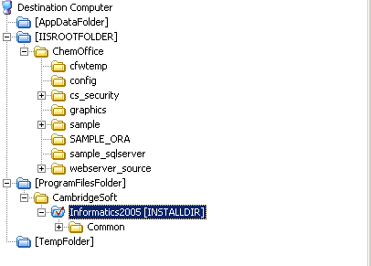
    - IIS Configuration
The installer would give the End User a List of WebSites available on the local IIS Server. User can choose the WebSite he wants to Install the ChemOffice under. All the Virtual Directories should be created under that WebSite.. The default document for this WebSite would be set to ChemOffice.asp.. The pre IIS 6.0 Version Virtual Directories would be marked to run under High Application Protection Option. The IIS 6.0 verison Virtual Directories would be associated with the New Application Pool (ChemOfficeAppPool) that would be created with this installation. Following Virtuals would be created Under the WebSite selected by the user:
ChemOffice
CS_Security
CFServerASP
CFServerADSI
CFServerAdmin
CFWTemp
Sample
Sample_Ora
Sample_SqlServer
The Authenticated Users Group on the Target Machine would be given full control access on all files in this website.
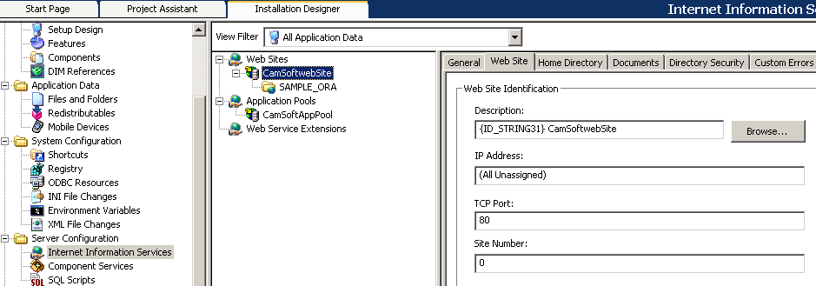

    - Additional Requirements
- Install Reports.exe as Service
A Windows Service, RPT Service, would be installed as part of the Core 10 Installation. This Service would be installed using the Credentials passed in by the user at the time of Authentication.
The service should be setup to start automatically and should be started at the end of the installation process.
- Oracle Service Name
User would be required to pass in the Oracle Service name he wishes to use with the application. This Service Name would be appended in the all the UDL files installed by the installer.
- Grant User LogOnAsSVC Rights
The User Name validated by the installer would be granted LogonAsSvc rights.
- Com+ Application Installation
The Installer would also be installing Five Com Components using the Same User Credentials passed in by the End User at the time of Installation. The Components that would be installed are:
Base64Decoder
COESSO
CSDO10
CSSecurityLDAP
ReportQ

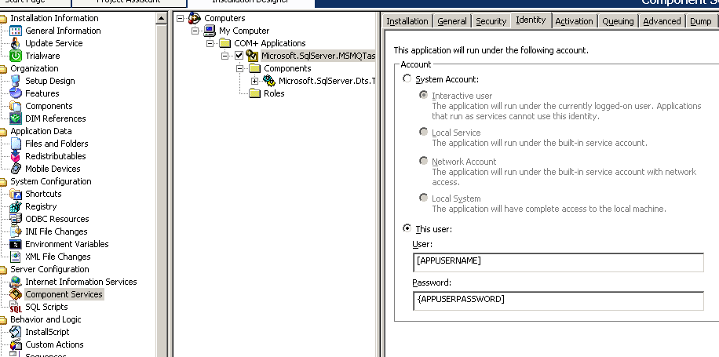
- Editing the INI and the UDL Files
Installer would also be Editing the INI Files and UDL files. The UDL files would be edited to append the OracleService Name passed in by the user while running the installation. The UDL file that would be edited by the Installer are:
<INSTALLDIR>\Sample\Config\Sample.udl
<INSTALLDIR>\CS_Security\Config\CS_Security.udl
<INSTALLDIR>\Sample_Ora\Config\Sample.udl
<INSTALLDIR>\Sample_SqlServer\Config\Sample.udl (In this UDL File the actual path based on the user selection of Install Directory would be appended for sample.mdf file.
The installer would be editing the INI Files as well. Most of the Keyvalue pairs may remain the same, just in case user decides to install the application in his desired directory than the default direstory, then all of the following values would be appended accordingly. The INI Files and the key Value Pairs that would be edited by the Installer are:
File Name | Section Name | Key Name | Value
<INSTALLDIR>\Sample\Config\Sample.ini | BASE_CFW_FORM | STRUC_DB_PATH | [INSTALLDIR]sample\database\sample.mst
 | BASE_CONNECTION | CONNECTION_STRING | [INSTALLDIR]sample\Config\sample.udl
 | GLOBALS | ABOUT_WINDOW | sample [BUILDVERSION]
<INSTALLDIR>\Sample\Config\cfserver.ini | GLOBALS | TEMP_DIR_PATH | [INSTALLDIR]cfwtemp\
<INSTALLDIR>\Config\ChemOffice.ini | GLOBALS | CHEMOFFICE_ENTERPRISE_VERSION | [BUILDVERSION]
<INSTALLDIR>\CS_Security\config\CFServer.ini | CS_SECURITY | CS_SECURITY_UDL_PATH | [INSTALLDIR]cs_security\config\cs_security.udl
<INSTALLDIR>\Sample_Ora\config\CfServer.ini | GLOBALS | TEMP_DIR_PATH | [INSTALLDIR]cfwtemp\
<INSTALLDIR>\Sample_Ora\Config\Sample.ini | BASE_CONNECTION | CONNECTION_STRING | [INSTALLDIR]sample_ora\config\sample.udl
 | GLOBALS | ABOUT_WINDOW | sample [BUILDVERSION]
<INSTALLDIR>Sample_SqlServer\Config\Sample.ini | BASE_CFW_FORM | STRUC_DB_PATH | [INSTALLDIR]sample_sqlserver\database\sample.mst
 | BASE_CONNECTION | CONNECTION_STRING | [INSTALLDIR]sample_ora\config\sample.udl
 | GLOBALS | ABOUT_WINDOW | sample [BUILDVERSION]
<INSTALLDIR>\Sample_SqlServer\Config\CFServer.ini | GLOBALS | TEMP_DIR_PATH | [INSTALLDIR]cfwtemp\
<WindowsFolder>\Cows.ini | GLOBALS | COWS_DIR | [INSTALLDIR]
 |  | COWS_ROOT | ChemOffice
 |  | COWS_VERSION | 10
 |  | DOC_ROOT | wwwroot
 |  | SERVER_DIR | Inetpub

- Deleting Mime-types in IIS
The .CDX Mimetype would be removed from the website configuration. By default the cdx extension is configured to be processed by the asp engine. This mapping would be deleted.
- Environment Path Variable
An Environment Path Variable would be created using the InstallShield inbuilt technology for Dll folder available in the <ProgramFilesFolder>\CambridgeSoft\Informatics2008\Common\DLL
- Creating/Selecting an Administrative User
A user would be given an option to either create or select an Admin User during the installation. If the user Select to use an Existing admin User, he should get a Dropdown populated with the list of Admin Users on the local box. He would be required to pass in the correct password for the selected account else the Installation shouldn’t proceed. In case the user opts to create a new user, Installer should check if the username the user entered does not exist on the machine. The installer would only create a local admin user. A check for password and confirm password should also be there.

- Pre-Defined System Search
A Pre-Defined System Search would be initiated before the installation starts to check the version of Windows, IIS and User Privileges. The installation would be cancelled in case these requirements are not met.
- Short Cuts
Two Shortcuts would be placed in the Startup menu for the Help Files i.e. Administrator’s Guide and User’s Guide.

    - Build Versioning
The Installer would be versioned in the following way:
a.bb.cccc e.g. 10.00.0000
Here ‘a’ would be reffering to a Major Build version.
Here ‘bb’ would be reffering to a Minor Build version.
Here ‘cccc’ would be reffering to Build Version and would be directly mapped to label Generated by CruiseControls .net.

