Inventory Enterprise 10 Functional Requirements Specification

Date Printed: 8-Nov-26

Publication Record
Version | Date Revised | Primary Author | Description
1 |  | M. Schoenberg | Initial version
1.1 | 07-26-07 | T. Matthews | First proposed implementation
1.2 | 10-04-07 | T. Matthews | Modified to include CellZome patch
1.3 | 11-14-07 | T. Matthews | Added sign-off page

Sign-Off

Author:
Name |  | Date

Table of Contents
Publication Record 2
Table of Contents 3
1. Introduction 4
1.1. Purpose 4
1.2. Scope 4
1.3. Document Conventions 4
1.4. Document References 4
2. Standard System Overview 4
3. Additional Requirements 5
3.1. Container Batching 5
3.1.1. Requirements addressed 5
3.1.2. Proposed Implementation 6
3.2. Request and Disbursement of Samples 9
3.2.1. Requirements addressed 9
3.2.2. Proposed Implementation 9
3.3. Shipping Orders 11
3.3.1. Requirements addressed 12
3.3.2. Proposed Implementation 12
3.4. Organizations 20
3.4.1. Requirements Addressed 20
3.4.2. Proposed Implementation 20
3.5. Millenium Pharma Patch 22
3.5.1. Requirements Addressed 22
3.5.2. Proposed Implementation 22

- Introduction
  - Purpose
The purpose of this document is to describe the enhancements to Inventory Enterprise 9.0SR3 required to achieve the functionality for Inventory Enterprise 10 whose requirements are outlined in Enterprise10 Requirements.doc. This document will be used as a reference for additional project documentation. The FRS will address the following:

  - Scope
The scope of this document is to detail the Functional Requirements Specifications of Inventory Enterprise 10.
  - Document Conventions
Italicized text – if found in the Requirements section refers to standard functionality in Inventory 9SR3
  - Document References
Document Title | Filename | Description
Enterprise 10 Requirements Document | Enterprise10 Requirements.doc | Requirements specification for ChemBioOffice Enterprise 10 (of which Inventory Enterprise 10 is a part)

- Standard System Overview
Inventory Enterprise is a ChemOffice WebServer based application designed to manage the reagent tracking needs of chemical and pharmaceutical research centers. The system manages data associated with both commercially and internally produced chemical substances.Inventory Enterprise can be tightly integrated with CambridgeSoft’s Registration Enterprise and chemical procurement ChemACX DATABASE. Inventory Enterprise is designed for a range of sizes large workgroups to enterprises, and captures both stockroom and reagent needs as well as high - throughput discovery data.
- 21CFR11 Audit Trails - Each change to the database is documented in the Inventory Enterprise audit trails. Electronically filter the data to see all changes made by a particular user, or only the changes made in a particular location between two dates.
- Barcode Generation and Scanning - Inventory Enterprise creates unique barcodes for each container in the system. Simply print the barcode and attach it to the container. Use your wireless scanner to rectify location contents by scanning the barcodes of the appropriate containers.
- Customized Report Generation/Creation - Built-in report generator. Use a wizard to rapidly generate new report templates. Customize report templates specific to your site's needs. Create reports (with sorted data) for search results or location contents. Reports can be exported to a variety of formats including PDF, HTML, Excel, RTF and JPEG. Email reports on the fly.
- Duplicate Checking/Substance Conflict Resolution - When a duplicate is detected, according to stereochemistry preferences set by the user, the user is asked if the new substance should be skipped, a duplicate record created, or if one of the duplicate records should be edited. Duplicates are detected according to the key fields the user defines (e.g. structure, CAS number, and Substance Name).
- Flexibility - Inventory Enterprise can be adapted to fit any organization's workflow and procedures. Administration tools give high level users the ability to customize the user interface. The software's open architecture allows the application to be easily integrated with additional onsite software (e.g. purchasing systems).
- Integration with BioAssay Enterprise - Plate data stored in the Inventory Enterprise system can be used in BioAssay Enterprise for use in protocols. While all contents data is maintained in the inventory system, BioAssay records the plate’s response to assays. This integration point allows you to both store and analyze biological screening data while tracking location and contents of a plate.
- Integration with Registration Enterprise and ChemACX - Search over the Registration Enterprise, ChemACX, and Inventory Enterprise databases simultaneously. Link directly to compounds in Registration Enterprise and ChemACX in inventory containers. Sharing data between applications limits the possibility of data entry error. If a change is made to the record in database of origin, it is reflected in Inventory Enterprise.
- MSDS Data - A database of MSDS data sheets are linked to Inventory Enterprise compounds by CAS number. If there are multiple data sheets available, all of the options are made available.
- Oracle Role Based Security - Usernames and passwords are linked to predefined roles in Oracle. These roles control which buttons are available after login, limiting the abilities of lower level users. Application administrators are permitted full control, while another user may only be able to search over the registration database.
- Plate Management - Managing plate information is much like managing container data. There are a number of options for creating plates in the system including importing information from pipette logs, or creating plates from a SD file allowing for both single compound and mixture plates. Much like the tools used to manipulate other containers, Inventory Enterprise steps you through the process of creating new plates, moving existing plates, creating daughter plates, and dithering plate contents.

- Additional Requirements
The following is a list of requirements to be addressed as part of Inventory Enterprise 10 and how these requirements will be implemented.
  - Container Batching

    - Requirements addressed
3.1 - Provide the ability to group containers into batches based on arbitrary container or substance attributes
3.1.1 - Provide the ability to view the list of containers in a batch and sum their content’s quantities. This information should be displayed by clicking on the “Amount on Hand” for the batch
3.1.2 - Provide the ability to search over batches by defined batch fields
3.1.3 - Provide the ability to request and reserve from a batch

    - Proposed Implementation
The administration of batch fields will be handled through a new interface accessible from the administrative menu via a “Manage Batching Fields” link:

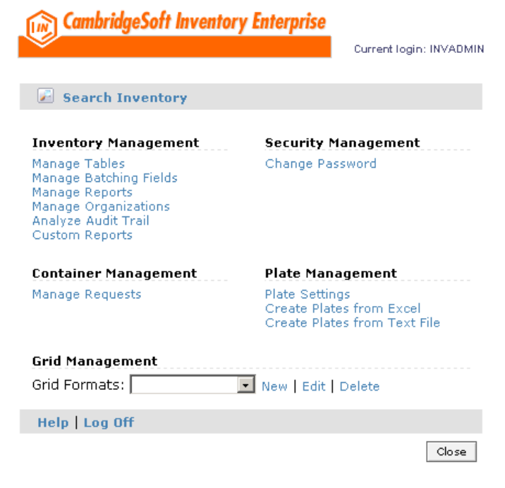
Figure 3.1.2.1

Clicking on the Manage Batching Fields link will open a form that will enable the user to select which container-level fields are to be used to organize batches:

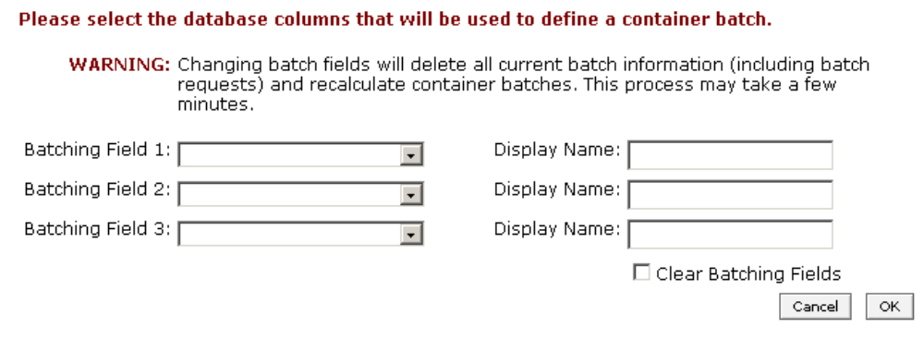
Figure 3.1.2.2

The three batching field picklists will be populated with valid columns from the inv_containers and inv_substances tables. Not all database columns should be selectable, owing to the fact that some are specific to batches themselves (IE batch_id_fk). Clicking on the OK button will commit the changes to the database and trigger the identification of existing batches based on those parameters. Clicking on the Cancel button will return the user to the administrative menu.

Searching on batch parameters is handled via the “Batch Search” tab on the search form. This tab will contain a substructure dialog, a container ID field, a batch id field, a batch status field, a minimum stock threshold field, and each of the “batching fields” defined by the administrator (see Figure 3.1.2.2). When a search is performed, the results form should display all of the batches that match the search criteria:

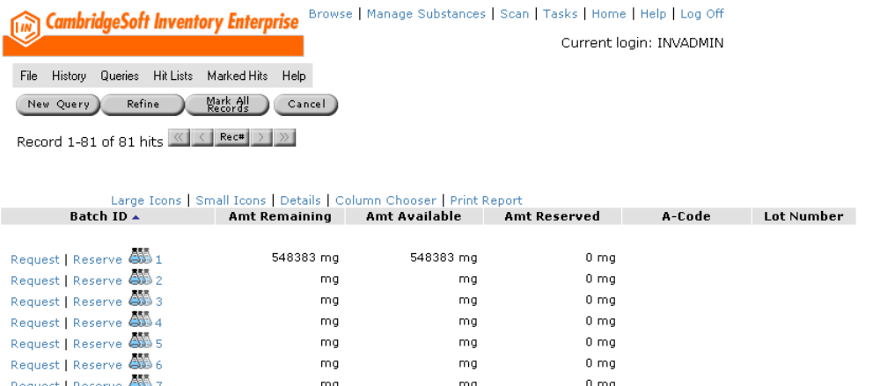
Figure 3.1.2.3

The user will have the ability to add the batching field columns to the display using the column chooser dialog. Clicking on a specific batch from the display list will open up the “Manage Batch Details” form, which will display more specific information about the batch itself:

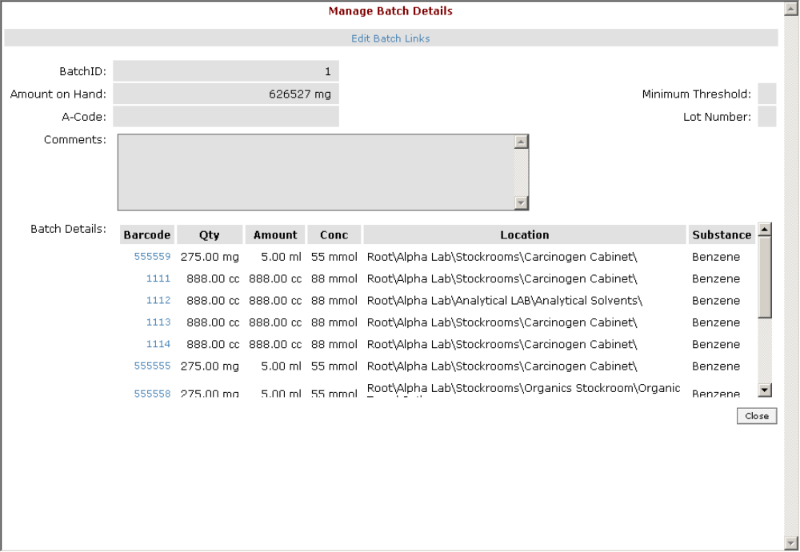
Figure 3.1.2.4

Clicking on the request link next to a batch in the search results list will open the “Request delivery” form:

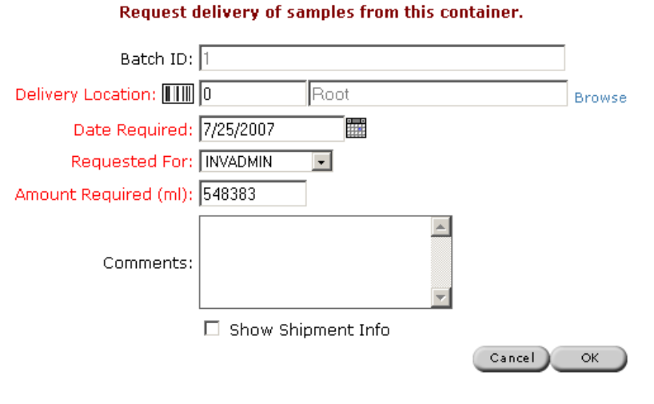
Figure 3.1.2.5

Clicking on the reserve link next to a batch in the search results list will open the “Reserve batch amount” form:

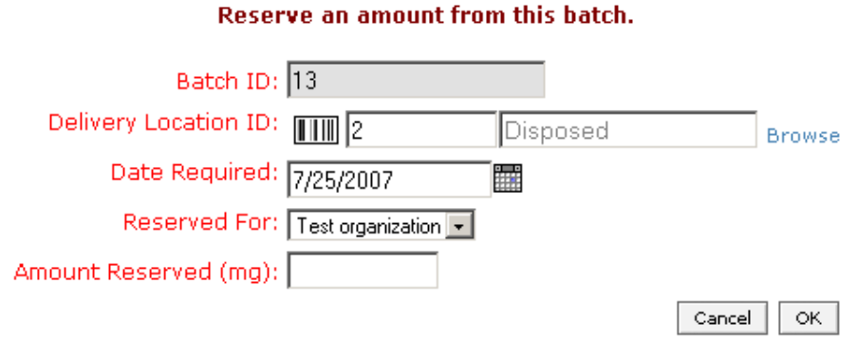
Figure 3.1.2.6

  - Request and Disbursement of Samples

    - Requirements addressed
3.2 - Provide the ability to request a sample of a container or a batch and track the disbursement of that sample.
3.2.1 - Provide the ability to configure additional fields to be exposed and used at the time of request.
3.2.2 - Provide the ability to evaluate and edit a sample request, as necessary, by the disbursing user.
3.2.3 - Provide the ability to assign a request awaiting disbursement to a disbursing user
3.2.4 - Provide the ability to disperse the requested samples to the appropriate requestor.
3.2.4.1 - Provide the ability to assign existing containers to a sample request in order to fulfill the request.
3.2.4.2 - Provide the ability to aliquot from a container in a batch in order to fulfill the request.
3.2.5 - Provide the ability to configure additional fields to be exposed and used at the time of disbursement.

    - Proposed Implementation
Requesting a sample from a container will be handled through the “Request delivery” form, accessible from the Obtain…Request pull-down menu option when browsing a container:

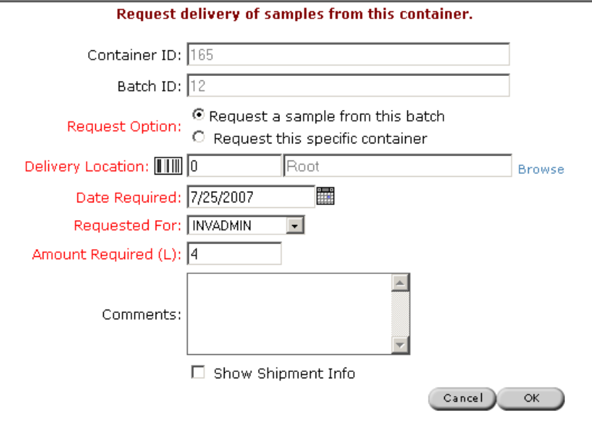
Figure 3.2.2.1

The user will have the option to either request directly from the container being browsed, or request a sample from the overall batch, which this container is a part of. The batch may contain multiple containers. Users may also request directly from a batch in lieu of a container by following the request link as documented in section 3.1.2. Additional fields out of the inv_requests table may be displayed on this form by making modifications to the INI file.

The fulfillment workflow of a sample request will be handled through the “Manage Requests” link off of the administrative menu. This form will be modified to support filtering batch requests through a “Sample Requests” link in the filtering section at the top:

Figure 3.2.2.2

Clicking on this link will change the display mode so that only pending sample requests, as submitted via the aforementioned pathways, will be displayed. The results list will then include columns pertaining to sample handling, such as Batch ID, and any configured fields.

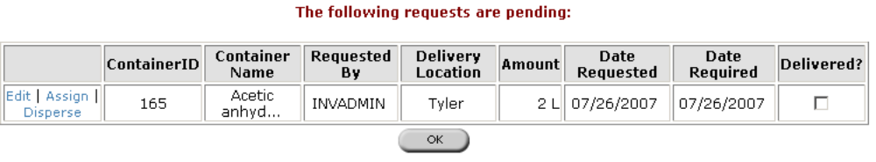
Figure 3.2.2.3

For either sample or container requests, editing an existing request will be handled by clicking on the Edit link next to a request in the display list. This action will open the “Edit this request” form:

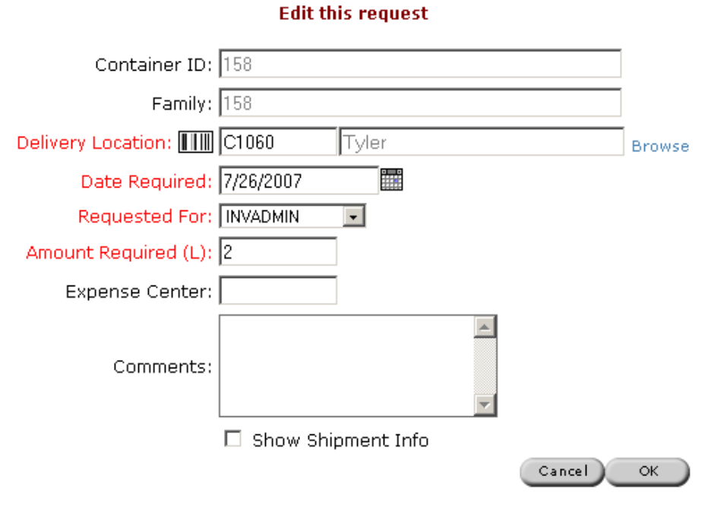
Figure 3.2.2.4

This form will display the proper fields (Container ID vs Batch ID) depending on the type of request and the configurable fields as defined by the INI file. After making changes to the request, clicking on the OK button will commit the changes to the database and return the user to the Manage Requests display. Clicking on the cancel button will return the user to the Manage Requests display without committing any changes to the database.

A user may choose to assign a pending request to a disbursing user that will in turn actually fulfill the request as part of their workflow. This action will be handled on a per-request basis by clicking on the Assign link next to a pending request (see Figure 3.2.2.3). Clicking on this link will open a form allowing the user to choose a disbursing user from a picklist built out of the current inventory user list, along with OK and Cancel buttons.

A disbursing user may fulfill a request by clicking on the “Disperse” link (see Figure 3.2.2.3). For sample requests, this action will bring up a form showing all of the containers belonging to that batch, along with the container information. The top portion of the form will display detailed information from the request, including the additional fields as configured in the INI file. The user may then choose to enter aliquots from each container to fulfill the request. Clicking on the OK button will commit the changes (decrement of quantities, removal of containers, etc.) and mark the request as being fulfilled. Clicking on the Cancel button will disregard any changes made. Either action will return the user to the “Manage Requests” form where they may continue fulfilling requests.

  - Shipping Orders

    - Requirements addressed
3.3 - Provide the ability to assign containers to an order and ship them.
3.3.1 - Provide the ability to associate a sample request with an order.
3.3.2 - Provide the ability to associate arbitrary containers with an order.
3.3.3 - Provide the ability to edit/enter shipping details for an order.
3.3.4 - Provide the ability to “ship” an order by updating the status and location of associated containers, requests, and orders to await receipt.
3.3.5 - Provide the ability to receive shipped containers.

    - Proposed Implementation

An “order” in this context is an internal workflow device to fulfill a pending request by “shipping” the corresponding inventory items to another location within the organization. A user will have previously submitted a request for a sample from a batch or a container, and the disbursing user has the need to group together this request (or multiple requests) and send them to the appropriate office or physical location. Once physically received at the ship-to site, the requesting user then confirms receipt of the containers and commits them to their new location.

The creation of an order for addressing this workflow will be handled in multiple locations within the application. First, when managing a closed request from the “Manage Sample Requests” form, the disbursing user will have the option to click on a link for “Assign to Order”. Clicking on this link will bring up a new form, wherein the user may choose to assign the request to an existing order from a picklist, or create a new order:

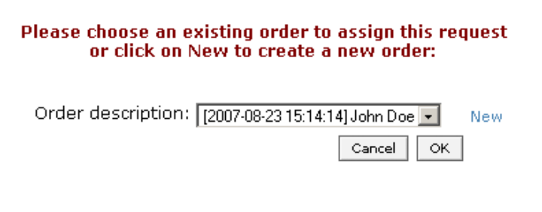
Figure 3.3.2.1

Clicking on OK with a valid order selected from the picklist will assign all of the containers within that request to the chosen order. Clicking on Cancel will return the user to the parent form without making any assignment. The user has the option to create a new order from this form by following the “New” link, which will open up the “Manage Order” form:

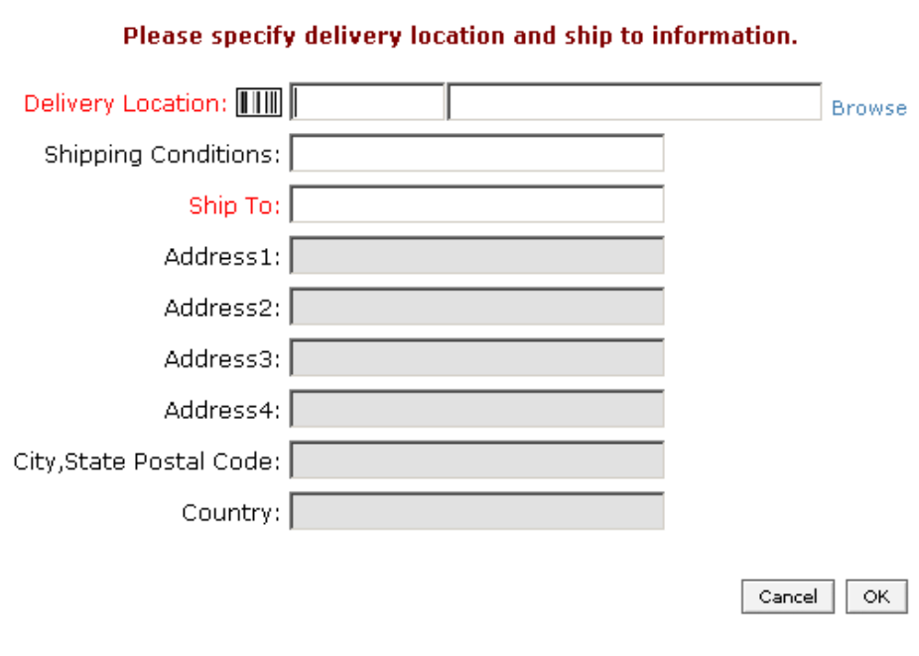
Figure 3.3.2.2

In order to create a new order, the user must specify both the delivery location and the ship to information. Shipping conditions are optional. When a delivery location is chosen using the Browse button, scanning the location barcode, or manually entering the location ID, the address fields will be automatically populated from the address information for that location:

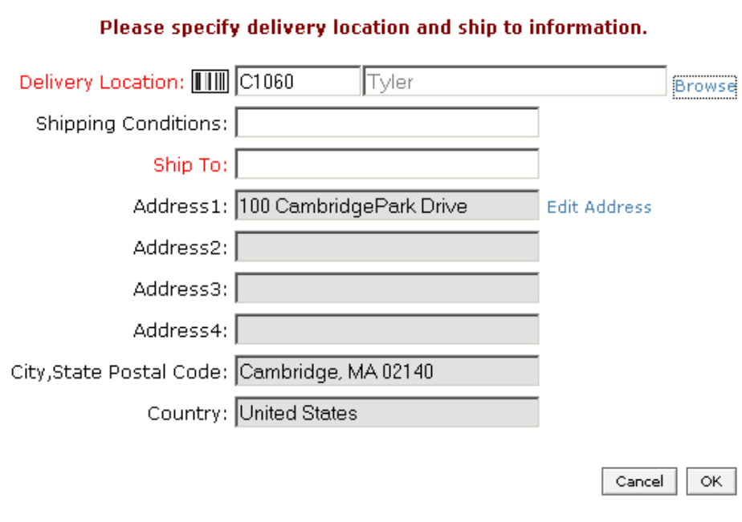
Figure 3.3.2.3

If no address is stored for the location, the address fields will remain empty. Upon choosing a location, the user will have the option to edit the address stored for that location by clicking on the “Edit Address” hyperlink:
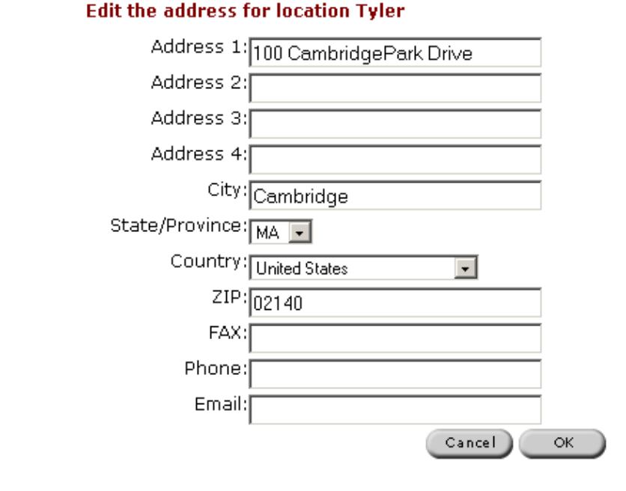
Figure 3.3.2.4

Any changes made to the address using this form will be saved permanently for that location, and not just that particular order.

After the delivery location and ship to information have been populated, the user may submit that order by clicking on the OK button. This will create the new order within the database and return the user to the Assign to Order form (Figure 3.3.2.1). The newly created order will then appear within the picklist and be automatically selected. The user may then choose that order (or another order within the picklist) and assign the respective containers to that order by clicking on the OK button. Clicking on the cancel button will avoid assignment of the containers to an order; however, any new orders created using the “New” link will still exist within the database. Both OK and Cancel will return the user to the “Manage Sample Requests” form.

The second workflow for order assignment is handled within the browse containers functionality. When a single container is selected, a new menu option under the “Other” heading labeled “Assign to Order” will provide access to the same form as assigning a request to an order. If the user selects an existing order or creates a new one, all of the selected containers will then be associated with that order.

In the event that no open orders (meaning status of “New”) exist within the database at the time the user chooses to assign a container or request to an order, the “New Order” form (Figure 3.3.2.2) will automatically be opened for the user to begin entering a new order. If they create an order through the form by accepting the changes, those containers will automatically be assigned to the order. If the user clicks on the Cancel button in this case, meaning no order was created, they will be returned to the “Choose Existing Order” form (Figure 3.3.2.1) where they may again opt to create a new order or click Cancel a second time to avoid assigning the container to an order.

The management of new and shipped orders will be handled through the “Manage Orders” link from the administrative menu:

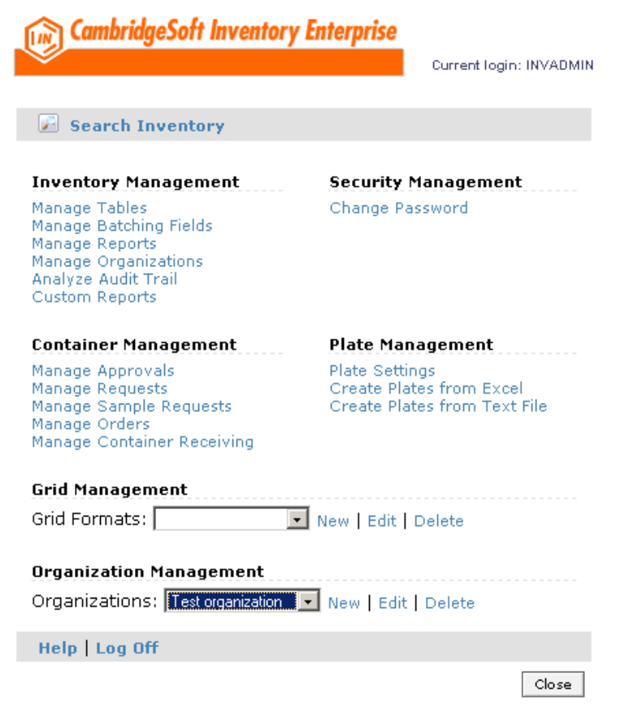
Figure 3.3.2.5

Clicking on this link will open the “Manage Orders” form:

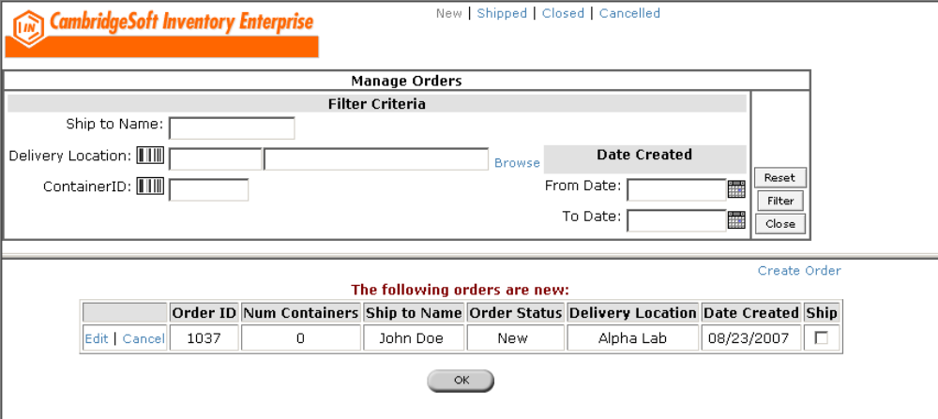
Figure 3.3.2.6

The user will be able to filter on order status by clicking on the filter links at the top of the form. Entering filter criteria will refine the list so that only orders that match the criteria will be displayed. There are four types of orders: New (may or may not hold containers, can be edited), Shipped (must have containers, cannot be edited except to remove/receive containers), Closed (all containers received) or Canceled. There are different tasks available for each order type. For “New” orders there are three tasks that may be triggered from the display list: edit the shipping details and containers, cancel, or ship. Clicking on the Edit link will open the “Create or Edit Order” form:

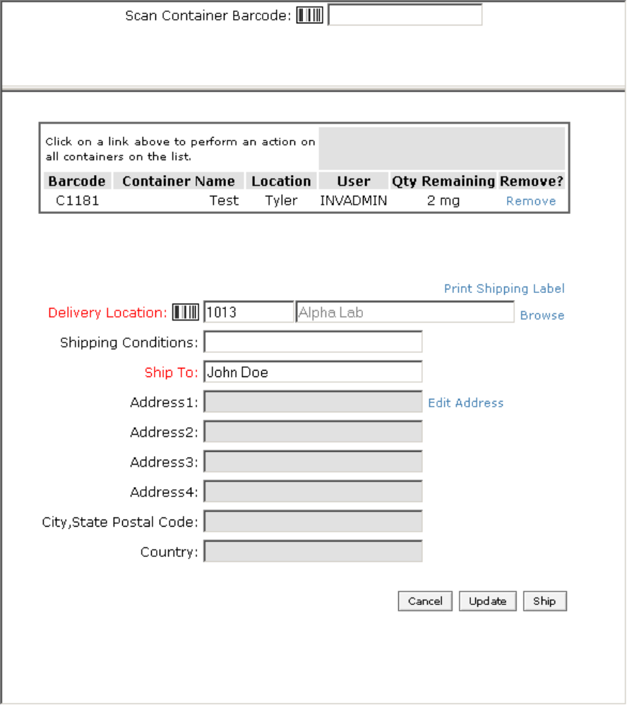
Figure 3.3.2.7

From this form, the user will be able to update the delivery location, shipping conditions, and ship to information for an existing order. The user will be able to add arbitrary containers to an order using this form by scanning in the barcode in the appropriate field at the very top of the form, or by manually entering the container barcode and leaving the field focus. To remove a container, the user may click on the “Remove” link next to a container from the display list. As in the case of creating a new order, the delivery location address may be modified using the “Edit Address” link. There are three methods for exiting this form. Clicking on cancel will abort any changes made to the order except for address modifications. Clicking on Update will commit any changes made to the order but leave the order in the “New” status. Clicking on Ship will mark the order as shipped and move the containers into the “On Order” location. The Ship button will only be available if containers have been assigned to the order. All three options will return the user to the “Manage Orders” form (Figure 3.3.2.6).

To ship an order, the user may follow the steps outlined in the previous paragraph or click the “Ship” checkbox next to a particular order in the display list on the Manage Orders form. Checking this box will not immediately ship the order; the user must then click on the OK button at the bottom of the list to ship all of the selected orders. As in the previous ship workflow, the containers for that order will be moved into the “On Order” location and the order status will be updated to “Shipped”.

To receive containers from a shipped order, the user will click on the “Shipped” link at the top of the “Manage Orders” form:

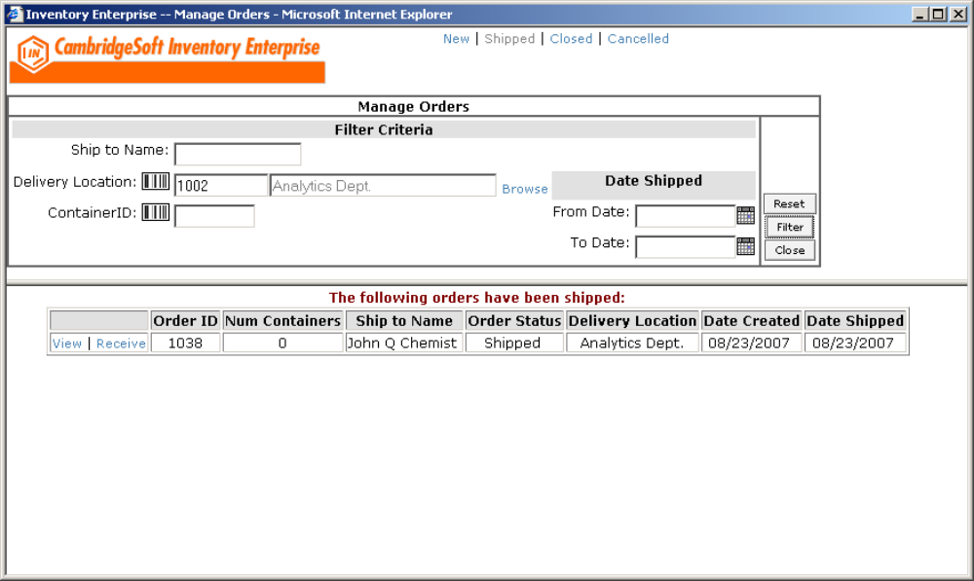
Figure 3.3.2.8

There are two tasks available for shipped orders: view the order details or receive the containers on that order, both of which are accessible from the respective links next to the order record in the display list.

Clicking on the “View” link will open the “Edit Order” form in a read-only mode such that all of the fields are disabled. At this point in the workflow, the order has already shipped and therefore can no longer be edited:

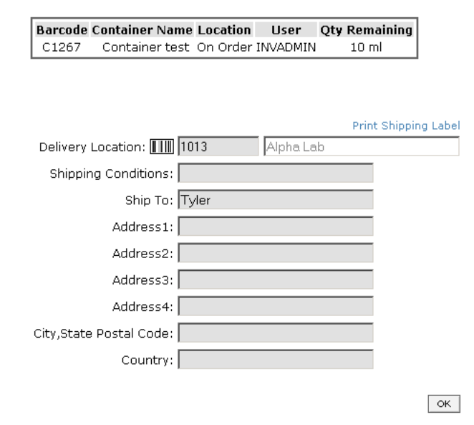
Figure 3.3.2.9

Clicking on the “Receive” link will open the “Receive an Order” form:

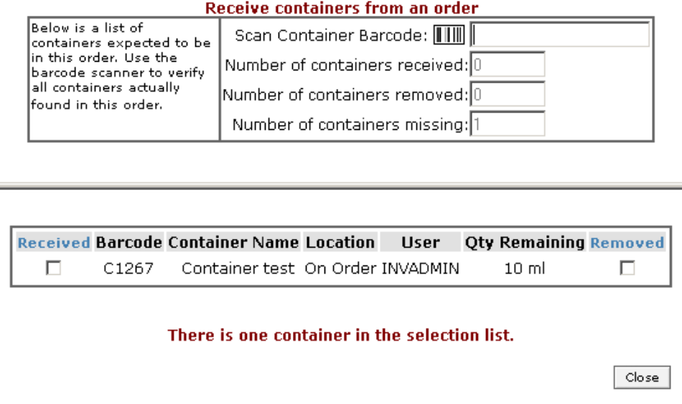
Figure 3.3.2.10

A list of all containers associated with the order will be displayed in the bottom portion of the form, with options to manually receive the container (clicking on the checkbox in the “Received” column) or to remove the container from the order entirely (clicking on the checkbox in the “Removed” column.. Optionally, the user may scan the barcode while in the appropriate field in the upper portion of the form to automatically receive the container, if found on that order. An “Update” button will appear in the lower-right portion of the form when the user has taken some action on any container in the list (by selecting either the Receive or Remove checkboxes.) Clicking on Update will either receive or remove those particular containers, and update the database accordingly. For received containers, this entails setting the container_status_id back to “Available” and moving the container to the delivery location. For removed containers, the container_status_id and location_id are reverted back to their original values prior to it being added to the order.

The user may choose to only partially receive and/or remove containers from an order. That is, there is no validation to ensure that all containers on an order have been addressed (e.g. either received or removed) before allowing an Update. In the case where there are still outstanding containers to be addressed, the order will remain with the “Shipped” status and continue to be “receivable”. However, any containers that had already been received previously will no longer be displayed on the “Receive Containers” form the next time that order is opened.

Once all of the appropriate containers have been properly addressed by the user clicking on Update, the application will automatically close the order so that it will no longer be receivable. This entails updating the order_status_id to the “Closed” status. An order with this status can only be viewed.

An alternate method for receiving containers on orders is through the “Receive Order” link found at the top of the browse page. Clicking on the link will open a lighter version of the “Receive Order” form:

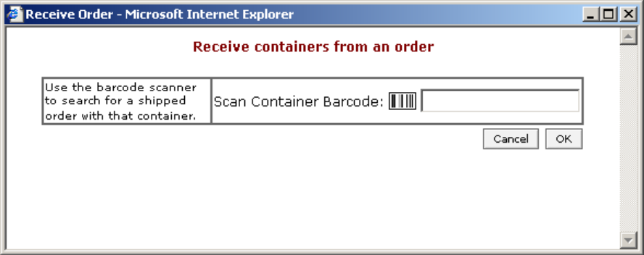
Figure 3.3.2.11

Using this form, the user may scan in a container barcode (or enter it manually) to initiate a database query to determine if the container is associated with an existing order. Scanning a barcode will trigger the lookup automatically; entering the barcode manually will trigger upon leaving the barcode input field. Alternately, the user may enter a barcode and click on the OK button. If an open order is found for the container specified, the regular “Receive an Order” form (Figure 3.3.2.10) will open and behave as documented previously. If the container is not associated with an open order, or the specified container barcode is invalid, a prompt will display informing the user of the problem. In either case, the form will remain open.

  - Organizations

    - Requirements Addressed
3.4 - Provide the ability to define “Organizations” and assign users to those organizations for reservation and request management.

    - Proposed Implementation
The administration of organizations will be handled through a new “Organization Management” section accessible within the administrative menu:

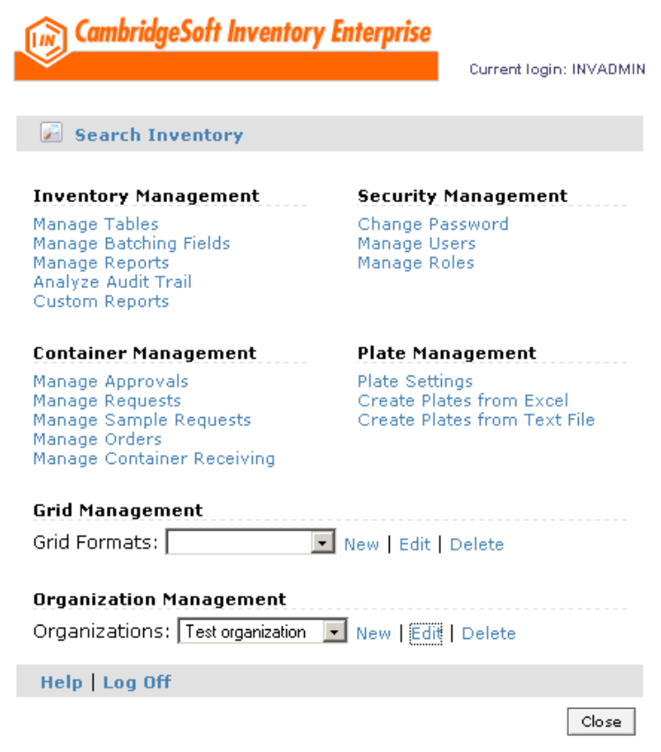
Figure 3.4.2.1

Users may choose an existing organization from the picklist and then click Edit or Delete to take the respective action on that organization, or click on the New link to create a new organization. Clicking New will open the Manage Organizations form in create mode:
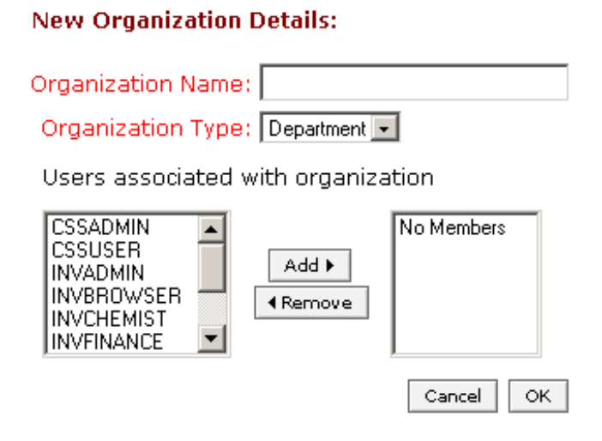
Figure 3.4.2.2

Only the organization name and type are required at this level; it is sufficient to create an organization and not have any users associated with it. The user may commit this new organization to the database by clicking on the OK button, followed by a confirmation page with a single OK button. Clicking on the cancel button will not commit the new record. Following through either path will return the user to the Administrative Menu. Validation must be performed to ensure that the new organization name does not already exist within the database. If the user attempts to duplicate a name, a soft error is output, allowing the user the chance to correct the problem.

Clicking on Edit from the Organization Management section with a valid organization chosen from the picklist will open the Manage Organizations form in edit mode:

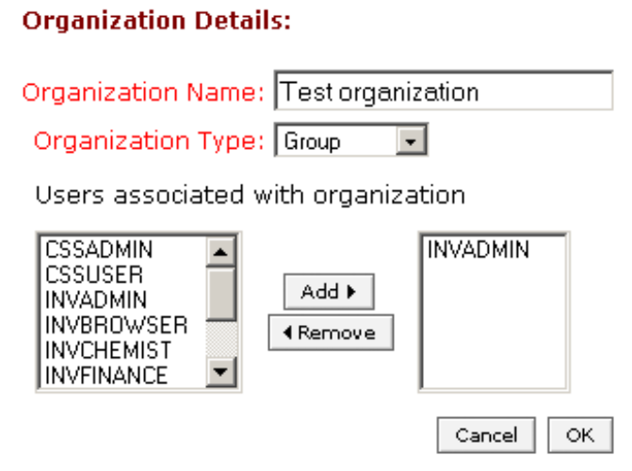
Figure 3.4.2.3

From this form, the user may choose to change any of the properties of the organization (including the name) or edit the list of users belonging to that organization. As in the case of creating a new organization, changing the name of an organization to one that already exists will output a soft error prompting the user to correct the problem. Clicking on OK will commit the changes the database, followed by a confirmation page, whereas clicking on Cancel will abort any changes. Following either path will return the user to the Administrative Menu.

The user may choose to delete an existing organization by first selecting an existing organization from the picklist and then clicking on the Delete link. This will open the Manage Organizations form in delete mode:

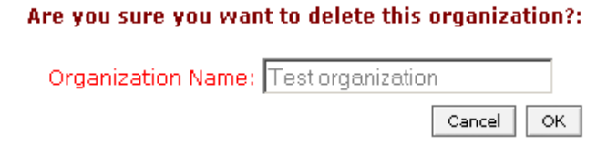
Figure 3.4.2.4

Clicking on OK will delete the record from the database, followed by a confirmation page, whereas clicking on Cancel will abort any changes. Following either path will return the user to the Administrative Menu. Attempting to delete an organization that is currently associated with an active reservation will result in an error message being displayed to the user.

  - Millennium Pharma Patch

    - Requirements Addressed
3.5 - Incorporate the enhanced attributes patch provided for Millennium Pharma in to Enterprise10. See embedded design documentation.
3.5.1 – Provide ability to update substance information from the Substance tab view when browsing a container’s contents.
3.5.2 – Provide ability to automatically select and print a label type from Other…Print Label when only one label type is available.
3.5.3 – Provide ability to create a new container directly from the home page

    - Proposed Implementation
The Millennium enhanced attribute modifications have already been incorporated into the Enterprise 10 code base.

A new “Manage Substance” link will be added to the Substance tab view which will enable the user to edit the substance data directly instead of having to go through the “Manage Substances” link:

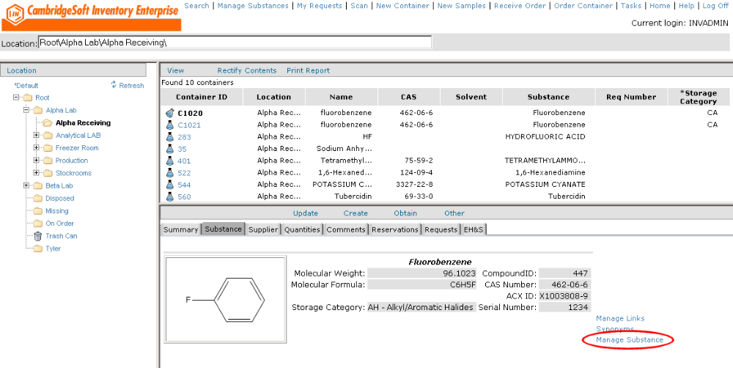
Figure 3.5.2.1

Clicking on this link will open the “Create or Edit substance in Inventory” form:

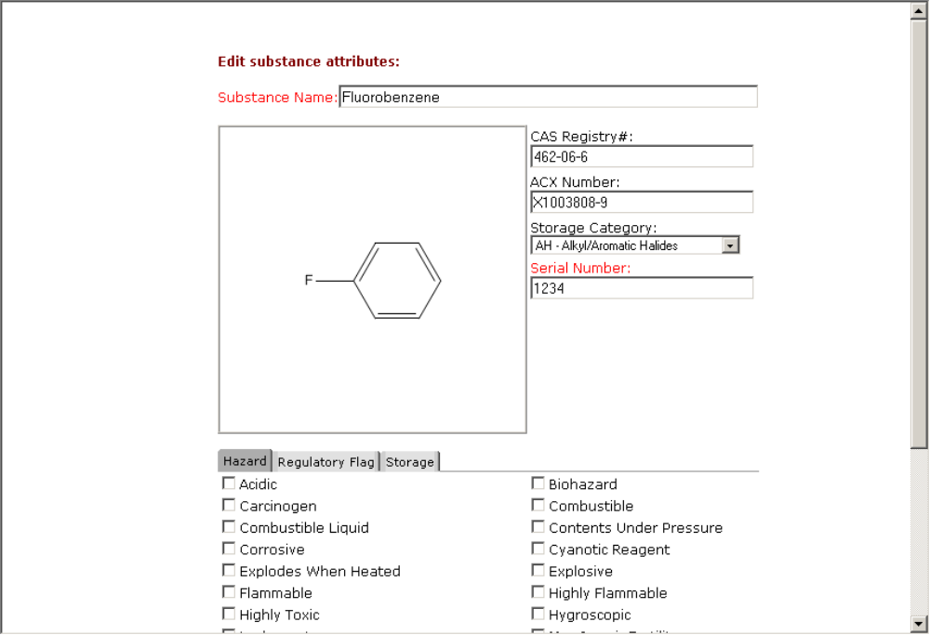
Figure 3.5.2.2

This form is identical to the normal “Manage Substance” workflow when editing a substance. A user may make modifications to the substance attributes here, including custom fields. Clicking on the Cancel button will close the “Edit substance” form and return the user to the browse window.
Clicking on the OK button will commit the changes to the database and open a confirmation form:

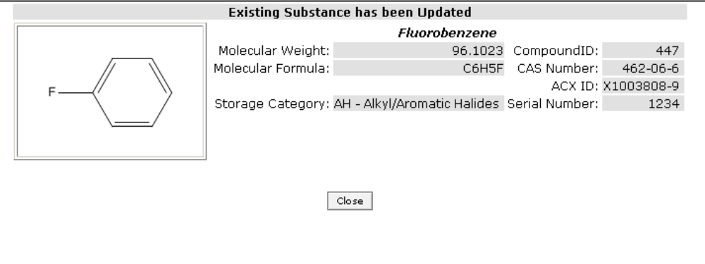
Figure 3.5.2.3

Clicking on the Close button from the confirmation form will close the form and reload the browse window so that any modifications made will be immediately visible.

To simplify the process for printing a barcode label for a given container, the application will be modified to first determine the number of label types available within the database, and only present a combo box when more than one type is found. The current functionality requires the user to select a label type from the dropdown, then print the label once the report has been displayed. The user interface will remain unchanged except for the case when only a single report exists within the database for a given report type. For container labels, choosing Other…Print Label will open the Print Label form; however, the combo box (see circled area in Figure 3.5.2.4) will no longer appear and the single label barcode will be automatically displayed, eliminating the need to choose the report name from the combo box. In addition, the Print dialog box, asking the user to choose a printer to send the label to, will display automatically (see Figure 3.5.2.5).

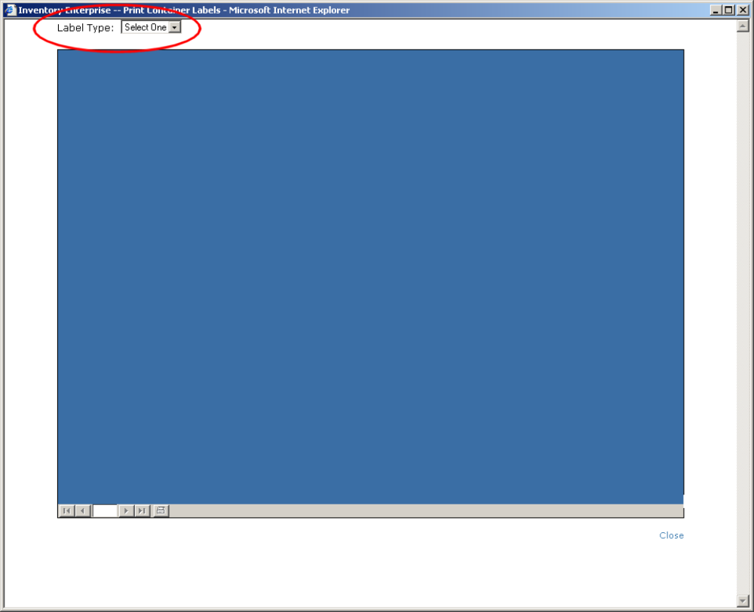
Figure 3.5.2.4: Print label form when multiple types are possible

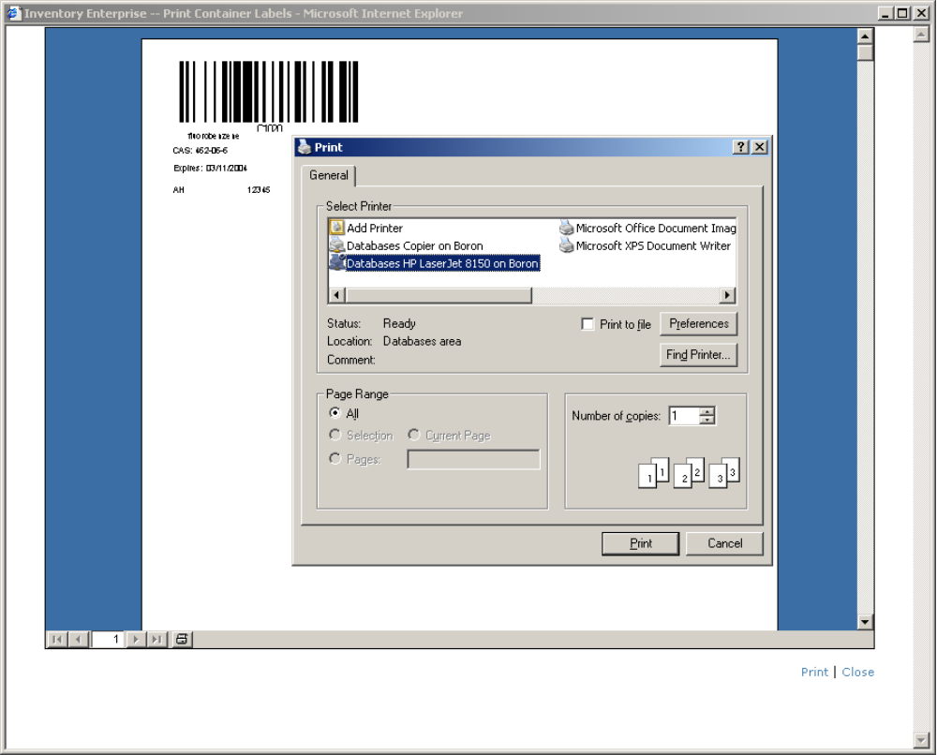
Figure 3.5.2.5: Print label form when only a single type is available

A “Print” link will be added to the Print Label form which will provide the same functionality as the print button within the snapshot viewer OCX control: to open the print dialog box and ask the user to choose a printer to send the label to.

A new link will be created on the main COE home page under the Inventory Enterprise heading to allow users to create a new container. This “New Container” link will first bring the user to browse mode and then open the standard “Create or Edit an Inventory Container”, just as if the user had clicked on those links individually. The default location for the Location ID for this new method of creating a container will be determined by a new invconfig.ini setting named DEFAULT_LOCATION_OVERRIDE found in the [CONTAINERS] section. This field should be set to any available user property specifying a valid location ID, such as “INVContainerOrderDeliveryLoc” or “INVDefLoc”, which correspond to the user’s default container order delivery location and the user’s default home location, respectively. If this setting is not found in the INI file, the form will default to Root as the new container location. Once the form is loaded, the standard “Create Container” workflow should be followed.

    - Addition of Pictograms to configured fields
      - Requirements Addressed
- Addition of optional pictograms to configurable fields in the manage substances interface.
- Addition of optional pictograms next to the fields in the display substance screens, in all cases where a pictogram exists for a configured dropdown, or in the case of a configured Boolean field, when the checkbox has been checked.

      - Proposed Implementation

In EU deployments, EH&S data can be handled at the substance level using the Boolean configured fields in 3.5.1. ; however, additional pictograms are required next to the field labels for the specific information. In addition, these pictograms should also be available for the configurable dropdowns outlined in this section.

The application will be modified to store a link for a defined custom field. When the manage substance or display substance pages are shown, this image should be displayed if it exists to the left of the label. If no image is configured, then only the label text will show up. This additional field can be managed by using the manage table functionality already in inventory with the addition of the INV_CUSTOM_FIELDS table to the editable tables in the invconfig.ini file.

A mockup of the substance view tab is included below:

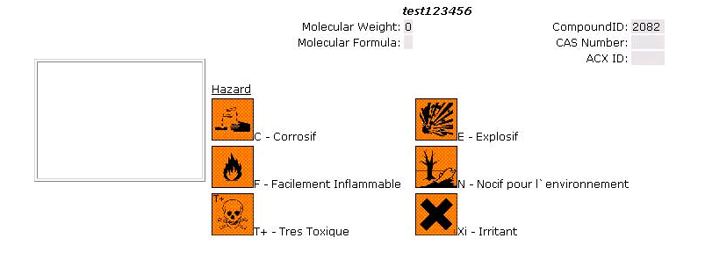

  - CellZome Patch

    - Requirements Addressed
3.5 - Incorporate the cherry-picking workflow implemented for CellZome
3.6 – Implement “deep copy” of a plate in order to preserve well-level data instead of using nominal plate values
3.7 – Implement dilution of target plates on a well-by-well basis

    - Proposed Implementation
There were a number of issues brought up by CellZome with the way in which Inventory was handling plates and plate functions. There are two main problems that are being addressed for the E10 release: creating daughter plates from source plates using a text file upload (cherry-picking) does not work properly insofar as the substance quantity is not decremented, and copying of plates creates target plates with nominal well values and does not preserve well-level information.

To address the cherry-picking issue, the application will be modified to utilize the solution volume at the well level to determine what ratio of the existing well substance quantity and solvent volume should be removed. If the text file field mapping includes solution volume, and the source well has a value for the current solution volume within the database, then the text file upload process will calculate the percentage being removed and use that percentage when determining how much of the substance and how much of the solvent should be removed. There are no GUI interface changes required for this implementation, only underlying API modifications during the processing of the text file. In order for the calculation to succeed, the text file must specify the solution_volume being removed and the solvent_unit_id, which must be a valid record within the inv_units.unit_id table.

To address the “deep copy” issue, a new radio button will be added to the “Create or Edit Plate” form:

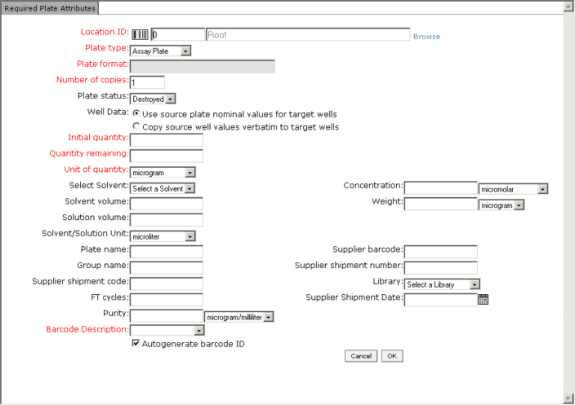
Figure 3.6.2.1

The two options for copying a plate are as follows:

Use source plate nominal values for target wells
Copy source well values verbatim to target wells

The first option (the default) is the existing functionality within Inventory. This creates a copy of the plate such that every well will have the plate-level nominal values for fields such as qty_initial, solvent, solvent_volume, solution_volume, etc. The second option is the new “deep copy” option that is desired by CellZome. This will make an exact copy of the plate, such that the two are indistinguishable if not for the new plate barcode. Every well on the target plate will be an exact copy of the corresponding source well, and no nominal values will be used.

Switching between the two options will hide and display other fields on the form. Specifically, the Initial Quantity, Quantity Remaining, Unit of Quantity, Solvent, Solvent Volume, Solution Volume, Solvent/Solution Unit, Concentration, and Weight fields will not be available when the user chooses to copy source well values verbatim and will not be validated when clicking on the OK button. Enabling these fields implies an override of any well-level value, eliminating the usefulness of even performing a deep copy. When the first option for using nominal values is chosen, these fields will become visible and will be validated when clicking on the OK button. Existing functionality should remain when this option is chosen.

To handle the dilution of a plate on a well-by-well basis, a new field mapping will be added to support the “Create plate from text file” workflow. This new mapping will be called “Solvent Dilution Volume” and will represent the amount of solvent to add to the target well after the target well has been created. This solvent amount will not affect the source well solvent volume at all; meaning, if the source well has 50uL, and the upload file indicates to pull 30uL then dilute with an additional 70uL, the source well solution_volume after the upload will hold 20uL, while the target well will hold 100uL (30 from source, 70 added as dilution). The amount of this field assumes that the solvent_unit_id matches.

