InvLoader Version 10
Functional Requirements Specification
Revision History
Version | Date | Author | Comment
1 | 2007-07-25 | Bill Claff | Initial version
1.1 | 2007-07-30 | Bill Claff | Add Document References
1.2 | 2007-09-19 | Tyler Matthews | Added enhancements details
1.3 | 2007-09-27 | Tyler Matthews | More enhancement details
1.4 | 2007-11-14 | Tyler Matthews | Added sign-off page

Document References
Document Title | Filename | Description
InvLoader 10 Requirements Document | InvLoader10FunctionalRequirements.doc | Requirements specification for ChemBioOffice Enterprise 10 (of which InvLoader 10 is a part)

Sign-Off

Author:
Name |  | Date
Introduction
The functional requirements are driven by the CSBR items that are targeted for the release timeframe of Inventory 10.
These items fall into 2 primary categories: Enhancements and Bugs.
Enhancements to be added as Features for InvLoader 10
- Add file types for input to InvLoader
  - Add ability to import from CSV files.
  - Add ability to import from XLS files.
- Improve appearance of inactive fields in the GUI
  - Salt, notebook, and other fields should be grayed-out when appropriate.
- Improve handling of duplicates
  - Duplicate handling should behave like Registration.
- Show additional information
  - Show field type for fields on mapping screen
  - Add ability to display the version of the software and the username of the currently logged in user.
- Handle additional fields
  - Add solvent amount field.
Mapping of FS# to Enhancements in CSBR
FS# | CSBR- | Imp. | Title
1 | 59254 | 13 | Enhancement (Polyphor): InvLoader should be able to take CSV or .xls files as input  for batch loading containers
2 | 51806 | 14 | Enhancement: salt, notebook and other fields should work like Chemloader and  grey out when appropriate
3 | 48556 | 17 | Enhancement: Handling of duplicates is confusing
3 | 48384 | 21 | Enhancement: Should behave like Registration regarding duplicate checking.
4a | 48515 | 17 | Enhancement: show field type for fields in mapping screen
4b | 52786 | 19 | Enhancement: Information about Version of software and logged in user name
5 | 56411 | 20 | Enhancement: add solvent amount field

List of Existing Bugs in CSBR to be Resolved
CSBR- | Imp. | Title
54458 | 7 | Bug: Unhandle exception error when loading this database
62894 | 14 | Bug (Myogen): No plates created when registering compounds in Reg using Invloader
64970 | 14 | Bug (St. Jude's): Invloader drops spaces out of text fields in plate database
55982 | 14 | Bug (Vanderbilt): Compound ID not populated in InvLoader
54498 | 14 | Bug: Data containing line feed character causes syntax error on viewing container
52637 | 14 | Bug: It is not Importing plates while entering values in some fields
54820 | 15 | Bug: Load fails with these matched fields
47875 | 16 | Bug: Cannot minimize app
48104 | 16 | Bug: During data load if another app is opened, Invloader screen no longer seen
55998 | 17 | Bug: Better error msg needed after loading file with wrong data type
47972 | 18 | Bug: Invloader.exe still running after closing application
58823 | 18 | Bug (Cambria): InvLoader fails to lookup reg numbers when RLS is enabled on reg
65792 | 18 | Bug: Assigned library field is not shown upon creating plates through Invloder
80335 | 18 | Bug: Plates contain no structures when the duplicate action for Registration system is  " Add new batch to Registered compound"
54335 | 20 | Bug: Dropdowns in container attribute list are cut off
52684 | 21 | Bug: Errors on mark and unmarking records in Registration after Invloader upload
48094 | 21 | Bug: Incorrect plate mapping not caught
60861 | 21 | Bug: No error message that plate is not created if you enter a invalid value in Plate Date 1 field.
48387 | 21 | Bug: Registration options all shown as text fields and not validated

1. Enhancement: Provide the ability to load/save field mappings.

During the loading of plates and structures, the mapping of fields and the default value specifications is a time-consuming and error-prone process. To enhance this functionality, the ability to save and load mapping “templates” will be implemented in the E10 version of InvLoader. When the user accesses the “Select Fields” form, two new buttons will appear (Load and Save):

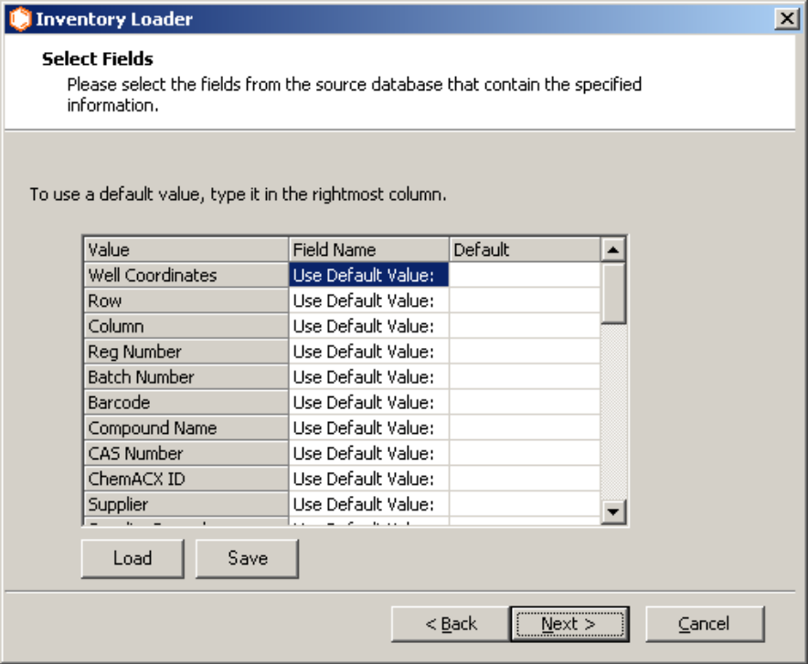
Figure 1.1

When the user clicks on the “Save” button, a dialog box will appear prompting the user to enter a name for the mapping template:

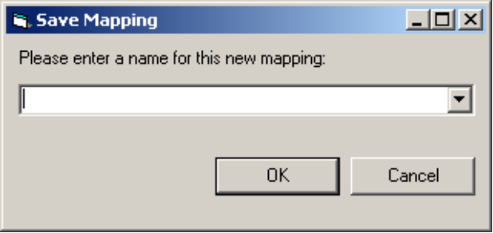
Figure 1.2

The user may either enter a new name by typing into the edit box, or select from an existing name using the drop-down list. If the user enters a unique name in the edit box and clicks OK, the “Save Mapping” dialog disappears and the application saves all of the existing mappings and default values to an XML file. This XML file will be stored in the “Mappings” folder found directly below the InvLoader application path. If the user chooses to use an existing name and then clicks OK, a warning will appear prompting the user as to whether they wish to overwrite the existing mapping. If the user chooses to overwrite the file, the application will do so and the old mapping information will be lost. If the user chooses not to overwrite the existing mapping, they will return to the “Save Mapping” dialog and be allowed to enter a new name. The user may choose to close this dialog without saving the mapping by clicking on the Cancel button.

When the user clicks on the Load button, the “Load Mapping” dialog box will appear:

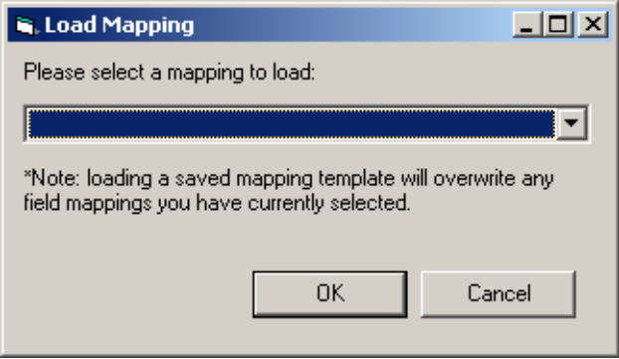
Figure 1.3

The combo box on this form will be populated with a list of existing XML templates that have previously been saved to the “Mappings” folder using the “Save” functionality documented above. This Load dialog is context-sensitive, in that only mappings of a particular type will be listed. There are three types of mappings, depending on what options the user has chosen: load plates, load structures only, and registration options. The first two options are mutually exclusive. When loading plates instead of just structures, additional fields will be exposed for mapping, and this limits the application of different types of saved mappings. The registration option mappings will only be visible if the user is loading plates and has checked the “Register compounds in registration” checkbox during the appropriate step. In short, a particular mapping can only be loaded if it was saved at the same point within the application.

To load a mapping, the user may select an existing name from the dropdown list and click on the OK button. This will overwrite any existing work the user had done within the “Select Fields” form, and return the user to that form for additional work if required. If no mappings have been saved for the particular mapping type, an error message will appear and no loading will be possible. The user may choose to not load a mapping template by clicking on the Cancel button. Once a load has been performed, the action cannot be undone, and the user must restart the application or simply remap fields as they see fit if they do not match what is required.

The loading and saving of registration option mappings happens in an identical fashion to the plates and structures mappings, only that it is accessible from a different form:

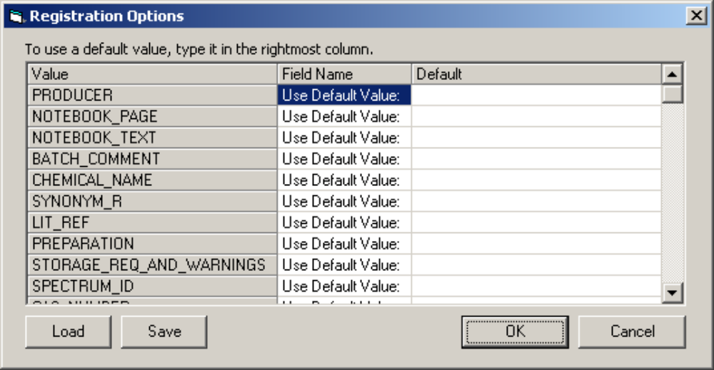
Figure 1.4

The user navigates to this form by choosing to load plates into inventory, clicking on the “Register new compounds in registration system” checkbox, and then clicking on the “Registration Options” button. The Load and Save buttons work exactly as for the plate and structure mappings documented above.

Notes: The list of existing names that will be populated in the “Save Mapping” dialog come from the list of XML files found within the “Mappings” folder. As these files are saved to the hard disk of the user’s computer, there are some application restrictions that must be enforced. First, the mapping name may not contain any of the following characters:

\ / : * ? ” < > |

The application will check for these characters prior to allowing the name to be used, and will prompt the user with an error if any are found. Second, the name given to a mapping must not be duplicated across all mapping types (Plates, Structures, and Registration). Since the name cannot be duplicated, the “Save Mapping” dialog will always display the entire list of mappings for all types, regardless of the user’s context within the application so that the user may become aware of the existing names. The “Load Mapping” dialog will only display names relevant to the user’s context.

Each mapping template that is saved will be given a mapping version number (currently 1.0) within the XML data. The application will be written to only support mapping versions that it is aware of; that is, it will only be backwards-compatible with versions at or below the version it was written for. If the mapping format changes in the future and a new version number is written to the XML file, any older instances of InvLoader will be unable to load that mapping. The most likely scenario for this occurring is a user copying a mapping template from another user who happens to be using a more recent version. Users are free to copy template mappings by dropping new XML files within the “Mappings” folder; however, users are discouraged from manually editing or creating the XML files and should instead use the application to save the mapping templates properly.

2. Enhancement: Provide the ability to validate field mappings and default values prior to upload

A consistent problem with customers using InvLoader is the difficulty in validating their data. Many bugs have been reported relating to plates not being created, and in the majority of these cases the root cause of the problem is the customer attempts to map a field with data that cannot be inserted into the respective database field. E.G. attempting to map a varchar value into a number field will generate an Oracle error. Part of the problem and frustration from the user perspective relates to the fact that no warning or error is given by InvLoader when this happens; the import runs to completion and appears to be successful. In fact, compounds can be registered properly even though the plate failed to be created, so in many cases it is halfway successful. It is only through careful analysis of the log file that the underlying Oracle error becomes apparent.

There are two important modifications for E10 that will be made to address this problem. First, InvLoader will have a much better method for validating the chosen mappings prior to attempting to load the plates. Second, the error handling and logging features in InvLoader will be enhanced to provide better troubleshooting information for the customer and services personnel.

In order to eliminate user frustration in mapping fields from their ChemFinder database to the Inventory fields, a new “Data Type” column will be added to the field mapping grid on the “Select Fields” pane:

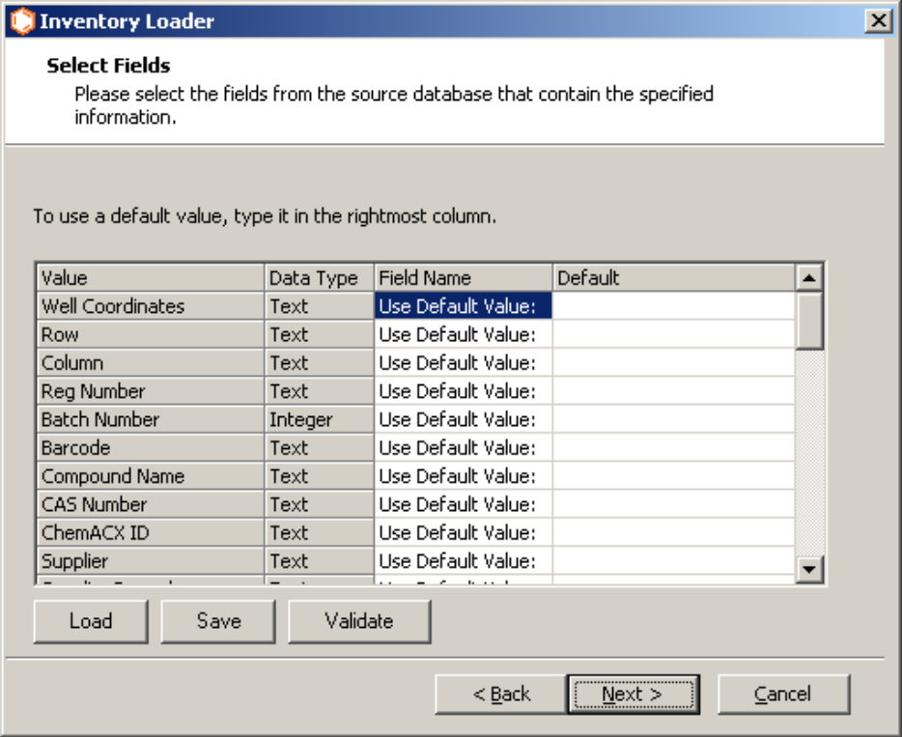
Figure 2.1

This column will display the Oracle data type expected for that mapping, so that the user has a better understanding of what ChemFinder fields or default values they may choose from.

While displaying the data type to the user will help to enhance user understanding of the mapping fields, that alone will not directly prevent mapping errors. Some level of validation is required prior to attempting the load in order to catch problems before a lengthy batch is undertaken that will inevitably fail. There will be two validation steps performed when the user sets up a mapping. First, if they attempt to enter a default value that is not of the proper type, a message box will appear informing the user of the problem. The value will then be overwritten with a proper value. Second, if they attempt to map a ChemFinder field that has data of the wrong type, a similar message will appear; however, the mapping will still be allowed in case the underlying Access database format for that field is not representative of the actual data records. This may occur in cases where the customer has defined their database fields to be of a text type, but has entered only numeric values. Thus the message will prompt the user to address a possible problem, but the user has the option to override the warning and still continue.

- Enhancement: Provide the ability to use XLS and CSV files in lieu of ChemFinder

Polyphor requested the ability to create containers using source data in a format other than a ChemFinder database (CFW file). This enhancement was given a CSBR as #59254. To enable loading of alternate formats, the “Browse” button on the “Select ChemFinder Database” step will display a dialog box that includes two new formats:

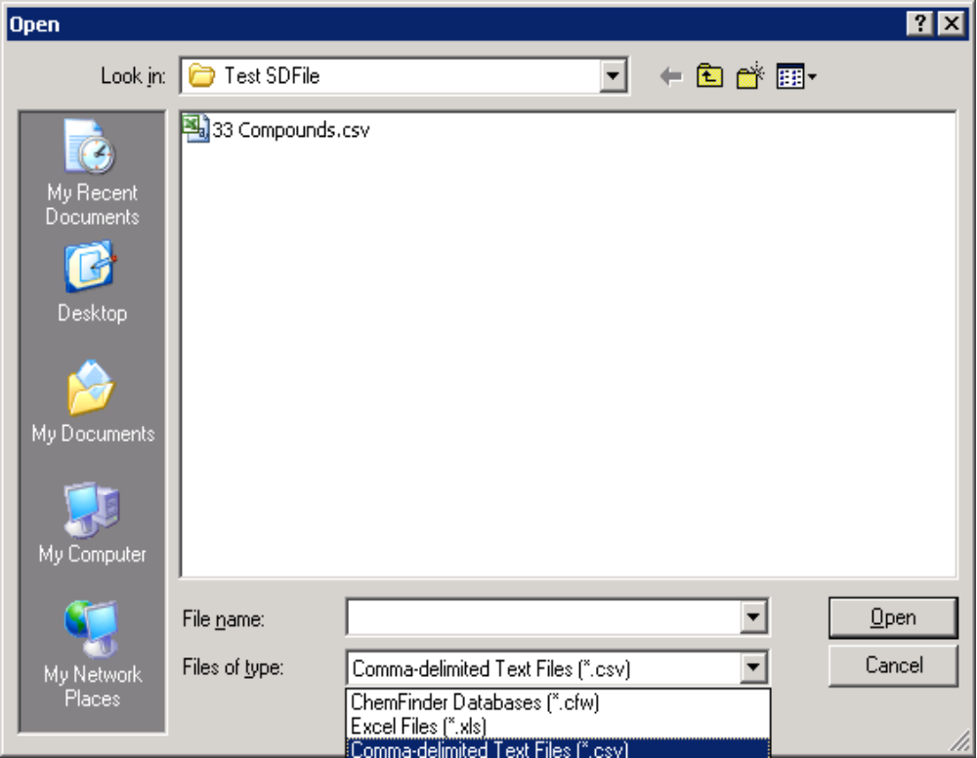
Figure 3.1

Selecting either “Excel Files” or “Comma-delimited Text Files” will filter the display so that only files with the appropriate extension will be visible.

Choosing a format other than ChemFinder will not have any impact on how the rest of the application functions. Field mappings and registration options will work exactly the same for all three formats. The only noticeable change will be when uploading an Excel document. In this case, it is very likely that there will be multiple sheets to choose from and the worksheet names will be arbitrary. As such, the user will be forced to choose the actual worksheet name that includes the data they wish to upload. This will be handled through the existing “Select Table” step, as in the case when the ChemFinder database includes multiple tables:

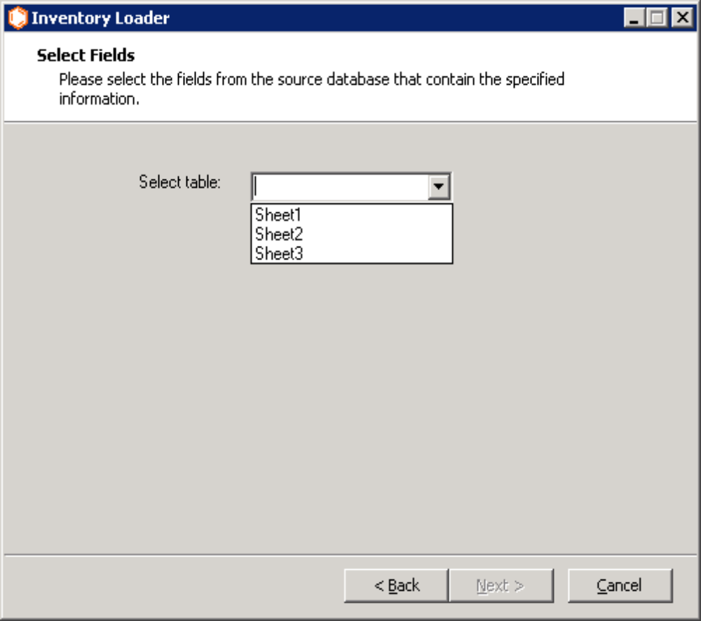
Figure 3.2

In the case of loading an Excel document, all available worksheets will be listed within the dropdown for the user to choose from. In the case of loading a Text (CSV) document, the file itself becomes the table, and the user will not be shown this prompt.

For both Excel and Text file databases, the very first row of the spreadsheet or file must be the list of column names in order for the application to perform the mapping. This pre-requisite is something that will need to be documented clearly in the InvLoader documentation. Sample XLS and CSV files will be included in the installer so that customers wishing to utilize these alternate formats will have examples to work from.

ChemFinder stores structure information internally in a binary database field named “mol_id”. For Excel and CSV files, this functionality will not be accessible. To support structure information when uploading data from an Excel or Text database, the application will look for a field named “Structure” instead of “mol_id”. The format of the data in this field must be the SMILES structure format (e.g. CCCCC\C=C/C\C=C/C\C=C/C=C/[C@@H](O)CCCC(O[H])=O). In order for InvLoader to process the SMILES format, the computer that it is running on must also have the ChemDraw plugins installed. This should not be an issue for any instance that has ChemFinder, as it also requires the ChemDraw plugins.

In order to test the new Excel and CSV structure format, the simplest way to generate SMILES structures is to export an existing ChemFinder database. Start ChemFinder and open the existing database. Go to File…Export…Delimited Text. Under the “Output File” edit box, change the extension of the file to .CSV. Make sure the field for “Structure” is checked on the left. Switch to the “Text Options” tab, and choose “Comma delimited” as the text file export, and choose SMILES as the structure text export format. Ensure the checkbox for “Include header” is checked. Click on Export to finish the process. Open the .CSV file in Excel to verify structure information was exported properly.

A CSV file can be converted readily to an XLS file by using Excel. Just open the CSV file, and do a SaveAs, changing the type to Microsoft Office Excel Workbook.

3.6 Enhance InvLoader to allow batch importing of containers supporting ChemOffice 9, 10

For the E10 release, the .NET version of InvLoader will be merged into the classic VB6 version so that all Inventory batch-loading functionality can be found in a unified executable. The existing functionality from .NET will be ported verbatim into the VB6 version, and any associated bugs will be addressed. To support the merging of the two versions of InvLoader, the VB6 application will undergo some modifications. The most obvious change will be to the “Select Database” form:

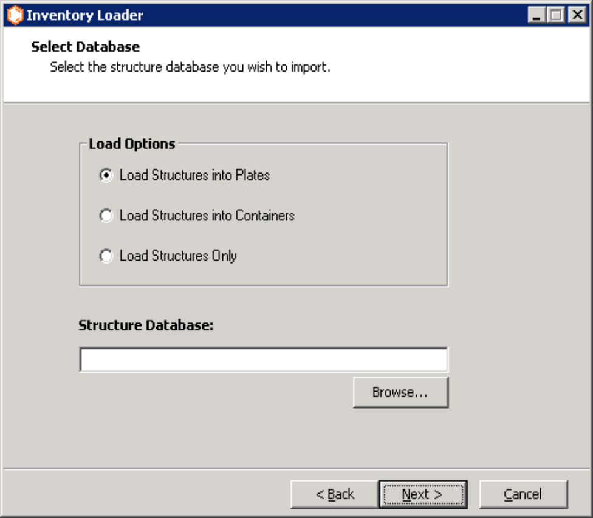
Figure 3.6.1

This form will be modified to include three options: load into plates, containers, or structures only.

When loading containers, some of the container attributes will be presented as drop-down lists after the user chooses the database field mappings. Four of these attributes are required in Inventory, and as such must be specified by the user. These attributes are: container location, container type, container status, and unit of measure. The labels for these attributes will appear in red, indicating to the user that they are required:

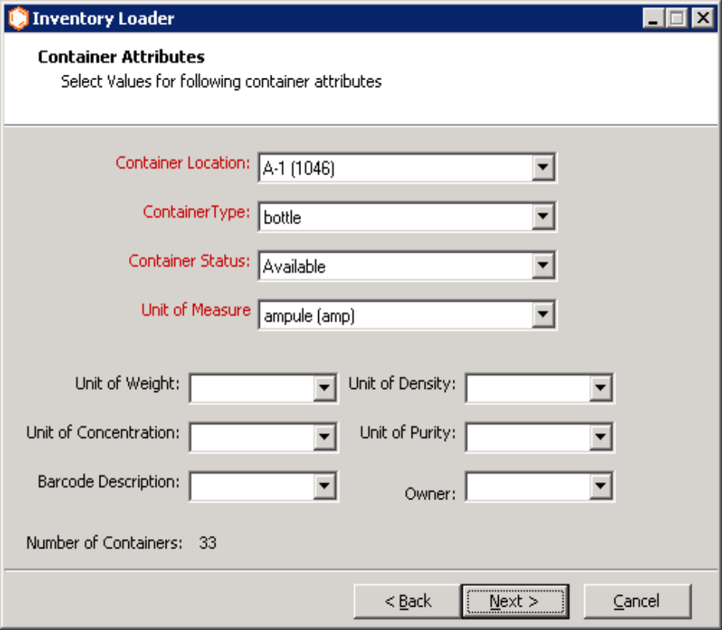
Figure 3.6.2

The remaining attributes are not required, and will appear in black. If the user had previously specified a field mapping from the source database for one of the attributes appearing on this form, the drop-down list for that attribute will be disabled. None of the drop-down lists will allow the user to enter free-form text.

All other functionality for loading of structures will be enabled for loading of containers; aside from the differences in database field mappings and the container attributes drop-down list form, the two paths are identical. For example, the user may load structures from the database and register compounds in RegDB.

