RPT Software
Report Server Instructions


Last Updated: | October 28, 2013
Table of Contents
1. Overview 3
2. Pre-requisites 3
3. Installation Instructions 3
3.1. Install Step1 – Download and Unzip the Evaluation File 3
3.2. Install Step 2 – Copy Files to Your Web Server 4
3.3. Install Step 3 – Test out the Reports.EXE Program 4
3.4. Install Step 4 – Register the ReportQ.DLL File 7
4. Examples 10
5. ReportQ DLL Methods 11
5.1. Make Report Method 11
5.2. GetQueueSize (ByVal QueuePath As String) As Integer 12
5.3. WriteQueueHTML (ByVal QueuePath As String, ByVal NumOfRecs As Integer) As String 12
5.4. ArchiveQueue (ByVal QueuePath As String) As Integer 12
6. Which PDF Printer Driver Should I use 13
6.1. Adobe PDF Writer – Pros and Cons 13
6.2. Win2PDF – Pros and Cons 13
7. How to get your own reports working 14
8. What’s New in Version 2.0 15
9. Reference 15

Overview
The RPT Software - Report Server is a web delivery system for Microsoft Access reports. It enables you to easily build a web site in which a user can create reports dynamically. Currently this software can produce Adobe PDF files, Rich Text Format, Microsoft Excel, Microsoft Snapshot format and Microsoft Excel (raw data based on the query).

Pre-requisites
The following software should be installed before installing the RPT Software – Report Server:
- Windows NT 4.0 (with IIS 4.0 and Microsoft Transaction Server) or Windows 2000
- Microsoft Access 2000 or Microsoft Access97
- Adobe PDFWriter 4.0 or Win2PDF printer driver (if you want to produce reports in PDF format)
See http://www.adobe.com or http://win2pdf.com for more details. Also see the section “Which PDF printer driver should I use” later in this document.

Installation Instructions
To install and configure RPT Software – Report Server, follow the steps mentioned below.

Install Step1 – Download and Unzip the Evaluation File
- Download the Report Server evaluation file from:
http://www.rptsoftware.com/eval2000.zip (Designed for Microsoft Access2000)
http://www.rptsoftware.com/eval97.zip (Designed for Microsoft Access97)
- Unzip the file using you favorite Zip utility.
- The following files are contained in the eval.zip:
Files | Description
Core Program Files:  - Reports.exe  - Reports.dat  - reportqueue.mdb  - reportqueuearchive.mdb | - Main EXE  - data file for EXE  - Access database to hold report requests  - Access database to hold archived report requests
Server-side Component:  - reportq.dll | - DLL used to interface ASP with reportqueue.mdb
Example Files:  - rpt_index.asp  - rpt_criteria.asp  - rpt_display.asp  - rpt_queue.asp  - rpt_example.mdb  - ball.gif | - Main ASP page  - ASP page used to gather report criteria  - ASP page used to create and display report  - ASP page used to demo queue operations and reporting  - Access database used for examples  - Picture used in rpt_display.asp
Documentation File:  - RPTSoftwareInstructions.doc | - This document.

Install Step 2 – Copy Files to Your Web Server
Copy all the above files, except documentation, to your IIS Web Server. The only requirements are as follows:
- All of the 4 core program files must be in the same directory
- The 6 example files must be in a web directory that has read and script execute privledges. They should also be placed in the same directory, to make things easier.
For example, you could copy the 4 core program files to d:\reports, copy the component to another directory and copy the example files to d:\inetpub\scripts directory. To quickly get everything up and running just copy everything to d:\inetpub\scripts. You may have to enable read access for that directory; otherwise you won’t see the ball.gif file when you run the examples.
Tip: After you finalize the location of where you want the 4 core program files, it is a good idea to create a shortcut in the startup folder, so if you reboot the computer the report server will start up again automatically.

Install Step 3 – Test out the Reports.EXE Program
- Start the Reports.EXE program. You will see the following screen.
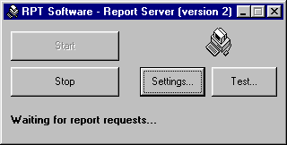
If you receive any errors, check to see if Microsoft Access is installed correctly.
- Click on the Settings button to configure the report server settings.
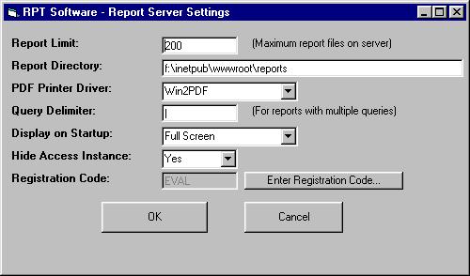
Report Limit is a setting used to determine how many reports are allowed to reside on the server. For example, if you set it to 200 a maximum of 200 report files will be saved on the server. When the 201st report is created it will overwrite report #1. This is done to conserve disk space. The minimum setting allowed is 100, no maximum restriction. Note: This setting applies to each report format, so you could have 200 PDF files and 200 RTF files for instance.
Report Directory is the directory that the report files will be stored in when they are created. This directory must exist! This directory also should be available to your web site (virtual or normal).
PDF Printer Driver is the printer driver to use when creating PDF files. Either printer driver will work however there are some pros and cons and special settings for each. See the section, “Which PDF printer Driver should I use” later in this document.
Query Delimiter is the character you want to use as a delimiter when specifying multiple queries, for a report with multiple sub reports. The examples help clarify how this setting is used.
Display on Startup gives you a choice of how this program will appear when it gets started. Usually you keep this setting at “Full Screen” until you are done experimenting with the product and you just always want it to start up minimized.
Note: When minimized the program icon shows up in the system tray area.
Hide Access Instance is a setting that allows you to show or hide the instance of Microsoft Access that is running. In most cases this setting should be set to “Yes”, except for possible debugging reasons.
Registration code is the product registration code. It starts out EVAL in evaluation mode. When you purchase the product you will receive a valid registration code that can be entered by pressing the button “Enter Registration Code…”, entering the code and accepting the legal agreement. During evaluation mode every 5th report request will be cancelled and a message will be sent to the user on the web site. This will be explained in more detail later in this document.
- Click on the Test button to create sample reports.
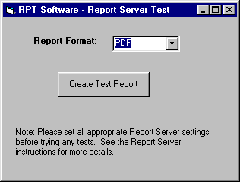
Please test out each format of report. When you create a test report the file will be saved in the report directory you specified in step 2. See the section, “Which PDF printer Driver should I use” later in this document for descriptions of how to configure the PDF printer driver if having trouble with PDF format. All other formats are created using built-in Microsoft Access functionality, if certain formats do not work you should look at how Microsoft Access is installed.

Install Step 4 – Register the ReportQ.DLL File
This step is different depending on whether you are using Windows NT4 or Windows 2000. Follow the set of steps for your particular operating system.
Windows NT4 | Windows 2000
- Start up Microsoft Management Console  Click Start/Programs/Windows NT 4.0 Option Pack/Microsoft Internet Information Server/Internet Service Manager  - Under the Microsoft Transaction Server Folder Right click on the Packages Installed folder and choose New/Package. The following screen should come up:  Create an empty package:  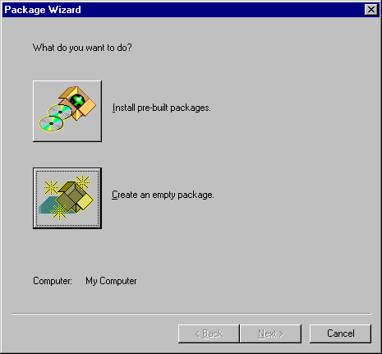 | - Goto Component Services  Click Start/Settings/Control Panel/Administartive Tools/Component Services  - Click on Create a new COM+ Application  - Right Click on COM+ Applications Folder and choose New/Application. The following screen comes up:  Choose Next  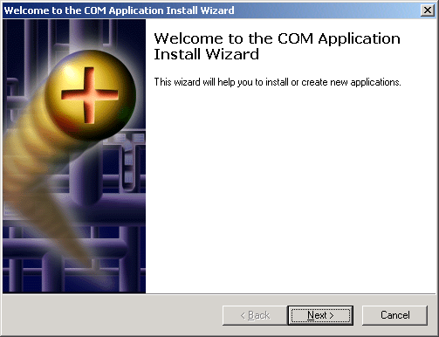  Create an empty application:  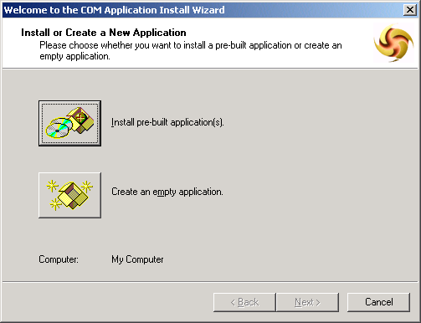

Step 4 – Windows NT4 (continued): | Step 4 – Windows 2000 (continued):
Type in whatever name you want to use for this package.  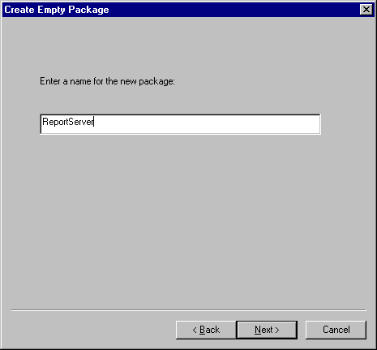  Specify whatever user you want this package to run under. Usually you would use a domain user that is a local administrator on this machine. Then click Finish.  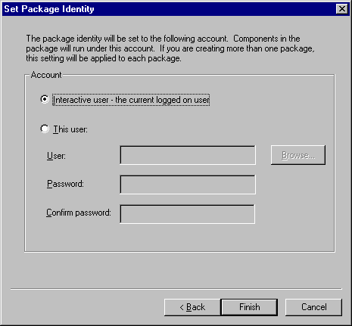 | Type in whatever name you want to use for the application, choose server application  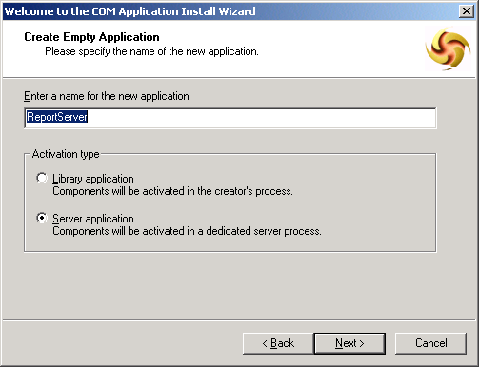  Specify whatever user you want this application to run under. Usually you would use a domain user that is a local administrator on this machine. Then click Next.  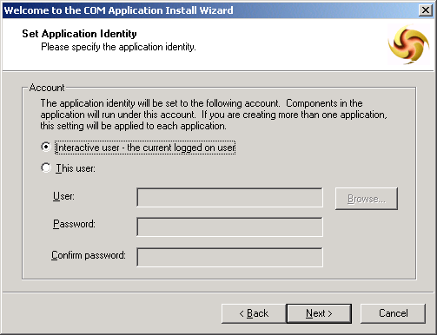  Click Finish  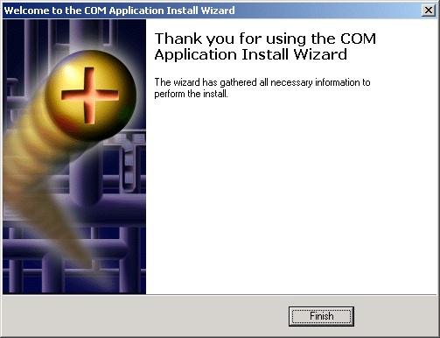

Step 4 – Windows NT4 (continued): | Step 4 – Windows 2000 (continued):
- Expand the package folder and Right click on the Components folder and choose New/Component. The following screen should come up:  Click on Install new component(s).  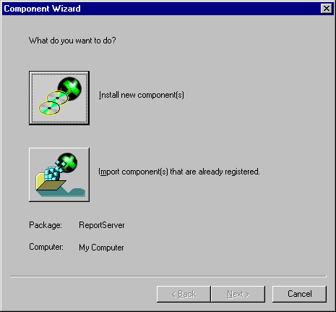  Click on the Add files… button and choose the ReportQ.DLL file. Then click Finish.  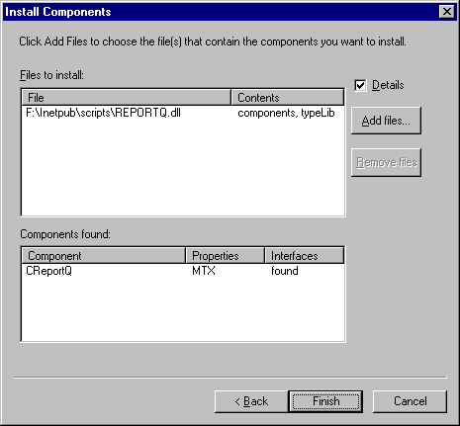 | Under the application you created (ReportServer in my example) right click on the components folder and choose New/Component  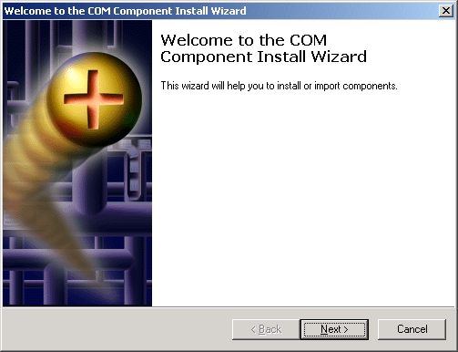  Pick Install new component  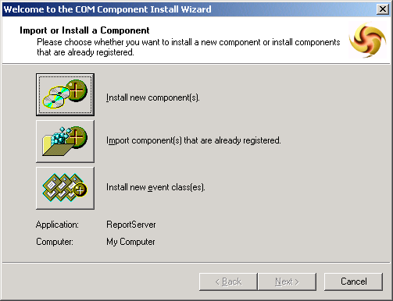  Add the ReportQ.DLL file  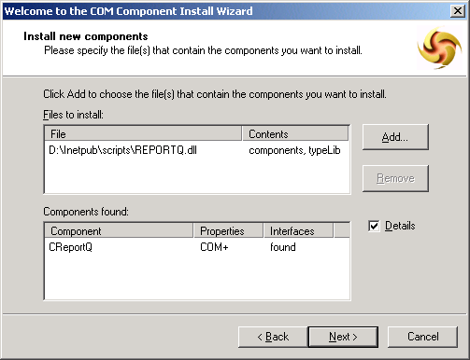  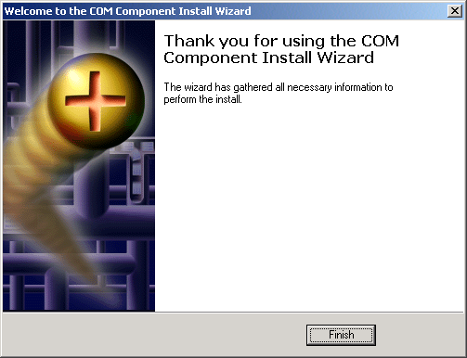

Examples
This section explains how to setup the RPT Software – Report Server examples. We only provide examples using ASP code (Active Server Pages), however this concept could work in almost any web environment. Please contact RPT Software if you would like to see other ways to generate reports without using ASP code.

- Copy the example files to your web server and setup the RPT Software – Report Server and ReportQ.DLL. See the above section Installation Instructions.
- Modify the rpt_display.asp page to specify the correct pathnames, default report format and report web directory.
Note: The ReportDirectory should match what you setup on the Reports.EXE settings page. For example directory F:\Inetpub\wwwroot\reports would be setup to be “/reports/”.
See the section:
'---------------------------------------------------------------------------
“Please change the following lines to the correct paths
'Note: All paths are assuming you are on the server (no mapped drives etc...)
TheQueuePath = "F:\InetPub\Scripts\reportqueue.mdb"
ExampleDatabasePath = "F:\InetPub\Scripts\rpt_example.mdb"
ArchiveDatabasePath = "F:\InetPub\Scripts\reportqueuearchive.mdb"
TheReportFormat = "PDF"
ReportDirectory = "/Reports/"
'---------------------------------------------------------------------------
- Modify rpt_queue.asp and change the line:
TheQueuePath = "F:\InetPub\Scripts\reportqueue.mdb"

ReportQ DLL Methods
The ReportQ DLL is setup to be a server-side component and has the following methods.

Make Report Method
Used to create a report, when report is complete a string is passed back with either the report name or a description of the error that occurred. Errors always start with the text “Report Error:”
MakeReport Parameters:
- QueuePath The full path of the reportqueue.mdb database
- DatabasePath The full path of the database which holds the Access report
- Reportname The name of the Access report
- QueryName The name of the Access query
- QueryText The text of the query, or the where clause you want to use
- ReportFormat The format of the report (PDF, RTF, XLS, RAW or SNP)
- P1 Optional parameter to pass in data you want to track
- P2 Optional parameter to pass in data you want to track
- P3 Optional parameter to pass in data you want to track
- P4 Optional parameter to pass in data you want to track
- P5 Optional parameter to pass in data you want to track
- P6 Optional parameter to pass in data you want to track
- P7 Optional parameter to pass in data you want to track
- P8 Optional parameter to pass in data you want to track
- P9 Optional parameter to pass in data you want to track
- P10 Optional parameter to pass in data you want to track
MakeReport Examples:
See the ASP examples for detailed examples of the many ways to call the MakeReport method.
- Simple example of calling a report with no criteria:
- QueuePath is always required (example: “d:\Inetpub\scripts\reportqueue.mdb”)
- DatabasePath is always required (example: “d:\Inetpub\scripts\rpt_example.mdb”)
- Reportname is always required (example: “rptRevenueForecast”)
- Queryname set to empty string since it is not needed (“”)
- QueryText set to empty string since it is not needed (“”)
- ReportFormat set to either “PDF”, “RTF”, “XLS”, “RAW”, or “SNP”
- Calling a report with a simple WHERE clause to specify criteria for the report:
Same as above example except specify the WHERE clause using the QueryText parameter
Example: “WHERE Salary > 50000”
Note: always include the word “WHERE”

- Calling a report and basing the report on a query created on the fly:
Same as the first example except now you have to specify both a Queryname and QueryText. Where Queryname is the name of your Access query and QueryText is the full SQL of the query to be used.

- Calling a report based on data from another database system:
Approach #1: Use a Pass Thru query to call a stored procedure and build the Querytext at runtime
Example: “Exec proc_mystoredprocedure State = ‘PA’, City = ‘Pittsburgh’”
Approach #2: Use linked tables and call Makereport as normal

- Calling a report that uses more than one query and has subreports

Same as example #3 from above except specify multiple querynames and multiple querytext values. Use the delimiter setup under the Report Server settings between each of these values.

GetQueueSize (ByVal QueuePath As String) As Integer
This method is passed the path of the reportqueue.mdb database and it returns the number of active report requests that are waiting to be completed. This method can be used before calling MakeReport() to determine if there are too many users waiting for report requests. Where you would return a simple message to the user such as “The server is too busy right now, please come back later.”

Tip #2: When beginning to use the RPT Software – Report Server product many people are unsure of how much activity the reports they are building will receive and how scalable of a solution is required. You can pass in the value returned by GetQueueSize() to the MakeReport() method as one of the optional parameters. Then after using the product for a week, month or many months check to see what the average number of reports that a user has to wait for is. Please contact RPT Software if our solution does not meet your scalability needs for help with possible other solutions.

WriteQueueHTML (ByVal QueuePath As String, ByVal NumOfRecs As Integer) As String
This method is passed the path of the reportqueue.mdb database and a number and then returns an HTML string of what the report queue looks like for those last report requests.

ArchiveQueue (ByVal QueuePath As String) As Integer
This method is passed the path of the reportqueue.mdb database and returns an integer either 1 for success or 0 for failure. It archives all completed report requests in the Reportqueue.mdb file to the reportqueuearchive.mdb database. This helps for two reasons, one it makes the table in reportqueue.mdb have less records so methods like GetQueueSize run a little faster and two it makes it easier to do reporting from a separate database such as reportqueuearchive.mdb. We recommend that you put all your usage statistic reports in this database and just archive the queue when needed to display these reports.

Which PDF Printer Driver Should I use

Our software supports both the Adobe PDF Writer printer driver (http://www.adobe.com) and the Win2PDF printer driver (http://www.win2pdf.com). While both printer drivers will work with our product to produce PDF output they do have some differences.

Adobe PDF Writer – Pros and Cons
Pros | Cons
- Adobe PDF Writer comes with the Adobe Acrobat package so you might already own this driver. Adobe is also the owner and creator of the PDF format so this driver should work as well as any third party printer driver. | - Does not work on a server which is locked (Ctrl/Atl/Del – Lock Workstation)  - More expensive when purchased separately

Win2PDF – Pros and Cons
Pros | Cons
- Does work on a locked server  - Cheaper  - Seems a little faster. However we haven’t done extensive testing comparing the two, just some initial observations on Access reports we have used with both printer drivers. | - Needs one change to the default settings:  Go to the property pages on the scheduling tab and change the setting in the middle to “Print directly to the printer”  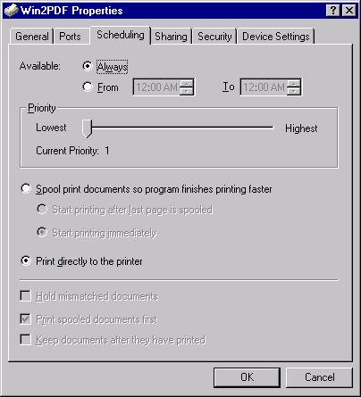
Note: The RPT Software – Report Server produces PDF files by setting the appropriate registry settings and then printing to the default printer. You must leave the PDF printer driver you installed set as the default printer. If you have another printer set as the default our software will print to that printer instead of creating a PDF file. Also our software is only designed to produce PDF files on Windows NT or Windows 2000 servers. On Windows 95/98/ME the Adobe printer driver expects changes to the Win.ini file instead of the registry and the Win2PDF does not work on these operating systems.

How to get your own reports working
Once you have tried the example asp pages you can easily make modifications to these pages to get your own reports up and running. One simple strategy we recommend when building a reporting system is to make the system driven off of metadata in some way or another. This way you can extend the system when you want to add more reports without changing the ASP code each time. For example, have one table which holds the meta data about the system where each row represents a report. For example:

ReportName | Report description | QueryName | PromptFor  DateRange | Prompt For Salary | Default Salary
rptExample | Employee Salary Report | QryExample | 0 | 1 | 40,000
rptExample2 | Revenue Forecast Report | QryExample2 | 1 | 0 | 0
rptExample3 | Sales Activity Report | QryExample3 | 1 | 0 | 0

Your reporting system can then consist of three main pages:
- Index.asp – Display the report names for the user to select (either in a straight list or list box or series of combo boxes using grouping (Summary reports, Detailed reports, etc…)
- Report_Criteria.asp – Displays the appropriate criteria for the selected report by looking at the metadata table and displaying the appropriate text boxes, combo boxes etc….
- Report_Display.asp – builds the query text or where clause based on the criteria and calls the makereport() method and displays the report to the user

Contact RPT Software for more ideas on ways to build your ideal reporting system.

What’s New in Version 2.0
For version 2.0 we changed a good portion of the software. The following new functionality is now available:
- We changed the DLL used by your active server page interface to get rid of the properties and just have methods. We also made it work with Microsoft Transaction Server on NT and work with COM+ on Windows 2000.
- The MakeReport() method now supports the ability to specify the entire querytext in addition to Where clause support. Where clauses should be passed in with the word WHERE to distinguish that it is just a where clause. Also you can now pass in multiple querytext strings to build multiple queries dynamically to drive a report with multiple subreports. In addition you can now pass in the report format which gives the product more flexibility. Also we added 10 extra optional parameters which let you pass in any type of data for use during statistical tracking (see ArchiveQueue()).
- The WriteQueueHTML() method now lets you pass in a number to specify how many records to return.
- The ArchiveQueue() method is new and lets you archive the report requests to a separate database for statistical tracking of what reports have been generated, how often, by who, etc…. You can use the 10 extra parameters available in MakeReport to pass in whatever information you need for statistical tracking reports.
- We changed all the examples to make them extremely simple and to require a very small database so the evaluation download was small.
- We improved the amount of documentation. This document being the main source.
- We added a test button to test out the functionality of the Report Server. This makes it easy to see if this portion is working correctly.
- We added the ability to work with the Win2PDF printer driver and extended out product to work with the latest version of the PDFWriter printer driver from Adobe.
- We added more report formats. Excel, Snapshot and Excel Raw data being the new formats.
- We changed the Report Server to always start when the program is run. This helps with making it automatically startup after server reboots.
- We added an option to startup the program minimized.
- We made the program when minimized display in the system tray area.
Bugs fixed:
- The EXE now sleeps 0.4 seconds between each poll of the reportqueue. This stops the server from always showing 100% resources. A minor bug we had in version 1.0.
- A where clause that used single quotes would crash version 1.0. The simple fix was to use two consecutive single quotes. This has been fixed in version 2.0 and you should now just pass in the where clause of querytext exactly like it need to be in Access.

Reference
RPT Software: http://www.rptsoftware.com

