ChemOffice Enterprise

TableEditor

Revision History
Date | Revision | Description | Contributors
06/04/2008 | v.1 | Initial draft | David Gosalvez
06/20/2008 | v.2 | Refined the object model | David Zhang/Jerry Yu/Ran Tao
06/26/2008 | v2.1 | Refined the object model | David Zhang/Jerry Yu/Ran Tao
07/07/2008 | V2.2 | Modified and created xml’s | David Zhang/Jerry Yu/Ran Tao
07/10/2008 | V2.2.2 | Using tables in regdb as sample | David Zhang/Jerry Yu/Ran Tao
07/15/2008 | V2.2.3 | Changed default sequence name | David Zhang/Jerry Yu/Ran Tao
07/17/2008 | V2.2.4 | sequence name property | David Zhang/Jerry Yu/Ran Tao

Copyright © 2008 CambridgeSoft Corporation. Cambridge, Massachusetts.
All Rights Reserved

This document is the property of CambridgeSoft Corporation and is intended for internal use only. Reproduction or transmission of this document in any form, in whole or in part, without prior written permission of CambridgeSoft Corporation is prohibited.

Overview:
ChemOffice Enterprise applications such as Registration, Inventory, or ChemBioViz make use of database tables whose data must be managed by the application administrator. For example, the Registration system has tables for Projects, Notebooks, Sequences, and Fragments. The Inventory system has tables such as Suppliers, Units of Measure, and Container Types. These tables need to be populated with appropriate customer specific values. In the past, each application has implemented its own graphical user interface to manage the data in this type of tables.

The COETableEditor is a new generic table management interface that can be used by any ChemOffice Enterprise application to populate and maintain simple database tables.

Requirements
- The graphical user interface of the COETableEditor must be implemented as ASP.NET pages or reusable controls that can be easily accessed from other ASP.NET applications.
Has been implemented as a control.
- The editor will only be able to access a configurable list of tables from each application.
- The editor will only be able to access a configurable list of columns within each editable table.
- Columns will be configurable to allow displaying translated (lookup) values.
- Lookup values could come from a related database table or from a hardcoded list of values in the configuration.
To support both or either?
We need to support both.
Refer to lvStructures.xml at the end of the document.
- Columns containing chemical structure data will be displayed and edited using the ChemDraw Plugin.
- Editable date columns will be displayed and edited using a calendar control.
- The table editor will use a configurable sequence to generate primary key values for new rows inserted into an editable table.
How will this sequence be configured? From UI?
A sequence name given in the configuration file. No need for UI configuration.
Discussed further below.
- Foreign key values will be displayed and edited using values from the related table.
Problem:
As to editing, if the translated value of the lookup field duplicates, the table editor would not always target the value right. For example:

Main table

 | Lookup field value | lookup field translated
4001 | 101 | AABB

Lookup table
ID | Translation
101 | AABB
102 | AABB

When all the translations are shown, then (when editing this field from the editor) if we want to change ID to 101, we would not know which AABB is the right one we should choose; when we show only distinct translation, then we would not show 102, thus we would never be able to edit the value to 102.
Lookup lists should in general not contain duplicate display values, but if they do, both values should be displayed. Show all display values, not just distinct ones.

The COETableEditor will be written using the CSLA design principles. First a set of movable business objects will be created to handle all configuration, validation, and data persistence operations. Then a set of graphical user interface elements will be created to mediate between the user input and business objects. The business objects to support the COETableEditor user interface will be implemented in the ChemOffice Enterprise Framework using the namespace:

CambridgeSoft.COE.Framework.COETableEditorService

Object Model

These objects will be used by the COETableEditor user interface to perform it tasks.

COETableEditor and COETableEditorData are in CambridgeSoft.COE.Framework.Common namespace.
COETableEditorBO and COETableEditorBOList are in COETableEditorService namespace.

COETableEditor

This object implements Microsoft.Practices.EnterpriseLibrary.Common.Configuration.NamedConfigurationElement to read table configuration information from the configuration file.
This object represents the table configuration information required by the COETableEditor to handle the editing tasks for database tables. Configuration information includes:

name: Table name
Description: Table description
PrimaryKeyField: Primary key
SequenceName: Sequence name

How primary key values should be generated
The primary key value is generated by a sequence named + "SEQ_"+_COETableEditorTableName. If the sequence already exists, the existed one will be used. If not, it will be created automatically with the increment as 1.
The name of the sequence should be read from the configuration file. Use “SEQ_”+_COETableEditorTableName only if no specific sequence name is provided in the configuration file.

The system administrator understands whether the edited table has a sequence and/or trigger associated with it and should be able to configure the editor to either use the sequence or leave the pk blank so that the trigger can fill its value. The configuration should therefore allow for a sequence name to be set. If no sequence name is set, then the editor will simply not populate the pk value and asume that it is handled by the database.

- Leave out SequenceName or set SequenceName=”” when you have a trigger taking care of PK.
- Set SequenceName=”sequecename” when you don’t have the trigger, Table Editor then takes care of PK and if the sequence does not exist, Table Editor will create it.

COETableEditorData

This object implements Microsoft.Practices.EnterpriseLibrary.Common.Configuration.NamedConfigurationElement to read table’s column configuration information from the configuration file.
This object represents the column configuration information required by the COETableEditorData to handle the editing tasks for tables. Configuration information includes:

name: Column names
dataType: Column data types
ValidationRule: Column validation rules
IsStructure: Is column value structure?
Judged by function IsCDXField, which looks for the column name in table cscartridge.all_csc_indexes. If found, it is structure (and is indexed), if not found, it is not. So structure column must be indexed..
The editor should support structure columns that are not indexed. Rather than trying to autodiscover via all_csc_indexes, the editor should rely on explicit configuration information.
StructureType: Structure data type
Would the structures be in a format other than base64_cdx? If positive, then how would ChemDraw control deal with it? Currently only structures in base64_cdx can be shown in ChemDraw in COETableEditor.
We need to support all formats supported by the CS Cartridge (B64CDX, CDXML, CDX, MOL, SMILES). The ChemDraw ActiveX is capable or rendering all these formats. We may need to make enhancements to the ASP.NET ChemDraw Embed control to support other formats.
LookupLocation; Lookup location
LookupLocation determines the location to find lookup values.
When lookup values are from table in database, LookupLocation should be set to “database”; when lookup values are from hard coded xml file, LookupLocation should be set to the xml file name preceding with its exact path info. Refer to the xml file.

LookupID: Lookup ID
LookupField: LookupField
IsStructureLookupField: IsStructureLookupField

Both above object namespace is CambridgeSoft.COE.Framework.Common
Additional property in ApplicationData.cs
/// <summary>
/// Gets the collection of defined <see cref="TableEditor"/> objects.
/// </summary>
/// <value>
/// The collection of defined <see cref="TableEditor"/> objects.
/// </value>
[ConfigurationProperty(tableEditorProperty, IsRequired = false)]
public NamedElementCollection<COETableEditorConfig> TableEditor
{
get { return (NamedElementCollection<COETableEditorConfig>)base[tableEditorProperty]; }
}

COETableEditorBO

This object represents a record of a COETableEditor editable table.

This object is implemented CSLA base business object including data portal methods to read/write table data from/to the database. The object is responsible for generating the necessary SQL (or PL/SQL) calls to be executed via the COEFramework DAL architecture. The object would be responsible for validation of input data.

COETableEditorBOList

This object is implemented CSLA BusinessListBase<T,C>
T is COETableEditorBOList,
C is COETableEditorBO

This object is implemented as a CSLA list object to hold a list of COETableEditorBO objects. The criteria to create the list of objects initially support creating a list of all editable tables for a given COE Application.

Class Diagram:

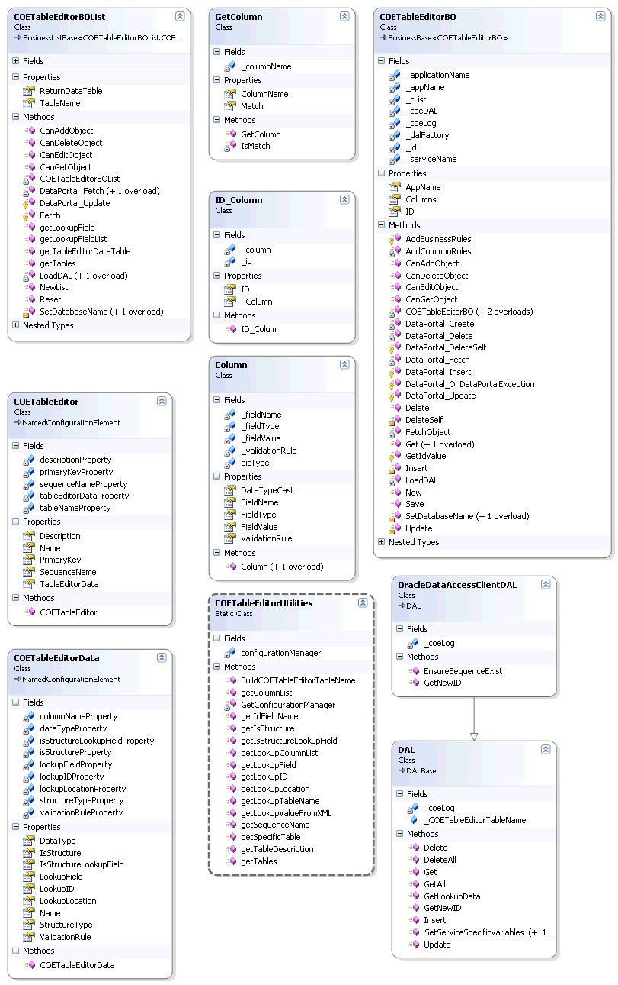

GUI Design

Use WebGrid to represent data as the asp version did.
Should the display of translated (lookup) values implement paging?
I don’t understand this question.
Ran,

I'll try to answer your question regarding "paging of lookup values". I am still not sure I fully understand it yet, but I'll try.

Lookup values come into play in two different contexts.

1. When viewing the editable table data, some columns will display a lookup rather than an internal value. This means that each row in a lookup column will display a single value from the lookup table so there is no need for paging here.

2. When Editing or Entering data on a lookup column, the application should display a dropdown of allowed lookup values. This dropdown should contain all possible lookup values. There does not need to be any paging capability over the lookup value list.

Has your team commited any of their code to Perforce yet? I would like to start reviewing the progress directly. Please let me know when I can look over it.

David

The graphical user interface for the table editor must be implemented in ASP.NET. It may be encapsulated into a user control, a server control, or simply be one or more dependent ASP.NET pages. The only requirement is that the entire editor be easily re-usable from other applications or application modules capable of presenting the user with a web browser or web browser control.

The table editor typically operates within the context of the application that uses it. The application configuration describes the list of editable tables, fields, and lookups.

The user must be able to accomplish the following tasks via the editor GUI:

- Select a table to edit
- View the first few (between 10 and 50) rows of the table to edit (including all editable columns).
- Page through the table rows.
- View chemical structure columns in ChemDraw Plugin
- Sort the table rows by any column (except structure).
- Edit one or more values within any row.
- Delete an entire row.
- Add a new row.

Below is an example of our existing table editor, written in classic asp. The existing one has the following limitations that should be overcome by the new one:

- Displays the entire table (does not allow paging)
- Does not allow sorting.
- Does not display or edit chemical structures
- Does not allow for translated (lookup) values to be shown.
- Does not hide non-editable fields, such as primary keys.
- Does not display picklist (lookup) values during data entry and edit.

Dialog #1: Select Table to be edited:

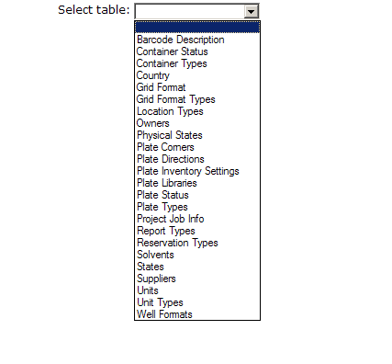
Dialog 2: View the data; Add a row, Delete a row, Drill down to edit

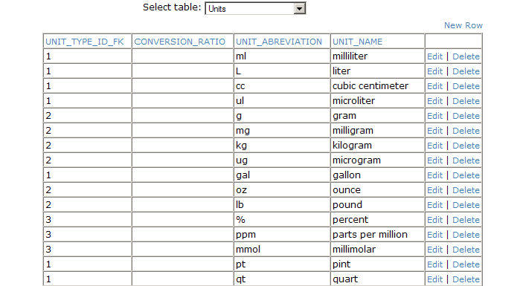

Dialog 3: Edit a selected row

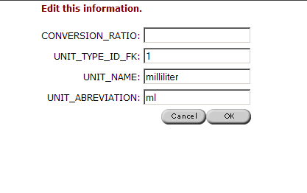

Dialog 4: Confirm row deletion:

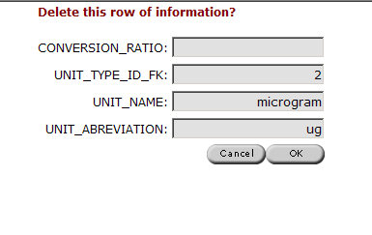
Dialog 4: Enter new row information:

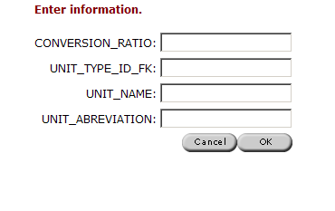

The requirements of the new COETableEditor can best be met by using standard functionality available in the Infragistics WebGrid and related ASP.NET controls. Complex functionality such as paging, sorting, in-place-editing, multiple simultaneous row edits, date pickers, etc… are provided natively by the Infragistics controls.

For an example of an application using an Infragistics grid to add/edit/data see:

http://samples.infragistics.com/2008.1/webshowcase/portfoliomanager/default.aspx

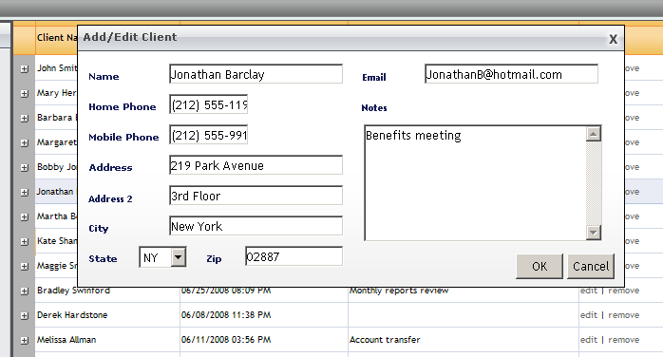

This example uses an “edit template” to edit the contents of an entire row at once. This may be an option for the COETableEditor but keep in mind that the actual fields that make up the row are not known at design time. They are defined the in configuration of the editor. This means that the “edit template” layout and behavior would need to be dynamically generated from configuration information.

Another example uses individual field editors so that cells are editable one at a time:

http://samples.infragistics.com/2008.1/webshowcase/appstyling/default.aspx

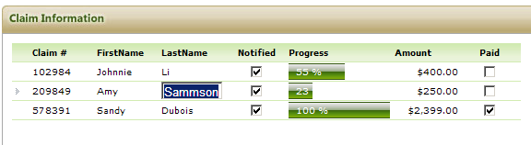

This approach may be simpler than the “edit template”, but may not be suitable for all fields (for example chemical structure editing in ChemDraw). Also note that a decision would need to be made as to whether each field edit would cause a postback to save data to the database or whether several edits could be saved at once.

There are may other examples of sophisticated database table editing scenarios in the Infragistics documentation. The main complexity in our implementation will be:

- Generalize the editor so that it can handle any table with unknown number or columns and column types.
- Drive the behavior of the grid from configuration data
- Implement a way to edit the chemical structures using the ChemDraw control.
- Have the GUI controls interact with CSLA business objects (CSLA data source) rather than directly with the database.

Actual GUI design information and screen shots

A dropdown for selecting a table:
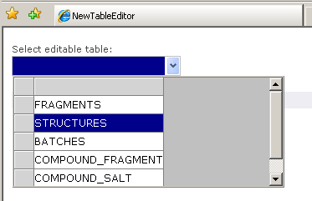

A WebGrid showing paged rows of the table with lookup value: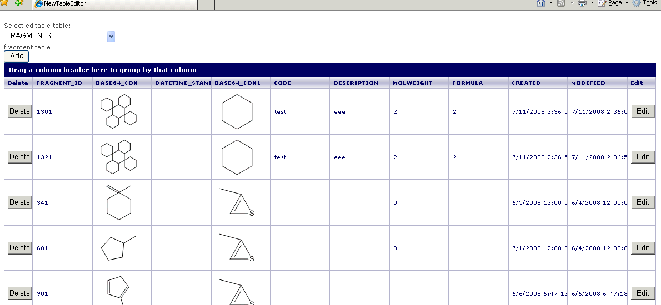

A panel for updating/adding a record, with lookup values that can be selected from a dropdown list:
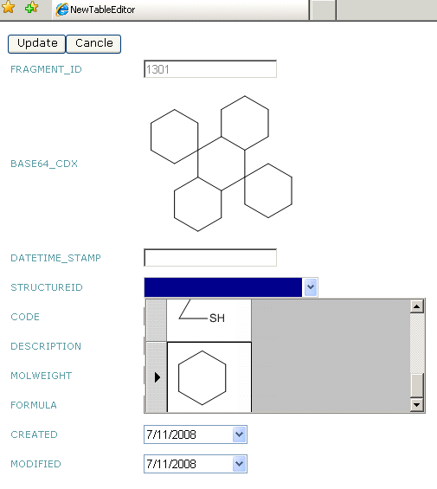

Configuration

As described above, the COETableEditor is driven by configuration data. This data will be initially stored in the COEFramework.config. The COETableEditorService business objects are responsible for reading this configuration data.

This section describes the current semantics of the table editor configuration data. The details of this configuration section may be changed as part of the new COETableEditor design. For example, it may be desirable to reorganize the data into a custom xml schema that can be read with a custom configuration section handler, rather than using the generic configuration section handler that forces the use of the much less intuitive “<add> tag” syntax.

<applications>
- <add name="REGISTRATION" database="REGDB">
- <tableEditor>
- <add name="FRAGMENTS" Description="" PrimaryKeyField="FRAGMENT_ID" SequenceName="" FieldToShow="FRAGMENT_ID">
- <tableEditorData>
<add name="FRAGMENT_ID" dataType="int" />
<add name="BASE64_CDX" dataType="string" IsStructure="true" StructureType="BASE64_CDX" />
<add name="DATETIME_STAMP" dataType="string" />
<add name="STRUCTUREID" dataType="int" LookupLocation="database" LookupID="STRUCTURES.CPD_INTERNAL_ID" LookupField="STRUCTURES.BASE64_CDX" IsStructureLookupField="true" StructureType="BASE64_CDX" />
<add name="CODE" dataType="string" ValidationRule="" />
<add name="DESCRIPTION" dataType="string" />
<add name="MOLWEIGHT" dataType="int" />
<add name="FORMULA" dataType="string" />
<add name="CREATED" dataType="date" />
<add name="MODIFIED" dataType="date" />
</tableEditorData>
</add>
- <add name="STRUCTURES" Description="Compound Structures" PrimaryKeyField="CPD_INTERNAL_ID" SequenceName="" FieldToShow="MOL_ID">
- <tableEditorData>
<add name="CPD_INTERNAL_ID" dataType="int" />
<add name="BASE64_CDX" dataType="string" IsStructure="true" StructureType="BASE64_CDX" />
<add name="MOL_ID" dataType="int" ValidationRule="" />
<add name="LOAD_ID" dataType="string" />
<add name="DATETIME_STAMP" dataType="string" />
</tableEditorData>
</add>
</tableEditor>
</add>
</applications>

How validation rules will be given?
TBD. We already have some xml syntax and related code to manage validation rules. We will incorporate this into table editor eventually. Details will be determined in the future.

lvStructures.xml: a hardcoded list of values as an xml file.

<?xml version="1.0" encoding="utf-8" ?>
- <!--
THIS FILE IS AN ALTERNATIVE WAY TO PROVIDE LOOKUP VALUE
-->
- <table name="Structures">
- <row>
<CPD_INTERNAL_ID DataType="int">11</CPD_INTERNAL_ID>
<BASE64_CDX DataType="string">VmpDRDAxMDAEAwIBAAAAAAAAAAAAAACAAAAAAAMADwAAAENoZW1EcmF3IDExLjAI ABMAAABVbnRpdGxlZCBEb2N1bWVudAQCEADtxOX/TSL/////AwCZfSgAAQkIAAAA AAAAAAAAAgkIAAAAhwAAAIcADQgBAAEIBwEAAToEAQABOwQBAABFBAEAATwEAQAA DAYBAAEPBgEAAQ0GAQAAQgQBAABDBAEAAEQEAQAACggIAAMAYADIAAMACwgIAAQA AADwAAMACQgEADOzAgAICAQAAAACAAcIBAAAAAEABggEAAAABAAFCAQAAAAeAAQI AgB4AAMIBAAAAHgAIwgBAAUMCAEAAAIIEAAAACQAAAAkAAAAJAAAACQAAAMyAAgA ////////AAAAAAAA//8AAAAA/////wAAAAD//wAAAAD/////AAAAAP////8AAP// AAEkAAAAAgADAOQEBQBBcmlhbAQA5AQPAFRpbWVzIE5ldyBSb21hbgGACwAAAAQC EAAAAAAAAAAAAAAA0AIAABwCFggEAAAAJAAYCAQAAAAkABkIAAAQCAIAAQAPCAIA AQADgAkAAAAEAhAA7cTl/00i/////wMAmX0oAASAAQAAAAACCAAAAAAAAAAAAAoA AgACAAEDBAADAAAANwQBAAEAAASAAgAAAAACCADtBOb/AAAPAAoAAgADAAEDBAAD AAAANwQBAAEAAASAAwAAAAACCAAAAAAAAAAeAAoAAgAEAAEDBAADAAAAAgQCABAA KwQCAAEANwQBAAEGgAAAAAAAAggAZuYDAACkGgAEAhAAEnH7/wCkGgD//wMAmX0o AAEDBAADAAAAIwgBAAACBwIAAAAFBwEAAQAHDgABAAAAAwBgAMgAAwBTSAAAAAAF gAUAAAAKAAIABQABAwQAAwAAAAQGBAABAAAABQYEAAIAAAAKBgEAAQAABYAHAAAA CgACAAcAAQMEAAMAAAAEBgQAAQAAAAUGBAADAAAACgYBAAEAAAAAAAAAAAAA</BASE64_CDX>
<MOL_ID DataType="int">321</MOL_ID>
<LOAD_ID DataType="string">7</LOAD_ID>
</row>
- <row>
<CPD_INTERNAL_ID DataType="int">12</CPD_INTERNAL_ID>
<BASE64_CDX DataType="string">VmpDRDAxMDAEAwIBAAAAAAAAAAAAAACAAAAAAAMADwAAAENoZW1EcmF3IDExLjAI ABMAAABVbnRpdGxlZCBEb2N1bWVudAQCEADck+H/TSL/////AwBmSiEAAQkIAAAA AAAAAAAAAgkIAAAAhwAAAIcADQgBAAEIBwEAAToEAQABOwQBAABFBAEAATwEAQAA DAYBAAEPBgEAAQ0GAQAAQgQBAABDBAEAAEQEAQAACggIAAMAYADIAAMACwgIAAQA AADwAAMACQgEADOzAgAICAQAAAACAAcIBAAAAAEABggEAAAABAAFCAQAAAAeAAQI AgB4AAMIBAAAAHgAIwgBAAUMCAEAAAIIEAAAACQAAAAkAAAAJAAAACQAAAMyAAgA ////////AAAAAAAA//8AAAAA/////wAAAAD//wAAAAD/////AAAAAP////8AAP// AAEkAAAAAgADAOQEBQBBcmlhbAQA5AQPAFRpbWVzIE5ldyBSb21hbgGACwAAAAQC EAAAAAAAAAAAAAAA0AIAABwCFggEAAAAJAAYCAQAAAAkABkIAAAQCAIAAQAPCAIA AQADgAkAAAAEAhAA3JPh/00i/////wMAZkohAASAAQAAAAACCAAAAAAAAAAAAAoA AgACAAEDBAADAAAANwQBAAEAAASAAgAAAAACCADtBOb/AAAPAAoAAgADAAEDBAAD AAAAAgQCAAcAKwQCAAAANwQBAAEGgAAAAAAAAggAVOvp/wBoCwAEAhAA3JPh/wBo CwBU6+n/M5sSAAEDBAADAAAAIwgBAAACBwIAAAAFBwEAAQAHDQABAAAAAwBgAMgA AwBOAAAAAASAAwAAAAACCAAAAAAAAAAeAAoAAgAEAAEDBAADAAAAAgQCABAAKwQC AAAANwQBAAEGgAAAAAAAAggAZuYDAACkGgAEAhAAEnH7/wCkGgD//wMAZkohAAED BAADAAAAIwgBAAACBwIAAAAABw0AAQAAAAMAYADIAAMAUwAAAAAFgAUAAAAKAAIA BQABAwQAAwAAAAQGBAABAAAABQYEAAIAAAAABgIAAgADBgIAAgALBhAAAAAAAAcA AAAGAAAAAAAAAAAABYAGAAAACgACAAYAAQMEAAMAAAAEBgQAAgAAAAUGBAADAAAA CgYBAAEAAAWABwAAAAoAAgAHAAEDBAADAAAABAYEAAEAAAAFBgQAAwAAAAoGAQAB AAAAAAAAAAAAAA==</BASE64_CDX>
<MOL_ID DataType="int">22</MOL_ID>
<LOAD_ID DataType="string">4</LOAD_ID>
</row>
- <row>
<CPD_INTERNAL_ID DataType="int">13</CPD_INTERNAL_ID>
<BASE64_CDX DataType="string">VmpDRDAxMDAEAwIBAAAAAAAAAAAAAACAAAAAAAMADwAAAENoZW1EcmF3IDExLjAI ABMAAABVbnRpdGxlZCBEb2N1bWVudAQCEACPxd3/kOTx////AwBmSiEAAQkIAAAA AAAAAAAAAgkIAAAAhwAAAIcADQgBAAEIBwEAAToEAQABOwQBAABFBAEAATwEAQAA DAYBAAEPBgEAAQ0GAQAAQgQBAABDBAEAAEQEAQAACggIAAMAYADIAAMACwgIAAQA AADwAAMACQgEADOzAgAICAQAAAACAAcIBAAAAAEABggEAAAABAAFCAQAAAAeAAQI AgB4AAMIBAAAAHgAIwgBAAUMCAEAAAIIEAAAACQAAAAkAAAAJAAAACQAAAMyAAgA ////////AAAAAAAA//8AAAAA/////wAAAAD//wAAAAD/////AAAAAP////8AAP// AAEkAAAAAgADAOQEBQBBcmlhbAQA5AQPAFRpbWVzIE5ldyBSb21hbgGADQAAAAQC EAAAAAAAAAAAAAAA0AIAABwCFggEAAAAJAAYCAQAAAAkABkIAAAQCAIAAQAPCAIA AQADgAkAAAAEAhAAj8Xd/5Dk8f///wMAZkohAASAAQAAAAACCAAAAAAAAAAAAAoA AgACAAEDBAADAAAANwQBAAEAAASAAgAAAAACCADtBOb/AAAPAAoAAgADAAEDBAAD AAAAAAAEgAMAAAAAAggAAAAAAAAAHgAKAAIABAABAwQAAwAAAAIEAgAQACsEAgAA ADcEAQABBoAAAAAAAAIIAGbmAwAApBoABAIQABJx+/8ApBoA//8DAGZKIQABAwQA AwAAACMIAQAAAgcCAAAAAAcNAAEAAAADAGAAyAADAFMAAAAABIAKAAAAAAIIADJB 3v+xBfL/CgACAAgAAQMEAAMAAAA3BAEAAQAABYAFAAAACgACAAUAAQMEAAMAAAAE BgQAAQAAAAUGBAACAAAAAAYCAAIAAwYCAAIACwYQAAAAAAAHAAAABgAAAAsAAAAA AAWABgAAAAoAAgAGAAEDBAADAAAABAYEAAIAAAAFBgQAAwAAAAoGAQABAAAFgAcA AAAKAAIABwABAwQAAwAAAAQGBAABAAAABQYEAAMAAAAKBgEAAQAABYALAAAACgAC AAkAAQMEAAMAAAAEBgQAAgAAAAUGBAAKAAAACgYBAAEAAAAAAAAAAAAA</BASE64_CDX>
<MOL_ID DataType="int">41</MOL_ID>
<LOAD_ID DataType="string">3</LOAD_ID>
</row>
</table>

Tables should be configured in C:\Documents and Settings\All Users\Application Data\ChemOfficeEnterprise11\COEFrameworkConfig.xml. Refer to the one in Ds-tran\Framework\CambridgeSoft\ServiceTier\CambridgeSoft.COE.Framework\TableEditor\xml & doc\

When LookupLocation is “database”, the lookup field is from the table in database, else the value must be the hard coded xml file name with it exact path that used to get the lookup values.

Refer to lvStructures.xml in Ds-tran\Framework\CambridgeSoft\ServiceTier\CambridgeSoft.COE.Framework\TableEditor\xml & doc\ for the format of the hard coded xml file.

<applications>
<add name="REGISTRATION" database="REGDB">
- <tableEditor>
- <add name="FRAGMENTS" Description="fragment table" PrimaryKeyField="FRAGMENT_ID" SequenceName="">
- <tableEditorData>
<add name="FRAGMENT_ID" dataType="int" />
<add name="BASE64_CDX" dataType="string" IsStructure="true" StructureType="BASE64_CDX" />
<add name="DATETIME_STAMP" dataType="string" />
<add name="STRUCTUREID" dataType="int" LookupLocation="database" LookupID="STRUCTURES.CPD_INTERNAL_ID" LookupField="STRUCTURES.BASE64_CDX" IsStructureLookupField="true" StructureType="BASE64_CDX" />
<add name="CODE" dataType="string" ValidationRule="" />
<add name="DESCRIPTION" dataType="string" />
<add name="MODIFIED" dataType="date" />
</tableEditorData>
</add>
- <add name="STRUCTURES" Description="Compound Structures" PrimaryKeyField="CPD_INTERNAL_ID" SequenceName="">
- <tableEditorData>
<add name="CPD_INTERNAL_ID" dataType="int" />
<add name="BASE64_CDX" dataType="string" IsStructure="true" StructureType="BASE64_CDX" />
<add name="MOL_ID" dataType="int" ValidationRule="" />
<add name="LOAD_ID" dataType="string" />
<add name="DATETIME_STAMP" dataType="string" />
</tableEditorData>
</add>
</tableEditor>
</add>
<add name="ADMINISTRATION" database="REGDB" />
</applications>

