Database Publishing Service Requirements Specification

Table of Contents
Table of Contents 2
1. Introduction 3
1.1. Purpose 3
1.2. Scope 3
2. Database Publishing Service Overview 4
2.1. Proposed Implementation 4
2.1.1. User Interface Design 4
2.1.2. Functional Design 5
2.1.2.1. GetDatabase 6
2.1.2.2. PublishDatabase 6

- Introduction
  - Purpose
The purpose of the Database Publishing Service Requirements Specification document is to describe the role of the Database Publishing Service in the COE Framework. It also explains the methods used to implement the Database Publishing Service.

  - Scope
The scope of this document is to detail the Database Publishing Service of the COE Framework. It also covers the proposed implementation for the Database Publishing Service.
- Database Publishing Service Overview
The primary role of the Database Publishing Service is to design the schema of the databases in the predefined XML format (DataView), which is used by the various Service, such as Search service. There are two tasks that can be performed using the Database Publishing Service:

- GetDatabase: Gets the list of schemas/owners used by a service of COE Framework.
- PublishDatabase: Publishes the specified database into the predefined XML format.
  - Proposed Implementation

    - User Interface Design
The proposed user interface design for the Database Publishing Service is shown below:

Select Schema/Owner

The above figure shows the proposed user interface design for the Database Publishing Service that contains the Select Database drop-down list box and the Publish Database button. The Select Database drop-down list box contains the list of databases specified in the COEFrameworkConfig.xml file. Clicking the Publish Database button prompts you to enter the password for the selected owner. If the password specified by the user is correct, the DataView for the selected schema is generated. The resulting DataView will be added to the COEDataView table for that schema.

    - Functional Design

The proposed functional design for the Database Publishing Service is shown below:

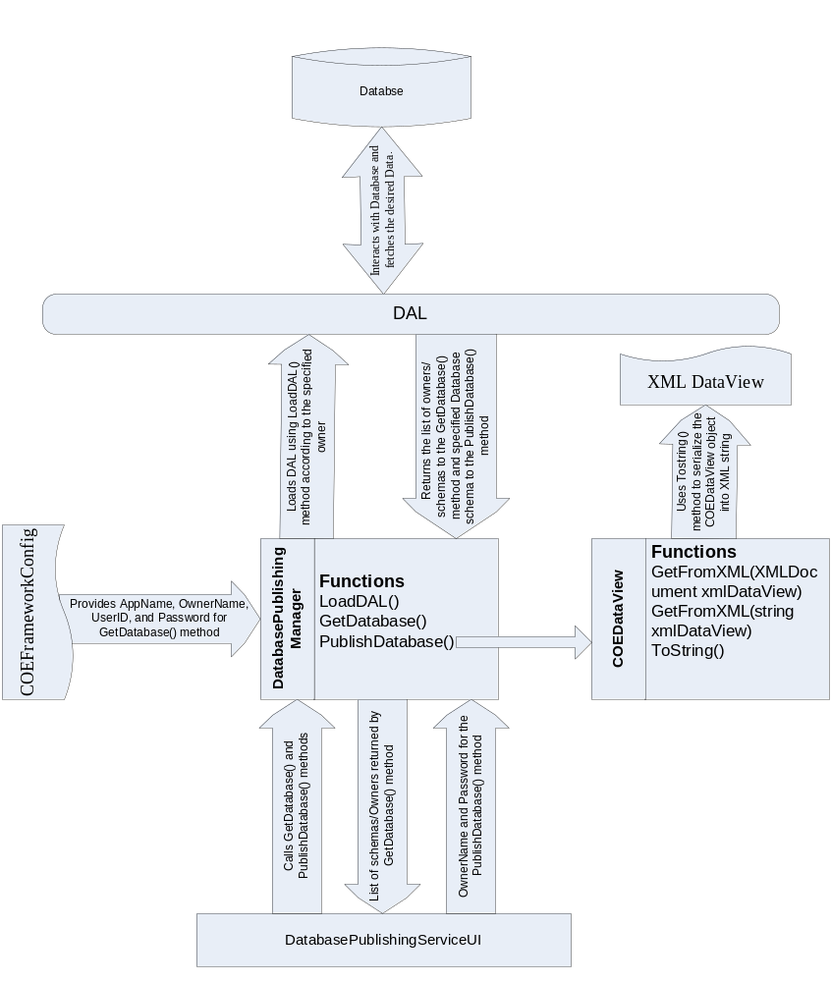

The Database Publishing Service is implemented in the COE Framework to design the XML schema for the databases. The service defines three classes to implement it. The class, DatabasePublishingManager, is defined in the Business Logic Layer (BLL) to implement the business logic of the service. The classes, DAL and OracleDataAccessClientDAL, are defined in the Data Access Layer (DAL) to interact with the database. The two main methods of the Database Publishing Service are:

      - GetDatabase
This method is defined in the DatabasePublishingManager class. It returns the list of schemas/owners. This method is called when the form is loaded.

      - PublishDatabase
This method converts the Database into the XML file known as DataView. It retrieves all the required details, such as column name, column type, constraints and relationships, from the database populates it into the Dataset, and then converts it into the XML file using the COEDataView class. This method is called when Publish Database button is clicked.

