ChemOffice Enterprise

FormDesigner

Revision History
Date | Revision | Description | Contributors
04/09/2008 | v.1 | Initial draft | Facundo Galdeano

Copyright © 2007 CambridgeSoft Corporation. Cambridge, Massachusetts.
All Rights Reserved

This document is the property of CambridgeSoft Corporation and is intended for internal use only. Reproduction or transmission of this document in any form, in whole or in part, without prior written permission of CambridgeSoft Corporation is prohibited.
Overview

FormDesigner is a web application that is meant to design a coeformgroup for a chembioviz gateway app. Chembioviz may be used as a standalone application or as an embed module for another application (like Inventory)
A typical workflow for designing a coeformgroup is the following:
- Choosing a dataview that was created and published by the schema manager, which is part of the ChemOfficeEnterprise Manager. (And that schema manager may be used also as an embed module for other applications)
- Selecting the tables that will be used.
- Choosing the fields, its order and the control to be used for each.
- Opting for one template for auto generating a coeform.

Once these steps were done, the user should be allowed for different kind of modifications.
- Add/Update/Delete Forms for each modality (Query-Detail-List)
- Add/Update/Delete Sub-Forms to the selected Form.
- Add/Update/Delete a FormElement.

Terminology

Form: A screen holding 1 or more sub forms. That screen is bound to a superset of information. (I.E.: a Data set).
Sub Form: A panel that is bound to its own data member. (I.E.: a Data table)
Form Element: A container of a control, with its own positioning information, that usually is bound to a field. (I.E.: a Data column)
Control Element: A web control for rendering the data of the formelement.

Design

ICOEGenerableControl interface needs to be updated with a property for specifying whether the control is currently in design mode (IsInDesignMode), so the control may render differently than in runtime.
This interface will also have a new method (GetConfiguratorContol) for getting the webcontrol for configuring its underlying control. That method will be used by the FormElement to be published to the FormDesigner.
A new interface is needed for being implemented by a control’s configurator. So each configurator would be a WebControl that implements the ICOEConfigurator interface. That interface needs to have two methods that are GetConfigInfo and SetConfigInfo for accessing the specific configuration information of the underlying control.

The static class diagram would be as follows:

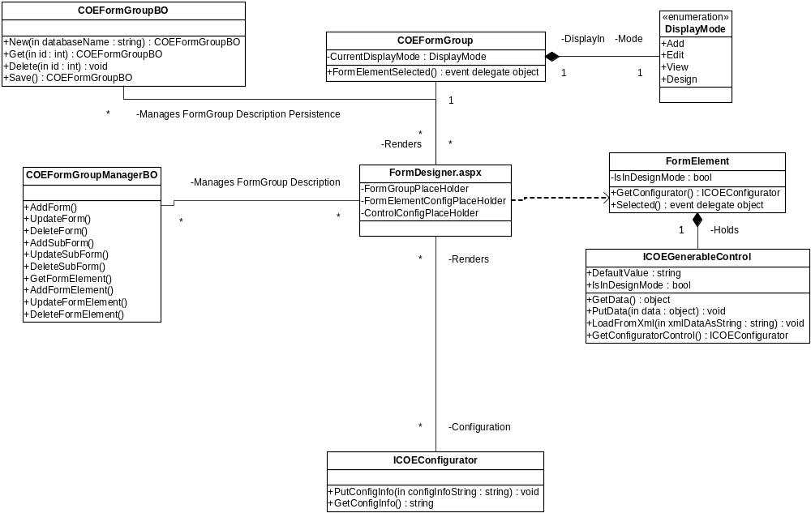

So, from the FormDesigner page perspective, the flow for configuring an existing control is:

- To get a COEFormGroup (Messaging type) through the COEFormGroupBO (Business object in charge of the persistence of that messaging type).
- To instantiate a COEFormGroup control (Web control) with the messaging type definition, and put it in Design Mode.
- To Register to the FormElementSelected event of COEFormGroup control
- When FormElementSelected is fired, the sender of the event handler will be a FormElement, so the page has to call the GetConfigurator Method of the FormElement, and has to add that control to a previously defined area of the page. That area needs an OK button and a CANCEL. Along with this, the page will need to save the formelement id for future reference.
- Then the page will retrieve the formelement’s xml snippet by asking for it to the COEFormGroupManager, and then will set that xml snippet to the configurator via the SetConfigInfo method.
- When OK is pressed the page has to call the GetConfigInfo method of the Configurator and then ask COEFormGroupManager to Update a FormElement with the formelement id

