COE Logging Service
Specification

Publication Record
Version | Date Revised | Primary Author | Description
1 | 11/21/2007 | L. Bialic | Initial version

1 Introduction 4
1.1 Purpose 4
1.2 Scope 4
1.3 Overview 4
2 Requirements 4
3 Functional Specification 4
3.1 Service Flow: 5
3.2 Class Diagram 6
3.3 Configuration 8
3.3.1 Client 8
3.3.2 Framework 8
3.3.3 Explanation of configuration. 9
4 Use Cases 10

Introduction

Purpose
This document describes the COE Logging service.

Scope
The scope of this document to detail the Logging Service.

Overview
The role of the Log Service is to provide a standard way to instrument the framework and calling client applications.

Requirements
The following are the requirements for the Logging Service
- Provide a logging framework that will server both client and server log requests
- Log events by user session
- Provide a filtering mechanism for determining
- Provide a standard template for output controlled by the framework
- Provide minimal configuration for client to contend with
- Provide a mechanism for client to retrieve all logging statements for it’s calls.
  - output that returns only information
relevant to the user session

Functional Specification
The logging service in general follows the command object COEFramework Service architecture. With the exception that there is no DAL within the service.
The logging service uses the enterprise library 2.0 logging application block to do the heavy lifting, but provides a simpler use for developers and allows both client and application server logging. The logging configuration is specified by the framework, but clients are able to turn logging on and off, specify the categories to log as well as the level/priority.

Service Flow:
The COELog object provides convenience methods for logging. The actually logging is done using the logging application block.
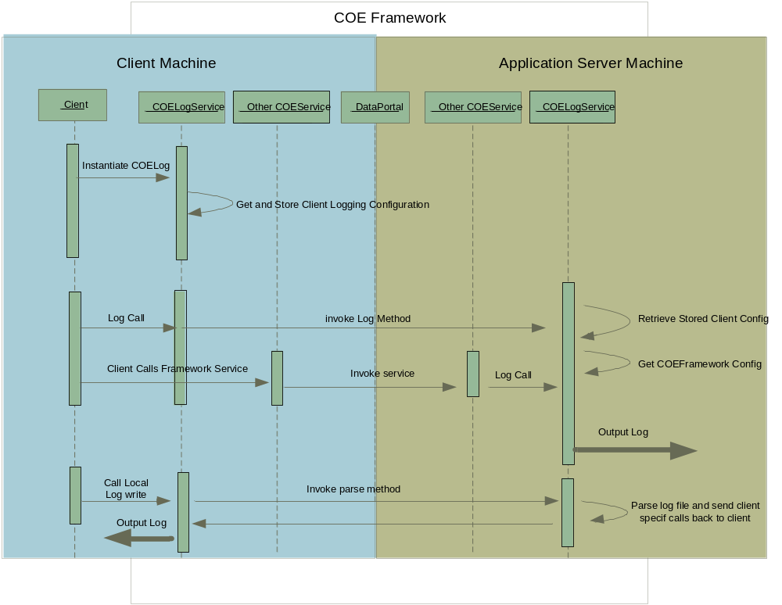

Class Diagram
Below is the class diagram for this service:
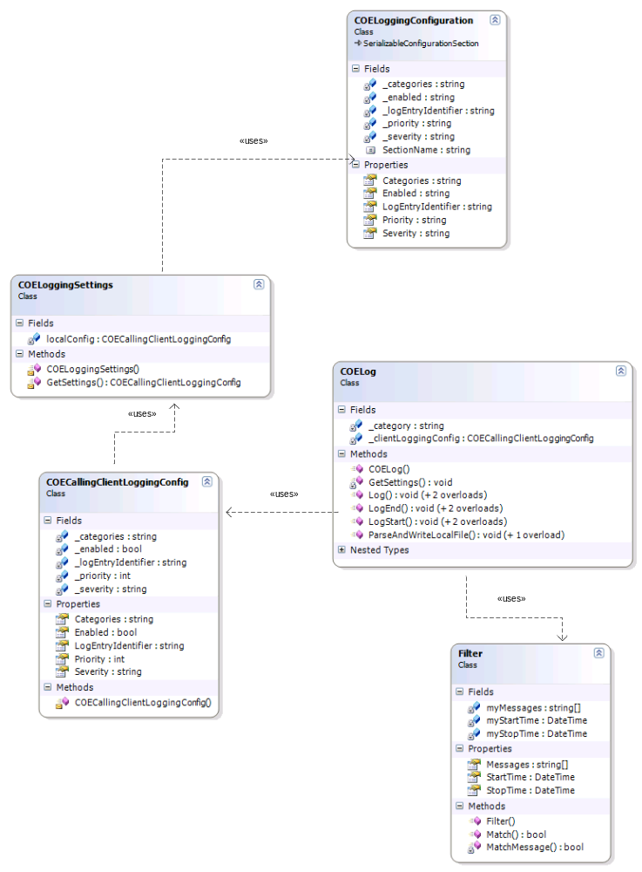

The public functions are contained in the COELog class. This is the class that clients will call and additionally this is the class that the framework calls.
Data Flow:
COELog must be instantiated by the client so that configuration can be gathered from the client applications default application configuration file. There are three classes involved:
COEFrameworkLogging: framework section handler, is used to access the values in the file.
COELoggingSettings: this is the class that calls the section handler.
COECallClientLoggingConfig: class that stores the configuration and is stored in csla global context for persistence.
NOTE: This information is stored in the COECallingClientLoggingConfig which is one step removed from the section handler. This is necessary because the section handler cannot be properly serialized due to the Enterprise Library configuration code classes not being serializable. Rather than change the enterprise library, a wrapper that is free of this restriction was created. The COECallingClientLoggingConfig is stored in CSLA global context so that it can be used by the application server. This is important for installations where the client and application server are on different machines.
Once the client instantiates COELog, they are free to use the log methods. In addition all log methods in the framework code will be logged when the category and priority set by the client is met.
The Log Methods are:
Log(message, priority): This is the main method that actually calls the dataportal and the logging applicaton block.
LogStart(message, priority): this simply appends “Start” to the information send to Log:
LogEnd(message, priority): this simply appends “End” to the information send to the log method.
Overloads have an addition parameter, severity. This is a System.Diganositcs enum that changes the amount of output.

An additional method, ParseAndLogLocally is present for clients to retrieve logging statements from the framework configuration file. This is useful in 3-tier mode since the framework configuration file may be on a machine that the client is unable to access.

Configuration
Both client and framework must include configuration information in their respective configuration files.

Client
Client configuration is handled by the COELoggingConfiguration section handler in framework.
In addition to the section handler, a reference to the enterprise logging handler must be specified so that the actual logging configuration will be gathered from the COEFrameowrkConfig.xml file.
<configSections>
<section name="enterpriseLibrary.ConfigurationSource" type="Microsoft.Practices.EnterpriseLibrary.Common.Configuration.ConfigurationSourceSection, Microsoft.Practices.EnterpriseLibrary.Common, Version=2.0.0.0, Culture=neutral, PublicKeyToken=6579c5fdfc419d72" />
<section name="coeLoggingConfiguration" type="CambridgeSoft.COE.Framework.Common.COELoggingConfiguration, CambridgeSoft.COE.Framework, Version=11.0.0.0, Culture=neutral, PublicKeyToken=1e3754866626dfbf" />
</configSections>
<enterpriseLibrary.ConfigurationSource selectedSource="File Configuration Source">
<sources>
<add name="File Configuration Source" type="Microsoft.Practices.EnterpriseLibrary.Common.Configuration.FileConfigurationSource, Microsoft.Practices.EnterpriseLibrary.Common, Version=2.0.0.0, Culture=neutral, PublicKeyToken=6579c5fdfc419d72"
filePath="C:\Documents and Settings\All Users\Application Data\ChemOfficeEnterprise11\COEFrameworkConfig.xml" />
</sources>
</enterpriseLibrary.ConfigurationSource>

<coeLoggingConfiguration logEntryIdentifier="COEFrameWorkUnitTests" enabled="false" categories="ALL" level="10"/>

Framework
The framework configuration is handled by the Enterprise Library 2.0 logging Applicaton Block configuration section handlers. This configuration specifies the following information:
- What listeners are used. For example, flat file listener, event log listener, email listener.
- Where the log is output too
- The formatter used for creating the message for the listener.
- The categories that available and what listener handles a particular category
- The priority of a category and what listener should handle it
This is the final configuration, the client indicates if it wants to turn logging on and off, what categories to log and what priority. These items are specified here, by the framework configuration. Currently we are using only – Flat File listerner. This is a simple text file.
The categories are not yet determined but, they will likely be based on service names, with an additional one for all client enabled logging calls. THIS IS IN PROGRESS – THE CONFIGURATION SECTION WILL CHANGE ONCE THIS IS DONE
<loggingConfiguration name="Logging Application Block" tracingEnabled="true" defaultCategory="General" logWarningsWhenNoCategoriesMatch="true">
<listeners>
<add fileName="C:\Documents and Settings\All Users\Application Data\ChemOfficeEnterprise11\COE11FrameworkLog.log"
formatter="Text Formatter" listenerDataType="Microsoft.Practices.EnterpriseLibrary.Logging.Configuration.FlatFileTraceListenerData, Microsoft.Practices.EnterpriseLibrary.Logging, Version=2.0.0.0, Culture=neutral, PublicKeyToken=7ae566350f7e2d48"
traceOutputOptions="None" type="Microsoft.Practices.EnterpriseLibrary.Logging.TraceListeners.FlatFileTraceListener, Microsoft.Practices.EnterpriseLibrary.Logging, Version=2.0.0.0, Culture=neutral, PublicKeyToken=7ae566350f7e2d48" name="FlatFile TraceListener" />
</listeners>
<formatters>
<add template="Calling Client: {title} , Timestamp: {timestamp} , Message: {message} , Category: {category} , Priority: {priority}, Applicaton Server Machine: {machine}, Application Server Domain: {appDomain} , Process Id: {processId} , Process Name: {processName} Win32, Thread Id: {win32ThreadId}, Extended Properties: {dictionary({key} - {value})}"
type="Microsoft.Practices.EnterpriseLibrary.Logging.Formatters.TextFormatter, Microsoft.Practices.EnterpriseLibrary.Logging, Version=2.0.0.0, Culture=neutral, PublicKeyToken=7ae566350f7e2d48" name="Text Formatter" />
</formatters>
<categorySources>
<add switchValue="All" name="General">
<listeners>
<add name="FlatFile TraceListener" />
</listeners>
</add>
</categorySources>
<specialSources>
<allEvents switchValue="All" name="All Events" />
<notProcessed switchValue="All" name="Unprocessed Category" />
<errors switchValue="All" name="Logging Errors &amp; Warnings">
<listeners>
<add name="FlatFile TraceListener" />
</listeners>
</errors>
</specialSources>
</loggingConfiguration>

Explanation of configuration.

- Trace Listeners. These are the conduit (sinks) for which event messages get to their intended destination. The Enterprise Library 2.0 applicaton block provides the following listerners are used by COEFrameowrk. Others can be added (database, email) if found to be needed.All:
  - Flat File TraceListener
  - Formatter Event Log TraceListener
  - System Diagnostics TraceListener
  - WMI Trace Listener

- Formatters. The log sink uses a formatter to convert the log entry into a string. There is one formatter available, TextFormater that has {} prests that you can add to the message.
- Severity ALL|Off|Critical|Error|Warning|Information|Verbose|ActivityTrace
- Category. These are a custom way of partiioning log entries. We use servicenames or client.

Use Cases

