Fragment behavior of Reg 10.0

In Reg 10.0 and previous version, fragments are refered as salt and solvate.

- Each salt or solvate can only have one structural fragment

When Batch_Level = COMPOUND:

On Main Menu, you have option of Add Compound and Add Batch, but not Add Salt.

When Add Compound, you can select a Salt from the drop down list.

The parent compound is a pure compound (no_salt) or a selected salt. The registration number is in format of AB-00000X.

When register another compound with same base but different salt, it pops up for duplicate options, being “New Compound” or “Add Batch”

If you choose “New Compound”, it creates another Reg Number being AB-00000Y.

If you choose “Add Batch”, it simply adds a batch to AB-00000X.

When register another compound with same base and same salt, it pops up for duplicate options, being “New Compound” or “Add Batch”

Solvate behaves the same.

So Salt and Solvate is not considered in duplicate checking. Duplicate checking is only performed on base structure.

When Batch_Level = SALT:

On Main Menu, you have option of Add Compound, Add Salt and Add Batch.

When Add Compound, you can select a Salt from the drop down list. By selecting a salt, the first batch is automatically populated as the selected salt.

The parent compound is a pure compound (no_salt) or a selected salt. The registration number is in format of AB-00000X/Na.

When register another compound with same base but different salt, it pops up for duplicate options, being “New Compound” or “Add Salt”

If you choose to Add Salt, it creates a Reg Number being AB-00000X/K.

If you choose to New Compound, it creates a Reg Number being AB-00000Y/K.

When register another compound with same base and same salt, it pops up for duplicate options, being “New Compound” or “Add Batch”

Solvate behaves the same.

So Salt and Solvate is not considered in duplicate checking. Duplicate checking is only performed on base structure.

To summarize:

 | BATCH_LEVEL=COMPOUND | BATCH_LEVEL=SALT
Main Menu | Add Compound, Add Batch | Add Compound, Add Salt, Add Batch
When enter Compound | Select a salt or no_salt | Select a salt or no_salt
Reg Number | AB-00000X | AB-00000X/Salt
Duplicate Checking | Over Base Fragment | Over Base Fragment
Duplicate Options (When Base and Salt are both same) | New Compound AB-00000Y | New Compound AB-00000Y/Salt
Duplicate Options (When Base and Salt are both same) | Add Batch AB-00000X | Add Batch –AB-00000X/Salt
Duplicate Options (When same Base but different Salt) | New Compound AB-00000Y | New Compound – AB-00000Y/Salt2
Duplicate Options (When same Base but different Salt) | Add Batch AB-00000X | Add Salt – AB-00000X/Salt2

Desired Fragment Behavior in Reg 11

Nomenclature:

Batch_Level = COMPOUND|SALT seems to be deprecatable to me, because the difference between the two is mostly whether to include salt in Reg Number. It can be achieved by a configuration of RegNumber generation rule.

Salt – Fragment. Fragments has structures.
Solvate – Fragment. Fragments has structures.
Compound Form – A combination of a Base Fragment and a FragmentList

Reg Number:

AB | - | 000001 | / | 2Na.3HCl | / | A
Prefix | Prefix Delimeter | Reg Sequence | Compound Form Delimiter | Compound Form Identifier | Batch Delimiter | Batch Identifier

When duplicate found (based on Base Fragment) in the system, there are app level configurations:

Allow Add RegistryRecord (equivalent to New Compound)
Allow Add Compound Form (equivalent to Add Salt)
Allow Add Batch

These configurations can be override by Sequence level configurations.

Another two app level configurations (Sequence level overridable):

CompoundFormIdentifierLabeling
Alphabetic
Numeric
Calculate by FragmentList. i.e. 2Na.3HCl
Whether to show CompoundFormIdentifier in Reg Number

BatchIdentifierLabeling
Alpahbetic
Numeric

Work Flow:

Duplicate checking is first done based on Base Fragment, if duplicate found, pops up with duplicate window. Based on the configuration defined above, the users are presented with options:

Add RegistryRecord -- no matter the FragmentList is the same with existing compound form or not, creates a new reg number which has nothing to do with the existing record

Database end: insert new base structure, create new regID

Add Compound Form – if the FragmentList is different from an existing compound form, create a new reg number, may or may not be the same root number with the existing compound form???.

Database end: refer to the existing base structure, create new regID

If the FragmentList is same with an existing compound form, create a reg number but somehow using a different algorithm to generate the CompoundFormIdentifier part of the Reg Number.

Add Batch – Enabled when the Base Fragment and FragmentList are both same with existing record.

Database End: insert to Batch table

Database end:

Compound Table is actually where the Compound Form resides.

Fragment Table is pre-populated.
Fragment Management UI Work Flow Diagram for Reg 11.1

Case 1: AllowCompoundForm = True

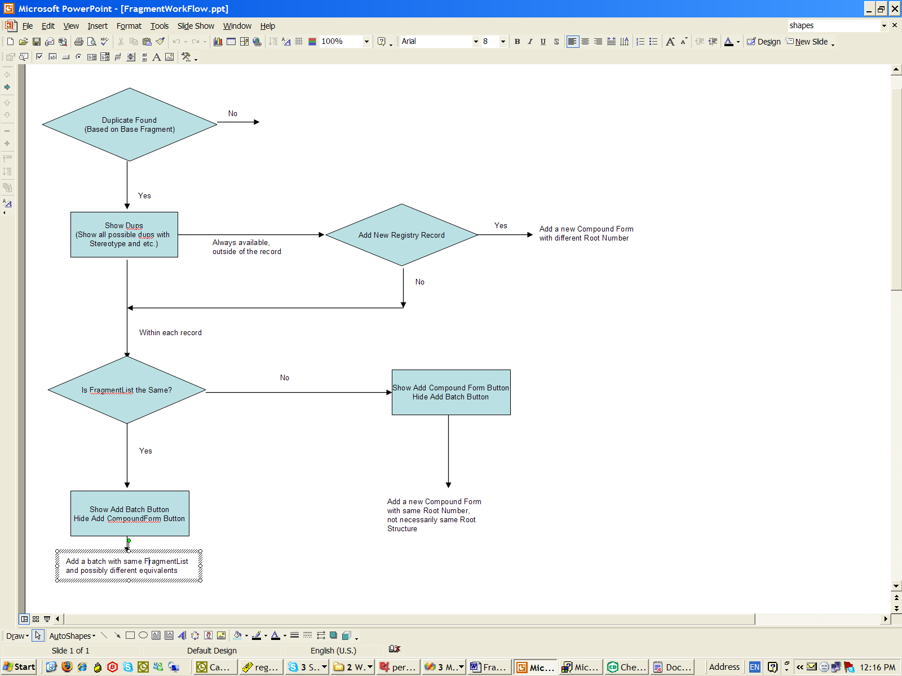

Case 1: AllowCompoundForm = False

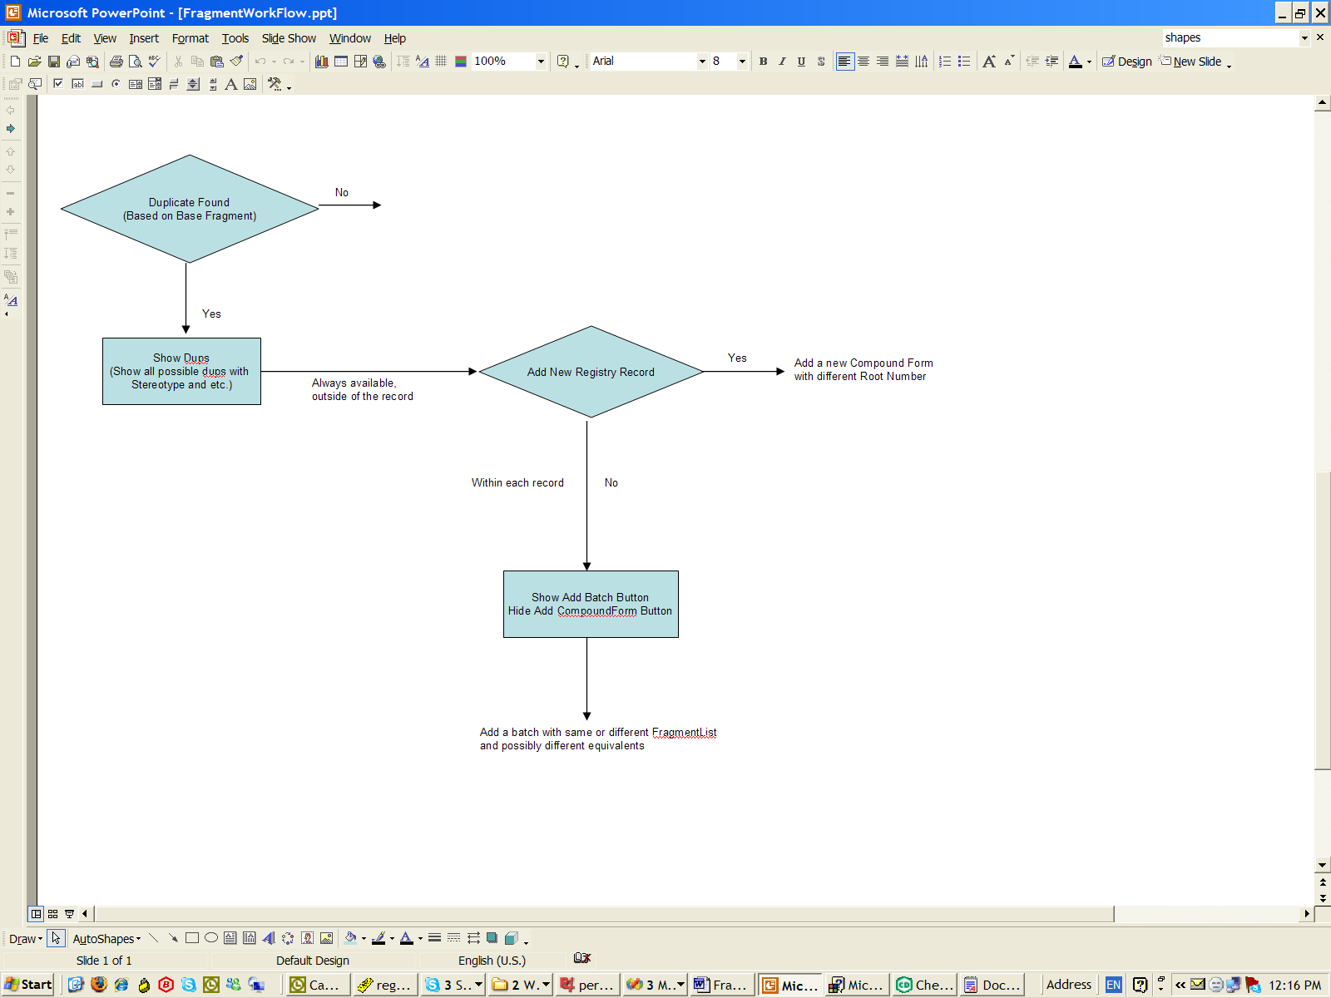
Data Model Diagram:

RegistryNumber
Mixture
MixtureComponent
Compound
BatchComponentFragment
Structure
Fragment
BatchComponent
Batch
CompoundFragment
RegID
MixID
MixComponentID
%
Equivalent
BatchID

Business Logic of inserting a Registry Record (Pure A):

- Create a row in RegistryNumber with a new RegID
- Create a row in Mixture linking back to RegistryNumber by RegID
- Identity of mixture component is stored in MixtureComponent table
- % of the mixture component is stored in BatchComponent table
- Fragment identity is stored in CompoundFragment table
- Equivalent of fragment is stored in BatchComponentFragment

