Registration Enterprise

Register Marked Hits

Revision History
Date | Revision | Description | Contributors
10/05/2008 | v.1 | Initial draft | David Gosalvez
10/07/2008 | v.1.01 | Listed queryForm fields | Ran Tao
10/17/2008 | v.1.02 | Object model | David Zhang / Ran Tao
10/20/2008 | V1.03 | Modified object model, add UI sequence | David Zhang / Ran Tao
10/30/2008 | V1.1.0 | Adjustment | Ran Tao / David Zhang
11/04/2008 | V1.1.1 | Adding log tables, views, sequence, trigger | Ran Tao
12/01/2008 | V1.1.2 | Updating. Add Figure 1, | Ran Tao / David Zhang / Jerry Yu
12/23/2008 | V1.2 | Reviewing and amending | Ran Tao

Copyright © 2008 CambridgeSoft Corporation. Cambridge, Massachusetts.
All Rights Reserved

This document is the property of CambridgeSoft Corporation and is intended for internal use only. Reproduction or transmission of this document in any form, in whole or in part, without prior written permission of CambridgeSoft Corporation is prohibited.

Scope:
This document discusses the implementation of the “Register Marked Hits” feature of Registration Enterprise 11. The feature already exists in previous Registration versions. The implementation described below has been adapted for version 11.

Overview:
As users submit RegistryRecords into the temporary registry tables, they may accumulate there in significant numbers. The registrar may wish to submit multiple temporary records for final registration without out having to individually inspect and submit each record.

There are three distinct steps in this process:

- Registrar generates a list of temporary records to be registered
- System “bulk” registers multiple records without user intervention and handles duplicate resolution according to a predefined action.
- System reports the results of the bulk registration indicated which records succeeded or failed to be registered.

The registration system GUI concerns itself only with the entry and display of RegisteredRecords “one-at-a-time”. That is, there is no facility in the application to present or modify more than one record at once. Therefore tasks 1) and 3) will be delegated to the “Search-runtime” facility provided by the COEFramework. Step 2) will be handled by the Registration application leveraging and extending existing bulk registration functionality present in the COE.Registration.Services.

This implementation will involve creating a set of query and display forms (known as a COEFormGroup) that will be used within the COEFramework search-runtime facilities to find and select temporary RegistryRecords to be furthered process into the Registry. This new search and selection interface will supersede the rudimentary “Review/Register” search form and selection grid control currently implemented in COERegistration 11.0. That is, the new temporary search formgroup will be used for finding and selecting an individual record to review and register as well as to select multiple temporary records to be processed by the new bulk registration process.

In addition, as a side-effect of the introduction of the search-runtime into COERegistration, the existing form that allows searching and retrieving registered records will also be replaced with a new COEFormGroup.

One of the main advantages of using the search-runtime and COEFormGroups for all searching and selection tasks within the Registration System is that it will allow customers to easily modify the contents of the query and display forms.

COE Search-runtime
The COE search-runtime is implemented as an ASP.NET application that delivers the basic search and selection interface against any arbitrary set of database tables. The search-runtime renders an interrelated set of web forms used for querying and displaying arbitrary data. The three most important forms in the search-runtime are:

- queryForm: Used for formulating a query against the database tables
- detailsForm: Used for displaying information related to single result of a query (hit)
- listForm: Used for displaying summary information related to a set of results from a query.

The combination of two or more of the above forms is assembled into a FormGroup. The search-runtime renders the formgroup forms and manages the search workflow controlling aspects such as producing the searchCriteria and resultsCriteria and interacting with the COESearch service to produce the resulting display DataSets. The two main inputs for the search-runtime are:

- DataView: The object that defines the tables, fields, and relationships available for searching.
- FormGroup: The object that defines how forms should be rendered and behave during the search process.

Review/Register (search temp) FormGroup
The first task in implementing the “Registered Marked” feature in COERegistration 11.0.1 is to create Datview and Formgroup capable of searching the REGDB.VW_TEMPORARYBATCH, and REGDB.VW_TEMPORARYCOMPOUND database views. These two views contain all the information related to temporary RegistryRecord.

This formgroup will allow querying the temporary Registry by some key fields such as Structure, MW, Formula, TempId, DateCreated, PersonCreated, Chemist, Comments etc… The base table for this query should be REGDB.VW_TEMPORARYBATCH. Some fields from the related (child) VW_TEMPORARYCOMPOUND will also be made available for query.

The listForm within this formgroup will display a summary table of the results including similar fields available for query form. The user will be able to select one or more hits (temporary RegistryRecords) by using the “Mark Hits” functionality currently being developed within the search-runtime. In addition, this form will also display “show details” hyperlink which will allow drill down into the selected temporary Registry Record.

This formgroup will not need a detailsForm because the drill-down from the listForm will be serviced by the existing view record pages of the Registration application.

Send-marked-hits
In addition to providing the ability to mark hits from the query result forms, the search-runtime will also implement a configurable “Send-to” menu. This menu item will post the selected hits to a third party service or asp.NET page. The selected hits can be transferred between the search-runtime as either a vector or hit id values (primary key of the temporarycompound view in this case) or as a hitlistid (a reference to the COEFramework hitlist that contains the same pk values).
hitlistid will be used here.

RegisterMarked.aspx
A new page will be created in the Registration web application that will be responsible for:

- Receiving the send-to request from the search-runtime
- Managing the calls to the service tier to effect the bulk registration
- Redirecting back to a search-runtime formgroup capable of presenting the results of the bulk registration log.

In Registration 11, click RegisterMarked button
→ in BioViz, COE Search-runtime query
→ display temporary register records
→ User to Mark records
→ send Hitlist (hitlistid and timestamp)
→ back to Registration 11, user to select duplicate action
→ RegistryRecordList.LoadRegistryRecordList (Figure 1: RegistryRecordList.LoadRegistryRecordList)
→ Show LOG_ID (show error message if failed)
→ Update log description. Click ‘See log details’
→ in BioViz, COE Search-runtime search the result (log) tables with LOG_ID to display the load result

In Data Loader
→ Call RegistryRecordList.LoadRegistryRecordList passing xml
→ If Success: return LOG_ID else return error message.]

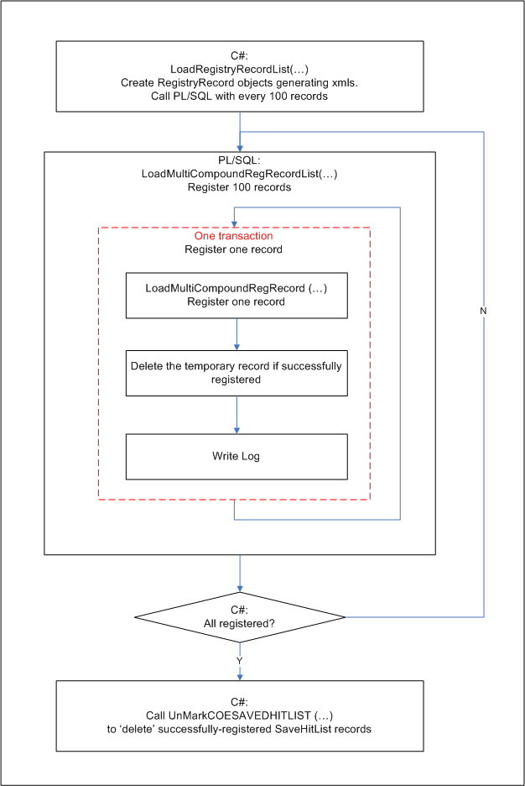

Figure 1: RegistryRecordList.LoadRegistryRecordList

Bulk Registration
The current Registration 11.0 application has implemented the facilities to register individual records via the RegistryRecord object which uses databases procedures such as CreateMultiCompoundRegistry, or UpdateMultiCompounRegistry.

The facilities for registering more than one record at once (and dealing with the automatic duplicate handling and exception logging) already exists in the database. See procedures RetrieveCompoundRegistryList and LoadMultiCompoundRegRecordList. There are however no objects in the COE.Registration.Services namespace to handle lists of registry record objects. In order to accomplish the bulk registration task expected of the RegisterMarked.apx, a RegistryRecordList object must be created that can exploit the above list handling procedures defined in the database. These objects are expected to be relatively simple as they will delegate most of the difficult work to the existing RegisryRecord object which can deal with the details.

Object Model

The following objects are used by the RegisterMarked.aspx to perform its tasks. RegistryRecord and RegistryRecordList are in CambridgeSoft.COE.Registration.Services.Types namespace.

RegistryRecord

This object represents a record that will be registered from temporary register table to permanent one. It is responsible for reading, editing, deleting or register a record. It implements CSLA base business object including data portal methods to read/write table data from/to the database. It has attributes such as ComponentList and BatchList that represent the specific information of a record.
[NOTE: RegistryRecord is the same object that is used to create an entry in the temporary register table.]

RegistryRecordList

Implementing CSLA BusinessBase object, this object is responsible for loading the records into the permanent table.

Some methods of this object are:

LoadRegistryRecordList(RegistryRecord.DuplicateAction actionDuplicates, int hitListID)
This method is for Registration
This method retrieves tempbatchid’s (identified by hitlistid) in coesavedhitlist table, then loop each tempbatchid, having the corresponding temporary registry record instantiated as a RegisterRecord, assempling its xml a hundred as a group, and having them registered.

LoadRegistryRecordList (RegistryRecord.DuplicateAction actionDuplicates, string xml):
This method is for DataLoader
Bulk Register the records in the list using data portal methods that calls the databases procedures LoadMultiCompoundRegRecordList.
xml: refer to List 1: xml passed by LoadRegistryRecordList

actionDuplicates in both methods tells the action that should be taken when duplicate found:

"D" Create duplicate
"B" Add batch to existing
"T" Put into temporary
"N" Do not store, duplicate is ignored

CanGetObject(): Authentication.

[TODO: Refactor the list registration PL/SQL procedures as needed to accommodate the new object. Coordinate with Bill Claff for COELoader and with Mauricio Fariello for database changes. It is expected that the procedures will need to be enhanced to produce an adequate log table to be exploited by the search-runtime to display the results of the bulk load.]
[NOTE: The PL/SQL has already been refactored but a return value or out parameter is still needed to adequately log the result of the operation.]

Need two more parameters in/out from PL/SQL procedure LoadMultiCompoundRegRecord: LoadMultiCompoundRegRecord (…, ADuplicateCheck in, BatchNumber out), UpdateMultiCompoundRegistry(…,BatchNumber out).

PL/SQL procedure LoadMultiCompoundRegRecordList returns LOG_ID of the tables that logs the registration result.

[Note: The Data Loader allows for direct registration as opposed to registration from temporary. So using tempid as an identifier within RegistryRecordList is not sufficient.]
Answer to above question:
To use LoadRegistryRecordList. Explained several paragraphs above.

RegRecordListInfo
This object provides the result info of
RegistryRecordList.LoadRegistryRecordList

RecordListInfo | return the LOG_ID of the tables | Return the Exception that is produced when load data to the database.

Display Bulk Registration Results
The results of the bulk registration will lead to a list of successfully registered tempids and their corresponding permanent registry numbers (or regids) and potentially to a list of failed tempids, with a reason form failure (like a conflicting regnumbers). It is expected that the raw data necessary to present the bulk registration results will be generated by the database procedures. The task of displaying the results to the end-user falls under the RegisteredMarked.aspx, which should in turn delegate the details of the display to search runtime.

The idea is that upon bulk registration, the user will be presented with a search-runtime listViewForm designed to display the contents of the bulk registration log together with temp and permanent registry record details. The user will further be allowed to use a queryForm to search or filter over the bulk registration log.

Class Diagram:
See Figure 1: Class Diagram.

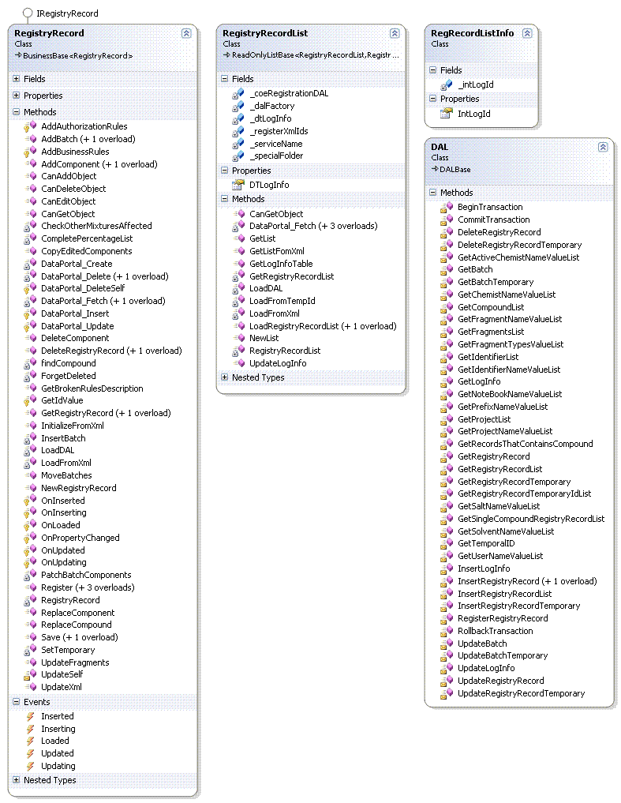
Figure 1: Class Diagram.

- <MultiCompoundRegistryRecordList>
- <MultiCompoundRegistryRecord>
<ID>0</ID>
<DateCreated>0001/01/01 12:00:00</DateCreated>
<DateLastModified>0001/01/01 12:00:00</DateLastModified>
<StructureAggregation>#678VvhySyACEyAMAuRUAAAAAAAAAAAAAADAAAAAAAEAyuAAAMNoQO9MtvFBRyMC LjARAUEAAAUVdlSh4GCcQDUMd+N9dOVT4AZDMAUEwjKA2SQcALf4tuAEMoAAAZmR AAAAAAAAAAAAAPmRAAAAwZAAAfMAyZPUAAMRUuMAAboMAZAUfuZUAAUFUAMAAbuM AZAAyAXUAAMYUPMAAZ1GAZAAZPZUAAUyUAMAAMZMAZAADPPRAAEAXAyRAAEADuPR AAZAAAyuAAEADZPMAyf0APARDAZAAAADAAtRUAAAAAMAUPPMAAAAUAAFDAZAAAAn AAZRAPUwAAERUAAAA/PARuPUAAKEDAMAAARRMAAAADZAAAAmAAAAIAAAADZAAAE7 AAPAHHHHHHHHAAAAAAAAHHzAAAAAHHHHHuAAAAyHHuAAAAyHHHHHAAAAAYHHHHzA AYHHAAMmAAAAAPAyAfZMUZUUtvcpdAZAxAZYAFShdOV0RMxc47UJd+9pdPGAFAAA AAZDMAAAAAAAAAAAAAAA1ARAAUuDFPPMAAAAIAAXDAZAAAAmAUmRAAAZDARAAZAY DARAAZAyPAKAAAAMApAAbfR9AYmOQZD0lgEAyU3AAAJAAPAAAAADDAAAuyXA2QQc AAoAAPAUAAMyUAAyAAAANuZUAAMAAAJAUAAAAAADDAAAuFZA2QQcAAoAAPAyAAMy UAAyAAAAAAAMPAXAAAAAAPPAAEUFAA7JWuA3AARAUZAUAuZAAuAAAAAAURALAAAA AARRAAyAXuAEmlzADPADAAoAAZEMAAEAAAAAAAJAyuAAAAADDAAAu/RA2QQcAAoA APANAAMyUAAyAAAANuZUAAMAAAOADAAAAAoAAPA/AAMyUAAyAAAAUAXMAARAAAAF UPZAUAAAAAoGAZAUAAAFPAmAAAA3AARADAAUAuZAAuAAAAZGUAAMAAAAUZXMAAXA AAA3UPMAAZAAUXA3AAAADPADAAmAAZEMAAEAAAAMUPZAUPAAAAKGUAADAAAADPXU AAMAAAOAyZAAAAoAAPALAAMyUAAyAAAAUAXMAAZAAAAFUPZADuAAAAoGAZAUAAAF PAwAAAA3AARAyAAUAuZAAuAAAAZGUAALAAAAUZXMAAXAAAA3UPMAAZAAUXASAAAA DPADAAwAAZEMAAEAAAAMUPZAUAAAAAKGUAAYAAAADPXUAAMAAAOAMPAAAAoAAPAY AAMyUAAyAAAAUAXMAAzAAAAFUPZADuAAAAoGAZAUAAAAAAAAAAAAAA==</StructureAggregation>
- <RegNumber>
<RegID>0</RegID>
<RootNumber />
<SequenceNumber>0</SequenceNumber>
<Sequence>1</Sequence>
<RegNumber />
</RegNumber>
- <PropertyList>
<Property />
</PropertyList>
- <ComponentList>
- <Component>
<ID>0</ID>
<ComponentIndex>-3</ComponentIndex>
<Percentage>0</Percentage>
- <Compound>
<CompoundID>3</CompoundID>
<DateCreated>2008/12/11 07:18:04</DateCreated>
<DateLastModified>2008/12/11 07:18:04</DateLastModified>
<PersonCreated>27</PersonCreated>
<PersonRegistered>27</PersonRegistered>
- <RegNumber>
<RegID>0</RegID>
<RootNumber />
<SequenceNumber>0</SequenceNumber>
<Sequence>1</Sequence>
<RegNumber />
</RegNumber>
- <BaseFragment>
<ID>0</ID>
- <Structure>
<StructureID>0</StructureID>
<StructureFormat />
<Structure formula="C5H6" molWeight="66.10114">#678VvhySyACEyAMAuRUAAAAAAAAAAAAAADAAAAAAAEAyuAAAMNoQO9MtvFBRyMC LjARAUEAAAUVdlSh4GCcQDUMd+N9dOVT4AZDMAUEwjKA2SQcALf4tuAEMoAAAZmR AAAAAAAAAAAAAPmRAAAAwZAAAfMAyZPUAAMRUuMAAboMAZAUfuZUAAUFUAMAAbuM AZAAyAXUAAMYUPMAAZ1GAZAAZPZUAAUyUAMAAMZMAZAADPPRAAEAXAyRAAEADuPR AAZAAAyuAAEADZPMAyf0APARDAZAAAADAAtRUAAAAAMAUPPMAAAAUAAFDAZAAAAn AAZRAPUwAAERUAAAA/PARuPUAAKEDAMAAARRMAAAADZAAAAmAAAAIAAAADZAAAE7 AAPAHHHHHHHHAAAAAAAAHHzAAAAAHHHHHuAAAAyHHuAAAAyHHHHHAAAAAYHHHHzA AYHHAAMmAAAAAPAyAfZMUZUUtvcpdAZAxAZYAFShdOV0RMxc47UJd+9pdPGAFAAA AAZDMAAAAAAAAAAAAAAA1ARAAUuDFPPMAAAAIAAXDAZAAAAmAUmRAAAZDARAAZAY DARAAZAyPAKAAAAMApAAbfR9AYmOQZD0lgEAyU3AAAJAAPAAAAADDAAAuyXA2QQc AAoAAPAUAAMyUAAyAAAANuZUAAMAAAJAUAAAAAADDAAAuFZA2QQcAAoAAPAyAAMy UAAyAAAAAAAMPAXAAAAAAPPAAEUFAA7JWuA3AARAUZAUAuZAAuAAAAAAURALAAAA AARRAAyAXuAEmlzADPADAAoAAZEMAAEAAAAAAAJAyuAAAAADDAAAu/RA2QQcAAoA APANAAMyUAAyAAAANuZUAAMAAAOADAAAAAoAAPA/AAMyUAAyAAAAUAXMAARAAAAF UPZAUAAAAAoGAZAUAAAFPAmAAAA3AARADAAUAuZAAuAAAAZGUAAMAAAAUZXMAAXA AAA3UPMAAZAAUXA3AAAADPADAAmAAZEMAAEAAAAMUPZAUPAAAAKGUAADAAAADPXU AAMAAAOAyZAAAAoAAPALAAMyUAAyAAAAUAXMAAZAAAAFUPZADuAAAAoGAZAUAAAF PAwAAAA3AARAyAAUAuZAAuAAAAZGUAALAAAAUZXMAAXAAAA3UPMAAZAAUXASAAAA DPADAAwAAZEMAAEAAAAMUPZAUAAAAAKGUAAYAAAADPXUAAMAAAOAMPAAAAoAAPAY AAMyUAAyAAAAUAXMAAzAAAAFUPZADuAAAAoGAZAUAAAAAAAAAAAAAA==</Structure>
<NormalizedStructure />
</Structure>
</BaseFragment>
- <PropertyList>
<Property name="CN" />
<Property name="PATENT" />
<Property name="HISTORY" />
<Property name="OCURR" />
<Property name="COMMENTS" />
<Property name="ENPRODUCTID" />
<Property name="ARCTANDER" />
<Property name="FEMA" />
<Property name="COMPOUNDNAME" />
<Property name="STEREO" />
<Property name="EXACTMASS" />
<Property name="MSID" />
</PropertyList>
</Compound>
</Component>
</ComponentList>
- <BatchList>
- <Batch>
<BatchID>3</BatchID>
<BatchNumber>0</BatchNumber>
<DateCreated>2008/12/11 07:18:04</DateCreated>
<PersonCreated>27</PersonCreated>
<PersonRegistered>27</PersonRegistered>
<DateLastModified>2008/12/11 07:18:04</DateLastModified>
- <PropertyList>
<Property name="CHEMIST">27</Property>
<Property name="STATUSID">1</Property>
<Property name="CO" />
<Property name="ITEMNUMBER" />
<Property name="NOTEBOOKREF" />
<Property name="PURITY" />
<Property name="OPTICALROTATION" />
<Property name="REFRACTIONINDEX" />
<Property name="NUMMS" />
<Property name="NUMANAL" />
<Property name="WORKNUMBER" />
<Property name="REMARKS" />
<Property name="COMMENTS" />
<Property name="DATEENTERED" />
<Property name="DELIVERYDATE" />
<Property name="MELTINGPOINT" />
<Property name="BOILINGPOINT" />
<Property name="DENSITY" />
<Property name="POLARITY" />
<Property name="SOLUBILITY" />
<Property name="RETENTIONINDEX" />
<Property name="MONOMERICCOMPOSITION" />
<Property name="DEGREEOFSUBSTITUTION" />
<Property name="RAMIFICATION" />
<Property name="FIRPROJECTID" />
<Property name="MN" />
<Property name="MW" />
<Property name="SAMPLEID" />
</PropertyList>
- <BatchComponentList>
- <BatchComponent>
<ID>0</ID>
<BatchID>3</BatchID>
<MixtureComponentID>0</MixtureComponentID>
<CompoundID>3</CompoundID>
<ComponentIndex>-3</ComponentIndex>
<OrderIndex>1</OrderIndex>
- <PropertyList>
<Property name="LABEL" />
<Property name="PERCENTAGE" />
<Property name="RATIO" />
<Property name="COMMENTS" />
</PropertyList>
</BatchComponent>
</BatchComponentList>
</Batch>
</BatchList>
</MultiCompoundRegistryRecord>
- <MultiCompoundRegistryRecord>
<ID>0</ID>
<DateCreated>0001/01/01 12:00:00</DateCreated>
<DateLastModified>0001/01/01 12:00:00</DateLastModified>
<StructureAggregation>#1943rzwCwAWQwAxAmXNAAAAAAAAAAAAAAVAAAAAAAQAwmAAAxJjKZLxSr50XwxW IcAXANQAAAN3b7Czi/W4KVNxbuJLbZ3yiA6VxAwkCVSA+CKQANsgp6Ajt8MAA6dX AAAAAAAAAAAAAUdXAAAA86AAAsxAw6UNAAxXNmxAAnjxA6ANsm6NAAN5NAxAAnmx A6AAwAMNAAxPNUxAA6D/A6AA6U6NAANwNAxAAx6xA6AAVUUXAAQAMAwXAAQAVmUX AA6AAAwmAAQAV6UxAws9AUAXVA6AAAAVAASXNAAAAAxANUUxAAAANAA5VA6AAAAq AA6XAUN8AAQXNAAAAHUAXmUNAAvQVAxAAAXXxAAAAV6AAAAdAAAAfAAAAV6AAAQe AAUAGGGGGGGGAAAAAAAAGGoAAAAAGGGGGmAAAAwGGmAAAAwGGGGGAAAAAPGGGGoA APGGAAxdAAAAAUAwAs6xN6NNSr4ObA6A2A6PA5CzbZ39Xx24ieNhbuLObU/A5UAA AA6VxAAAAAAAAAAAAAAADAXAANmV5UUxAAAAfAAMVA6AAAAdANdXAAA6VAXAA6AP VAXAA6AwUAvAAAAxAOAAgx67APdZnAAny8dAlly/AAhAAUAAAAAVVAAA6xxA+CKb AAjAAUANAAxwNAAwAAAAAAAxUA6AAAAAAUUAAxNaAPdZZmAlAAXAAmANAm6AAmAA AAAANXA/AAAAAAXXAANAvAAQx7vAVUAVAAvAA6QxAAQAAAAAAAhAVmAAAAAVVAAA 6/8AwNfLAAjAAUAlAAxwNAAwAAAAAAAxUAoAAAAAAUUAx9yXAAmhOAAlAAXAw6AN Am6AAmAAAwSxA6ANAAAxUNQAAAAAAUUAgx67APdZnAAlAAXAwmANAm6AAmAAAwSx A6ANAAA5UAUAAAAlAAXANmANAm6AAmAAAA6/NAAVAAAAN6MxAA6AAAAlNUxAA6AA NMAfAAAAVUAVAAUAA6QxAAQAAAAxNU6ANAAAAAv/NAA/AAAAVUMNAAxAAAZAVUAA AAjAAUAfAAxwNAAwAAAANAMxAAMAAAA5NU6AAUAAAAj/A6ANAAA5UADAAAAlAAXA VmANAm6AAmAAAA6/NAAxAAAAN6MxAAkAAAAlNUxAA6AANMAsAAAAVUAVAAmAA6Qx AAQAAAAxNU6AVmAAAAv/NAA/AAAAVUMNAAxAAAZAxAAAAAjAAUAsAAxwNAAwAAAA NAMxAAkAAAA5NU6AwmAAAAx/AUA/AAj/A6ANAAA5UN6AAAAlAAXAxAANAm6AAmAA AA6/NAAVAAAAN6MxANQAAAAANUXAANAlNUxAA6AAAAAAAAAAAAA=</StructureAggregation>
- <RegNumber>
<RegID>0</RegID>
<RootNumber />
<SequenceNumber>0</SequenceNumber>
<Sequence>1</Sequence>
<RegNumber />
</RegNumber>
- <PropertyList>
<Property />
</PropertyList>
- <ComponentList>
- <Component>
<ID>0</ID>
<ComponentIndex>-4</ComponentIndex>
<Percentage>0</Percentage>
- <Compound>
<CompoundID>4</CompoundID>
<DateCreated>2008/12/11 07:18:51</DateCreated>
<DateLastModified>2008/12/11 07:18:51</DateLastModified>
<PersonCreated>27</PersonCreated>
<PersonRegistered>27</PersonRegistered>
- <RegNumber>
<RegID>0</RegID>
<RootNumber />
<SequenceNumber>0</SequenceNumber>
<Sequence>1</Sequence>
<RegNumber />
</RegNumber>
- <BaseFragment>
<ID>0</ID>
- <Structure>
<StructureID>0</StructureID>
<StructureFormat />
<Structure formula="C6H8" molWeight="80.12772">#1943rzwCwAWQwAxAmXNAAAAAAAAAAAAAAVAAAAAAAQAwmAAAxJjKZLxSr50XwxW IcAXANQAAAN3b7Czi/W4KVNxbuJLbZ3yiA6VxAwkCVSA+CKQANsgp6Ajt8MAA6dX AAAAAAAAAAAAAUdXAAAA86AAAsxAw6UNAAxXNmxAAnjxA6ANsm6NAAN5NAxAAnmx A6AAwAMNAAxPNUxAA6D/A6AA6U6NAANwNAxAAx6xA6AAVUUXAAQAMAwXAAQAVmUX AA6AAAwmAAQAV6UxAws9AUAXVA6AAAAVAASXNAAAAAxANUUxAAAANAA5VA6AAAAq AA6XAUN8AAQXNAAAAHUAXmUNAAvQVAxAAAXXxAAAAV6AAAAdAAAAfAAAAV6AAAQe AAUAGGGGGGGGAAAAAAAAGGoAAAAAGGGGGmAAAAwGGmAAAAwGGGGGAAAAAPGGGGoA APGGAAxdAAAAAUAwAs6xN6NNSr4ObA6A2A6PA5CzbZ39Xx24ieNhbuLObU/A5UAA AA6VxAAAAAAAAAAAAAAADAXAANmV5UUxAAAAfAAMVA6AAAAdANdXAAA6VAXAA6AP VAXAA6AwUAvAAAAxAOAAgx67APdZnAAny8dAlly/AAhAAUAAAAAVVAAA6xxA+CKb AAjAAUANAAxwNAAwAAAAAAAxUA6AAAAAAUUAAxNaAPdZZmAlAAXAAmANAm6AAmAA AAAANXA/AAAAAAXXAANAvAAQx7vAVUAVAAvAA6QxAAQAAAAAAAhAVmAAAAAVVAAA 6/8AwNfLAAjAAUAlAAxwNAAwAAAAAAAxUAoAAAAAAUUAx9yXAAmhOAAlAAXAw6AN Am6AAmAAAwSxA6ANAAAxUNQAAAAAAUUAgx67APdZnAAlAAXAwmANAm6AAmAAAwSx A6ANAAA5UAUAAAAlAAXANmANAm6AAmAAAA6/NAAVAAAAN6MxAA6AAAAlNUxAA6AA NMAfAAAAVUAVAAUAA6QxAAQAAAAxNU6ANAAAAAv/NAA/AAAAVUMNAAxAAAZAVUAA AAjAAUAfAAxwNAAwAAAANAMxAAMAAAA5NU6AAUAAAAj/A6ANAAA5UADAAAAlAAXA VmANAm6AAmAAAA6/NAAxAAAAN6MxAAkAAAAlNUxAA6AANMAsAAAAVUAVAAmAA6Qx AAQAAAAxNU6AVmAAAAv/NAA/AAAAVUMNAAxAAAZAxAAAAAjAAUAsAAxwNAAwAAAA NAMxAAkAAAA5NU6AwmAAAAx/AUA/AAj/A6ANAAA5UN6AAAAlAAXAxAANAm6AAmAA AA6/NAAVAAAAN6MxANQAAAAANUXAANAlNUxAA6AAAAAAAAAAAAA=</Structure>
<NormalizedStructure />
</Structure>
</BaseFragment>
- <PropertyList>
<Property name="CN" />
<Property name="PATENT" />
<Property name="HISTORY" />
<Property name="OCURR" />
<Property name="COMMENTS" />
<Property name="ENPRODUCTID" />
<Property name="ARCTANDER" />
<Property name="FEMA" />
<Property name="COMPOUNDNAME" />
<Property name="STEREO" />
<Property name="EXACTMASS" />
<Property name="MSID" />
</PropertyList>
</Compound>
</Component>
</ComponentList>
- <BatchList>
- <Batch>
<BatchID>4</BatchID>
<BatchNumber>0</BatchNumber>
<DateCreated>2008/12/11 07:18:51</DateCreated>
<PersonCreated>27</PersonCreated>
<PersonRegistered>27</PersonRegistered>
<DateLastModified>2008/12/11 07:18:51</DateLastModified>
- <PropertyList>
<Property name="CHEMIST">27</Property>
<Property name="STATUSID">1</Property>
<Property name="CO" />
<Property name="ITEMNUMBER" />
<Property name="NOTEBOOKREF" />
<Property name="PURITY" />
<Property name="OPTICALROTATION" />
<Property name="REFRACTIONINDEX" />
<Property name="NUMMS" />
<Property name="NUMANAL" />
<Property name="WORKNUMBER" />
<Property name="REMARKS" />
<Property name="COMMENTS" />
<Property name="DATEENTERED" />
<Property name="DELIVERYDATE" />
<Property name="MELTINGPOINT" />
<Property name="BOILINGPOINT" />
<Property name="DENSITY" />
<Property name="POLARITY" />
<Property name="SOLUBILITY" />
<Property name="RETENTIONINDEX" />
<Property name="MONOMERICCOMPOSITION" />
<Property name="DEGREEOFSUBSTITUTION" />
<Property name="RAMIFICATION" />
<Property name="FIRPROJECTID" />
<Property name="MN" />
<Property name="MW" />
<Property name="SAMPLEID" />
</PropertyList>
- <BatchComponentList>
- <BatchComponent>
<ID>0</ID>
<BatchID>4</BatchID>
<MixtureComponentID>0</MixtureComponentID>
<CompoundID>4</CompoundID>
<ComponentIndex>-4</ComponentIndex>
<OrderIndex>1</OrderIndex>
- <PropertyList>
<Property name="LABEL" />
<Property name="PERCENTAGE" />
<Property name="RATIO" />
<Property name="COMMENTS" />
</PropertyList>
</BatchComponent>
</BatchComponentList>
</Batch>
</BatchList>
</MultiCompoundRegistryRecord>
- <MultiCompoundRegistryRecord>
<ID>0</ID>
<DateCreated>0001/01/01 12:00:00</DateCreated>
<DateLastModified>0001/01/01 12:00:00</DateLastModified>
<StructureAggregation>#904aCW3K3AlP3A/AzYNAAAAAAAAAAAAAAVAAAAAAAPA3zAAA/6jZBu/vCyDY3/l QcAYANPAAANaUsKWiGlxZVN/U26uUBaRiAnV/AAAn//AAPNpA6CRUb3mqDwAAn7Y AAAAAAAAAAAAAb7YAAAALnAAA5/A3nbNAA/YNz/AAfj/AnAN5znNAANyNA/AAfz/ AnAA3AMNAA/INb/AAnkGAnAAnbnNAAN3NA/AA/n/AnAAVbbYAAPAMA3YAAPAVzbY AAnAAA3zAAPAVnb/A35gAbAYVAnAAAAVAAvYNAAAAA/ANbb/AAAANAAyVAnAAAAq AAnYAbNLAAPYNAAAAHbAYzbNAAXPVA/AAAYY/AAAAVnAAAA7AAAAJAAAAVnAAAPd AAbA44444444AAAAAAAA44wAAAAA44444zAAAA344zAAAA344444AAAAAI4444wA AI44AA/7AAAAAbA3A5n/NnNNvCxOUAnA+AnIAyKWUBagY/+xidNSU2uOUbGAVnAA AAnV/AAAAAAAAAAAAAAAkAYAANzVybb/AAAAJAAMVAnAAAA7AN7YAAAnVAYAAnAI VAYAAnA3bAPAAAA/AOAAA/NNAA3AMb3ZrCLAoEm4AASAAbAAAAAVVAAAnGLAAANc AAjAAbANAA/3NAA3AAAA6znNAA/AAASANAAAAAAVVAAAnywA/4mwAAjAAbA3AA/3 NAA3AAAA6znNAA/AAASANbAAAAAVVAAAn//A/4mwAAjAAbAyAA/3NAA3AAAA6znN AA/AAABANnAAAAjAAbA/AA/3NAA3AAAANAM/AAYAAAAyNbnANAAAAAAGAbAA/AjG AnANAAAybAvAAAAtAAYANbANAznAAzAAAAnGNAA/AAAANnM/AAMAAAAANbYAANAt Nb/AAnAAAAAAAAAAAAA=</StructureAggregation>
- <RegNumber>
<RegID>0</RegID>
<RootNumber />
<SequenceNumber>0</SequenceNumber>
<Sequence>1</Sequence>
<RegNumber />
</RegNumber>
- <PropertyList>
<Property />
</PropertyList>
- <ComponentList>
- <Component>
<ID>0</ID>
<ComponentIndex>-5</ComponentIndex>
<Percentage>0</Percentage>
- <Compound>
<CompoundID>5</CompoundID>
<DateCreated>2008/12/11 07:20:46</DateCreated>
<DateLastModified>2008/12/11 07:20:46</DateLastModified>
<PersonCreated>27</PersonCreated>
<PersonRegistered>27</PersonRegistered>
- <RegNumber>
<RegID>0</RegID>
<RootNumber />
<SequenceNumber>0</SequenceNumber>
<Sequence>1</Sequence>
<RegNumber />
</RegNumber>
- <BaseFragment>
<ID>0</ID>
- <Structure>
<StructureID>0</StructureID>
<StructureFormat />
<Structure formula="C3H6" molWeight="42.07974">#904aCW3K3AlP3A/AzYNAAAAAAAAAAAAAAVAAAAAAAPA3zAAA/6jZBu/vCyDY3/l QcAYANPAAANaUsKWiGlxZVN/U26uUBaRiAnV/AAAn//AAPNpA6CRUb3mqDwAAn7Y AAAAAAAAAAAAAb7YAAAALnAAA5/A3nbNAA/YNz/AAfj/AnAN5znNAANyNA/AAfz/ AnAA3AMNAA/INb/AAnkGAnAAnbnNAAN3NA/AA/n/AnAAVbbYAAPAMA3YAAPAVzbY AAnAAA3zAAPAVnb/A35gAbAYVAnAAAAVAAvYNAAAAA/ANbb/AAAANAAyVAnAAAAq AAnYAbNLAAPYNAAAAHbAYzbNAAXPVA/AAAYY/AAAAVnAAAA7AAAAJAAAAVnAAAPd AAbA44444444AAAAAAAA44wAAAAA44444zAAAA344zAAAA344444AAAAAI4444wA AI44AA/7AAAAAbA3A5n/NnNNvCxOUAnA+AnIAyKWUBagY/+xidNSU2uOUbGAVnAA AAnV/AAAAAAAAAAAAAAAkAYAANzVybb/AAAAJAAMVAnAAAA7AN7YAAAnVAYAAnAI VAYAAnA3bAPAAAA/AOAAA/NNAA3AMb3ZrCLAoEm4AASAAbAAAAAVVAAAnGLAAANc AAjAAbANAA/3NAA3AAAA6znNAA/AAASANAAAAAAVVAAAnywA/4mwAAjAAbA3AA/3 NAA3AAAA6znNAA/AAASANbAAAAAVVAAAn//A/4mwAAjAAbAyAA/3NAA3AAAA6znN AA/AAABANnAAAAjAAbA/AA/3NAA3AAAANAM/AAYAAAAyNbnANAAAAAAGAbAA/AjG AnANAAAybAvAAAAtAAYANbANAznAAzAAAAnGNAA/AAAANnM/AAMAAAAANbYAANAt Nb/AAnAAAAAAAAAAAAA=</Structure>
<NormalizedStructure />
</Structure>
</BaseFragment>
- <PropertyList>
<Property name="CN" />
<Property name="PATENT" />
<Property name="HISTORY" />
<Property name="OCURR" />
<Property name="COMMENTS" />
<Property name="ENPRODUCTID" />
<Property name="ARCTANDER" />
<Property name="FEMA" />
<Property name="COMPOUNDNAME" />
<Property name="STEREO" />
<Property name="EXACTMASS" />
<Property name="MSID" />
</PropertyList>
</Compound>
</Component>
</ComponentList>
- <BatchList>
- <Batch>
<BatchID>5</BatchID>
<BatchNumber>0</BatchNumber>
<DateCreated>2008/12/11 07:20:46</DateCreated>
<PersonCreated>27</PersonCreated>
<PersonRegistered>27</PersonRegistered>
<DateLastModified>2008/12/11 07:20:46</DateLastModified>
- <PropertyList>
<Property name="CHEMIST">27</Property>
<Property name="STATUSID">1</Property>
<Property name="CO" />
<Property name="ITEMNUMBER" />
<Property name="NOTEBOOKREF" />
<Property name="PURITY" />
<Property name="OPTICALROTATION" />
<Property name="REFRACTIONINDEX" />
<Property name="NUMMS" />
<Property name="NUMANAL" />
<Property name="WORKNUMBER" />
<Property name="REMARKS" />
<Property name="COMMENTS" />
<Property name="DATEENTERED" />
<Property name="DELIVERYDATE" />
<Property name="MELTINGPOINT" />
<Property name="BOILINGPOINT" />
<Property name="DENSITY" />
<Property name="POLARITY" />
<Property name="SOLUBILITY" />
<Property name="RETENTIONINDEX" />
<Property name="MONOMERICCOMPOSITION" />
<Property name="DEGREEOFSUBSTITUTION" />
<Property name="RAMIFICATION" />
<Property name="FIRPROJECTID" />
<Property name="MN" />
<Property name="MW" />
<Property name="SAMPLEID" />
</PropertyList>
- <BatchComponentList>
- <BatchComponent>
<ID>0</ID>
<BatchID>5</BatchID>
<MixtureComponentID>0</MixtureComponentID>
<CompoundID>5</CompoundID>
<ComponentIndex>-5</ComponentIndex>
<OrderIndex>1</OrderIndex>
- <PropertyList>
<Property name="LABEL" />
<Property name="PERCENTAGE" />
<Property name="RATIO" />
<Property name="COMMENTS" />
</PropertyList>
</BatchComponent>
</BatchComponentList>
</Batch>
</BatchList>
</MultiCompoundRegistryRecord>
<MultiCompoundRegistryRecord>
…
…
</MultiCompoundRegistryRecord>

</MultiCompoundRegistryRecordList>

List 1: xml passed by LoadRegistryRecordList

