COE Configuration

Configuration settings are controlled by classes in the Common/Configuration directory.
These class inherit from Enterprise Library Configuration classes that makes it easier to write section handlers when compared to the shipping .NET 2.0 framework.

The parent element for COE service specific configuration file is name: COEConfiguration. This section is being expanded as needed.

Location of configuration information:

The ConfigUtils.cs file loads the configuration sections. Currently it looks in the config file of the calling client. Eventully, however, the configuration file for the COE services will be located in a standard directory /program files/CambridgeSoft/Informatics2006/Configuration/Framework

Configuration File XML

Currently COE Configuration has the following basic structure (There are specific sections for the various services, but they are specific to the service and not added in this description).

<coeConfiguration>
<applications>
<add name=" " dbmsType=" " tracing =" " oracleTracing=" " connectionString=" " providerName=" ">
<sqlGeneratorData>
<add chemCartrigeType=" " schema=" "/>
</sqlGeneratorData>
</add>
</applications>
<services>
<add name=" " bllManagerClass=" ">
<dalProviders>
<add name=" " dalClass=" "/>
</dalProviders>
</add>
</coeConfiguration>

Configuration Classes

Below are the current set of classes that read the sections are shown below:
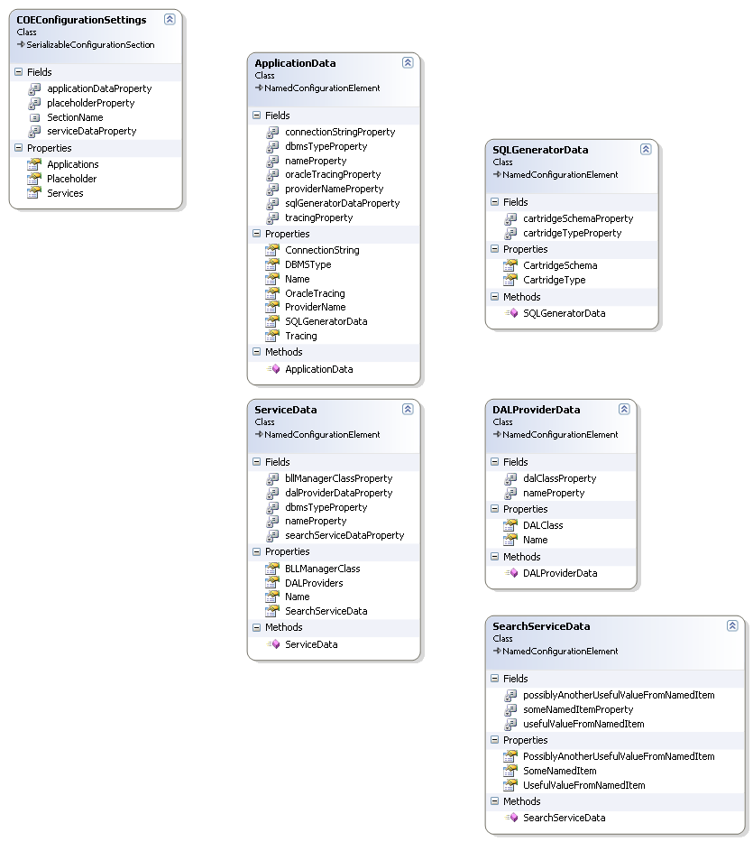

The parent class is COEConfiguration. It is made up of two main sections

Application and Services

The appliation section contains information that is specific for an application that is calling the COE services. Currently this includes connection information and information relevant to the sqlgenerator. There can be 1…n applications in this section.

<add name="SAMPLE" dbmsType="ORACLE" tracing ="false" oracleTracing="true" connectionString="Data Source=SUSHI;User ID=SAMPLE;Password=Oracle;" providerName="Oracle.DataAccess.Client">
<sqlGeneratorData>
<add chemCartrigeType="CSCARTRIDGE" schema="CSCARTRIDGE"/>
</sqlGeneratorData>
</add>

The services section contains information about the individual services. Each service has a name, information about the manager class that implements it and information about the various DAL classes that are used for DBMS specific functionality. The DAL class are only necessary if the functionality in the generic DAL needs to be overridden. Below, for an exmpale, all three extended DAL files are shown for Oracle, SQLServer and MSAccess(OLEDB).

<add name="ServiceName" bllManagerClass="ServiceNameManager">
<dalProviders>
<add name="Oracle.DataAccess.Client" dalClass="OracleDataAccessClientDAL"/>
<add name="System.Data.Sql.Client" dalClass=" SystemDataSqlClient"/>
<add name="System.Data.Oledb.Client" dalClass=" SystemDataOledbClientDAL"/>
</dalProviders>

In addition each service may have another section relevant on to it. Currenlty SearchServiceData exists in this role, however there could be a HitlistServiceData, etc. The properties for SearchServiceData are just for examples. They should be change to something more realistic when needed.

<searchServiceData>
<add usefulNamedItem="example" usefulValueFromNamedItem="" possiblyAnotherUsefulValueFromNamedItem=""/>
</searchServiceData>
</add>

</services>

By following the classes structure addition sections and properties can be added as needed.

Reading Data

The ConfigUtils Class holds methods for reading the various sections. Methods should be added as needed to manage the data changes in the configuration classes.

