ChemOffice Enterprise

Page Control Settings

Revision History
Date | Revision | Description | Contributors
03/03/2009 | V1 | Initial draft | David Zhang/Jerry Yu/Ran Tao

Copyright © 2009 CambridgeSoft Corporation. Cambridge, Massachusetts.
All Rights Reserved
This document is the property of CambridgeSoft Corporation and is intended for internal use only. Reproduction or transmission of this document in any form, in whole or in part, without prior written permission of CambridgeSoft Corporation is prohibited.

Using COEPageControlSettings in an Application
- Add into web.config a line within <appSettings> section if it not exist, where value equals application’s name:
<appSettings>
<add key="AppName" value=""/>
</appSettings>
- Add into COEFrameworkConfig.xml a line within <services> section.
<add name="COEPageControlSettings" dalProviderAssemblyNameShort="CambridgeSoft.COE.Framework" dalProviderAssemblyNameFull="CambridgeSoft.COE.Framework, Version=11.0.1.0, Culture=neutral, PublicKeyToken=1e3754866626dfbf"/>
- Insert Master.xml and Privileges.xml into COEPAGECONTROL.
Sample:
ID | APPLICATION | TYPE | CONFIGURATIONXML
1 | Registration | Master | Master.xml
2 | Registration | Privileges | Privileges.xml

- Update the file property of images and css files. Set the Build Action to Embedded Resource.
- Create a form to use this server control.
Sample:
~\Registration\PresentationTier\RegistrationWebApp\Forms\PageControlSetting\ContentArea\PageControlSetting.aspx

Users Are Able to Accomplish the Following Tasks
- Init view
At first, the GUI will just show the left tree. The tree contains three levels. The root is application node, the second level is Page node and the third level is PrivilegeList node.
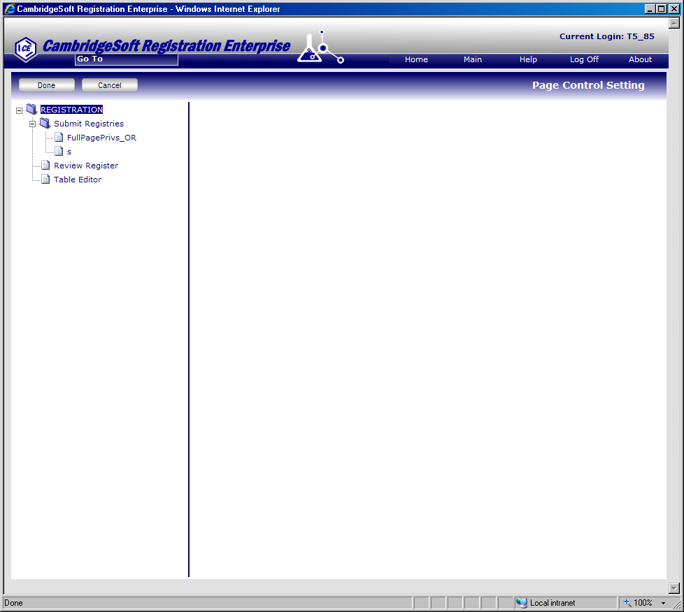
- Select a node without root node to work with in a tree view.
If the user selects a node then the right section will show. If the node is type of Page, the right section will show “Add” mode and user can add a PrivilegeList. If the node is type of PrivilegeList, the right section will show “Update” mode and user can update a PrivilegeList.
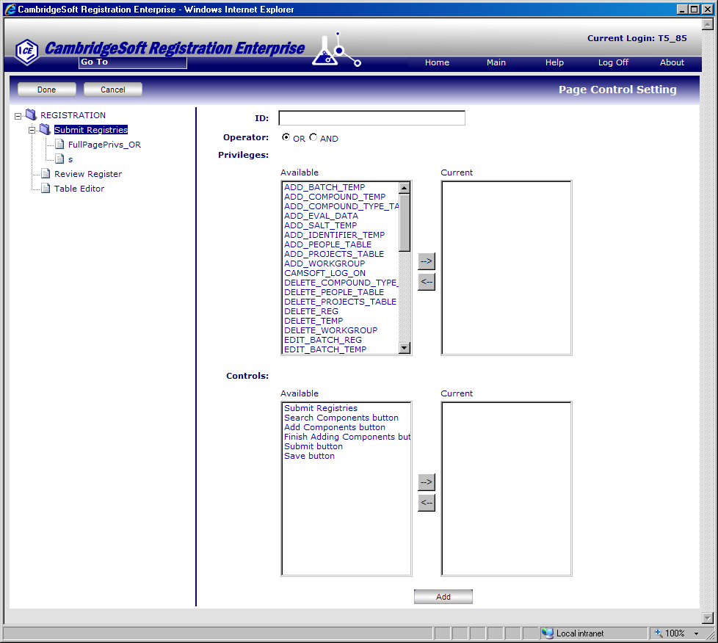

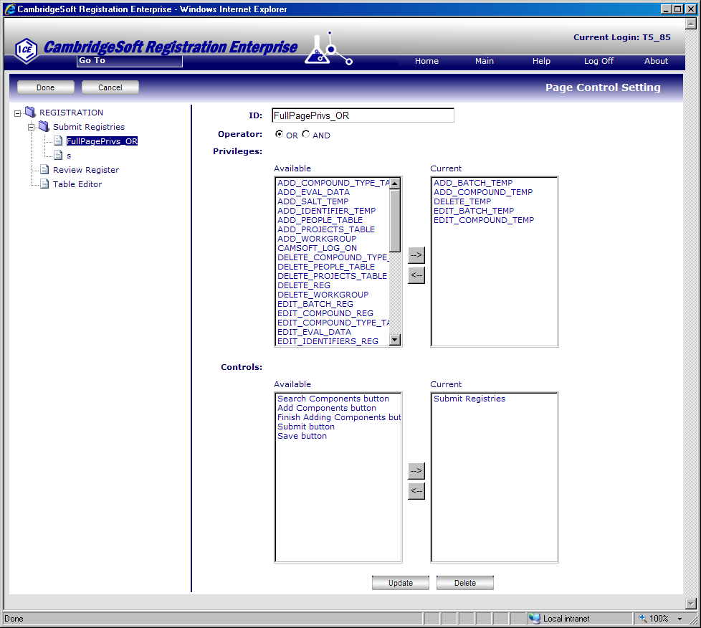
- Add/Update a PrivilegeList.
To click “Add/Update” button you will add or update a PrivilegeList. It will add or update the PrivilegeList into the business object but not in database.
- Delete a PrivilegeList
To click Delete button, the application will show a confirm dialog. If you select OK, the PrivilegeList will be deleted.
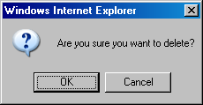
- Save the configuration settings into the DB.
To click “Done” button, it will save the configuration settings into the DB.

XML Template
Master
If the controls(e.g. a page, a control, a form, etc)of application have changed, you should update this master.xml.
<?xml version='1.0' encoding='utf-8'?>
<COEPageControlSettings type="Master">
<Application>Registration</Application>
<ID>COEPageControlSettings_Registration_Master</ID>
<Pages>
<Page>
<ID>ASP.FORMS_SUBMITRECORD_CONTENTAREA_SUBMITMIXTURE_ASPX</ID>
<Description>Page to submit registries (temporary registries until registration)</Description>
<FriendlyName>Submit Registries</FriendlyName>
<Controls>
<Control>
<ID>ASP.FORMS_SUBMITRECORD_CONTENTAREA_SUBMITMIXTURE_ASPX</ID>
<Description>Page to submit registries (temporary registries until registration)</Description>
<FriendlyName>Submit Registries</FriendlyName>
<PlaceHolderID/>
<TypeOfControl>Page</TypeOfControl>
</Control>
<Control>
<ID>SearchComponentButton</ID>
<Description>Search components to add to the current registry</Description>
<FriendlyName>Search Components button</FriendlyName>
<PlaceHolderID/>
<TypeOfControl>Control</TypeOfControl>
</Control>
<Control>
<ID>AddComponentButton</ID>
<Description>Add components to the current registry</Description>
<FriendlyName>Add Components button</FriendlyName>
<PlaceHolderID/>
<TypeOfControl>Control</TypeOfControl>
</Control>
<Control>
<ID>DoneAddingButton</ID>
<Description>Finish adding components to the current registry</Description>
<FriendlyName>Finish Adding Components button</FriendlyName>
<PlaceHolderID/>
<TypeOfControl>Control</TypeOfControl>
</Control>
<Control>
<ID>SubmitButton</ID>
<Description>Submit the current registry</Description>
<FriendlyName>Submit button</FriendlyName>
<PlaceHolderID/>
<TypeOfControl>Control</TypeOfControl>
</Control>
<Control>
<ID>SaveButton</ID>
<Description>Save the current registry</Description>
<FriendlyName>Save button</FriendlyName>
<PlaceHolderID/>
<TypeOfControl>Control</TypeOfControl>
</Control>
</Controls>
</Page>
</Pages>
</COEPageControlSettings>

Privileges
<?xml version='1.0' encoding='utf-8'?>
<!-- Full list of privileges for Registration users - LastModification: Ulises 02/18/2009 -->
<Privileges>
<ID>FullListPrivilges_REGISTRATION</ID>
<Privilege>
<ID>ADD_BATCH_TEMP</ID>
<Description>add batch information to a compound that is in the temporary table</Description>
<FriendlyName>add batch information temp</FriendlyName>
</Privilege>
<Privilege>
<ID>ADD_COMPOUND_TEMP</ID>
<Description>add a compound to the temporary table</Description>
<FriendlyName>add a compound to the temporary table</FriendlyName>
</Privilege>
<Privilege>
<ID>ADD_COMPOUND_TYPE_TABLE </ID>
<Description>add entries to the Compound Type table</Description>
<FriendlyName>add entries to the Compound Type table</FriendlyName>
</Privilege>
<Privilege>
<ID>ADD_EVAL_DATA </ID>
<Description>add Analytics data to a batch</Description>
<FriendlyName>add Analytics data to a batch</FriendlyName>
</Privilege>
<Privilege>
<ID>ADD_SALT_TEMP </ID>
<Description>add salt information to a compound that is in the temporary table </Description>
<FriendlyName>add salt information</FriendlyName>
</Privilege>
<Privilege>
<ID>ADD_IDENTIFIER_TEMP</ID>
<Description>add an identifier to a compound that is in the temporary table </Description>
<FriendlyName>add an identifier to a compound that is in the temporary table </FriendlyName>
</Privilege>
<Privilege>
<ID>ADD_PEOPLE_TABLE</ID>
<Description>add entries to the People table</Description>
<FriendlyName>add entries to the People table</FriendlyName>
</Privilege>
<Privilege>
<ID>ADD_PROJECTS_TABLE</ID>
<Description>add entries to the People table</Description>
<FriendlyName>add entries to the People table</FriendlyName>
</Privilege>
<Privilege>
<ID>ADD_WORKGROUP</ID>
<Description>add entries to the workgroup table </Description>
<FriendlyName>add entries to the workgroup table </FriendlyName>
</Privilege>
<Privilege>
<ID>CAMSOFT_LOG_ON</ID>
<Description>open Registration System by logging on</Description>
<FriendlyName>open Registration System by logging on</FriendlyName>
</Privilege>
<Privilege>
<ID>DELETE_COMPOUND_TYPE_TABLE</ID>
<Description>delete entries from the Compound Type table </Description>
<FriendlyName>delete entries from the Compound Type table </FriendlyName>
</Privilege>
<Privilege>
<ID>DELETE_PEOPLE_TABLE</ID>
<Description>delete entries from the People table</Description>
<FriendlyName>delete entries from the People table</FriendlyName>
</Privilege>
<Privilege>
<ID>DELETE_PROJECTS_TABLE</ID>
<Description>delete entries from the projects table</Description>
<FriendlyName>delete entries from the projects table</FriendlyName>
</Privilege>
<Privilege>
<ID>DELETE_REG</ID>
<Description>delete a compound from the registry </Description>
<FriendlyName>delete a compound from the registry </FriendlyName>
</Privilege>
<Privilege>
<ID>DELETE_TEMP</ID>
<Description>delete a compound from the temporary table </Description>
<FriendlyName>delete a compound from the temporary table </FriendlyName>
</Privilege>
<Privilege>
<ID>DELETE_WORKGROUP</ID>
<Description>delete entries from the workgroup table </Description>
<FriendlyName>delete entries from the workgroup table </FriendlyName>
</Privilege>
<Privilege>
<ID>EDIT_BATCH_REG</ID>
<Description>edit batch information about a compound that is in the registry </Description>
<FriendlyName>edit batch information about a compound that is in the registry </FriendlyName>
</Privilege>
<Privilege>
<ID>EDIT_BATCH_TEMP</ID>
<Description>edit information about a compound that is in the registry </Description>
<FriendlyName>edit information about a compound that is in the registry </FriendlyName>
</Privilege>
<Privilege>
<ID>EDIT_COMPOUND_REG</ID>
<Description>edit information about a compound that is in the registry </Description>
<FriendlyName>edit information about a compound that is in the registry </FriendlyName>
</Privilege>
<Privilege>
<ID>EDIT_COMPOUND_TEMP</ID>
<Description>edit information about a compound that is in the temporary table</Description>
<FriendlyName>edit information about a compound that is in the temporary table</FriendlyName>
</Privilege>
<Privilege>
<ID>EDIT_COMPOUND_TYPE_TABLE</ID>
<Description>edit the Compound Type table </Description>
<FriendlyName>edit the Compound Type table </FriendlyName>
</Privilege>
<Privilege>
<ID>EDIT_EVAL_DATA</ID>
<Description>edit Analytics data </Description>
<FriendlyName>edit Analytics data </FriendlyName>
</Privilege>
<Privilege>
<ID>EDIT_IDENTIFIERS_REG</ID>
<Description>edit identifiers for a compound that is in the registry </Description>
<FriendlyName>edit identifiers for a compound that is in the registry </FriendlyName>
</Privilege>
<Privilege>
<ID>EDIT_IDENTIFIERS_TEMP</ID>
<Description>edit identifiers for a compound that is in the temporary table </Description>
<FriendlyName>edit identifiers for a compound that is in the temporary table </FriendlyName>
</Privilege>
<Privilege>
<ID>EDIT_NOTEBOOKS_TABLE</ID>
<Description>edit the notebooks table </Description>
<FriendlyName>edit the notebooks table </FriendlyName>
</Privilege>
<Privilege>
<ID>EDIT_PEOPLE_TABLE</ID>
<Description>edit the table of people who are known to the system</Description>
<FriendlyName>edit the table of people who are known to the system</FriendlyName>
</Privilege>
<Privilege>
<ID>EDIT_PROJECTS_TABLE</ID>
<Description>edit the projects table </Description>
<FriendlyName>edit the projects table </FriendlyName>
</Privilege>
<Privilege>
<ID>EDIT_SALT_REG</ID>
<Description>edit salt information about a compound that is in the registry </Description>
<FriendlyName>edit salt information about a compound that is in the registry </FriendlyName>
</Privilege>
<Privilege>
<ID>EDIT_SALT_TABLE</ID>
<Description>edit the salt form table</Description>
<FriendlyName>edit the salt form table</FriendlyName>
</Privilege>
<Privilege>
<ID>EDIT_SALT_TEMP</ID>
<Description>edit salt information about a compound that is in the temporary table </Description>
<FriendlyName>edit salt information about a compound that is in the temporary table </FriendlyName>
</Privilege>
<Privilege>
<ID>EDIT_SCOPE_ALL</ID>
<Description>apply all of the edit/register features to everyone at a site </Description>
<FriendlyName>apply all of the edit/register features to everyone at a site </FriendlyName>
</Privilege>
<Privilege>
<ID>EDIT_SCOPE_SELF</ID>
<Description>apply all of the edit/register features to their person_id </Description>
<FriendlyName>apply all of the edit/register features to their person_id </FriendlyName>
</Privilege>
<Privilege>
<ID>EDIT_SCOPE_SUPERVISOR</ID>
<Description>apply all of the edit/register features to their person_id, and to anyone who uses it as their supervisor_id </Description>
<FriendlyName>apply all of the edit/register features to their person_id, and to anyone who uses it as their supervisor_id </FriendlyName>
</Privilege>
<Privilege>
<ID>EDIT_SEQUENCES_TABLE</ID>
<Description>edit the compound numbering table </Description>
<FriendlyName>edit the compound numbering table </FriendlyName>
</Privilege>
<Privilege>
<ID>EDIT_SITES_TABLE</ID>
<Description>edit the table of sites that are known to the system </Description>
<FriendlyName>edit the table of sites that are known to the system </FriendlyName>
</Privilege>
<Privilege>
<ID>EDIT_USERS_TABLE</ID>
<Description>edit the table of sites that are known to the system </Description>
<FriendlyName>edit the table of sites that are known to the system </FriendlyName>
</Privilege>
<Privilege>
<ID>EDIT_USERS_TABLE</ID>
<Description>edit Users table </Description>
<FriendlyName>edit Users table </FriendlyName>
</Privilege>
<Privilege>
<ID>EDIT_WORKGROUP</ID>
<Description>edit workgroup information </Description>
<FriendlyName>edit workgroup information </FriendlyName>
</Privilege>
<Privilege>
<ID>REGISTER_TEMP</ID>
<Description>remove a compound from the temporary table and place it permanently in the Registration System registry</Description>
<FriendlyName>remove a compound from the temporary table and place it permanently in the Registration System registry</FriendlyName>
</Privilege>
<Privilege>
<ID>SEARCH_EVAL_DATA</ID>
<Description>view the Analytics spreadsheet data </Description>
<FriendlyName>view the Analytics spreadsheet data </FriendlyName>
</Privilege>
<Privilege>
<ID>SEARCH_TEMP</ID>
<Description>search for a compound that is in the temporary table </Description>
<FriendlyName>search for a compound that is in the temporary table </FriendlyName>
</Privilege>
<Privilege>
<ID>SET_APPROVED_FLAG</ID>
<Description/>
<FriendlyName/>
</Privilege>
<Privilege>
<ID>SET_QUALITY_CHECK_FLAG</ID>
<Description/>
<FriendlyName/>
</Privilege>
<Privilege>
<ID>SITE_ACCESS_ALL</ID>
<Description/>
<FriendlyName/>
</Privilege>
<Privilege>
<ID>TOGGLE_APPROVED_FLAG</ID>
<Description/>
<FriendlyName/>
</Privilege>
<Privilege>
<ID>TOGGLE_QUALITY_CHECK_FLAG</ID>
<Description/>
<FriendlyName/>
</Privilege>
</Privileges>

