Project ChemBioViz.NET^{(*)}

Below, I’ve pasted some information that could be useful for you. Basically, I gathered some recipes we use to write anytime we add a new feature to our project.

For starters, here is a link with a User guide we wrote at the very beginning. Now, it’s incomplete and some things are absolete but it could help you somehow.

http://csnet/CSPartnerNet/Desktop/ChemFinder/CBVNet/UserGuide/user_guide.htm

(*) From now on I’ll use the abbreviate CBVN name for ChemBioViz.NET

Installation requeriments

You can get CBVN installer from this place: \\coebuild\CBVNInstaller

Actually, our app is delivered along with the ChemOfficeEnterprise installer, in the same package (\\newshare\installers\Development\ChemOfficeEnterprise\11.0.1\Dev\Client).

There are some prerequisites. You'll need to have the following things installed on your machine:
- Windows installer 4.5
- .NET Framework 3.5
- ChemDraw 12(I’m almost sure you have it ☺ )

Once you have CBVN installed, you will see the Server dropdown list in the login dialog. There you can select to work in 3-Tiers or 2-Tiers mode. I would suggest you to work in 3-Tiers

3-Tiers mode means that you will be working with the client (CBVN) in your machine, and the app server (COE Framework) and the Oracle server are situated in different machines.

(*)The middle tier is hardcode with “Mothball” for the time being. But it’s meant to be flexible so that the user could enter another server name and it should work.

2-Tiers mode means that you will be working with the client (CBVN) and the app server (COE Framework) in the same machine and with the Oracle server located in another machine.

Login

Login dialog and the MRU-list drop-down.

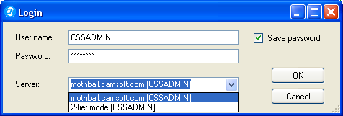

What we have in our Dev environment:

Nowadays we are working with a VM called “Mothball”. This machine is not only the Oracle server but also the app server. It has the COE Framework installed on it. This could be confusing but when we want to work in a simulated “3-Tier” mode we select Mothball from the Server dropdown. On the other hand, when we want to work in “2Tier”, we use “Mothball” just as the Oracle server.

1. The first time you bring CBVN up on a clean system, you'll see one hard-coded CS-specific entries, one for Mothball middle tier and one for 2-tier. At release time, the dialog will come up empty the first time you see it, but I left these CS entries in there for now since that's what we're used to.

2. When you choose an item from the list, it puts the associated username and password into the boxes. In other words, you are not just choosing a server, but also a username (as the items in the drop-down indicate).

3. You can edit the server name in the Server box. This will add a new item to the list and make it the topmost (selected) item next time you see the dialog. Editing the username in the Server box has no effect.

4. The Save Password checkbox is now hooked up. If you uncheck it, then the next time you call up that entry, the password box will be blank.

5. There is a sneaky way to edit the list. To remove an entry, (a) call it up, (b) blank the username box, (c) click OK. You will be prompted to confirm that you want to erase that entry.

There is a new "Connections" item on the Help menu, which brings up a message box showing various aspects of the current connection.

Navigation Pane

It’s a doclable pane you can move around and close anytime you would like to.
Pane title: indicates which pane group you are in and which item (for example, which form) you have selected.

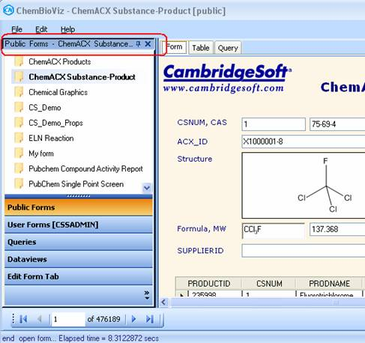

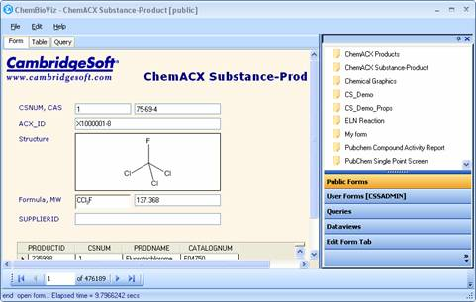

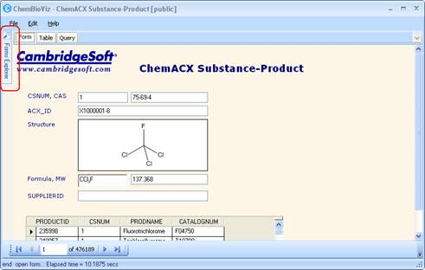

If you close this Pane, then you can restore it going to the “View"> “Explorer”
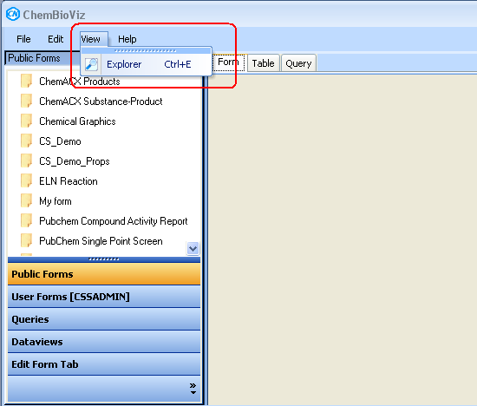

Settings Scheme

There is a file called ChemBioViz.NET.setttings located in
C:\Documents and Settings\All Users\Application Data\CambridgeSoft\ChemBioViz.NET\11.0.1.0
which contains all the necessary info to configure the application.

The settings are divided into sections. Each one is stored in a separate tag inside the file. General: stores everything related to the UI customization.
Search: stores everything related to the search preferences.

Most of these prefs are managed in “File”>”Preferences” menu.

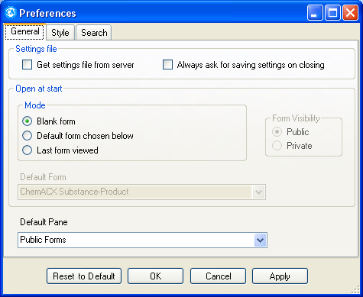

This is how the two main workflows are working now.

WorkFlow1 | WorkFlow2
- App starts.

- All settings get loaded in the Preferences helper instance.

- The user goes to Query Tab. There, he already has his settings loaded. | - The user goes to Pref menu.
 | - Preferences Dialog. Tabs: General & Style.  User checks some general prefs | - Preferences Dialog. Tab: Search.  User checks some Search prefs
 |  | - Advanced Search Dialog.
 |  | - User checks some Advanced Search prefs
 |  | - User presses OK button.  - Only new Advanced search prefs got stored in the Settings variables. |  | - User presses Cancel button  - Previous Advanced search settings get loaded again on the Settings variables.
 | 5. User presses:
 | - OK / Apply button;
    - Save all settings:
      - ALL settings get stored in user.config file.
      - ALL settings get loaded through PreferencesHelper class.
 | - Cancel button;
    - NONE of the settings get stored.
    - Restores all previous settings.
 | - Reset to Defaults button;
 | - If user is in General or Styles Tabs, then, only General prefs go back to their default values. |  | - If user is in Search Tab, then, only Search prefs go back to their default values.
 | - The user goes to Query tab and there, he already has his settings loaded.
- Stores the last opened form name
- Save all settings
- App exits.

These are some other added behaviors and validations:
  - General Tab:
    - Validate if the form that is being loaded from the settings really exists in the bank.
    - Validate if the “Default form” option is checked (open mode), then, the user has to select a form in the combobox. If not, a message appears when pressing OK or Apply buttons and we don’t let the user to move forward till he does so or checks any of the other options (Blank or Last viewed forms).
    - Added a validation that enables the “Default Form” comobobox and the Visibility RadioButtons only when “Default form” is selected.
  - Search Tab:
    - Threshold trackbar is only available if the “Similar” structure search is checked.
    - AdvancedSearch Dialog >Stereochemistry tab:
      - Made all controls -that appear in this tab- available only if “Match Stereochemistry” option is checked.

This is a basic workflow:
- Suppose you’ve just gotten settings from server and you’re there at the Preferences Dialog.
- Uncheck the “Get from server” option
- Set your own configuration.
- Press Ok to get them saved to the ChemBioViz.NET.settings file (C:\Documents and Settings\<user>\Application Data\CambridgeSoft\ChemBioViz.NET)
- You can opt not to restart the app since your settings are already saved.
- Enter to Preferences Dialog again.
- You’ll see your settings there.
- Now, you decide to get the prefs from db again.
- Check “Get from server” option.
- Warning shows up. Click YES.
- The app’ll be refreshed with the server version
- What happens internally?
  - Your local version is renamed to LocalChemBioViz.NET.settings
  - The server version is saved as usual, but this time, it won’t overwrite your local settings because we backed it up renaming our old file. So, now, you’re going to see two files in your C:\Documents and Settings\<user>\Application Data\CambridgeSoft\ChemBioViz.NET folder:
- LocalChemBioViz.NET.settings: your own preferences.
- ChemBioViz.NET.settings: db version.
- Imagine you decide to go back to your local prefs.
- Well, you have to uncheck the “Get from server” option. Internally,
  - It’ll look for a file called LocalChemBioViz.NET.settings
    - If it exists, then it will delete the server version (named as ChemBioViz.NET.settings) and rename the LocalChemBioViz.NET.settings file again to ChemBioViz.NET.settings
    - If it doesn’t exist, it’ll work with the ChemBioViz.NET.settings file. This could be the first time the user is setting prefs of his own.
  - The app’ll be refreshed with your version.

This workflow maybe sounds a little bit confusing but the main idea is to backup your own prefs and switch easily between the two of them.

Suppose we are in Preferences Dialog and it has the “save on server” option un-checked. If you check it, an event is raised and it asks if you want to bring the settings from server and overwrite the ones you already have. If you press YES, then it gets the settings, and the Pref Dialog gets refreshed with the server settings. This is a last moment change. Yesterday, I was not able to get it working. But I realized what was wrong today and made it.
Besides, I noticed a bug I had with the Sim Threshold and fixed it too.

Basic Steps:
- First the app checks if the file exists in the AppData folder.
- If it exists, then checks what the "GetPrefsFromServer" attribute indicates.
  - If true, gets the settings from the server.
  - If false, then works with the local ones.
- If the file doesn’t exist, it uses the Settings default values (the ones you see in the Settings grid). In this case, that attribute is set to True and the settings are brought from the server by default.
- If you un-check that “save on server” in Preferences dialog and change some other options, it’s supposed to store the settings locally and never go back to the server unless you do check it again.

Command line

To exercise the command-line features, start the program in a command box with a help argument, like this:

> chembioviz.net.exe /help

(or use /? or /h instead of /help).

This gives you a list of command-line options. All require that you enter a form name (path to a local xml file or name of a public or private form), followed optionally by arguments which allow you to:
(a) specify whether the form is public or private -- if omitted, it will search both lists and return the first match;
(b) give the name of a query to be run -- the query must be saved with the form being opened; (c) give a search query over a text or numeric or date field (not structure), specified by a field name and a query string;
(d) login from the command line, skipping the prompt dialog.

C:\Program Files\CambridgeSoft\ChemBioViz.NET>ChemBioViz.NET.exe /?

You’ll get:

Command line format:

chembioviz.net.exe <form> [/option=value ...]

where <form> = pathname to xml file or name of public or user form.

Options:

/login=name,password skip login dialog
/search=fieldname:query perform text or numeric search on open
/query=queryname run named query on open
/public named form is in Public collection
/user or /private named form is in User collection
/help or /? display this text

Examples:

Chembioviz.net.exe C:\myform.xml /login=admin,admin /query=Q2
chembioviz.net.exe CS_Demo /public /search=molweight:>200

Blank forms

1. Start the program in blank mode, or close the current form so you get a blank one.

2. Go into the form editor -- it will prompt you to select a dataview table if you don't have one selected.

In that case, click Dataviews and choose a table. After you select a dataview you have to click Edit Form again.

3. Now you're in the form editor with a table attached but no boxes. You can create boxes (including ChemDrawBox, now renamed in the toolbox) and bind them to the data source, and thus, create a form by hand from scratch.

Tab Creation

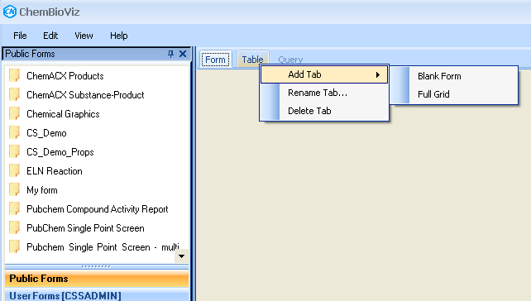

There are four options under the Add Tab menu when you right-click a tab depending on the type of the tab:

Blank Form -- creates a blank formview tab. You can go into the editor to add boxes. (1)

Duplicate Form -- makes a copy of the selected formview or query tab. (2)

Grid from Form -- creates a grid tab to match the selected formview tab . The columns of the new grid match the boxes of the formview. (3,4) This is new as of today.

Full Grid -- creates a new grid tab with all fields of the overall form. (5)

This is how it behaves:

 | Blank Form | Duplicate Form | Grid from Form | Full Grid | Query Form
FormView | x | x | x | x | x
GridView | X | - | - | x | -
QueryView | x | x | - | x | x

Create Grid From Form command.

1. Open a form.
2. On the Form tab, right-click and choose "Grid From Form”. You get a new grid tab, where each row can be expanded to show the subrows.
3. Now edit the form and delete the subform box.
4. Repeat step 2. This time the grid rows do not have the child rows under them. (If you want, you can choose Edit Grid to bring up the field chooser and get them back again).

Subforms

1. Open an existing form or create one from the dataviews pane. Each subform is created automatically from the data source.

2. In browse mode, you can modify a grid by dragging to resize or reposition columns.

3. Go into the form editor. Grids change to Windows DataGridView controls, with column sizes and orders preserved. There is a lot you can do in the form editor, using the properties window and the smart tag on the grid control -- rearrange or remove columns, bind to data sources, set properties including column width (but not by dragging). Exit form editing and the grid turns back into Infragistics, retaining the changes made in the editor.

Note the bottom checkbox on the grid smart tag: "allow repositioning columns." Check this if you want to be able to drag column headers while in browse mode. (The default should be YES, but currently it isn't.)

4. Add a new subform in the editor. Drag a "SubFormGrid" control onto the form. In the props grid, choose DataSource and select one of the child table binding sources (these still don't have friendly names, but pick one and you'll see the data).

Context menu:

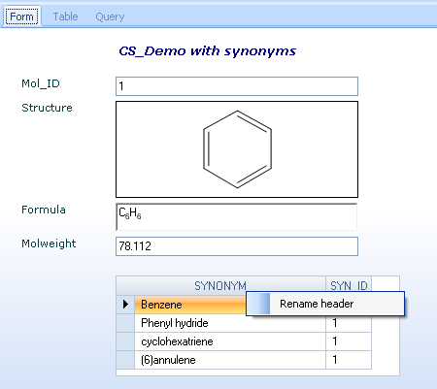

Grids

Field chooser:
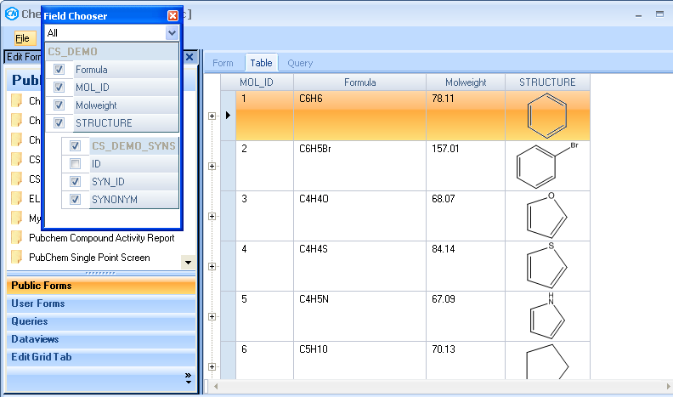

Changes are remembered

If you reorder or resize columns in a grid view tab, the changes are remembered. This happens for subform grids too.

To see this in action:

1. Open a form from.
2. Go to the Table tab.
3. Click a column header to select it, then press and drag to drop it between two other columns. Resize and rearrange columns to suit.
4. Save Local.
5. Close and reopen. When you go to the grid tab, columns should be as you left them.

Note: if you save a form while it has a grid tab showing, when you reopen, it shows the form tab. It should probably remember which tab was visible at the time of saving

Context menu:

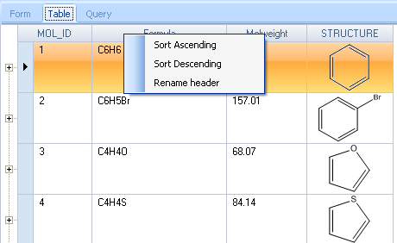
Sorting

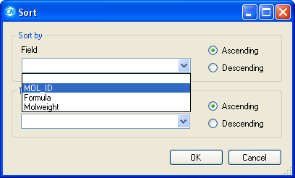

1. Open a form.
2. Choose Edit > Sort.
3. This brings up a dialog.
4. Select a field or two and the sorting order.
5. Press ok and you have to get the subform sorted.

Queries

To make a query form:
1. Open a form.
2. Go to the Query tab, then into the form editor (in case you want to add another field that is not already there).
3. Add a text box.
4. Under Data Bindings, choose Advanced, then select SYNONYM from BindingSource2.
5. Save and return.
6. Now try a search on this field: in the new box, enter a query like "benz" or "azo" or "cyclo". 7. Result will be hits which have this string somewhere among one of the synonyms.
8. The new query is added to the Session Queries Panel.

To try auto-link:
9. Repeat steps 2-5 but this time on the main form tab.
10. Browse the records. In the new synonyms box, you see a name which matches the first one in the subform.

Notes: Text searches. The default is with wildcards on both ends. I understand you can override this by including your own wildcard (*) at one end or the other.
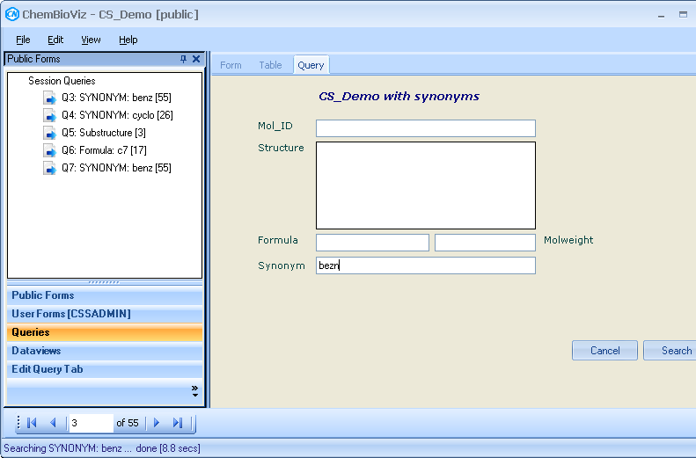

Saved queries

1. Create a form from a dataview, edit as desired.
2. Do a couple of searches.
3. Use File Save to store the form in the db.
4. The new saved form should be in the tree, and it should be visible.
5. File Close (or not), then double-click the saved form to open it.
6. Go to the queries pane and see if your queries are there. Double-click one to run it.

Note: These queries, as the name indicates, are stored for the whole group of forms.

Context Menu
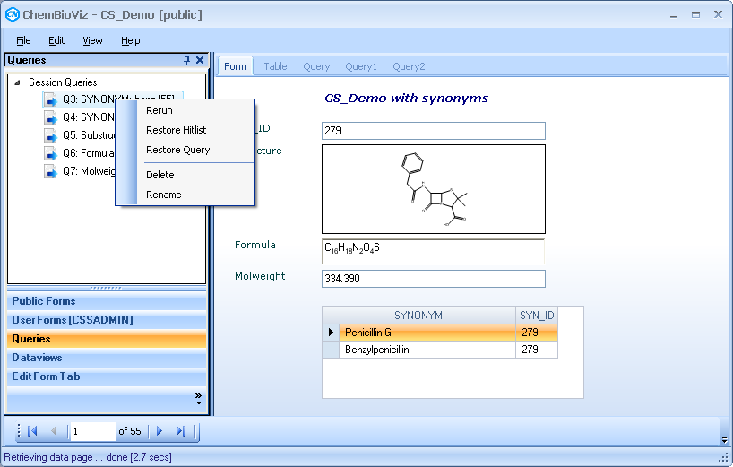

- Rerun
- Restore HitList (does the same Rerun command does)
- Restore Query
- Delete
- Rename

Restore Query

1. Open a form.
2. Bring up Queries pane.
3. Click to select one, then right-click and choose Restore Query.

The query tab comes up and the query that generated the query is shown in it. You can then modify it and/or hit Search.

Merging queries

Steps:

- Suppose you have more than one query.
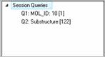
- Select one of them. For example, you want to make a Union between Q1 and Q2.
- Drag Q1 over Q2.
- Drop Q1 over Q2.
- When the left mouse button is released to perform the “drop” action, the MergeList dialog shows up.

- This dialog receives these two queries. I’ve replicated the dialog as it is on ChemFinder but I added a detail. Note that the L1 and L2 labels are showing the query.Description too. I thought that this could be helpful to have along with the query.Name and query.NumHits.
- The default option is “Replace”.

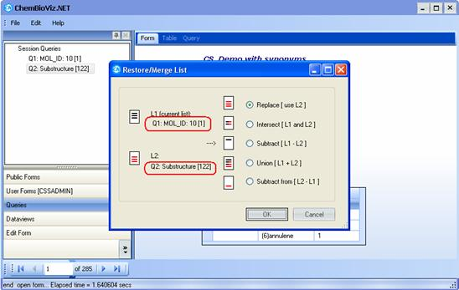

- Select any of the operation options.
- Click Ok
- The result is a new Query
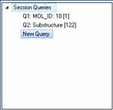

Notes: the first time you do a Restore Hitlist on a query, it does a Rerun instead. This means when you restore a merged query, it reruns both component searches.

Form Editor

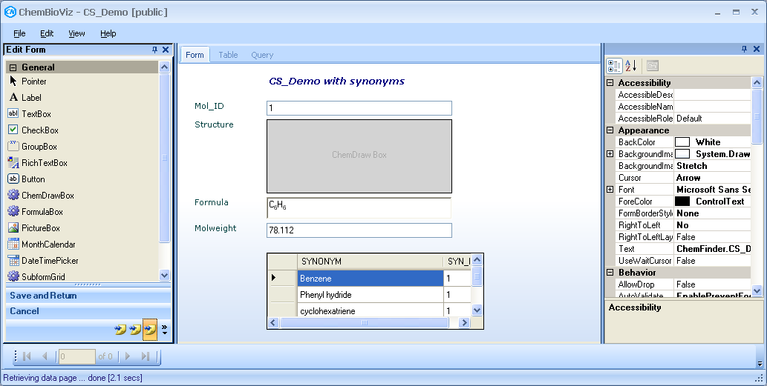

If you want to add a new box, then you could bind it to a field.

For example:

    - Open Cs_demo form.
    - Suppose you want to add the Molname field.
    - Go to the form editor.
    - Add a new textbox control taken from the Toolbox pane.
    - Go to Data section on the Properties Pane.
    - Click on the “…” button of the DataBindings > Advanced feature.
    - You’ll get this dialog as shown below
    - Press ok
    - Press Save and return button
    - Return to Form Tab.
    - You’ll see the new field bound to Molname.

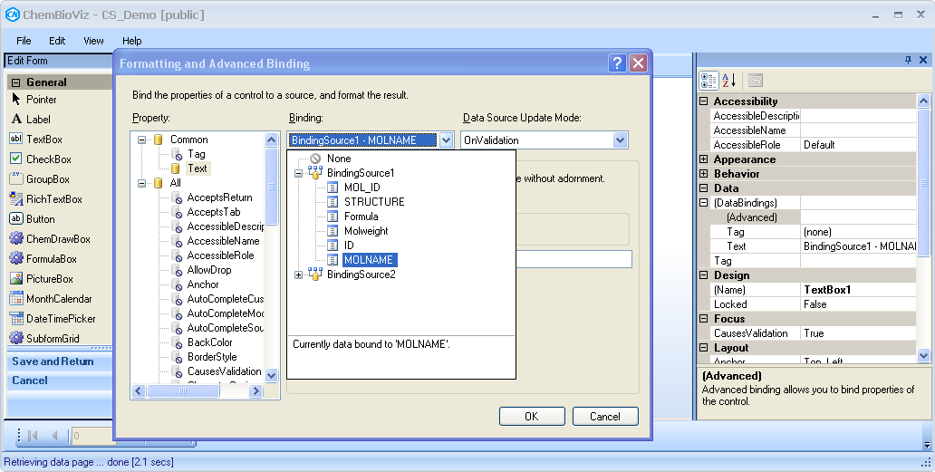

Adding Buttons

To try the button features, go into the form editor and add a button object to the form. In the props grid, you can bind it to a data field in the usual way (or not), then go to the bottom of the grid and specify an action from the drop-down, plus an argument telling the action what to work with, plus optionally a string to display on the button. Both the argument and display items allow embedding of fieldnames enclosed in percent signs, where "%%" represents the field bound to the button.

Actions are:

Launch <target> execute target -- path to any doc or exe or url
LaunchURL <url> open url in browser
OpenForm <form> open form in new app instance
Search for query tabs: behaves like existing Search button
Cancel for query tabs: abort without searching
Google <query> open browser and search for query
Message <text> display text in message box

For example, if the action is LaunchURL, the argument needs to be a url, starting with "http://...." If the action is OpenForm, the argument could be a pathname to a local xml file, or the name of a public or private form.

On closing

This commit is a scheme to prompt on closing whether you want to save changes.

To try:

1. Open a form.
2. Go into form editor.
3. Click Save & Return button.
4. Close window or exit. You should get a prompt about saving changes.

Save/ Save As…

File menu:

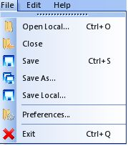

Open Local: opens a form saved on the user’s machine.

Close: clears the screen.

Save overwrites the previous version without prompt. This now applies to local files as well as database ones -- it overwrites whichever you started with, and shows you on the status bar what it's saving. If the form was not previously saved, then this command does a Save As instead.

Save As brings up the database form props box so you can enter name and comments, then saves to the database. If the name you choose is already in use, it says so and gives you a chance to change or not. This is for database-stored forms only.

Save Local brings up a file save dialog, as before.

Deffered requeriments

- Printing
- Exporting

