ChemOffice Enterprise

TableEditor

Revision History
Date | Revision | Description | Contributors
06/04/2008 | v.1 | Initial draft | David Gosalvez
06/20/2008 | v.2 | Refined the object model | David Zhang/Jerry Yu/Ran Tao
06/26/2008 | v2.1 | Refined the object model | David Zhang/Jerry Yu/Ran Tao
07/07/2008 | V2.2 | Modified and created xml’s | David Zhang/Jerry Yu/Ran Tao
07/10/2008 | V2.2.2 | Using tables in regdb as sample | David Zhang/Jerry Yu/Ran Tao
07/15/2008 | V2.2.3 | Changed default sequence name | David Zhang/Jerry Yu/Ran Tao
07/17/2008 | V2.2.4 | sequence name property | David Zhang/Jerry Yu/Ran Tao
07/18/2008 | V3 | Cleared up discussion | David Zhang/Jerry Yu/Ran Tao
09/23/2008 | V3.1 | Adding validation rule | Ran Tao
09/25/2008 | V3.2 | Overall amending | Ran Tao
01/07/2009 | V3.3 | Inner xml lookup feature | Ran Tao
01/16/2009 | V3.4 | Child table | Ran Tao/David Zhang
02/06/2009 | V3.4.1 | Paging note, child table | Ran Tao
02/09/2009 | V3.4.2 | Inner xml lookup default value | Ran Tao
02/11/2009 | V3.4.3 | Configuration xmls | Ran Tao

Copyright © 2008 CambridgeSoft Corporation. Cambridge, Massachusetts.
All Rights Reserved
This document is the property of CambridgeSoft Corporation and is intended for internal use only. Reproduction or transmission of this document in any form, in whole or in part, without prior written permission of CambridgeSoft Corporation is prohibited.

Overview:
ChemOffice Enterprise applications such as Registration, Inventory, or ChemBioViz make use of database tables whose data must be managed by the application administrator. For example, the Registration system has tables for Projects, Notebooks, Sequences, and Fragments. The Inventory system has tables such as Suppliers, Units of Measure, and Container Types. These tables need to be populated with appropriate customer specific values. In the past, each application has implemented its own graphical user interface to manage the data in this type of tables.

The COETableEditor is a new generic table management interface that can be used by any ChemOffice Enterprise application to populate and maintain simple database tables.

Requirements
- The graphical user interface of the COETableEditor must be implemented as ASP.NET pages or reusable controls that can be easily accessed from other ASP.NET applications.
- The editor will only be able to access a configurable list of tables from each application.
- The editor will only be able to access a configurable list of columns within each editable table.
- Columns will be configurable to allow displaying translated (lookup) values.
- Lookup values could come from a related database table or from a hardcoded list of values in the configuration.
- Columns containing chemical structure data will be displayed and edited using the ChemDraw Plugin.
- Editable date columns will be displayed and edited using a calendar control.
- If sequence is set in the configuration file, the table editor use the sequence to generate primary key values for new rows inserted into an editable table.
- Foreign key values will be displayed and edited using values from the related table.

- Child table support:
To provide a way to populate the VW_PEOPLE_PROJECT table. This table keeps track of which users have access to which projects in the registration system. The table has a many-to-one relationship with both the PEOPLE and the PROJECT tables. When populating or editing the PEOPLE table via the TableEditor, in addition to managing the data in the PEOPLE row, the TableEditor also needs to manage the related data in the PEOPLE_PROJECT table.

The COETableEditor will be written using the CSLA design principles. First a set of movable business objects will be created to handle all configuration, validation, and data persistence operations. Then a set of graphical user interface elements will be created to mediate between the user input and business objects. The business objects to support the COETableEditor user interface will be implemented in the ChemOffice Enterprise Framework using the namespace: CambridgeSoft.COE.Framework.COETableEditorService

Object Model

The following objects are used by the COETableEditor user interface to perform its tasks. COETableEditor and COETableEditorData are in CambridgeSoft.COE.Framework.Common namespace. COETableEditorBO and COETableEditorBOList are in COETableEditorService namespace.

COETableEditor

This object represents the table configuration information required by the COETableEditor to handle the table editing tasks for database tables. This object implements Microsoft.Practices.EnterpriseLibrary.Common.Configuration.NamedConfigurationElement to read table configuration information from the configuration file.

COETableEditorData

This object represents the column configuration information required by the COETableEditorData to handle the table editing tasks for database tables. This object implements Microsoft.Practices.EnterpriseLibrary.Common.Configuration.NamedConfigurationElement to read table’s column configuration information from the configuration file.

Additional property in ApplicationData.cs
/// <summary>
/// Gets the collection of defined <see cref="COETableEditor"/> objects.
/// </summary>
/// <value>
/// The collection of defined <see cref="COETableEditor"/> objects.
/// </value>
[ConfigurationProperty(tableEditorProperty, IsRequired = false)]
public NamedElementCollection<COETableEditor> TableEditor
{
get { return (NamedElementCollection<COETableEditor>)base[tableEditorProperty]; }
}

COETableEditorBO

This object represents a record of a COETableEditor editable table. This object implements CSLA base business object including data portal methods to read/write table data from/to the database. The object is responsible for generating the necessary SQL (or PL/SQL) calls to be executed via the COEFramework DAL architecture.

COETableEditorBOList

This object is implemented as a CSLA list object to hold a list of COETableEditorBO objects. The criteria to create the list of objects initially support creating a list of all editable tables for a given COE Application.

ValidationRule

This object represents a record of a validation rule of a column of a table. The object is responsible for validation of input data.

COEChildTable

This object represents the child table configuration information for parent-child table situation. This object contains parent-child relation information. When
PEOPLE is parent table, PROJECT is child table, in which way it potencially supports displaying multi-field of child table.

COEChildTableData

This object represents the column configuration information of the child table.

Class Diagram:

See Figure 1
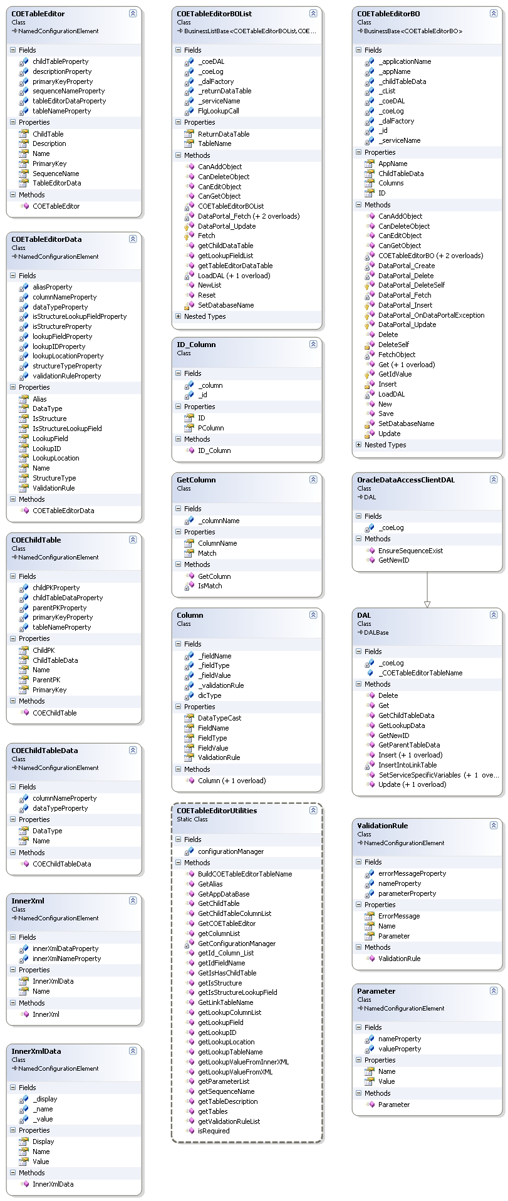

Figure 1: Class Diagram.
GUI Design

The graphical user interface for the table editor is implemented in ASP.NET. It is encapsulated into a control, which is easily re-usable from other applications. The table editor typically operates within the context of the application that uses it. The application configuration describes the list of editable tables, fields, and lookups.

Users are able to accomplish the following tasks via the editor GUI:
- Select a table to edit
- View a certain number of records of the table to edit (configurable, including all editable fields). Page through the table records (configurable, if set an invalid value, it uses the default 10).
- Sort the records in one page by any field.
- Hide non-editable fields, such as primary keys.
- Add, edit or delete a new record.
- View chemical structure fields in ChemDraw Plugin.
- Allow for translated (lookup) values to be shown, from a related database table, from a hardcoded xml, or from a list of values (inner XML) in the configuration are all supported. Display picklist (lookup) values during data entry and edit. Also allow null to be displayed and assigned to the field to be translated. In the lookup dropdown list, the first value is null.
- Provide a convenient way to update “child” table with bi-direction arrow buttons. For example, VW_PEOPLE_PROJECT table keeps track of which users have access to which projects in the registration system. The table has a many-to-one relationship with both the PEOPLE and the PROJECT tables. When populating or editing the PEOPLE table via the TableEditor, in addition to managing the data in the PEOPLE row, the TableEditor also manages the related data in the PEOPLE_PROJECT table.
- Set validation rules for a field.

GUI styles can be modified through the control’s properties.
Property | Default Value | Applied to
UltraWebGridHeaderStyle | HeaderStyle | UltraWebGrid
UltraWebGridFrameStyle | FrameStyle | UltraWebGrid
PanelEditBtnStyle | pnlEditBtnStyle | Button panels in add page and edit page
PanelEditRecordStyle | pnlEditRecordStyle | Field panels in add page and edit page
PanelSetPageStyle | pnlPageStyle | Paging config. panel
PanelTableDescriptionStyle | pnlTableDescriptionStyle | Table description panel
PanelViewTableStyle | pnlViewTableStyle | WebGrid page panel, which contains all the items of this page.
Screen Shots

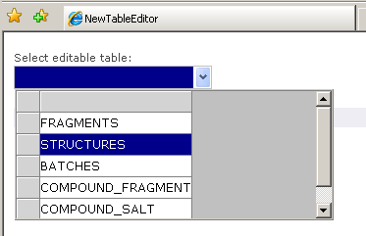
Figure 2:
A dropdown for selecting a table.

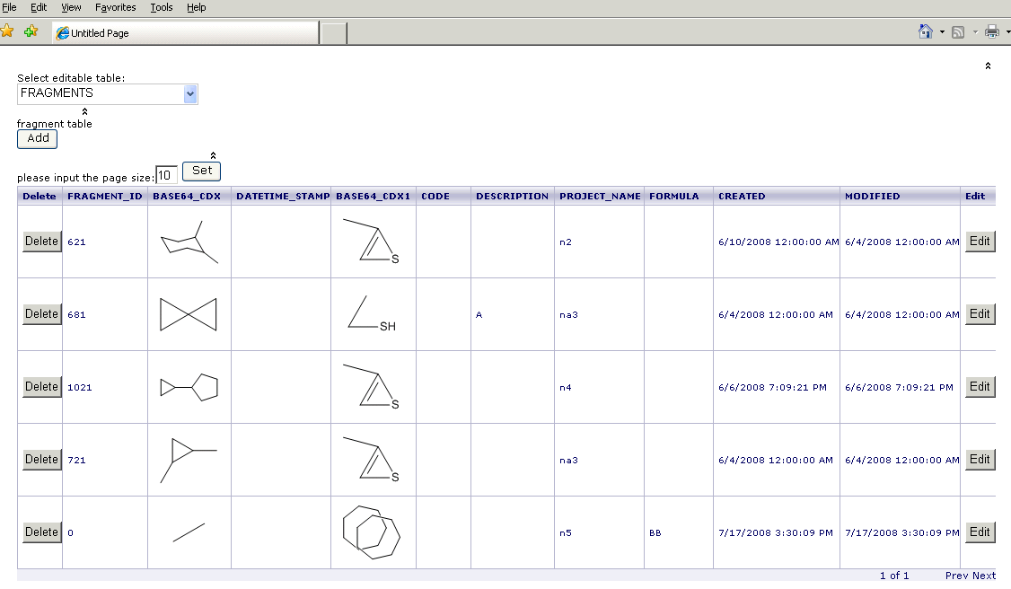
Figure 3:
A WebGrid showing paged rows of the table with lookup value.
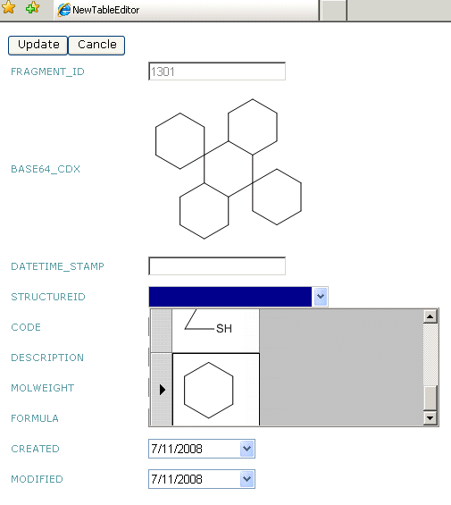
Figure 4:
A panel for updating/adding a record, with lookup values that can be selected from a dropdown list.

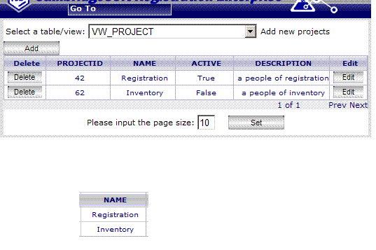
Figure 5: Parent-child table situation in View panel. When a record of parent table (above) is highlighted, the corresponding information of child table is shown below.

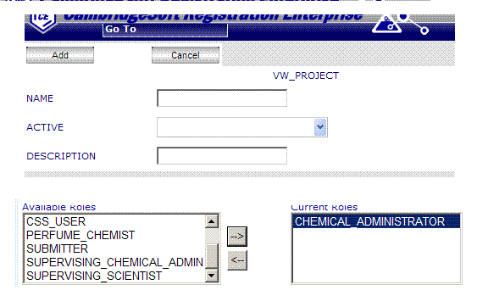
Figure 6: Parent-child table situation in Add panel. By using two list boxes and bi-direction arrows, both parent table and child table will be inserted with new records.

Configuration

As described above, the COETableEditor is driven by configuration data. This data will be initially stored in the COEFrameworkConfig.xml. The COETableEditorService business objects are responsible for reading this configuration data. Refer to List 2 for the semantics of the table editor configuration data.

Configuration information directly under Node <tableEditor> includes:
name: Table name
description: Table description
primaryKeyField: Primary key
Must have a corresponding column set in <tableEditorData>
sequenceName: Sequence name
- Omit sequenceName or set sequenceName=”” when there is a trigger in database generating primary key values.
- Set sequenceName=”sequecename” when the trigger does not exist. Table Editor then uses the sequence to generate primary key values and if the sequence does not exist, Table Editor creates it.

Configuration information directly under Node <tableEditorData> includes:
name: Column name
dataType: Column data type
number, string or date
alias: Column header
isStructure: If a column value is structure
The editor relies on this explicit configuration information to determine whether a field is structure.
structureType: Structure data type
This property would be used in the future. The ChemDraw ActiveX should be capable or rendering all the formats supported by the CS Cartridge (B64CDX, CDXML, CDX, MOL, SMILES). We may need to make enhancements to the ASP.NET ChemDraw Embed control to support the formats.
lookupLocation: Lookup location
LookupLocation determines the location where to find lookup values.
- Set to “database” when lookup values are from table in database.
- Set to the xml file name proceeding with its exact path info when lookup values are from hard coded xml file. Refer to List 1: lvStructures.xml for the hard coded xml file format.
- Set to “innerXml_<innerXmlName>” when lookup values are from xml element within COEFrameworkConfig.xml. <innerXmlName> is the value of “name” attribute of “add” element within “innerXml” element. lookupID or lookupField in this case are not required due to the limitation of the format of COEFrameworkConfig.xml. Refer to List 2: Table and innerXml configuration in COEFrameworkConfig.xml.
lookupID: Lookup ID
The field that is to be translated into lookupField value uses lookupID, which should be the primary key of the lookup table, to locate the corresponding record. Although such a field will be translated, TableEditor supports that it is null, by allowing null to be displayed and be assigned.
lookupField: Lookup field
isStructureLookupField: If the lookup field value is structure
validationRule: Column validation rules
To check if the value user entered is valid. Implemented with ASP.NET validation controls. Refer to List 2 for the semantics.
name: validation rule name
errorMessage: validation rule error message
parameter: parameter of the validation rule
name: parameter name
value: parameter value

Configuration information directly under Node <childTable> includes:
name: Child table name
primaryKeyField: Primary key
Must have a corresponding column set in <childTableData>
parentPK: Link table’s foreign key of parent table’s primary key
childPK: Link table’s foreign key of child table’s primary key

Configuration information directly under Node <childTableData> includes:
name: Column name of child table
dataType: Column data type of child table
The last item within <childTableData> will be the item showing in listboxes on Insert and Edit panels.

Configuration information directly under Node <innerXml> includes:
name: inner xml name
Must meet the part after underline of the corresponding lookupLocation value

Configuration information directly under Node <innerXmlData> includes:
name: Column name
Only to avoid parsing error. They could be set with any string however, not duplicate to each other.
value: works as lookupID
display: works as lookupField
The names and roles of attribute value and display are fixed and unchangeable.
The first child node will be used as the default value if the field to be looked up is set to required.

Validation Rules

requiredField: Cannot be empty
chemicallyValid: Must be a valid chemical structure. For structure field only, by checking MW>0
textLength: Must be between min and max (both included) if not null. For string field only.
positiveInteger: Must be a positive integer if not null
positiveNumber: Must be a positive number if not null
numericRange: Must be between min and max (both included) if not null. For number field only.
custom: Custom validation script, which is defined in clientScript.

<?xml version="1.0" encoding="utf-8" ?>
<!-- THIS FILE IS AN ALTERNATIVE WAY TO PROVIDE LOOKUP VALUE -->
<table name="STRUCTURES">
<row>
<CPD_INTERNAL_ID dataType="number">11</CPD_INTERNAL_ID>
<BASE64_CDX dataType="string">VmpDRDAxMDAEAwIBAAAAAAAAAAAAAACAAAAAAAMADwAAAENoZW1EcmF3IDExLjAI ABMAAABVbnRpdGxlZCBEb2N1bWVudAQCEADtxOX/TSL/////AwCZfSgAAQkIAAAA AAAAAAAAAgkIAAAAhwAAAIcADQgBAAEIBwEAAToEAQABOwQBAABFBAEAATwEAQAA DAYBAAEPBgEAAQ0GAQAAQgQBAABDBAEAAEQEAQAACggIAAMAYADIAAMACwgIAAQA AADwAAMACQgEADOzAgAICAQAAAACAAcIBAAAAAEABggEAAAABAAFCAQAAAAeAAQI AgB4AAMIBAAAAHgAIwgBAAUMCAEAAAIIEAAAACQAAAAkAAAAJAAAACQAAAMyAAgA ////////AAAAAAAA//8AAAAA/////wAAAAD//wAAAAD/////AAAAAP////8AAP// AAEkAAAAAgADAOQEBQBBcmlhbAQA5AQPAFRpbWVzIE5ldyBSb21hbgGACwAAAAQC EAAAAAAAAAAAAAAA0AIAABwCFggEAAAAJAAYCAQAAAAkABkIAAAQCAIAAQAPCAIA AQADgAkAAAAEAhAA7cTl/00i/////wMAmX0oAASAAQAAAAACCAAAAAAAAAAAAAoA AgACAAEDBAADAAAANwQBAAEAAASAAgAAAAACCADtBOb/AAAPAAoAAgADAAEDBAAD AAAANwQBAAEAAASAAwAAAAACCAAAAAAAAAAeAAoAAgAEAAEDBAADAAAAAgQCABAA KwQCAAEANwQBAAEGgAAAAAAAAggAZuYDAACkGgAEAhAAEnH7/wCkGgD//wMAmX0o AAEDBAADAAAAIwgBAAACBwIAAAAFBwEAAQAHDgABAAAAAwBgAMgAAwBTSAAAAAAF gAUAAAAKAAIABQABAwQAAwAAAAQGBAABAAAABQYEAAIAAAAKBgEAAQAABYAHAAAA CgACAAcAAQMEAAMAAAAEBgQAAQAAAAUGBAADAAAACgYBAAEAAAAAAAAAAAAA</BASE64_CDX>
<MOL_ID dataType="number">321</MOL_ID>
<LOAD_ID dataType="string">7</LOAD_ID>
</row>
<row>
<CPD_INTERNAL_ID dataType="number">12</CPD_INTERNAL_ID>
<BASE64_CDX dataType="string">VmpDRDAxMDAEAwIBAAAAAAAAAAAAAACAAAAAAAMADwAAAENoZW1EcmF3IDExLjAI ABMAAABVbnRpdGxlZCBEb2N1bWVudAQCEADck+H/TSL/////AwBmSiEAAQkIAAAA AAAAAAAAAgkIAAAAhwAAAIcADQgBAAEIBwEAAToEAQABOwQBAABFBAEAATwEAQAA DAYBAAEPBgEAAQ0GAQAAQgQBAABDBAEAAEQEAQAACggIAAMAYADIAAMACwgIAAQA AADwAAMACQgEADOzAgAICAQAAAACAAcIBAAAAAEABggEAAAABAAFCAQAAAAeAAQI AgB4AAMIBAAAAHgAIwgBAAUMCAEAAAIIEAAAACQAAAAkAAAAJAAAACQAAAMyAAgA ////////AAAAAAAA//8AAAAA/////wAAAAD//wAAAAD/////AAAAAP////8AAP// AAEkAAAAAgADAOQEBQBBcmlhbAQA5AQPAFRpbWVzIE5ldyBSb21hbgGACwAAAAQC EAAAAAAAAAAAAAAA0AIAABwCFggEAAAAJAAYCAQAAAAkABkIAAAQCAIAAQAPCAIA AQADgAkAAAAEAhAA3JPh/00i/////wMAZkohAASAAQAAAAACCAAAAAAAAAAAAAoA AgACAAEDBAADAAAANwQBAAEAAASAAgAAAAACCADtBOb/AAAPAAoAAgADAAEDBAAD AAAAAgQCAAcAKwQCAAAANwQBAAEGgAAAAAAAAggAVOvp/wBoCwAEAhAA3JPh/wBo CwBU6+n/M5sSAAEDBAADAAAAIwgBAAACBwIAAAAFBwEAAQAHDQABAAAAAwBgAMgA AwBOAAAAAASAAwAAAAACCAAAAAAAAAAeAAoAAgAEAAEDBAADAAAAAgQCABAAKwQC AAAANwQBAAEGgAAAAAAAAggAZuYDAACkGgAEAhAAEnH7/wCkGgD//wMAZkohAAED BAADAAAAIwgBAAACBwIAAAAABw0AAQAAAAMAYADIAAMAUwAAAAAFgAUAAAAKAAIA BQABAwQAAwAAAAQGBAABAAAABQYEAAIAAAAABgIAAgADBgIAAgALBhAAAAAAAAcA AAAGAAAAAAAAAAAABYAGAAAACgACAAYAAQMEAAMAAAAEBgQAAgAAAAUGBAADAAAA CgYBAAEAAAWABwAAAAoAAgAHAAEDBAADAAAABAYEAAEAAAAFBgQAAwAAAAoGAQAB AAAAAAAAAAAAAA==</BASE64_CDX>
<MOL_ID dataType="number">22</MOL_ID>
<LOAD_ID dataType="string">4</LOAD_ID>
</row>
<row>
<CPD_INTERNAL_ID dataType="number">13</CPD_INTERNAL_ID>
<BASE64_CDX dataType="string">VmpDRDAxMDAEAwIBAAAAAAAAAAAAAACAAAAAAAMADwAAAENoZW1EcmF3IDExLjAI ABMAAABVbnRpdGxlZCBEb2N1bWVudAQCEADck+H/TSL/////AwBmSiEAAQkIAAAA AAAAAAAAAgkIAAAAhwAAAIcADQgBAAEIBwEAAToEAQABOwQBAABFBAEAATwEAQAA DAYBAAEPBgEAAQ0GAQAAQgQBAABDBAEAAEQEAQAACggIAAMAYADIAAMACwgIAAQA AADwAAMACQgEADOzAgAICAQAAAACAAcIBAAAAAEABggEAAAABAAFCAQAAAAeAAQI AgB4AAMIBAAAAHgAIwgBAAUMCAEAAAIIEAAAACQAAAAkAAAAJAAAACQAAAMyAAgA ////////AAAAAAAA//8AAAAA/////wAAAAD//wAAAAD/////AAAAAP////8AAP// AAEkAAAAAgADAOQEBQBBcmlhbAQA5AQPAFRpbWVzIE5ldyBSb21hbgGACwAAAAQC EAAAAAAAAAAAAAAA0AIAABwCFggEAAAAJAAYCAQAAAAkABkIAAAQCAIAAQAPCAIA AQADgAkAAAAEAhAA3JPh/00i/////wMAZkohAASAAQAAAAACCAAAAAAAAAAAAAoA AgACAAEDBAADAAAANwQBAAEAAASAAgAAAAACCADtBOb/AAAPAAoAAgADAAEDBAAD AAAAAgQCAAcAKwQCAAAANwQBAAEGgAAAAAAAAggAVOvp/wBoCwAEAhAA3JPh/wBo CwBU6+n/M5sSAAEDBAADAAAAIwgBAAACBwIAAAAFBwEAAQAHDQABAAAAAwBgAMgA AwBOAAAAAASAAwAAAAACCAAAAAAAAAAeAAoAAgAEAAEDBAADAAAAAgQCABAAKwQC AAAANwQBAAEGgAAAAAAAAggAZuYDAACkGgAEAhAAEnH7/wCkGgD//wMAZkohAAED BAADAAAAIwgBAAACBwIAAAAABw0AAQAAAAMAYADIAAMAUwAAAAAFgAUAAAAKAAIA BQABAwQAAwAAAAQGBAABAAAABQYEAAIAAAAABgIAAgADBgIAAgALBhAAAAAAAAcA AAAGAAAAAAAAAAAABYAGAAAACgACAAYAAQMEAAMAAAAEBgQAAgAAAAUGBAADAAAA CgYBAAEAAAWABwAAAAoAAgAHAAEDBAADAAAABAYEAAEAAAAFBgQAAwAAAAoGAQAB AAAAAAAAAAAAAA==</BASE64_CDX>
<MOL_ID dataType="number">41</MOL_ID>
<LOAD_ID dataType="string">3</LOAD_ID>
</row>
<row>
<CPD_INTERNAL_ID DataType="number">22</CPD_INTERNAL_ID>
<BASE64_CDX DataType="string" />
<MOL_ID DataType="number" />
<LOAD_ID DataType="string">3</LOAD_ID>
</row>
</table>

List 1: lvStructures.xml, a hardcoded list of values as an xml file.
<applications>
<add name="REGISTRATION" database="REGDB">
<tableEditor>
<add name="FRAGMENTS" description="fragment table" primaryKeyField="FRAGMENT_ID" sequenceName="SEQ_FRAGMENTS">
<tableEditorData>
<add name="FRAGMENT_ID" dataType="number" alias="FragmentID_Alias" />
<add name="BASE64_CDX" dataType="string" isStructure="true" structureType="BASE64_CDX">
<validationRule>
<add name="requiredField" errorMessage="This field is required." />
<add name="chemicallyValid" errorMessage="This field must be a chemical structure." />
</validationRule>
</add>
<add name="DATETIME_STAMP" dataType="string" />
<!-- <add name="STRUCTUREID" dataType="number" lookupLocation="C:\lvStructures.xml" lookupID="STRUCTURES.CPD_INTERNAL_ID" lookupField="STRUCTURES.BASE64_CDX" isStructureLookupField="true" structureType="BASE64_CDX"> -->
<add name="STRUCTUREID" dataType="number" lookupLocation="database" lookupID="STRUCTURES.CPD_INTERNAL_ID" lookupField="STRUCTURES.BASE64_CDX" isStructureLookupField="true" structureType="BASE64_CDX">
<validationRule>
<add name="requiredField" errorMessage="This field is required." />
</validationRule>
</add>
<add name="CODE" dataType="string" />
<add name="DESCRIPTION" dataType="string" alias="Fragment Description" >
<validationRule>
<add name="textLength" errorMessage="The length must be between 1 and 10.">
<parameter>
<add name="min" value="1" />
<add name="max" value="10" />
</parameter>
</add>
</validationRule>
</add>
<add name="FRAGMENTTYPEID" dataType="number" lookupLocation="database" lookupID="VW_FRAGMENTTYPE.ID" lookupField="VW_FRAGMENTTYPE.DESCRIPTION" alias="Fragment Type" />
<add name="MOLWEIGHT" dataType="number">
<validationRule>
<add name="requiredField" errorMessage="This field is required." />
<add name="positiveInteger" errorMessage="This field must be a positive integer." />
<add name="positiveNumber" errorMessage="This field must be a positive number." />
<add name="numericRange" errorMessage="This field must be between 0.1 and 10.5.">
<parameter>
<add name="min" value="0.1" />
<add name="max" value="10.5" />
</parameter>
</add>
</validationRule>
</add>
<add name="FORMULA" dataType="string">
<validationRule>
<add name="custom" errorMessage="The value should contain 'aaa'.">
<parameter>
<add name="clientScript" value="var num = arguments.Value; if(num.indexOf('aaa')>-1) { arguments.IsValid = true; } else { arguments.IsValid = false; }" />
</parameter>
</add>
</validationRule>
</add>
<add name="CREATED" dataType="date" />
<add name="MODIFIED" dataType="date" />
</tableEditorData>
</add>
<add name="STRUCTURES" description="Compound Structures" primaryKeyField="CPD_INTERNAL_ID" sequenceName="SEQ_STRUCTURES">
<tableEditorData>
<add name="CPD_INTERNAL_ID" dataType="number" />
<add name="BASE64_CDX" dataType="string" isStructure="true" structureType="BASE64_CDX" />
<add name="MOL_ID" dataType="number" />
<add name="LOAD_ID" dataType="string" />
<add name="DATETIME_STAMP" dataType="string" />
</tableEditorData>
</add>
<add name="COMPOUND_TYPE" description="COMPOUND_TYPE" primaryKeyField="COMPOUND_TYPE" sequenceName="SEQ_COMPOUND_TYPE">
<tableEditorData>
<add name="COMPOUND_TYPE" dataType="number" />
<add name="DESCRIPTION" dataType="string" />
<add name="ACTIVE" dataType="number" />
</tableEditorData>
</add>
<add name="VW_BATCH_PROJECT" description="VW_BATCH_PROJECT" primaryKeyField="ID">
<tableEditorData>
<add name="ID" dataType="number" />
<add name="BATCHID" dataType="number" />
<add name="PROJECTID" dataType="number" />
</tableEditorData>
</add>
<add name="COEDB.PEOPLE" description="COEDB.PEOPLE" primaryKeyField="PERSON_ID">
<tableEditorData>
<add name="PERSON_ID" dataType="number" />
<add name="TITLE" dataType="string" />
</tableEditorData>
<childTable>
<add name="VW_PROJECT" primaryKeyField="PROJECTID" parentPK="VW_PEOPLEPROJECT.PERSONID" childPK="VW_PEOPLEPROJECT.PROJECTID">
<childTableData>
<add name="PROJECTID" dataType="number" />
<add name="NAME" dataType="string" />
</childTableData>
</add>
</childTable>
</add>
<add name="VW_PROJECT" description="VW_PROJECT" primaryKeyField="PROJECTID">
<tableEditorData>
<add name="PROJECTID" dataType="number" />
<add name="NAME" dataType="string" />
<add name="ACTIVE" dataType="string" lookupLocation="innerXml_ACTIVECASES">
<validationRule>
<add name="requiredField" errorMessage="This field is required." />
</validationRule>
</add>
</tableEditorData>
<childTable>
<add name="COEDB.PEOPLE" primaryKeyField="PERSON_ID" parentPK="VW_PEOPLEPROJECT.PROJECTID" childPK="VW_PEOPLEPROJECT.PERSONID">
<childTableData>
<add name="PERSON_ID" dataType="number" />
<add name="TITLE" dataType="string" />
</childTableData>
</add>
</childTable>
</add>
</tableEditor>
<innerXml>
<add name="ACTIVECASES">
<innerXmlData>
<add name="id1" value="1" display="True" />
<add name="id2" value="0" display="False" />
</innerXmlData>
</add>
</innerXml>
</add>
</applications>

List 2: Table and innerXml configuration in COEFrameworkConfig.xml.

