COE Export Service Specification

Publication Record
Version | Date Revised | Primary Author | Description
1 | 11/21/2007 | L. Bialic | Initial version

Table of Contents
Publication Record 1
Table of Contents 2
1. Introduction 3
1.1. Purpose 3
1.2. Scope 3
1.3. Overview 3
1.4. Implementation 3
1.4.1. Class Diagram 5
1.4.1.1. GetData 5
1.4.1.2. GetFormatters 5
Formatters: 5

- Introduction
  - Purpose
This document describes the COE Export service.

  - Scope
The scope of this document to detail the Export Service.

  - Overview
The role of the Export Service is to provide a way to export data from a search in a format other then a dataset. The conversion is performed by classes called Formatters.. The architecture of the export service is flexible so as to provide an expansion route for adding new formatters as needed.

  - Implementation
The export service in general follows the command object COEFramework Service architecture. With the exception that there is no DAL within the service. The DAL functionality is provided as part of the search service on which the export service uses to retrieve the dataset to be reshaped..

Service Flow:

The COEExport object calls COESearch to get the dataset. Prior to getting the dataset from the search service, the COEExport service loads a formatter based on the export type desired. As part of the formatter process, it may modify the incoming ResultsCriteria in order to add alternate items. Once this is done the COEExport service then calls the search service to get a result set in the form of a dataset. The loaded formatter is then once again called and passed the dataset to reshape and return. The client receives the

Formatter
COEExport
COESearch
Client sends a hitlistid from a previous search
Database
COESearch returns a DataSet
ResultCriteria and COEDataView send to COESearch

DataSet sent to formatter
Reshaped dataset as string

ExportType, HitlistID, resultsCriteria and Dataview sent to COEExport
Export data as string returned to client.

    - Class Diagram

Below is the class diagram for this service:

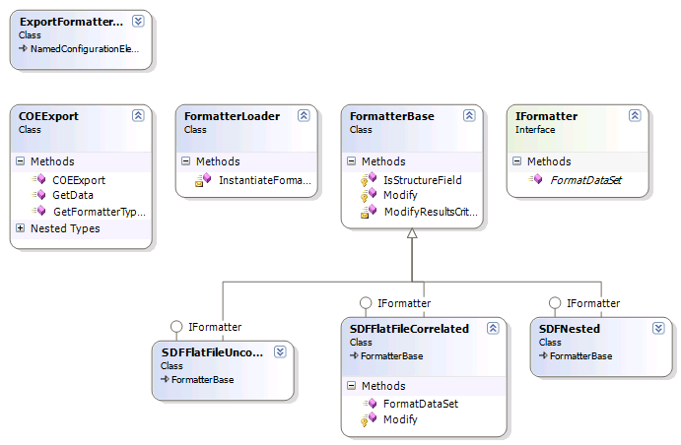

The public functions are contained in the COEExport class. This is the class that clients will call. The methods are:

      - Get Data
This is the main method of the COEExport class. It is responsible for loading the formatter using the FormatterLoader factory. Formatter classes are found by using the exporttype sent to COEExport and interogatting the COEFrameworkConfig using the ExportFormatter configurationhandler, which returns the assembly and type for the formatter. Each formatter inherits from the FormatterBase and IFormatter interface. . The FormatterBase provides virtual methods that allow for modifying the ResultsCriteria for special situations. For example, converting a base64 structure filed to its molfile equivalent.

Implementation for determining if a field from the ResultsCriteria is a structure have default implementations, but can be overridden. The Modify method is also virtual and is used to add criteria to a ResultCriteriaTable when a field of interest is found. In the case of molfile conversion, for example, the criteria item added is of the type SelectClauseCDXtoMolFile.

      - GetFormatterList
This method simply returns the list of formatters available to the framework by interrogating the COEFrameworkConfig file. Thii method would be used by a client to determine the export types available to use. This still needs to be implemented.

  - Formatters
As already mentioned above, each formatter inherits from the FormatterBase and implements the IFormatter interface.
The formatterBase provides virtual methods with default implementations for modifying results criteria to add a specialized selectclause item, . This changes the resulting sql that the sql generator uses to create the dataset.

The first formatters provided are SDFile formatters. These come in three flavors, SDFlatFileCorrelated, SDFileFlatUncorreled and SDFNested.

Each formatter is a single class file that implements to methods:

Modify: returns resultscriteria that is modified, or if no modification is done returns
FormateDataSet: performs the reshaping of the dataset based on the needs of the formatter.

Formatter Implementations:

For the following examples, the table organization below will be used. The basetable is RegNumbers with two child tables, IC50 and EC50 each having three results.

RegNumbers | IC50 | EC50
AB-000001 | 10  10  10 | 11  11  11
AB-000002 | 20 | 22
 | 20 | 22
 | 20 | 22

SDFFlatFileCorrelated : implies that there is some relationship between child tables

The formatter should take these results and create a sdfile containing the following records:
RegNumbers | IC50 | EC50
AB-000001 | 10 | 11
AB-000001 | 10 | 11
AB-000001 | 10 | 11
AB-000002 | 20 | 22
AB-000002 | 20 | 22
AB-000002 | 20 | 22
SDFFlatFileUncorrelated : implies that is no relationship between child tables

The formatter should take these results and create a sdfile containing the following records:
RegNumbers | IC50 | EC50
AB-000001 | 10
AB-000001 | 10
AB-000001 | 10
AB-000001 |  | 11
AB-000001 |  | 11
AB-000001 |  | 11
AB-000002 | 20
AB-000002 | 20
AB-000002 | 20
AB-000002 |  | 22
AB-000002 |  | 22
AB-000002 |  | 22

SDFNested maintains associations between base and child tables

The formatter should take these results and create a sdfile containing the following records:
RegNumbers | IC50 | EC50
AB-000001 | 10  10  10 | 11  11  11
AB-000002 | 20 | 22
 | 20 | 22
 | 20 | 22

