ChemOffice Enterprise

Page Control Settings

Revision History
Date | Revision | Description | Contributors
02/10/2009 | v.1 | Initial draft | Ulises Arcidiacono
02/14/2009 | V1.0.1 | Added master xml examples and class changes | Ulises Arcidiacono
02/22/2009 | V2.1 | Refined the object model | David Zhang/Jerry Yu/Ran Tao
02/23/2009 | V2.2 | Modified Database | David Zhang/Jerry Yu/Ran Tao
02/25/2009 | V2.2.1 | Modified GUI | David Zhang/Jerry Yu/Ran Tao
02/26/2009 | V2.2.2 | Add the deploy notes | David Zhang/Jerry Yu/Ran Tao

Copyright © 2009 CambridgeSoft Corporation. Cambridge, Massachusetts.
All Rights Reserved
This document is the property of CambridgeSoft Corporation and is intended for internal use only. Reproduction or transmission of this document in any form, in whole or in part, without prior written permission of CambridgeSoft Corporation is prohibited.
Overview:
ChemOffice Enterprise applications such as Registration, Inventory, or ChemBioViz need a way to disable controls, pages, forms according the privileges of the authenticated user.
In the past (only was implemented for Registration) we had a xml called COEPageControlSettings.xml that had the list of privileges and controls to be disable if the user didn’t have any of those listed privileges. The GUIShell class was in charge to read and parse this xml and disabling controls accordingly.

Changes in the xml were done by hand because the lack of a tool to accomplish this.

This feature contains three important sections:
- Framework control to allow edition of customized controls/pages settings.
- CSLA objects definition (Master and customized)
- GUIShell settings to work with this data source.

Note that we are specifying the controls that we want to disable in the application given a list of missing privileges. This means that with a COEPageControlSettings object that has the details of all the pages and controls but it doesn’t have any information about privileges that entire application will be available to any user. This means that we only have to edit the control when we want to disable a given control to a given particular privilege.

P4 location:
//depot/Informatics/Team/.net/ChemOfficeEnterprise/Framework/CambridgeSoft/ServiceTier/CambridgeSoft.COE.Framework/Common/PageControlSettings/

Requirements
- The graphical user interface of the COEPageControlSettings must be implemented as an ASP.NET reusable control that can be easily accessed from other ASP.NET applications (e.g. COEManager and Registration).
- The edition control will only be able to access a configurable list of pages/controls/forms from each application and to a list of privileges and the control will provide a way to associate a list of privileges to a given control (e.g. a control, a form, etc).
- The COEControlPagesetting will be able to manage 2 configurations:
  - “Master”: contains the definition of all the controls, all the pages and all the forms that are able to set its visibility, but it doesn’t contain any information regarding privileges. It also will contain details of each control as name, description, friendly name, etc.
  - “Custom”: contains the most basic information to disable a control in a page. It doesn’t contain details such as name, description, etc.

The COEPageControlSettings will be written using the CSLA design principles. First a set of mobile business objects will be created to handle all configuration, and data persistence operations. Then a set of graphical user interface elements will be created to mediate between the user input and business objects. The business objects to support the COEPageControlSettings user interface will be implemented in the ChemOffice Enterprise Framework using the namespace:
CambridgeSoft.COE.Framework.Common.PageControlSettings

Object Model
Here is a list of the implemented CSLA objects and some details about each one of them.

COEPageControlSettings

- Enum Variables
Type
Master: With this setting, it contains all the pages/controls and coeforms that we are able to set its visibility. There is no information about privileges, because that belongs to the customized one. This master object will be edited by an external configuration tool (e.g. RegAdmin) but it shows a map of all the controls of the application. When we say control, we refer to a coeform, a page, etc.

Customized: This is what the GUI tool will be in charge to edit. This object type contains just the ids of all the inner objects as PageList, Control, etc. This is because in case the configuration tool modifies for instance a name, this doesn’t need to be updated into the customized object. Of course, this also forze us to merge both in order to have a full datasource for the GUI edition tool.

Privileges: With this setting, it shows a map of all the privileges of the application. It will display in GUI that we able to set it into custom.xml.

- Important Properties
- FullListOfPrivileges
It contains all the privileges for the given application. This property is readonly.
- PageList
It contains all the info of pages/controls/privileges which is the result of merging the Master, Custom and Privileges.

- Important Methods
- GetSettings(string appName)
It will return a object type of COEPageControlSettings with all the settings’ info for the given application’s name.

(UML Sequence)
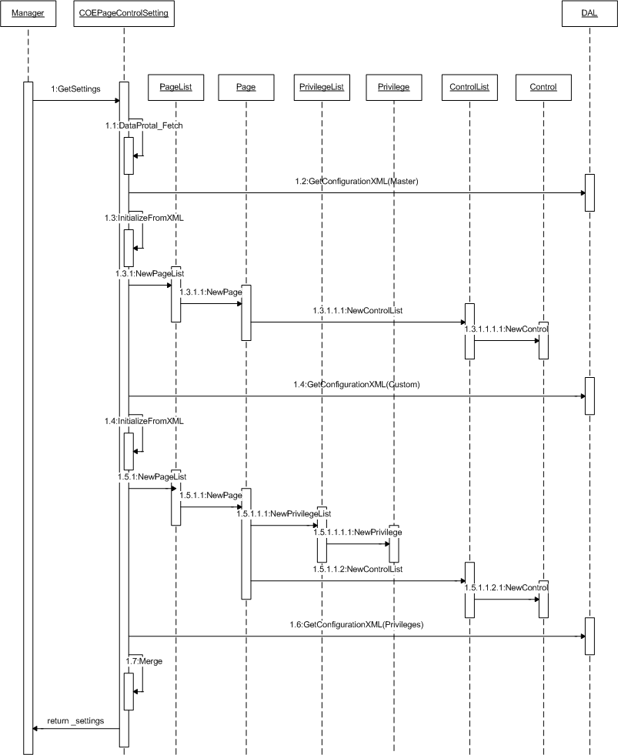

- CreateTree():
It will return a object type of UltraWebTree with all pages and privilegeList for showing the tree view.

(UML Sequence)
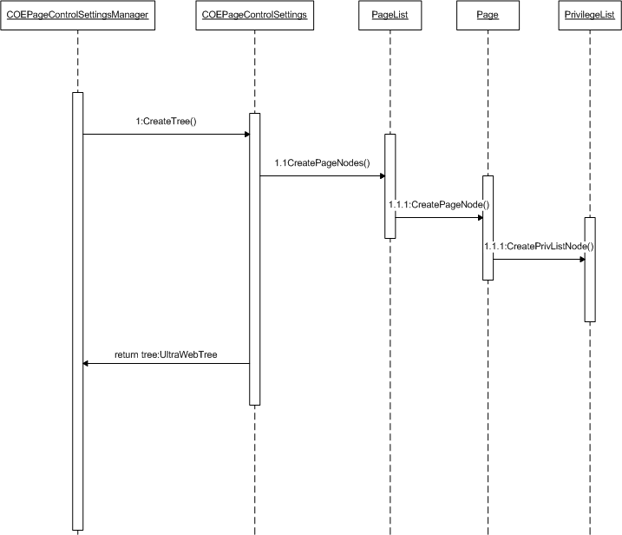

- UpdateSettings(string appName)
At first, this method will build all settings’ info into xml and then update/insert the xml into the Database.

(UML Sequence)
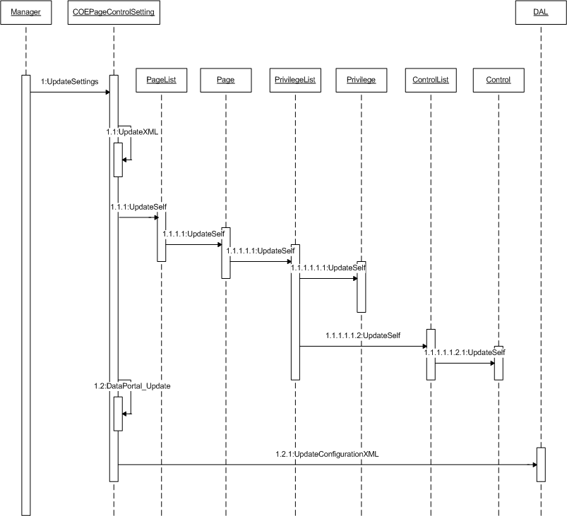

PageList
List of pages that are part of the application.

- Important Properties
- FilteredList
It contains all the pages for the given application. This property is readonly.

- Important Methods
- NewPageList(string xml, COEPageControlSettings.Type type)
It will return a object type of PageListfor the given xml and type.

- GetByID(string Id)
It will return a object type of Page for the given id.

- UpdateSelf(COEPageControlSettings.Type type)
It will build self into custom xml.

- CreatePageNodes()
It will create page nodes for tree.
Page
Page that contains several controls and a list of privileges. Note that a page could contain a control with the controlid = pageid. This means that we disable the entire page.

- Important Properties
- ListOfPrivilegeList
It contains all the PrivilegeList of this page.
- CtrlList
It contains all the controls of this page.

- Important Methods
- NewPage(string xml, COEPageControlSettings.Type type)
It will return a object type of Page for the given xml and type.

- GetPrivListById(string privListId)
It will return a object type of PrivilegeList for the given id.

- AddORUpdatePrivList(PrivilegeList privList)
It will add/update a object type of PrivilegeList into this page.

- RemovePrivList(PrivilegeList privList)
It will remove a object type of PrivilegeList from this page.

- UpdateSelf(COEPageControlSettings.Type type)
It will build self into custom xml.

- CreatePageNode()
It will create page node for tree.

PrivileList
List of privileges associated to a list of controls. It’s required to create some DB calls to get all the available privileges in order to populate a PrivilegeList that will be shown in the GUI (more details in GUI section). Here is also very important the Operator property. This tells us how we should handle the privileges. For instance, if it says OR and the list of privieleges is ADD_COMPOUND_TEMP and EDIT_COMPOUND_TEMP we know we if the current user has at least one of this privileges he can see the page.

- Important Properties
- FilteredList
It contains all the privilegs of this.
- CtrlList
It contains all the controls of this.
- OperatorToApply
It is the operator (and/or) of this.
- Important Methods
- NewPrivilegeList (string xml, COEPageControlSettings.Type type)
It will return a object type of PrivilegeList for the given xml and type.

- GetById(string privListId)
It will return a object type of Privilege for the given id.

- AddCtrl (Control ctrl)
It will add a object type of Control into this.

- GetAvailablePrivList(PrivilegeList fullPrivList)
It will return a list of privilegs that is available for displaying in GUI.

- GetCurrentPrivList(PrivilegeList fullPrivList)
It will return a list of privilegs that is current for displaying in GUI.

- GetAvailableCtrlList(ControlList fullCtrlList)
It will return a list of controls that is available for displaying in GUI.

- GetCurrentCtrlList(ControlList fullCtrlList)
It will return a list of controls that is current for displaying in GUI.

- UpdateSelf(COEPageControlSettings.Type type)
It will build self into custom xml.

- CreatePrivListNode ()
It will create PrivilegeList node for tree.

Privilege
Privilege information like name, description and friendly name.

- Important Properties
- FriendlyName
A nicer name for the privilege
- Description
A brief description of the current privilege

- Important Methods
- NewPrivilege (string xml, COEPageControlSettings.Type type)
It will return a object type of Privilege the given xml and type.

- UpdateSelf(COEPageControlSettings.Type type)
It will build self into custom xml.

ControlList
List of control to disable according the privilege list.

- Important Properties
- Controls
It contains all the controls of this.

- Important Methods
- NewControlList (string xml, COEPageControlSettings.Type type)
It will return a object type of ControlList the given xml and type.

- UpdateSelf(COEPageControlSettings.Type type)
It will build self into custom xml.
- GetById(string id)
It will return a object type of Control for the given id.

Control
Here the most important property is the ID, since it’s required by the GUIShell to disable the control. Of course, the type of control rules how the disable method will be. (e.g to disable a COEForm is different from a page)

- Important Properties
- FriendlyName
A nicer name for the privilege.
- Description
A brief description of the current privilege.
- TypeOfControl
This is required is order to understand how to disable the control. E.g the way to disable a page (yes, it's a control) it's very different from a COEForm.
- PlaceHolderID
Holder of the control in the page.Required for COEForms, not important at all for pages and simple controls
- Important Methods
- NewControl (string xml, COEPageControlSettings.Type type)
It will return a object type of Control the given xml and type.

- UpdateSelf(COEPageControlSettings.Type type)
It will build self into custom xml.

Class Diagram.
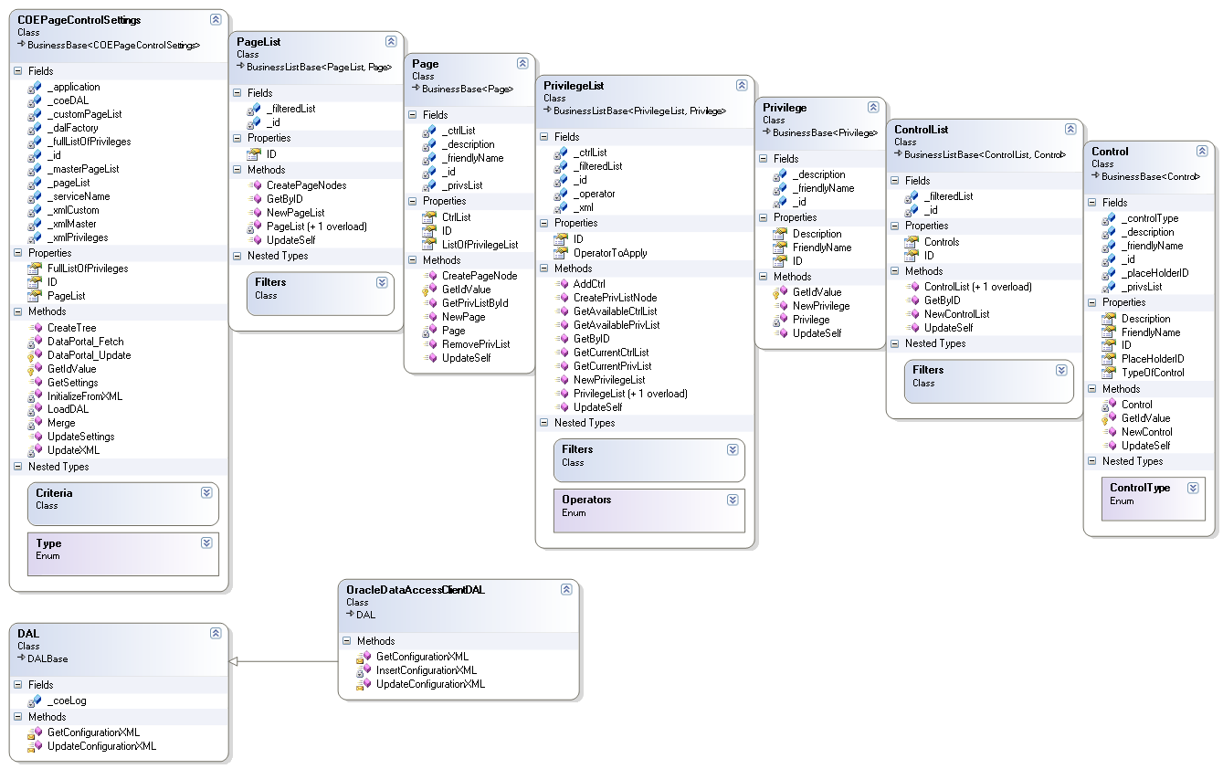
GUI Design.
The graphical user interface for the page control settings is implemented in ASP.NET. It is encapsulated into a composite control, which is easily re-usable from other applications. The page control settings control typically operates within the context of the application that uses it.

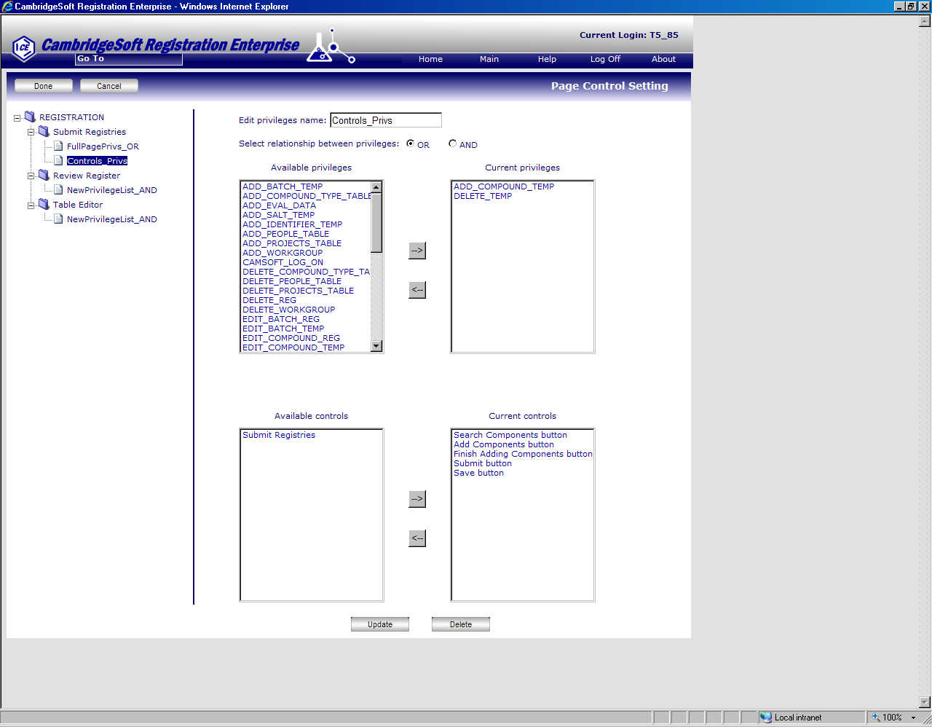

- Sections
The GUI will contain three main sections:

- Left Section
Containing a tree that shows the Application name as root node and below it should show the list of pages and PrivilegeList. Clicking in a tree node will update/refresh what is shown in the right section.
- Right section
This section will display four ListBox to add/remove a list of privileges and controls. It’s important here to show as selected those that already are associated to the selected node. At first, this section will hide and when you click/select a tree node without root node then it will be showing.
- Top section
This section will be a just a button bar where are display buttons like Done, Cancel.
- Tasks
Users are able to accomplish the following tasks via the editor GUI.

- Init view
At first, the GUI will just show the left tree. The tree contains three levels. The root is application node, the second level is Page node and the third level is PrivilegeList node.
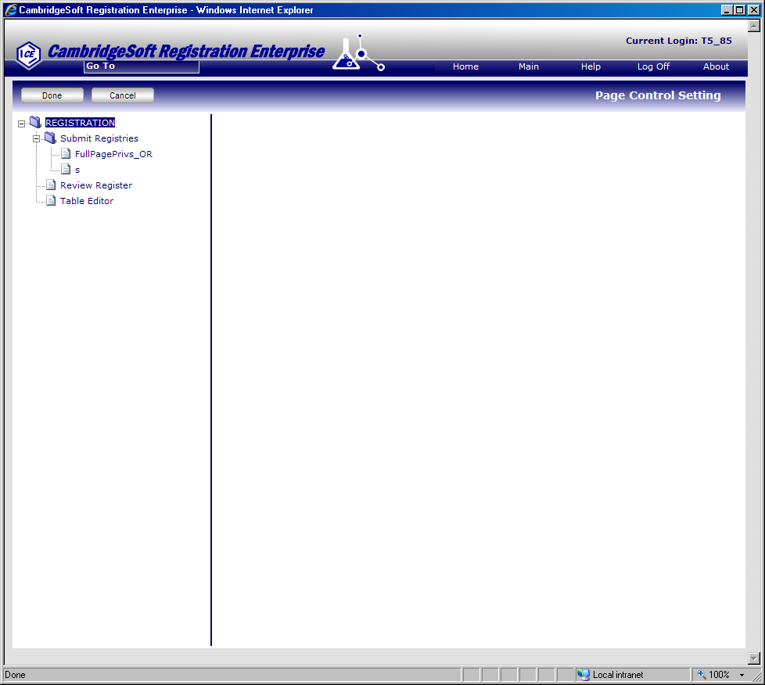
- Select a node without root node to work with in a tree view.
If the user selects a node then the right section will show. If the node is type of Page, the right section will show “Add” mode and user can add a PrivilegeList. If the node is type of PrivilegeList, the right section will show “Update” mode and user can update a PrivilegeList.
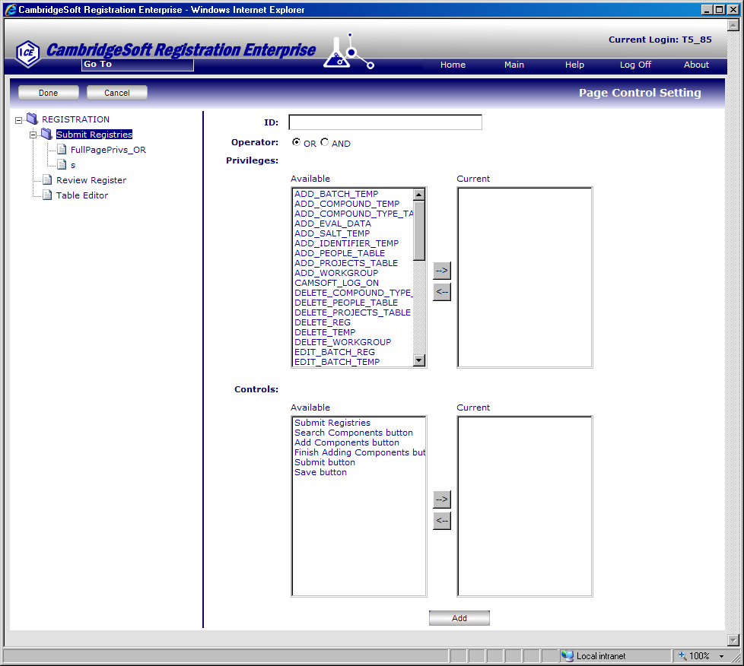

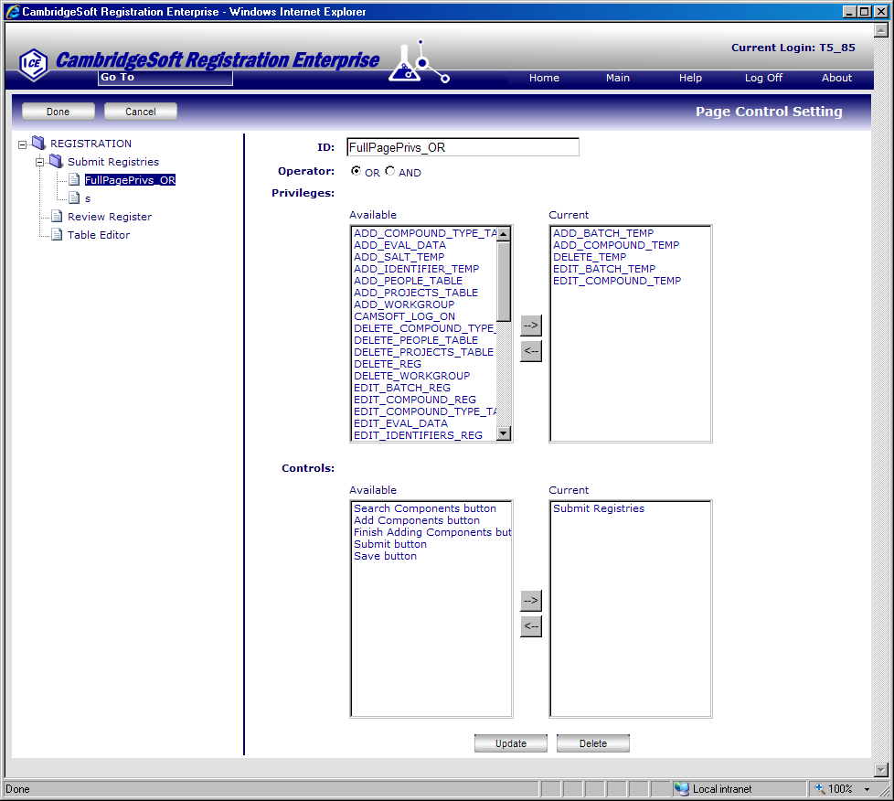
- Add/Update a PrivilegeList.
To click “Add/Update” button you will add or update a PrivilegeList. It will add or update the PrivilegeList into the business object but not in database.
- Save the configuration settings into the DB.
To click “Done” button, it will save the configuration settings into the DB.

COEPageControlSettingsManager
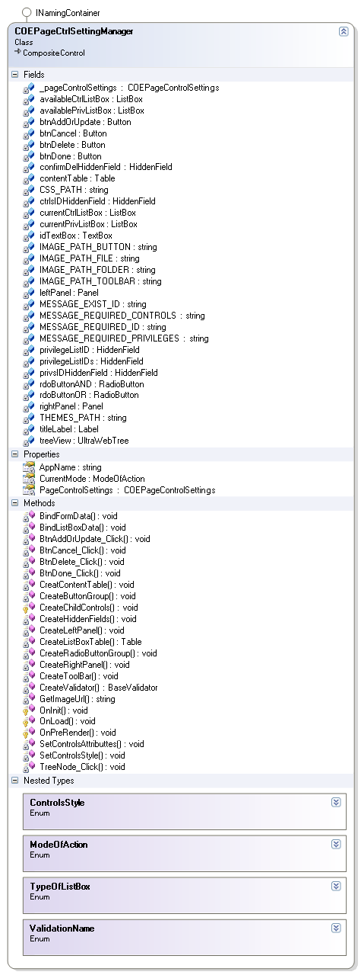

- Show settings’ view
- Get property “PageControlSettings” value:
COEPageControlSettings.GetSettings(AppName);
- Get tree view:
treeView = PageControlSettings.CreateTree();
- Get the data source of the control “availablePrivListBox”:
PrivilegeList selectedPrivList = (PrivilegeList)treeView.SelectedNode.Tag;
availablePrivListBox.DataSource = selectedPrivList.GetAvailablePrivList();
- Get the data source of the control “currentPrivListBox”:
PrivilegeList selectedPrivList = (PrivilegeList)treeView.SelectedNode.Tag;
currentPrivListBox.DataSource = selectedPrivList. GetCurrentPrivList();
- Get the data source of the control “availableCtrlListBox”:
PrivilegeList selectedPrivList = (PrivilegeList)treeView.SelectedNode.Tag;
availableCtrlListBox.DataSource = selectedPrivList. GetAvailableCtrlList();
- Get the data source of the control “currentCtrlListBox”:
PrivilegeList selectedPrivList = (PrivilegeList)treeView.SelectedNode.Tag;
currentCtrlListBox.DataSource = selectedPrivList. GetCurrentCtrlList();
- Update configuration settings
void DoneButton_Click(object sender, EventArgs e)
{
PageControlSettings.UpdateSettings(AppName);
}
Database
CREATE SEQUENCE COEPAGECONTROL_SEQ
START WITH 1
MAXVALUE 999999999999999999999999999
MINVALUE 1
NOCYCLE
NOCACHE
NOORDER;

CREATE TABLE COEPAGECONTROL
(
ID INTEGER,
APPLICATION VARCHAR2(20 BYTE),
TYPE VARCHAR2(20 BYTE),
CONFIGURATIONXML CLOB
)
TABLESPACE T_COEDB_TABL
PCTUSED 0
PCTFREE 10
INITRANS 1
MAXTRANS 255
STORAGE (
INITIAL 64K
MINEXTENTS 1
MAXEXTENTS 2147483645
PCTINCREASE 0
BUFFER_POOL DEFAULT
)
LOGGING
NOCOMPRESS
LOB (CONFIGURATIONXML) STORE AS
( TABLESPACE T_COEDB_TABL
ENABLE STORAGE IN ROW
CHUNK 8192
PCTVERSION 0
NOCACHE
STORAGE (
INITIAL 64K
MINEXTENTS 1
MAXEXTENTS 2147483645
PCTINCREASE 0
BUFFER_POOL DEFAULT
)
)
NOCACHE
NOPARALLEL
MONITORING;

CREATE OR REPLACE TRIGGER trg_coepagecontrol
BEFORE INSERT
ON COEPAGECONTROL FOR EACH ROW
BEGIN
SELECT coepagecontrol_seq.NEXTVAL
INTO :NEW.ID
FROM DUAL;
END trg_coepagecontrol;

