Table Editor

(Function Specification)

Copyright © 2006 CambridgeSoft Corporation. Cambridge, Massachusetts.
All Rights Reserved

This document is the property of CambridgeSoft Corporation and is intended for internal use only. Reproduction or transmission of this document in any form, in whole or in part, without prior written permission of CambridgeSoft Corporation is prohibited.

OverView

The high level goal of this Control is to provide the simplest way for developers to edit the contents of the Tables. Operations included: Add Record, Delete Record and Edit the particular record. These functions can be applied to the tables from the particular selected Database/ApplicationName. e.g; Sample, Cheminv, etc.

Business Context

The Table Editing work in Classic ASP application has been done under the Browse ->Task->Manage Tables of the Inventory Module. End User must be able to select the table that he/she want to edit. Then the details view would present him with Records/contents that can e edited/deleted.

The Old Table Editor functionally uses ADO Database Objects in order to interact with database. Now, because the Complete Database Architecture of the application is using CSLA.Net, this component would use the same in the Control.

After creating this control the complete functionality would be encapsulated inside a particular WebControl along with the CSLA DatabaseObjects functionality.

UI Specification (Demo):
The Screenshot below is just to describe the UI methods that can be used for the Table Editor. Though it is not representing the correct Table and Fields and Database/ApplicationNames as Currently this screenshot has been created using the DataViewManager. 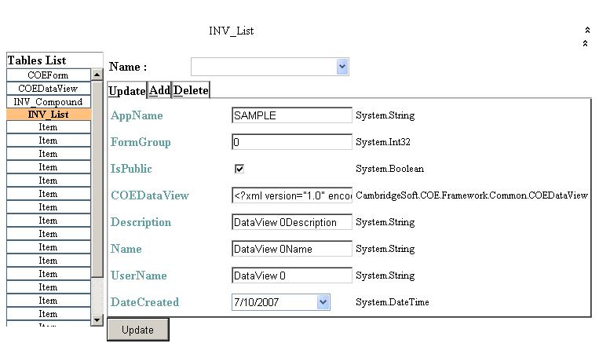
Table Name that has been selected
List of Tables in the Applications
Combo to show the list of Records
Fields in the Record

Note: Please let us know your suggestions about the UI. We have another designs where we can use Grid instead of WebTabs in order to present and Edit Data of the Table. Just like the Classic ASP application.

Functional Specification
Control Flow & modules: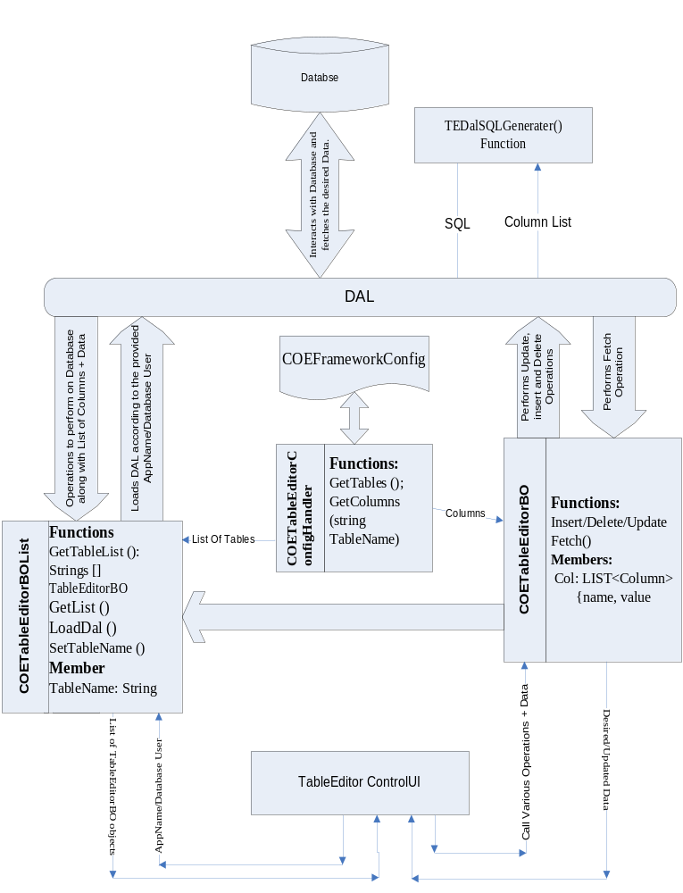

Functional Specifications:

TableObjectBOList would take the used AppName from the application and would Load the DAL with the same Database. TableEditorBOList is responsible for generating the list of TableEditorBO Objects using functions like GetList() etc.

Because, all the information regarding Tables and their columns to be used by TableEditor would be inside COEFrameWork Config. NamedConfigurationElement

Additional Property in ApplicationData.cs:

/// <summary>
/// Gets the collection of defined <see cref="TableEditor"/> objects.
/// </summary>
/// <value>
/// The collection of defined <see cref="TableEditor"/> objects.
/// </value>
[ConfigurationProperty(tableEditorProperty, IsRequired = false)]
public NamedElementCollection<TableEditor> TableEditor
{
get { return (NamedElementCollection<TableEditor>)base[tableEditorProperty]; }
}

Two NamedConfigurationElement classed named TabledEditor (to define Tables to be used) and TableEditorData (To defind Columns to be used) would be created. I have created these Classes and submitted in Perforce for review.

List of Tables would be generated by the COETableEditorConfigHandler class which would read COEFrameworkConfig for retrieving the list of Tablenames on the call of TableEditorBOList, which would be used to populate the Accordion Panel in the Table Editor UI.

In the general scenario the services have the number of properties in the BusinessObjects is based on the Field in the DataTable they dealt with. While dealing with multiple Tables at once (with one BusinessObject) we need to keep track of the flexibility for the number and type of the Fields.

COMMENT BY LJB – I will have to see this in action in order to more fully understand
From Sumeet : I am working on this.

Here our idea is to create a class “Column” that would have to members:
- FieldName : String
- FieldData: Generic

A “List<Column>” type would be used to create a property “Columns” in the TableEditorBO. TableEditorBO would fetch these columns from COETableEditorConfigHandler, which in turn would read the provided information in the COEFrameworkConfig.

Further this list object would be used by TableEditorBO to provide Column info to DAL in order to perform Update operations. DAL would generate the Update or other desired SQL based on the provided list of columns.

Above implementation would restrict any DataSource (CSLADataSource) to read the List of TableEditorBO returned by TableEditorBOList, in order to get the data for each field in the Object. TableEditorUI would read these objects explicitly in order to create UI.

Note: Please provide us your views or suggestions on this.

XML Section that would be available in COEFrameWorkConfig.xml would be as follows (This is tested against the latest development of TableEditor.cs and TableEditorData.cs):

<coeConfiguration singleSignOnURL="http://localhost/COESingleSignOn/SingleSignon.asmx">
<applications>
<add name="SAMPLE" enableCSSecurity="false" dbmsType="ORACLE" owner="SAMPLE" tracing ="false" oracleTracing="false" connectionString="Data Source=rohit;User ID=SAMPLE;Password=ORACLE;" providerName="Oracle.DataAccess.Client">
<sqlGeneratorData>
<add name="CSORACLECARTRIDGE" schema="CSCARTRIDGE" tempQueriesTableName="TempQueries" />

</sqlGeneratorData>
<tableEditor>
<add name="COEDataView" PrimaryKeyField="ID" >
<tableEditorData>
<add name="Name" dataType="varchar" />
</tableEditorData>
</add>
</tableEditor>
</add> </applications>

