**Step 01: Make sure all the files and folders (6) are present as follows -**

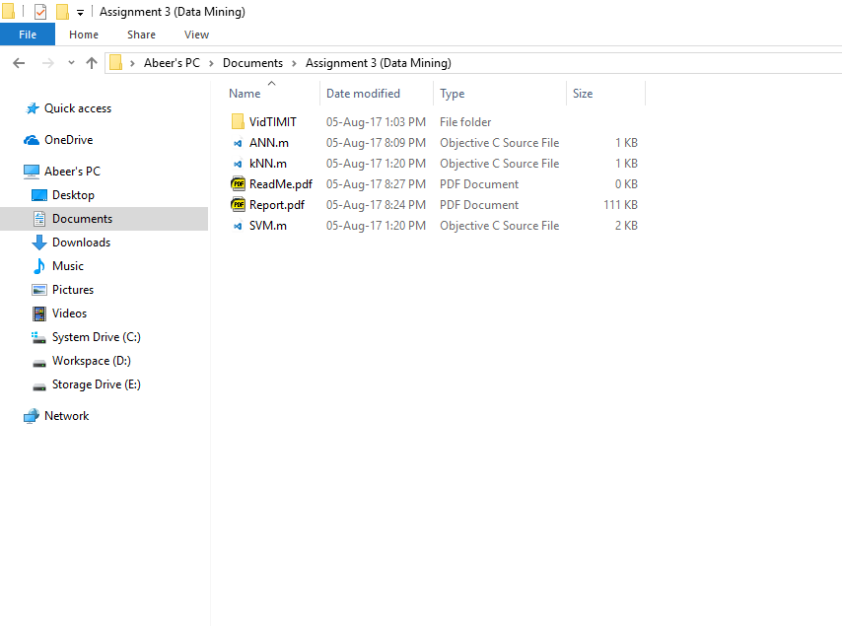

**Step 02: Make sure all the files and folders (6) are present as follows and follow the steps in shown here-**

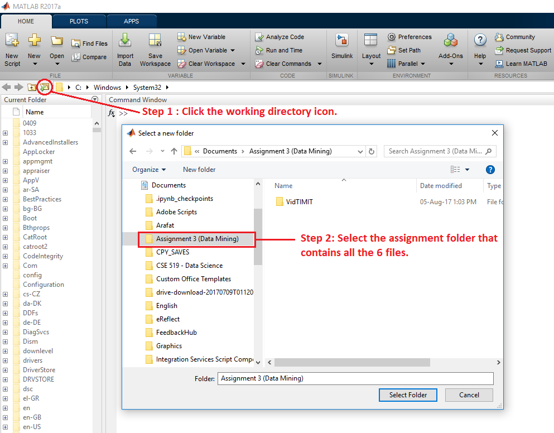

**Step 03: Open the code script for kNN and follow the steps in shown here-**

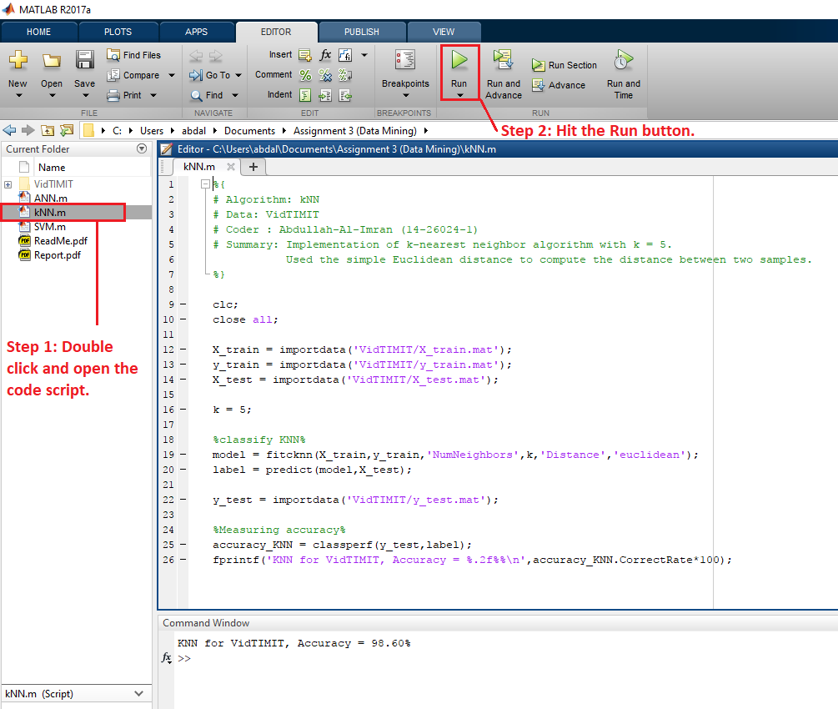

**Step 04: Open the code script for ANN and follow the steps in shown here-**

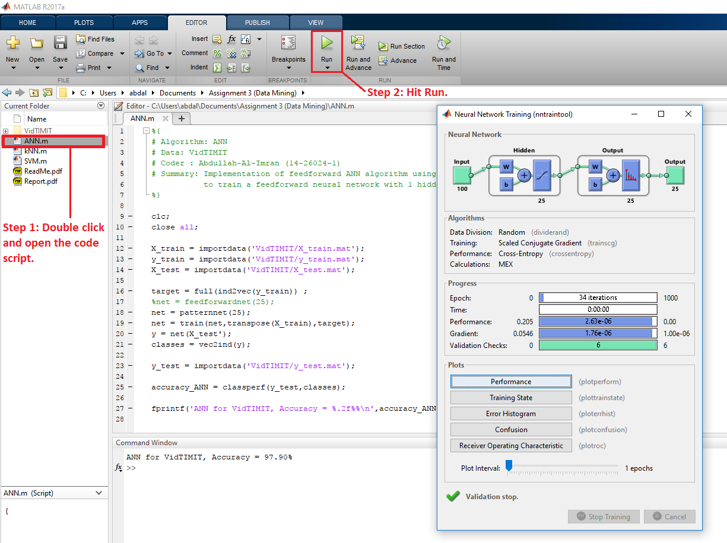

**Step 05: Open the code script for SVM and follow the steps in shown here-**

