**Question 1:**

Employee Management System is portal which hold the employee data such as employee number as unique, first name, last name and email as unique. You are required to write a code for a web services that outputs JSON data. The structure for web services should follow the structure of building the spring boot services as follow. a. Create Spring Boot Project

1. Write a step to create a project using spring initializer or using maven commands
2. Maven Dependencies
3. Create pom.xml file which you will add the basic spring boot services includes MySQL/PostgreSQL database
4. Configure MySQL/PostgreSQL Database: Using application.properties or application.yml file for database connectivity, create a properties file.
5. Create Models
6. Write a code for employee model
7. Employee Repository: Write a code for employee repository
8. Services Layer: Write a code for employee service layer
9. Controller Layer: Write a code for GET,POST,DELETE,PUT and GET by ID
10. Create anEmployee Application class which will be used as Main Class.
11. Show how you can test your API using API client.

A)

The first step are open browser then type start.Spring.io the select the maven at project and select java language and then choose spring version and change name of demo to employee and then add dependence you want to use

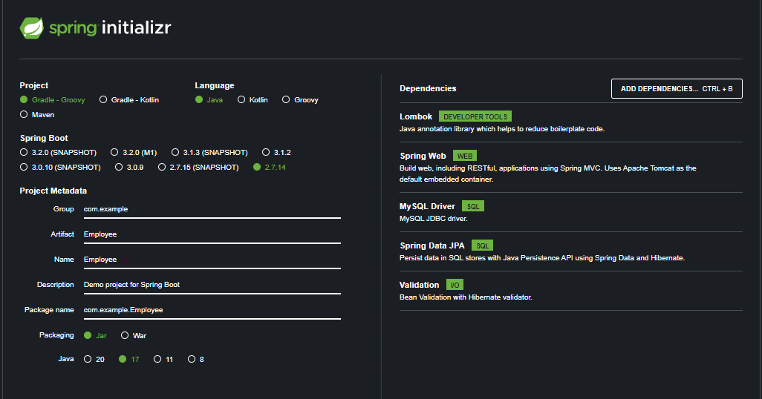

b)

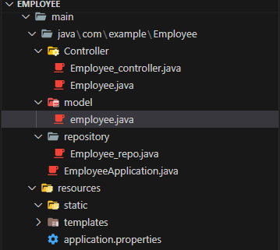

c)

