  - Global Power Plant Trends: Insights for Energy Transition
  - CAPSTONE project
Abdalla Osman Abdelrahiem Mohamed | 22/11/2025
Contents
1. Introduction 2
2. Problem Statement 2
3. Objective 2
4. Target Audiences 3
5. Data Set 3
6. Data Handling 5
7. Analysis and Findings 6
8. Conclusion & Recommendations: 10
9. Limitations and Assumptions: 11
10. References 12

Introduction
The global energy landscape is at a turning point. While nations pledge to cut carbon emissions and accelerate the shift toward sustainable power, fossil fuels continue to dominate electricity generation worldwide. This imbalance highlights both the urgency of transition and the scale of opportunity.
By analyzing the Global Power Plant Database (2013–2017), we uncover where renewable energy is advancing, where fossil reliance persists, and how these trends shape investment, policy, and advocacy. For stakeholders—policy makers, investors, and NGOs—this data provides the clarity needed to plan strategically, allocate resources wisely, and drive meaningful progress toward a sustainable energy future.

Problem Statement
Energy data is vital for guiding policy, investment, and sustainability decisions. Yet despite global commitments to cut carbon emissions, power generation remains dominated by fossil fuels. Stakeholders lack accessible, visual insights that show where the energy transition is advancing—or stalling—making it harder to plan, invest, and advocate effectively.

Objective
To analyze the global distribution, composition, and evolution of power plants using the Global Power Plant Database, and to develop insights that enables stakeholders—particularly policymakers, investors, and NGOs—to:
- Understand the current energy mix and infrastructure by country and region
- Identify trends in renewable vs. non-renewable energy development over time
- Support data-driven decision-making for energy transition strategies

Target Audiences
- Policy Makers/ Regulators
- Business Leaders/Investors
- Academics/NGOs

Data Set

- Raw data: CSV File
  - 36 Columns
  - 34,937 Rows
- Data Descriptions:
World Resources Institute (WRI) experts and their partners created the Global Power Plant Database from official government data and independent sources around the world, integrated them with crowdsourced data such as analysis of satellite images, and delivered the final database as an open data resource.
The Global Power Plant Database leverages existing data sources and methodologies to build a comprehensive and open-access power sector database. The database collects the following characteristics and indicators:
- All types of fuel
- Technical characteristics (fuel, technology, ownership)
- Operational characteristics (generation)
- Plants’ geolocation
- Plants over 1 megawatt (MW)
- Plants in operation only (in first iteration)
It is refer to this database as open, as all data are traceable to sources that are publicly available on websites. Most of the publicly available sources we draw upon are collected from national governments and other official sources. In addition, the database is published under a Creative Commons—Attribution 4.0 International license (CC BY 4.0), allowing it to be used and republished in any fashion, with source attribution. By providing a common information source, the database will facilitate collaborative analysis of the power sector. It is important to note that although the database is the most comprehensive in terms of fuel types and capacity covered, because power sector information is not fully reported or instantly updated, the database will never be fully comprehensive and will show the power sector data with some time delay.
- Data Dictionary:
- Fuel Type: Fuel category
- Capacity: Installed electrical capacity (Mw)
- Location: Latitude and longitude
- Year of Capacity: Year of reported capacity
- Year of Generation: Year of reported generation
- Data Source: Source of data
- URL: URL link to the data
- Annual Generation: Annual generation (Calander year) in gigawatt hours (GWhs) gross
- Operation status: Commissioned/retired/planned
- Generator technology: Technology used to generate electricity
- Owner: Primary owner of the power plant
- Commissioning year: First year plant generated electricity

Data Handling

Data Handling:
- Added a table with 2 columns for each country and its continents from https://worldpopulationreview.com/country-rankings/list-of-countries-by-continent
- Cleaned the table to match the countries names with the raw data set.
- Changed the columns data types based on appropriate types (text, numbers, dates …etc)
- Categorized each fuel type into 3 categories:
  - Renewables
  - None Renewables
  - Others
- Calculated each year production in Mw instead of GWh.
- Added a column with the total production in Mw form 2013-2017
- Added a measure of Capacity share percentage from Total capacity in Mw
- Added a measure to count the number of plants
- Added a measure of the total capacity of all the plants

Analysis and Findings
- Global Energy Mix.
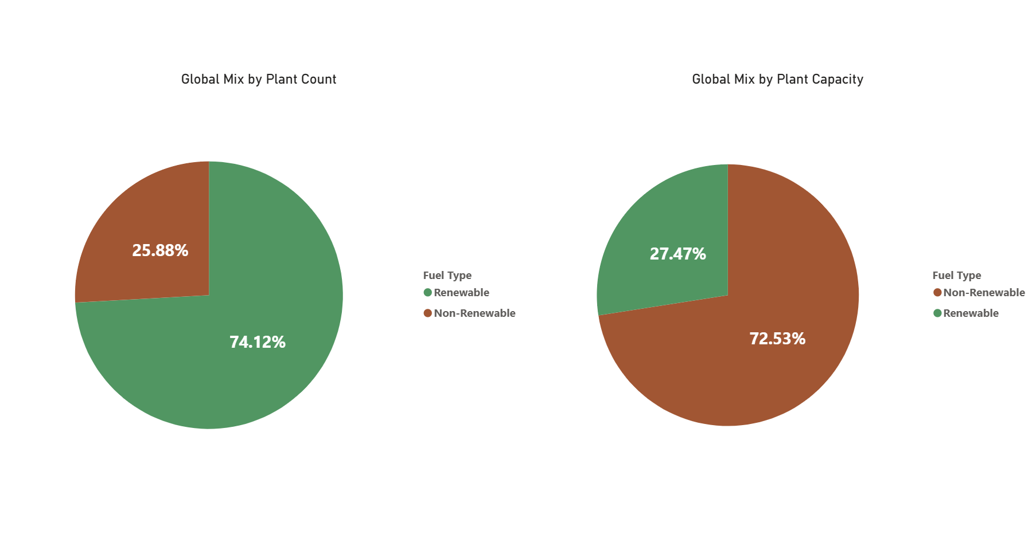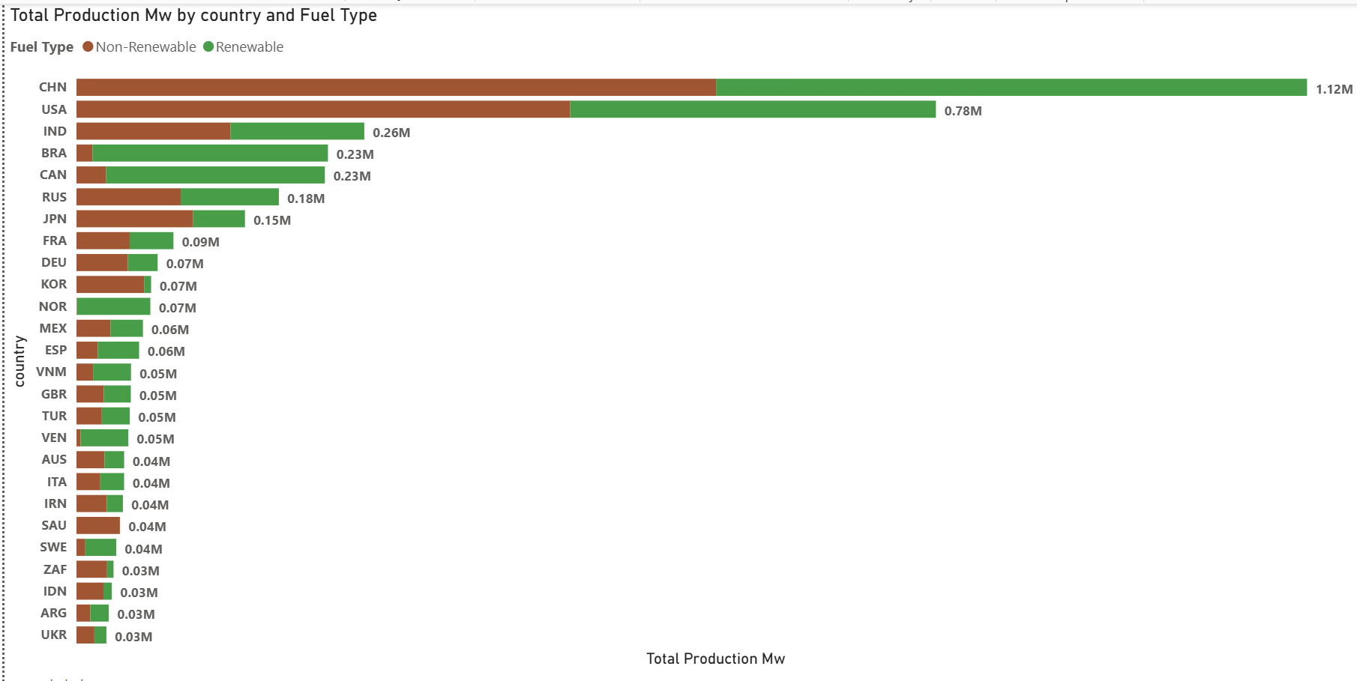
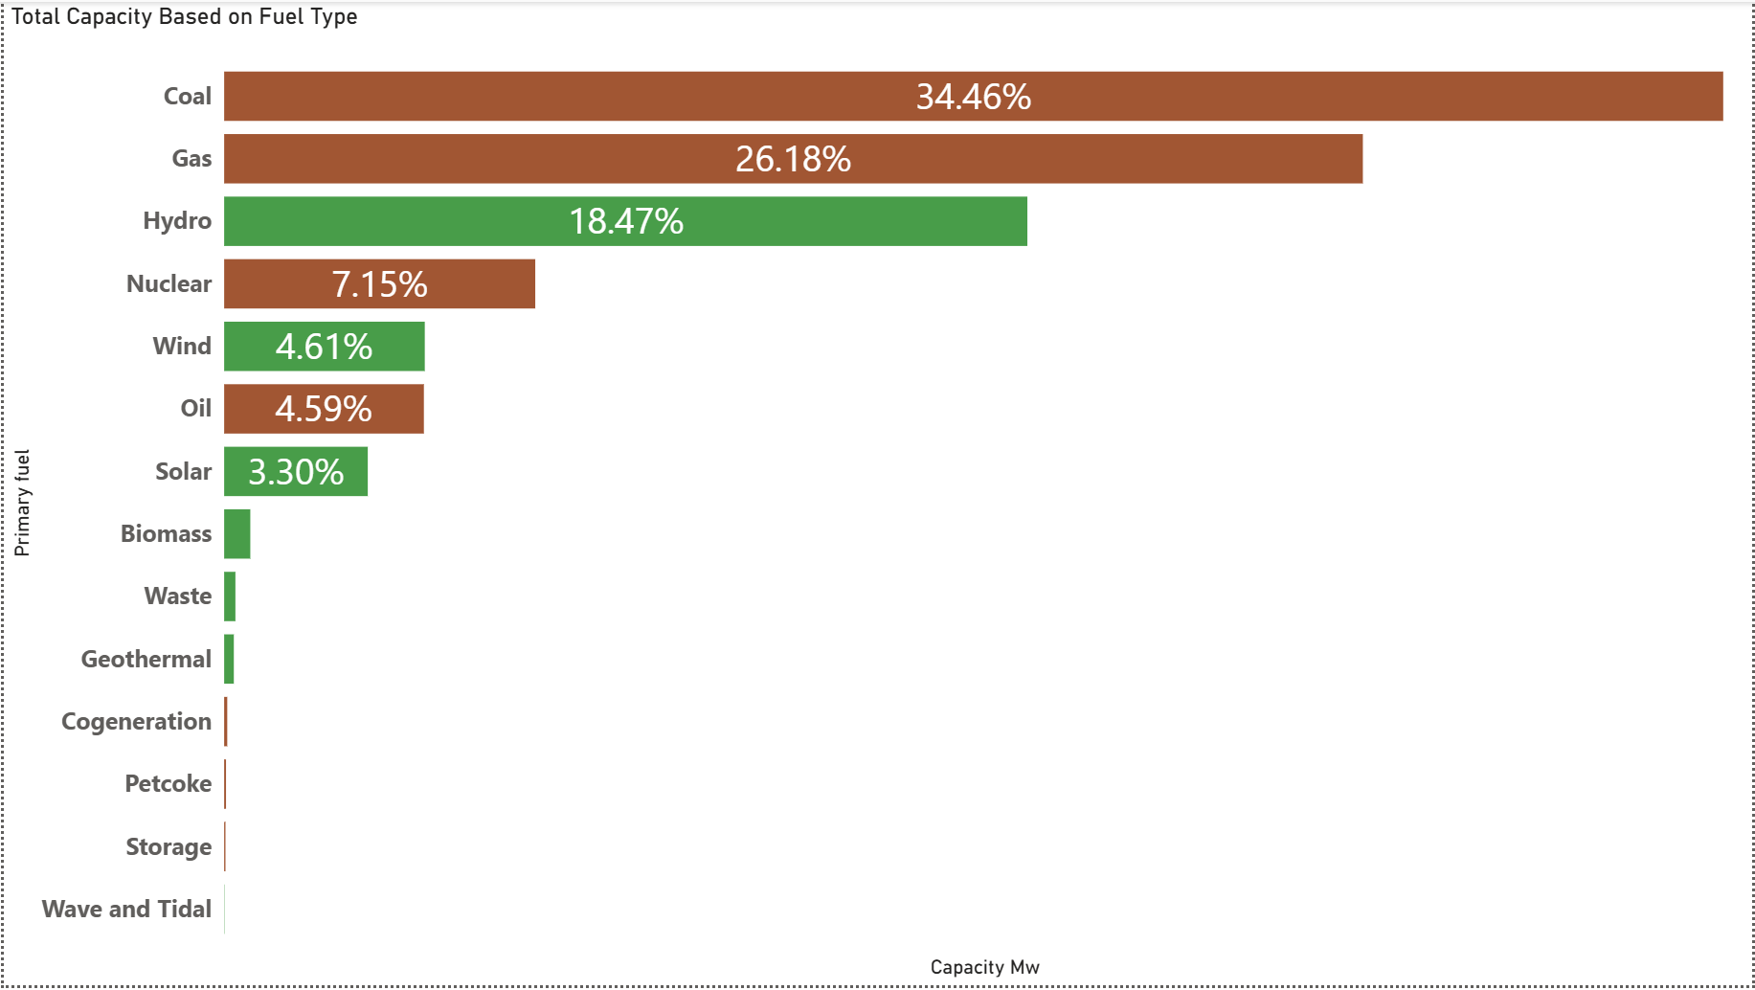
Fossil fuels still dominate capacity, but renewables are growing quickly. This imbalance highlights both the challenge and the opportunity: the world is still heavily reliant on coal, gas, and oil, but the momentum is shifting toward clean energy

- Geographical Distribution

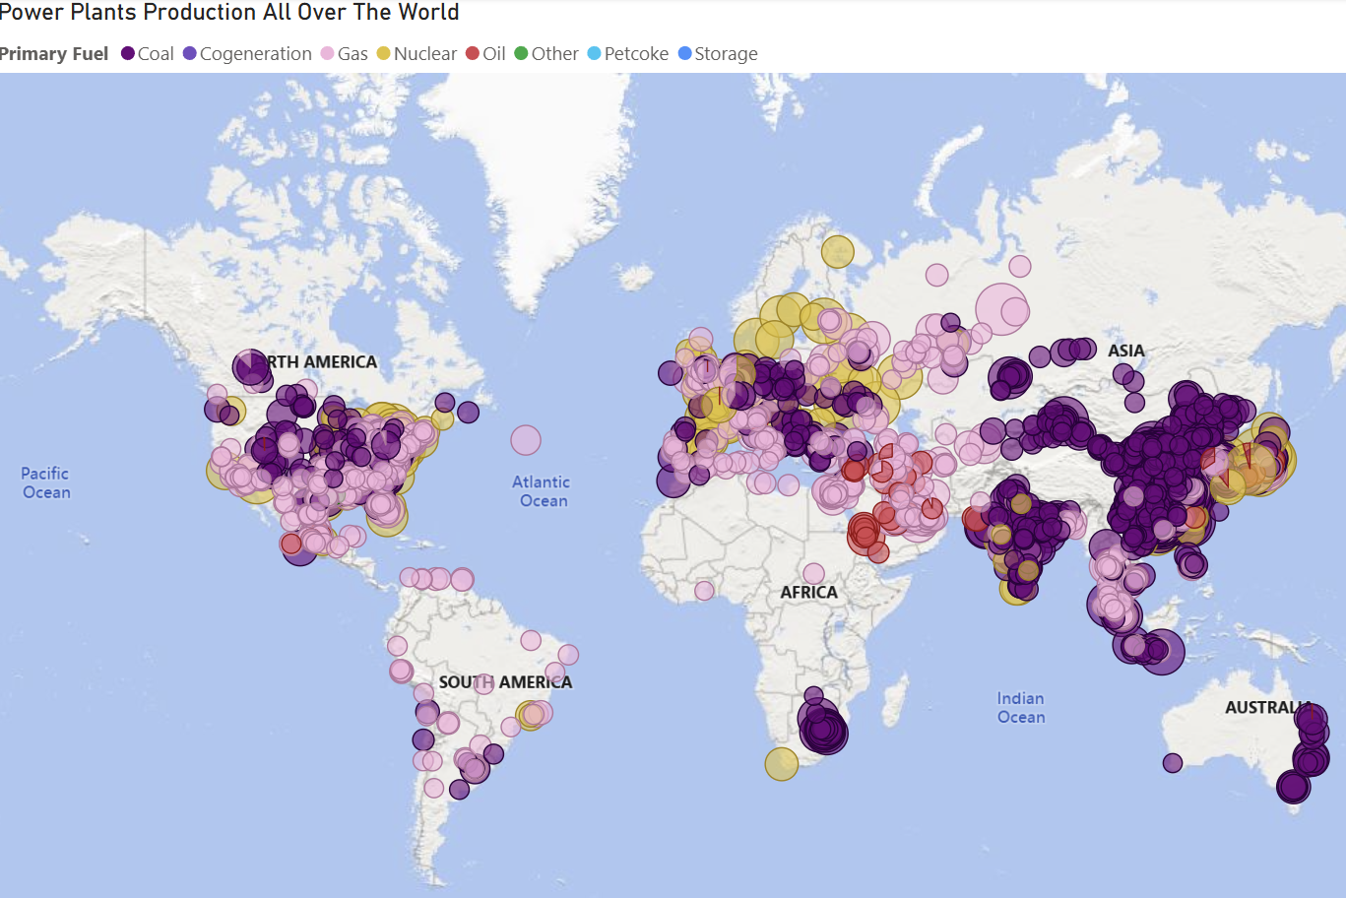

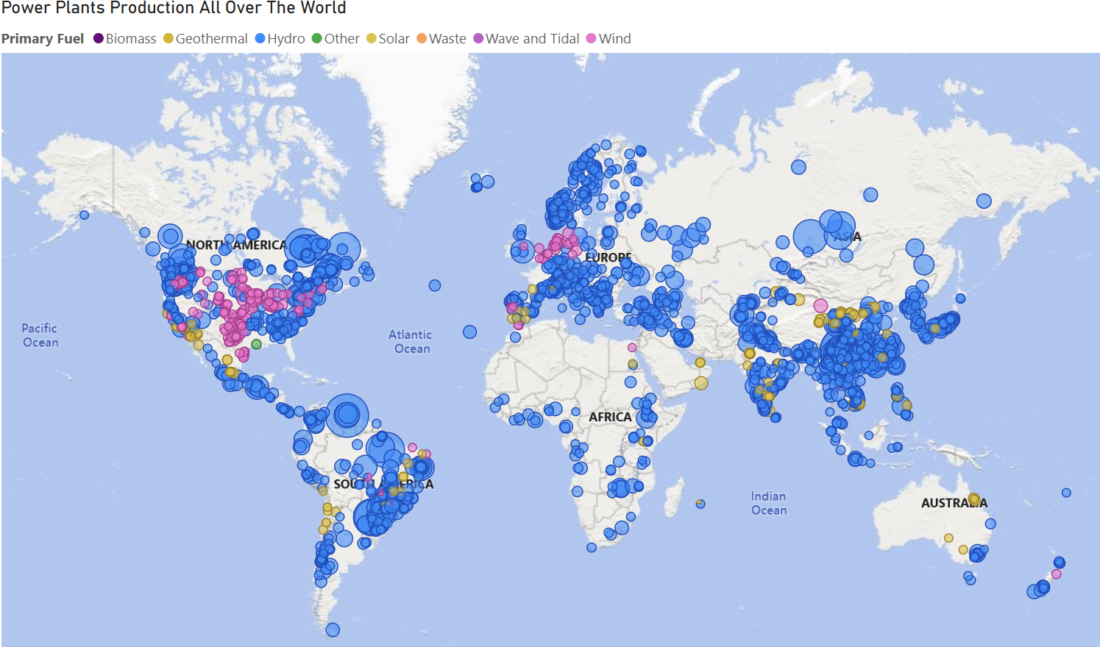

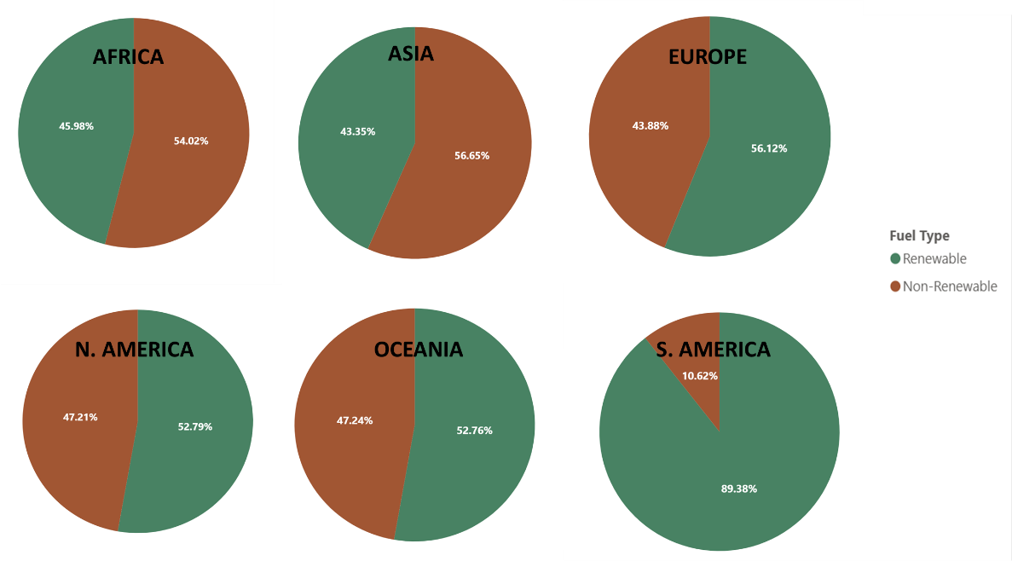
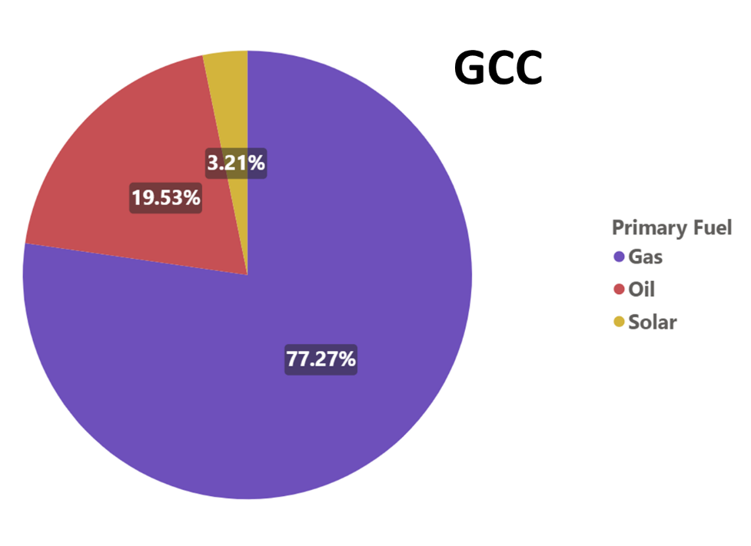
Mapping the plants shows us where energy infrastructure is concentrated. Asia has large clusters of fossil fuel plants, while Europe and North America show higher renewable penetration. Geography and resource availability play a big role in shaping these patterns.
- Time Trends
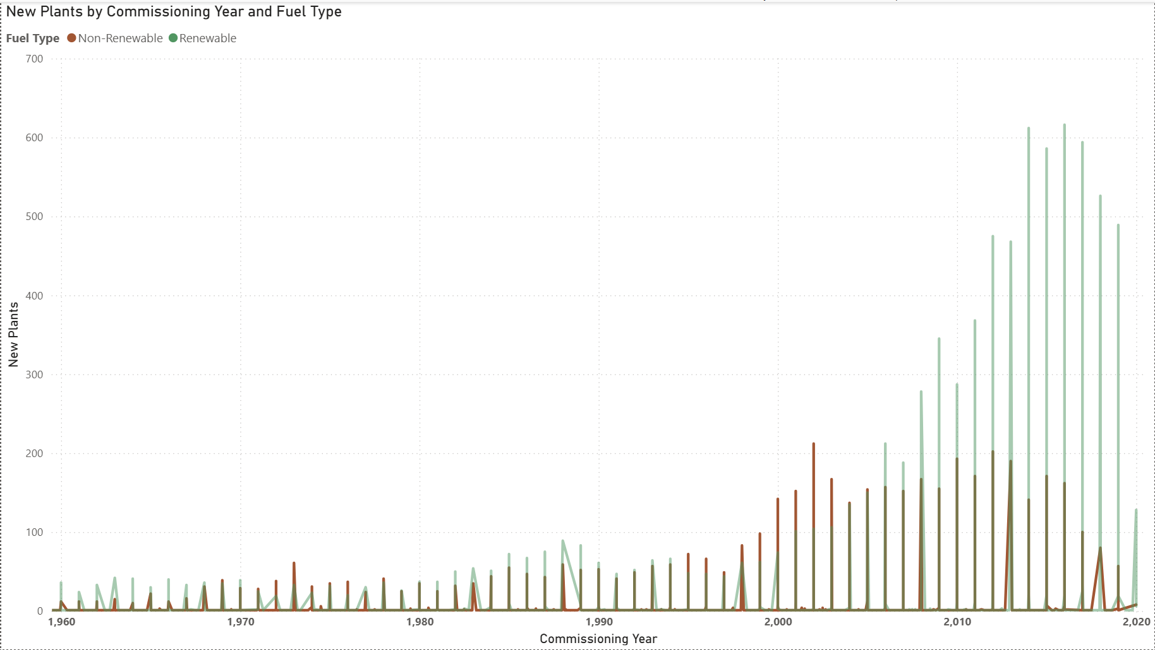
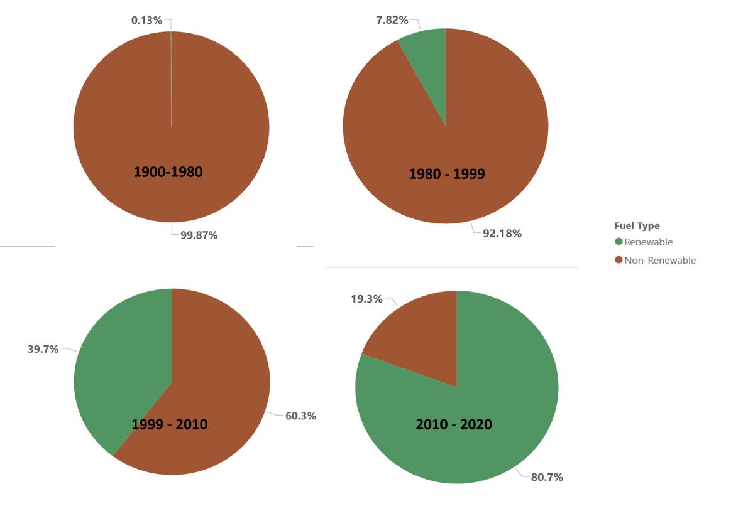

the global energy transition is underway, but progress is uneven. The data shows clear opportunities for renewables

Conclusion & Recommendations:

Based on the above analysis below are my conclusion:
- Global energy transition is underway but uneven
- Although the world is transitioning, a single non-renewable plant produced far more than a renewable based plant
- Data is showing clear opportunities for renewables specially in 3rd world countries and Africa specifically
With the above analysis, I recommend the following:
Policy Makers:
- Plan infrastructure and Incentives for renewables. Phase out aging coal plants
- Dedicate budgets and incentive for universitas and research centers with focus in renewable break throughs
Businesses and Investors:
- Invest in Solar/Wind Projects. Ex. Prioritize solar expansion in high-sun regions
- Back R&D initiatives that can improve renewable efficiency
NGOs:
- Advocates for equitable energy access and Encourage regional collaboration on renewables
- Support new power plants in 3rd world countries with limited energy access

Limitations and Assumptions:

The primary limitations are listed below:

- Data availability (of small and renewable power plants)
- Reporting delay
- Data reliability
- Lack of operational data reported (electricity generation, emissions, water use)

Data availability is the primary limitation. Because most countries do not publicly report their power sector data, it is not feasible to assemble 100 percent power plant coverage. It is particularly difficult to identify the smaller, distributed power plants, a category that includes smaller renewables and diesel generators. Renewable power plants are not always reported in public documentation as they are relatively new and smaller, causing wind and solar plants to have the lowest global coverage of installed capacity in the database (38 percent and 30 percent, respectively). Conventional power plants, including thermal and large hydro plants, are more extensively covered.

References

The primary limitations are listed below:
- A GLOBAL DATABASE OF POWER PLANTS - LOGAN BYERS, JOHANNES FRIEDRICH, ROMAN HENNIG, AARON KRESSIG, XINYUE LI, COLIN MCCORMICK, LAURA MALAGUZZI VALERI.
- Data Set: Link

