Test case | Input | Expected Output | Actual output | Expected and actual output compatible? | Notes
Upload JPG image | JPG image << 100 KB | JSON with id, filename, risk_level: LOW, overall_risk_score: 0.0 | {  "id": "6b4c235b-c0ae-443f-8afb-4370ee4c3ead",  "filename": "uploads/6b4c235b-c0ae-443f-8afb-4370ee4c3ead.jpg",  "risk_level": "LOW",  "overall_risk_score": 0  } | YES
Upload PNG image | PNG image << 100 KB | JSON with id, filename, risk_level: LOW, overall_risk_score: 0.0 | {  "id": "7d19f8d4-cd18-4889-9fd1-8b95485b8e83",  "filename": "uploads/7d19f8d4-cd18-4889-9fd1-8b95485b8e83.jpg",  "risk_level": "LOW",  "overall_risk_score": 0  } | YES
Upload small image | JPG image < 10 KB | JSON with id, filename, risk_level: LOW, overall_risk_score: 0.0 | {  "id": "04312c1f-d2d0-496d-a5bb-82b66c631d01",  "filename": "uploads/04312c1f-d2d0-496d-a5bb-82b66c631d01.jpg",  "risk_level": "LOW",  "overall_risk_score": 0  } | YES
Upload a gif | .gif file | JSON with id, filename, risk_level: LOW, overall_risk_score: 0.0 | {  "id": "649230e8-2881-45f6-ac29-0a31b1403412",  "filename": "uploads/649230e8-2881-45f6-ac29-0a31b1403412.jpg",  "risk_level": "LOW",  "overall_risk_score": 0  } | YES | Gif saved to the uploads folder but unclear
Upload a high resolution image | 4000*4000 px image | JSON with id, filename, risk_level: LOW, overall_risk_score: 0.0 | {  "id": "43d9e73b-c780-41ed-904c-65fa04ec723c",  "filename": "uploads/43d9e73b-c780-41ed-904c-65fa04ec723c.jpg",  "risk_level": "LOW",  "overall_risk_score": 0  } | YES
Re-upload the same file | The gif file I aleardy uploaded previously | JSON returned with different id, new filename | {  "id": "fed4ba3a-65f2-4eeb-a959-2a3c3ca0e1d0",  "filename": "uploads/fed4ba3a-65f2-4eeb-a959-2a3c3ca0e1d0.jpg",  "risk_level": "LOW",  "overall_risk_score": 0  } | YES | JSON gave different ID "fed4ba3a-65f2-4eeb-a959-2a3c3ca0e1d0" than the previous same file "649230e8-2881-45f6-ac29-0a31b1403412"
Upload a medium-sized image | 1.8 MB jpg image | JSON returned with different id, new filename | {  "id": "a87608f4-918b-4338-81fe-8f80728d55f2",  "filename": "uploads/a87608f4-918b-4338-81fe-8f80728d55f2.jpg",  "risk_level": "LOW",  "overall_risk_score": 0  } | YES

SCREENSHOTS OF JSON RESPONSES

Case 1:
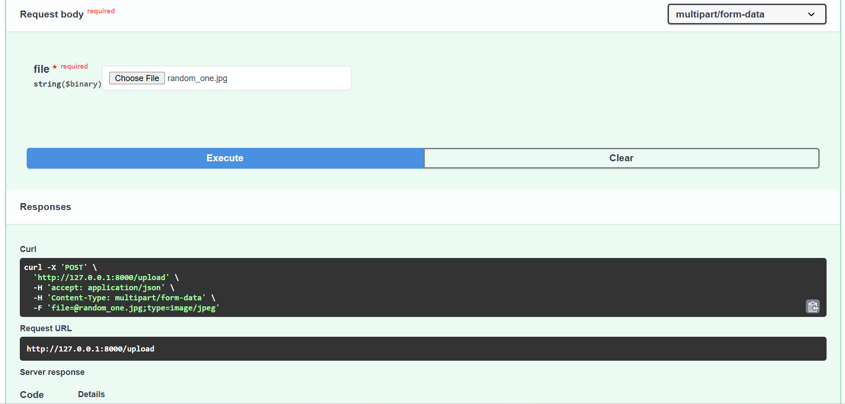
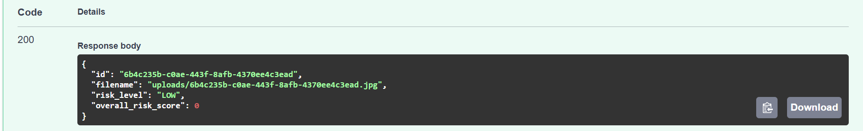

Case 2:
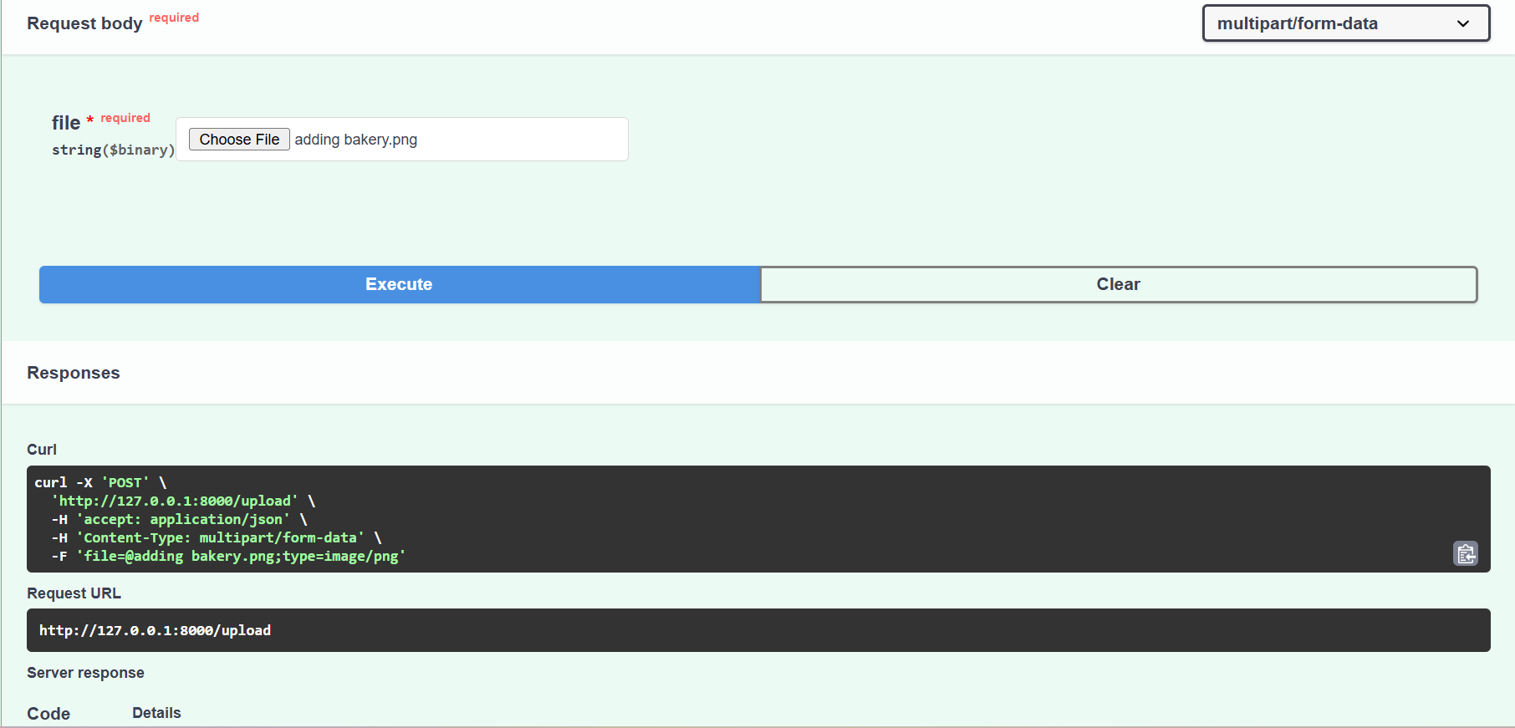
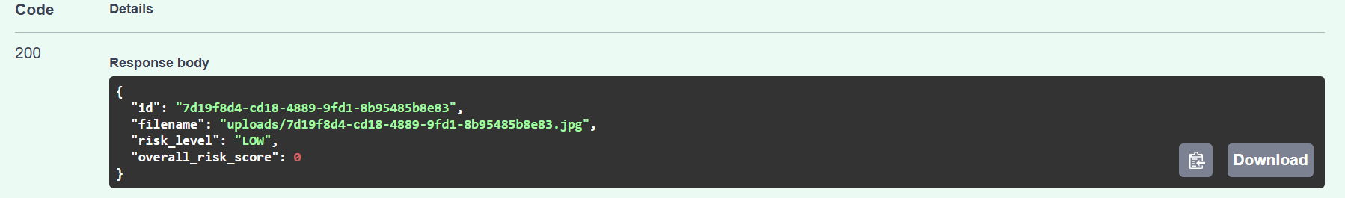

Case 3:
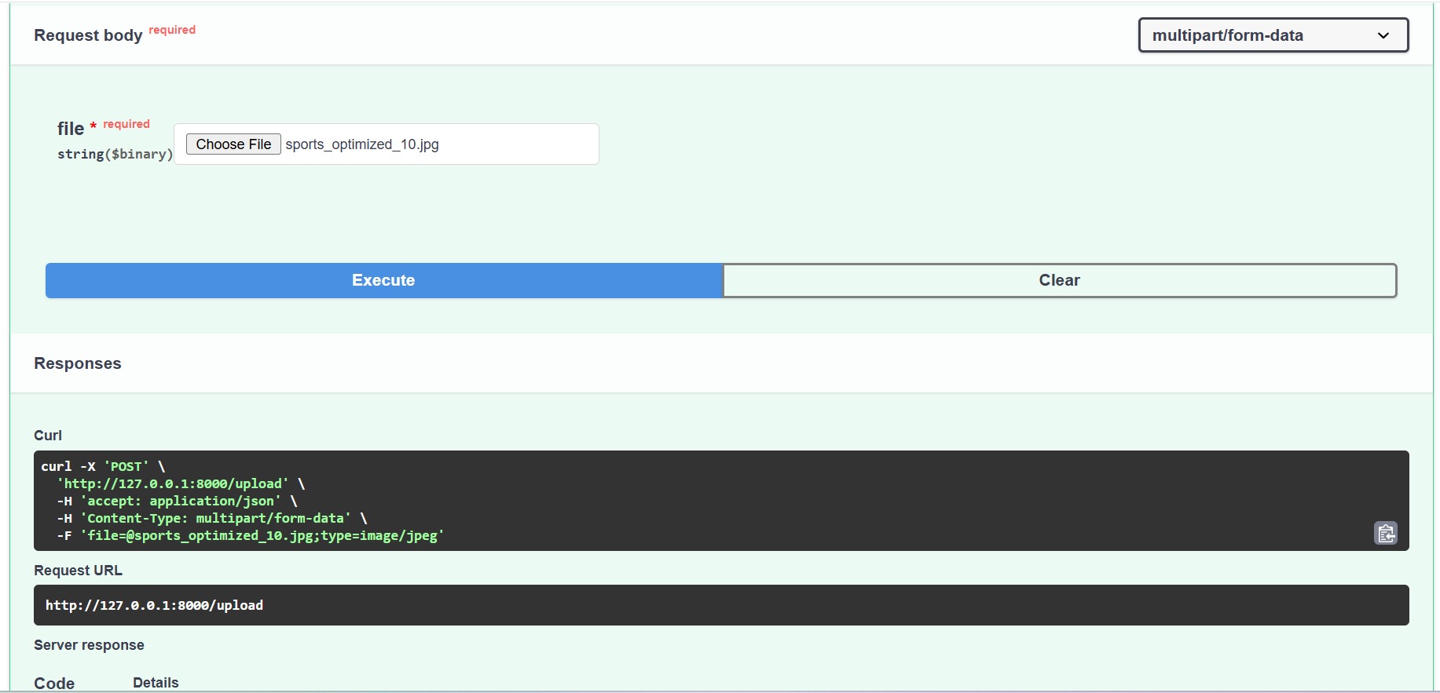
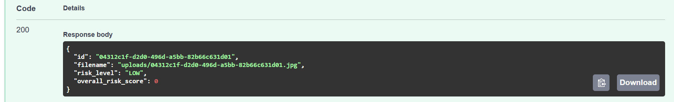
Case 4:
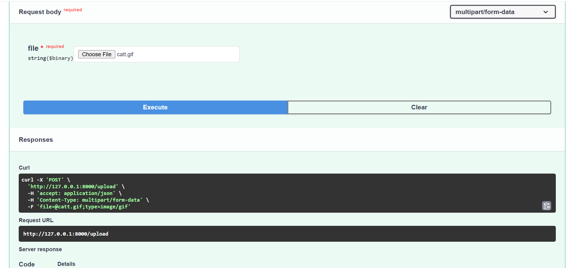
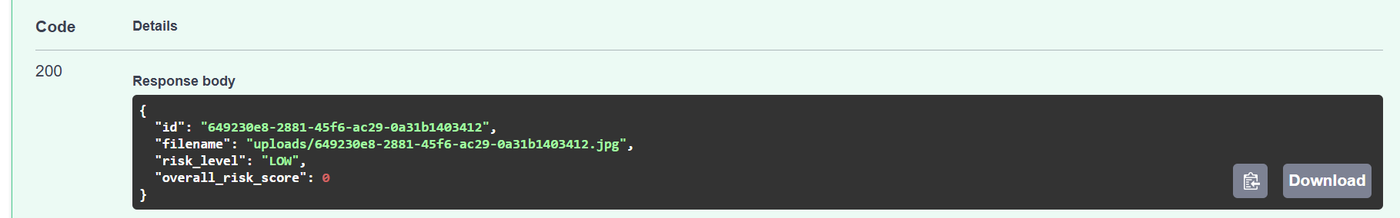

Case 5:
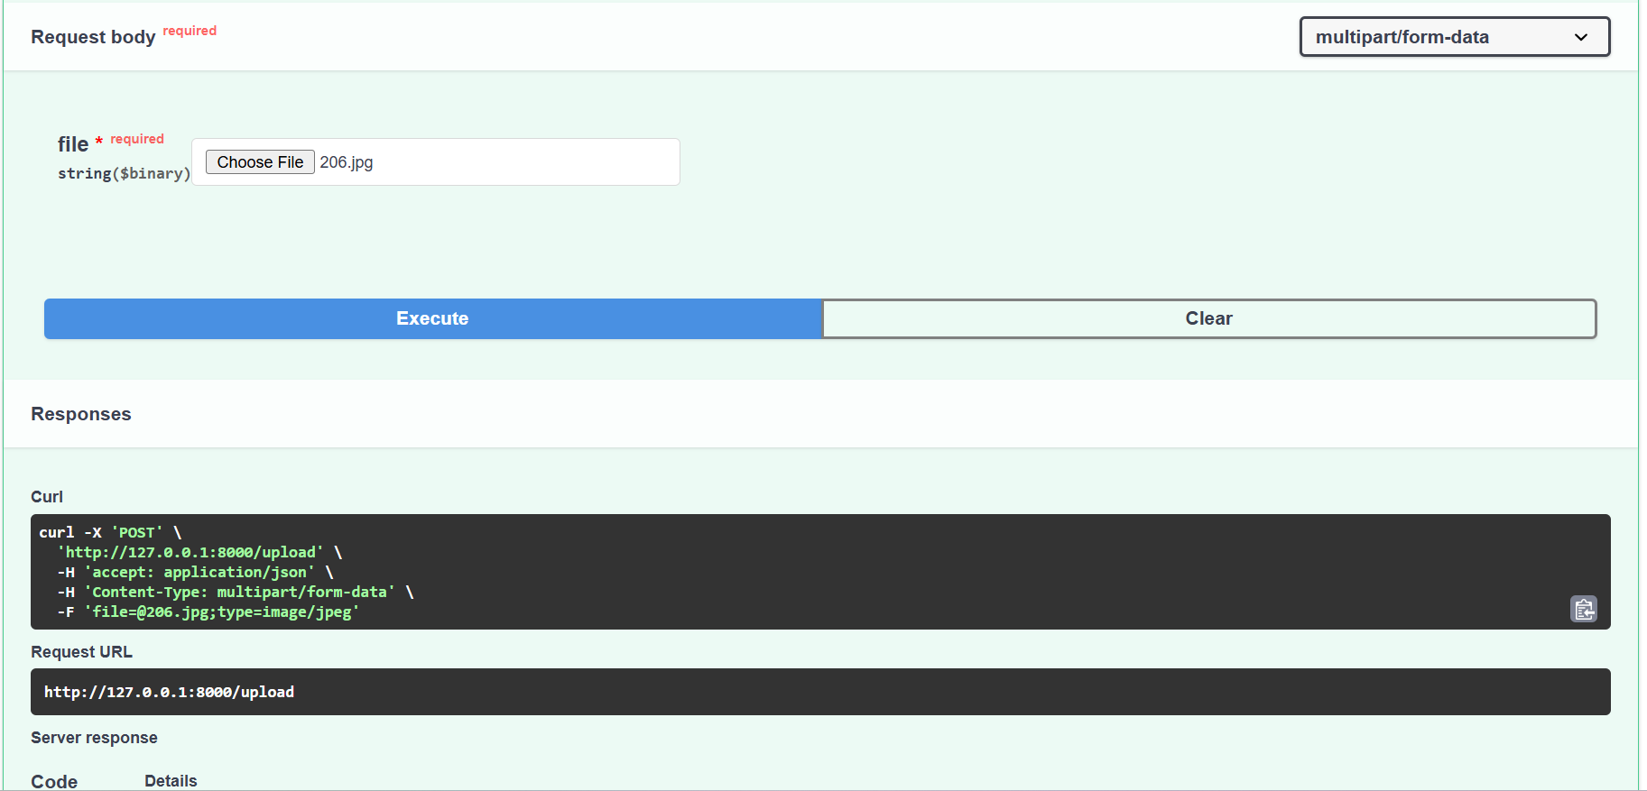
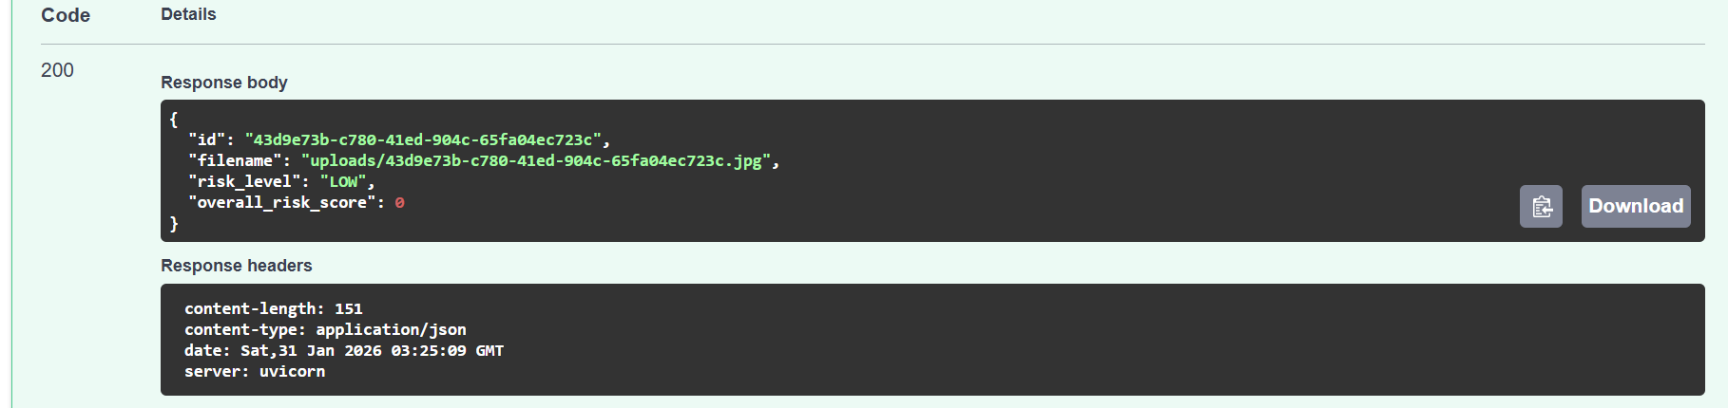
Case 6:
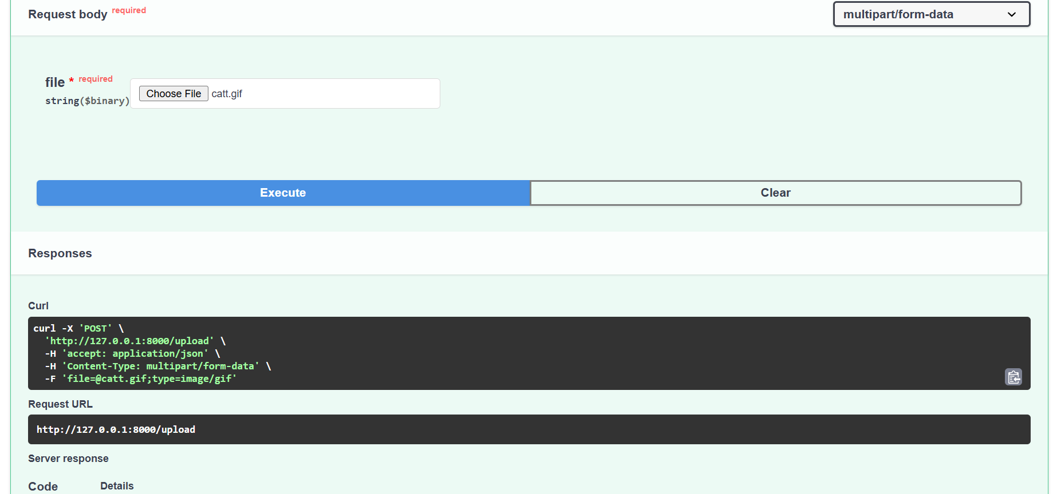
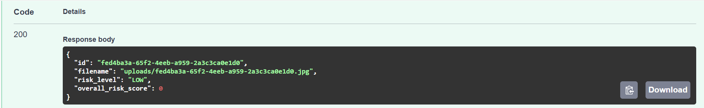

Case 7:
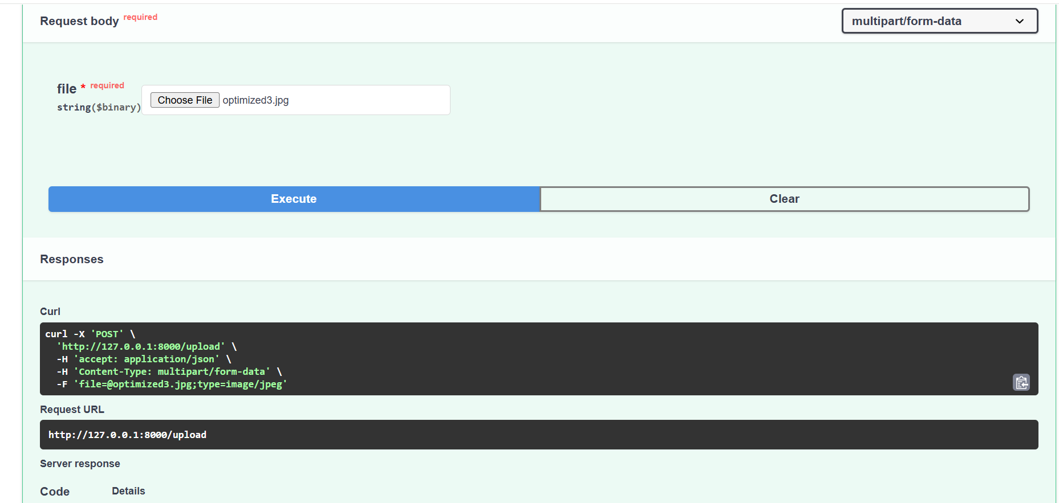
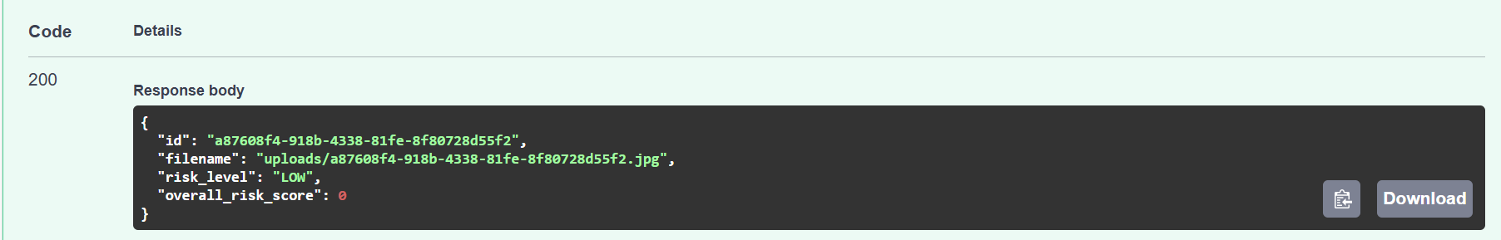

SCREENSHOTS OF UPLOADS FOLDER
Each input was successfully automatically added to the uploads folder:
