Olist E-Commerce Data Warehouse

Introduction
This comprehensive document details the end-to-end design, architecture, and implementation of an enterprise-grade Data Warehouse for Olist, a prominent Brazilian e-commerce marketplace enabler. The project encompasses the full data engineering lifecycle, meticulously following a 9-phase requirement structure. The primary objective is to transform disparate, highly normalized operational datasets into a centralized, highly performant analytical source of truth. By doing so, the organization can transition from fragmented operational reporting to strategic, data-driven decision-making.

Phase 1: Business Understanding
Olist operates a unique B2B2C business model. On one side, it acts as a platform for small and medium-sized Brazilian merchants, connecting them with major online marketplaces without the hassle of individual contracts. On the other side, it ensures a seamless purchasing and fulfillment experience for the end consumer. However, because Olist manages the logistics but relies on third-party sellers for product listing and dispatch, maintaining quality control and timely delivery is a significant operational challenge. Late deliveries directly harm customer satisfaction, which is reflected in review scores.
To effectively monitor and optimize this ecosystem, the business requires visibility into both the seller acquisition funnel (from Marketing Qualified Leads to Closed Deals) and the consumer transaction loop (Orders, Payments, and Fulfillment). The primary Key Performance Indicators (KPIs) established for this project include Gross Merchandise Value (GMV), Average Order Value (AOV), Total Order Volume, Payment Method Distribution, and Customer Satisfaction (Average Review Score).

Phase 2: OLTP Database Design (Source Systems)
For this project, instead of building a simulated OLTP database from scratch, we leverage a robust, real-world operational data extract provided by Olist (via Kaggle). This authentic source data reflects the true complexity of a production environment and consists of 11 highly normalized flat files across two primary operational domains:

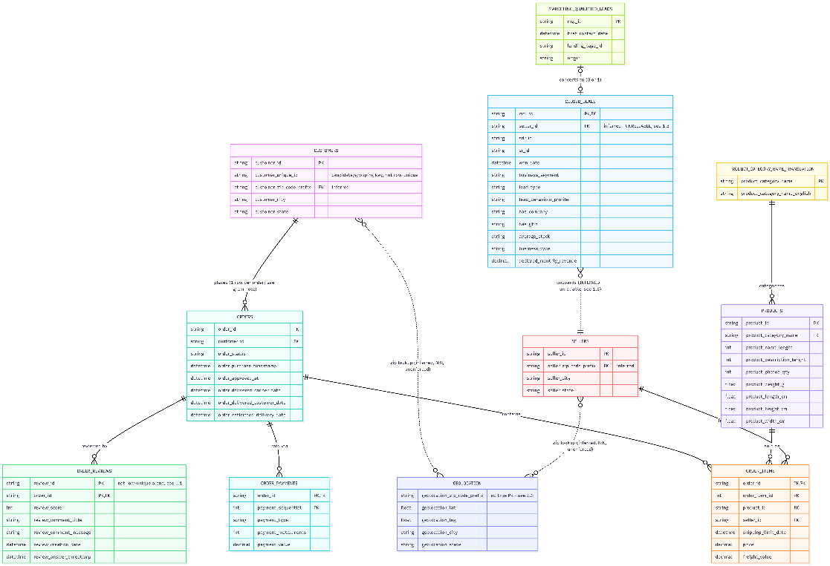
- CRM System: Tracks the B2B seller acquisition funnel, containing tables for Marketing Qualified Leads (MQLs) and Closed Deals, Reviews, Customers.
2. ERP/E-commerce System: Manages the B2C transactional flow, comprising heavily normalized tables for Orders, Order Items, Payments, Products, Sellers, and Geolocation mapping.

Phase 3: OLTP Workload Simulation
Simulating a transactional workload typically involves creating scripts to generate random insert, update, and delete statements. However, because the provided historical operational extracts contain over 100,000 real orders and 8,000 marketing leads, a live concurrency simulation was bypassed in favor of processing actual historical transactions. The workload was effectively simulated by performing bulk ingestions of these massive datasets into a 'Bronze' staging layer, mirroring a realistic snapshot extraction from a high-volume, live transactional database.
Phase 4: OLTP Limitations Analysis
An analysis of the highly normalized 3NF source structure (spread across 11 distinct tables) revealed severe analytical limitations. In a standard OLTP environment, data is optimized for fast, single row inserts and updates. However, attempting to generate analytical reports—such as calculating platform-wide GMV by product category or correlating marketing lead sources with eventual customer delivery satisfaction—required complex queries with 6 to 8 table joins. These operations are computationally expensive, cause table locking, and are highly inefficient for Business Intelligence (BI) tools. This
explicitly justifies the necessity of migrating the data into a denormalized Data Warehouse.
OLTP vs. OLAP Architectural Comparison:
Feature | OLTP | OLAP
Primary Purpose | Managing day-to-day business operations and transactions(inserts/updates). | Complex analysis, extracting business insights, and strategic decision-making.
Data Schema | Highly normalized (3NF) to avoid redundancy and ensure fast row-level writes. | Denormalized / Dimensional (Star Schema with Fact & Dimension tables).
Query Type | Simple, targeted lookups on specific records  (SELECT * WHERE id = ). | Heavy aggregations, complex multi-table JOINs, Window Functions, and statistical routines.
Handling Complex Queries | Poor / High Latency: Causes heavy CPU/RAM spikes, table locking, and degrades live application performance. | Purpose-Optimized: Designed with columnar storage strategies and pre-computed relationships to execute queries in seconds.
To understand why transitioning from OLTP to OLAP is mandatory for complex analytics, consider the following structural comparison:

With Yearly_Revenue As (
Select
p.Category_Name_En product_category,
d.Year_Number order_year,
Sum(oi.price + oi.freight_value) total_revenue
From Gold.Fact_Order_Items oi
Join Gold.Fact_Orders o On oi.order_id = o.order_id
Join Gold.Dim_Date d On o.Purchase_Date_Key = d.Date_Key
Join Gold.Dim_Product p On oi.Product_Key = p.Product_Key
Where o.order_status = 'delivered'
Group By p.Category_Name_En, d.Year_Number
),
Calculated_Growth As (
Select
product_category,
order_year,
total_revenue,
Coalesce(Cast(Lag(total_revenue) Over (Partition By product_category Order By order_year)As Float), 0) As prev_year_revenue
From Yearly_Revenue
)
Select
product_category,
order_year,
total_revenue,
prev_year_revenue,
Case
When prev_year_revenue = 0 then '0%'
Else CONCAT(ROUND(CAST(((total_revenue - prev_year_revenue) / prev_year_revenue) * 100 AS FLOAT), 2),'%')
End As yoy_growth_pct
From Calculated_Growth
Where product_category Is Not Null
Order BY product_category, order_year;

Furthermore, attempting to run complex analytical queries—such as Year-over-Year Growth calculations using LAG() window functionson a normalized OLTP schema causes severe performance breakdown. This explicitly validates why an OLAP architecture is required.

Query Execution Plan:
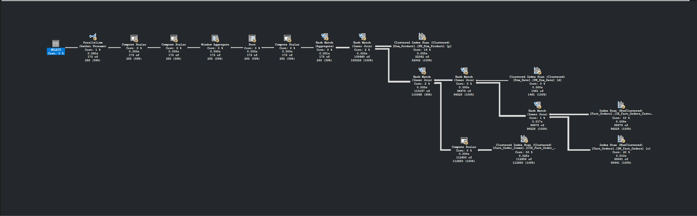

Phase 5: ETL Design
The ETL (Extract, Transform, Load) pipeline was engineered using Microsoft SQL Server and T-SQL, structured across a modern Medallion Architecture to ensure data quality, lineage, and auditability:
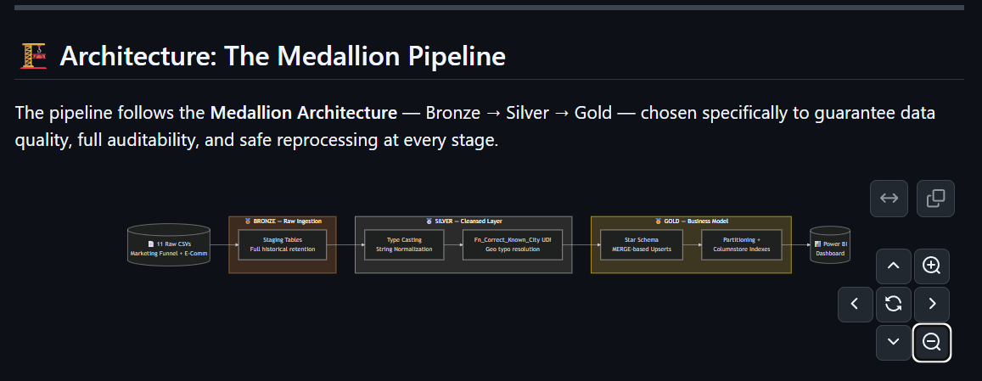
• Bronze Layer (Raw): Ingests the raw CSV files directly into staging tables via BULK INSERT. No transformations are applied here, serving as an immutable historical archive.
• Silver Layer (Cleansed): This layer acts as the enterprise integration point. Data types are cast correctly, strings are standardized (trimming, lowercasing, and accent removal), and missing values are handled. A notable transformation includes the use of a custom UDF (Fn_Correct_Known_City) to resolve extensive typos and abbreviations in Brazilian city names.
• Gold Layer (Business Model): The final layer where cleansed data is restructured into Star Schema dimensions and facts, utilizing MERGE statements to handle incremental updates (Upserts).

Phase 6: Data Warehouse Design
The Gold layer is intentionally designed as a Star Schema, shifting the structural focus from transactional efficiency to analytical speed. This design reduces the number of required joins and provides an intuitive data model for BI developers.

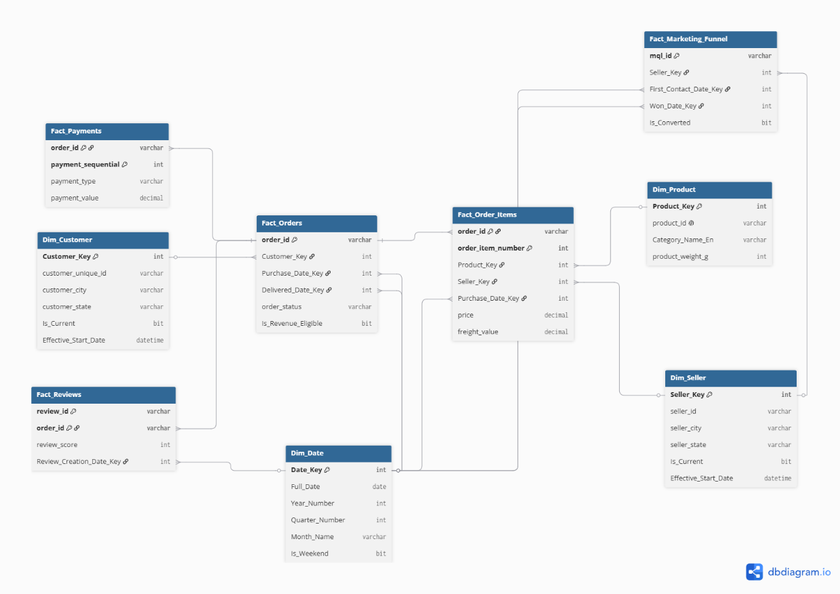
The schema consists of several domain-specific Fact Tables:
• Fact_Orders: Tracks the high-level order lifecycle and statuses.
• Fact_Order_Items: The most granular transactional table, holding product price and freight value for revenue calculations.
• Fact_Payments: Records the financial transaction methods and installment details.
• Fact_Reviews: Stores customer satisfaction scores and feedback timestamps.
• Fact_Marketing_Funnel: Bridges the B2B pipeline, tracking the conversion of MQLs into active sellers.
These facts are surrounded by conformed Dimension Tables: Dim_Customer, Dim_Seller, Dim_Product, and a generated Dim_Date.

Phase 7: Advanced Modeling
To ensure the Data Warehouse maintains historical accuracy and handles data anomalies, advanced modeling techniques were employed:
• Surrogate Keys & Unknown Members: All dimensions utilize system-generated IDENTITY columns (e.g., Customer_Key, Seller_Key) rather than relying on source system natural keys. Default 'Unknown' rows (Key = -1) are injected to handle early-arriving facts, ensuring referential integrity is never broken even if a seller's dimension data is delayed.
• Slowly Changing Dimensions (SCD Type 2): Applied to the Customer and Seller dimensions to track geographical changes over time. For example, if a seller moves their operations from 'Sao Paulo' to 'Rio de Janeiro', the existing record is closed (Effective_End_Date is set, Is_Current becomes 0), and a new record is inserted. This guarantees that historical orders report the correct freight and routing logic based on where the seller was located at the exact time of the transaction.
Phase 8: Performance & Scalability
Given the massive volume of transactional data, specific database tuning techniques were applied to the Gold Layer to guarantee fast analytical query response times:
• Table Partitioning: The largest fact tables (Fact_Orders and Fact_Order_Items) are physically partitioned across the disk by Purchase_Date_Key. A Partition Function divides the data into yearly chunks (2016,2017, 2018,), allowing the SQL engine to completely ignore irrelevant partitions during time-series queries (Partition Elimination).
• Columnstore Indexing: Nonclustered Columnstore Indexes (NCCI) were applied to the Fact tables. Unlike traditional row-based B-Tree indexes, columnstore indexes compress data highly and process columns in batches, drastically reducing I/O for the heavy SUM and AVG aggregations executed by the BI layer.
Phase 9: Analytical Queries & Reporting
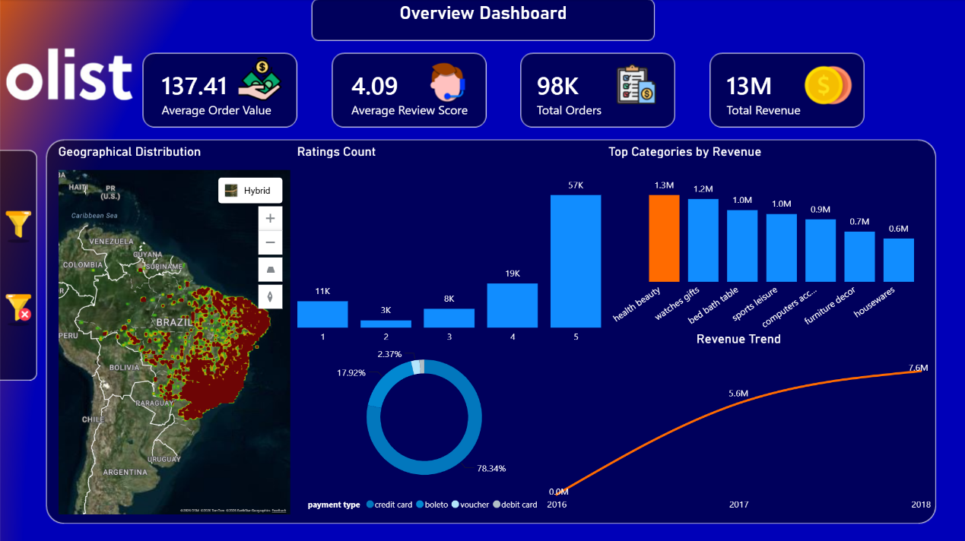
The culmination of the Data Warehouse project is the reporting layer. A comprehensive Power BI dashboard was constructed atop the Gold Star Schema, directly addressing the strategic questions outlined in Phase 1.
Key Dashboard Insights Derived from the Data:
• Platform Scale & Revenue: The platform successfully processed 98K total orders, generating a total revenue of 13M. The Average Order Value (AOV) stands at $137.41, indicating healthy individual transaction sizes.
• Revenue Trend Analysis: The data reveals a massive scale-up trajectory. Revenue grew from a very small footprint in 2016, skyrocketing to 5.6M in 2017, and continuing to grow to 7.6M by 2018.
• Top Categories by Revenue: The product categories driving the most significant financial value are 'Health & Beauty' (1.3M), followed closely by 'Watches & Gifts' (1.2M) and 'Bed Bath Table' (1.0M).
• Customer Satisfaction Polarization: While the overall Average Review Score is a positive 4.09, the distribution highlights an operational challenge. The majority of reviews are 5-stars (57K), but the second most frequent rating is 1-star (11K), indicating that when logistics fail, the customer experience degrades severely.
• Payment Preferences: Brazilian consumers heavily favor Credit Cards, which account for 78.34% of all transaction volume. The traditional Boleto (bank slip) remains the second most popular method at 17.92%, which has implications for order approval delays given the clearance time required for Boletos.

