The Anatomy of a Goal
Decoding Scoring Patterns Across Europe’s Top Leagues
AI-Assisted Data Analysis Using Agentic AI — Report

Dataset: Wyscout Soccer Match Event Dataset (Kaggle) | AI Tool: Claude (Anthropic) |
Analysis: Python, pandas, matplotlib, seaborn
1. Dataset Description
This study analyzes a football match event dataset from Wyscout, a professional football analytics resource published on the Kaggle platform (aleespinosa/soccer-match-event-dataset). The data covers all ball movements in 1,941 matches played during the 2017/18 club season, UEFA Euro 2016, and the 2018 FIFA World Cup. The raw events were converted to SPADL format (Soccer Player Action Description Language), which standardizes each action with pitch coordinates, an action type, a result, and the body part used.
The analysis uses three row-aligned core files plus six supporting reference tables:

File | Rows × Columns | Description
actions.csv | 2,462,726 × 17 | Every on-ball action: x/y coordinates, type, result, body part
features.csv | 2,462,726 × 86 | Engineered spatial features for 3-action sequences (distance, angle)
labels.csv | 2,462,726 × 2 | VAEP labels: "scores" and "concedes" (does the sequence lead to a goal?)
games.csv | 1,941 × 8 | Match reference: competition, date, home/away teams
players / teams | 3,603 / 142 | Player profiles (position, foot, height) and club metadata
playerank.csv | 46,897 × 6 | Per-match player ratings with positional role clusters

Main variables. The most analytically valuable columns are the spatial coordinates (start_x, start_y, end_x, end_y on a 105 × 68 m pitch), the action type_name (19 distinct types including pass, cross, dribble, shot, interception, and tackle), the result_name (success / fail / offside / owngoal), the bodypart_name (foot / head / other), and the engineered features start_distance_to_goal and start_angle_to_goal. The binary scores label flags the actions that belong to a goal-scoring sequence. In total the dataset contains 2,462,726 actions, of which 45,937 are shots and 5,104 are goals — an overall conversion rate of 11.1% and an average of 2.63 goals per match.
2. AI-Assisted Analysis
The full analysis was conducted in a Jupyter Notebook generated and iteratively refined with the help of Claude (Anthropic). Claude assisted in four phases: (a) exploring and joining the 27 raw files, (b) detecting and explaining missing values, (c) computing descriptive statistics and 13 visualizations, and (d) interpreting the spatial, sequential and cross-league patterns behind goals.
2.1 Missing Values & Preprocessing
Missing-value detection showed the dataset is remarkably complete. Only original_event_id had a notable gap (6.85%), and the sequence-context columns (suffixed -1 and -2) were missing in just 0.08–0.16% of rows. Crucially, these gaps are not data corruption: they correspond to the first and second actions of each match half, which have no preceding action to describe. The recommended preprocessing — filling these context columns with 0 and treating the success/fail result as the outcome of interest — was applied before the analysis.

2.2 Where Goals Come From
Mapping all 5,104 goals onto the pitch reveals an unmistakable concentration: goals are scored from a narrow central corridor directly in front of the goal, overwhelmingly inside the penalty area. The build-up heatmap (Chart 2) shows scoring sequences gather most density just outside the box before the decisive entry.
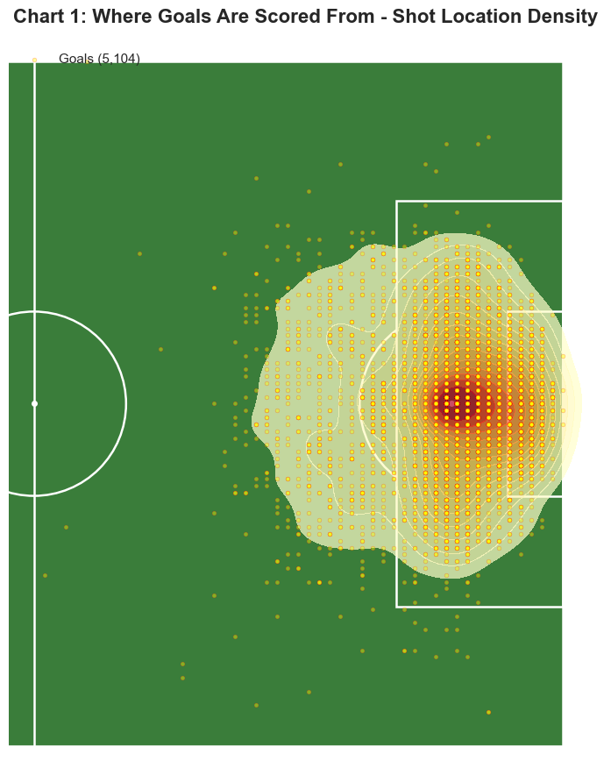
Chart 1 — Goal density: nearly all goals originate within ~18 m of the goal, centrally.
2.3 The Winning Formula: Sequences That Score
A goal is the climax of a sequence, not an isolated event. Examining the three consecutive actions that end in a goal, the single most common chain is pass → pass → shot (831 goals), followed by pass → cross → shot (542) and pass → dribble → shot (436). Three signatures stand out: a passing core, a wide-delivery route in which a cross feeds the shot, and a dribble-led route where a player beats an opponent before shooting or assisting. Two further patterns are revealing — shot → save → shot (225 goals) shows the value of following up rebounds, while sequences that win a foul in the box convert into penalties. Across all chains, shots are 9.1× (you cannot score without shooting, so shots heavily dominate the final actions of a goal.), crosses 2.45×, and dribbles 1.49× over-represented in goal-scoring sequences versus normal play.
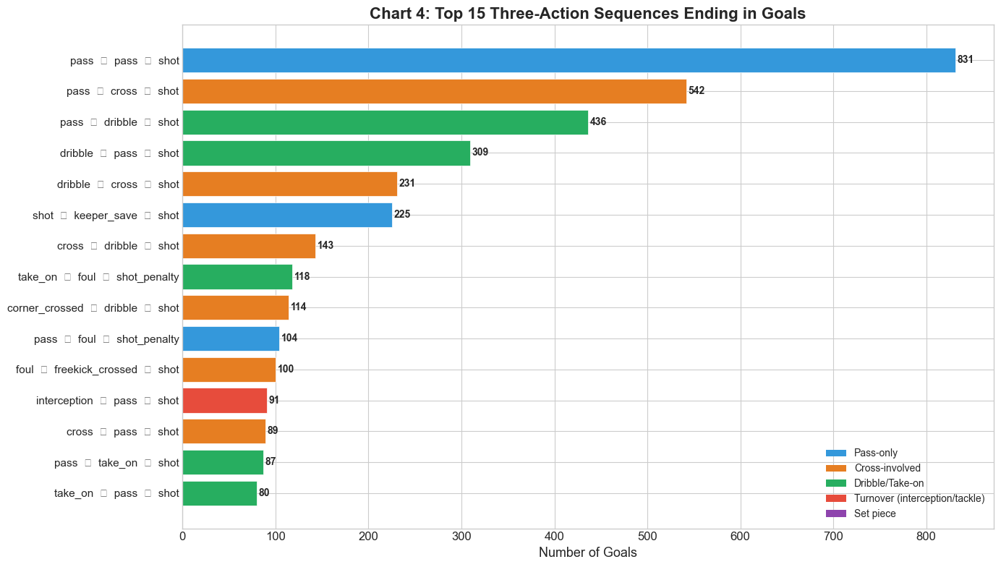
Chart 4 — The 15 most common three-action sequences that end in goals, colour-coded by play type.
2.4 League Fingerprints: How Scoring Differs Across Europe
Each competition has a distinct scoring signature. The 2018 World Cup was the most prolific at 2.86 goals per match, with the Bundesliga the highest-scoring domestic league (2.72). The starkest contrast is the source of goals: in the international tournaments, penalties account for 26–27% of goals (Euro 27.1%, World Cup 26.2%) — three to four times their 6–10% share in the domestic leagues, an effect inflated by penalty shootouts in the knockout rounds. Open-play creation differs too: Ligue 1 (19.3%) and La Liga (19.0%) lean most heavily on crosses, whereas the World Cup is the least cross-dependent (11.5%), favouring more varied, direct attacks. Headed goals stay broadly consistent (14–18%), while average shot distance is slightly longer in the international tournaments.
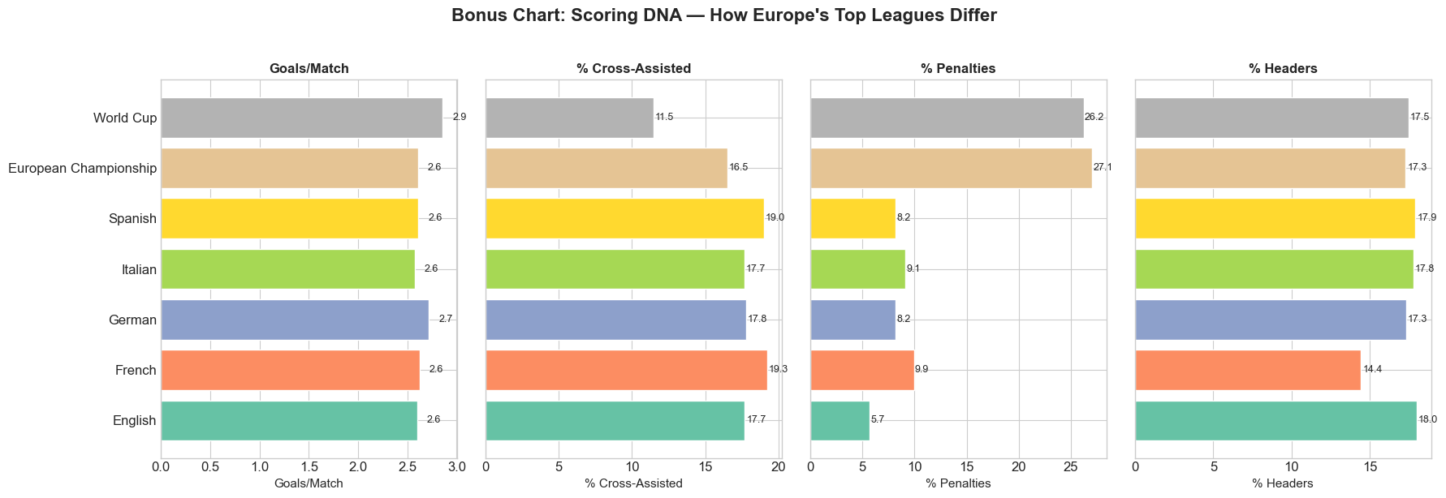
Chart 13 — Scoring DNA: goals per match, cross-assisted %, penalty %, and headed % across the seven competitions.
3. Key Insights
Six data-backed findings emerged. Each was computed directly from the data, stress-tested for robustness, and cross-checked against football intuition.
- Insight 1 — The Golden Zone. 84.4% of all goals come from within 18 m of goal, where shots convert at 18.1% versus just 3.6% from outside — a 5× edge. Closer still, the point-blank zone (≤11 m) alone supplies 46% of all goals at a 28% conversion rate. The lesson is blunt: work the ball into the box rather than shoot from distance.
- Insight 2 — The Cross-Shot Pipeline. A cross is the most efficient final ball in football: crosses convert at 16.6% versus 9.3% for a normal pass — nearly twice as likely to produce a goal — and they supply 18% of all goals. Delivery skews to one flank, with the right wing creating more than the left (503 vs 405).
- Insight 3 — The Cut-Back Is King. Roughly 19% of goals are created by a cut-back: a player carries the ball to the deep, wide byline and pulls it back to a teammate arriving centrally. It is one of the most repeatable, coachable patterns in the modern game, and it stands out clearly in the assist-delivery map (Chart 3).
- Insight 4 — Two Routes Into the Box. The decisive pass is almost always played close: 64.6% of assists are delivered from inside the penalty area, a median of just 20.3 m from goal. That supply splits into two complementary routes — wide deliveries (57% of cross-assists come from the flanks) and central short passes (43% played from inside the box).
- Insight 5 — Formation Vulnerability. Among formations used in at least 100 matches, goals conceded range from 1.01 per match (a 2-3-5 shape) to 1.56 (3-6-1). A caution on causation: lining up with more defenders correlates with conceding more — not because deep blocks fail, but because teams already losing tend to pack the defense, so the shape is partly an effect of the scoreline, not just a cause.
- Insight 6 — The Counter-Attack Premium. Shots taken right after winning the ball back convert at 13.4% versus 10.5% in sustained build-up — a 1.3× premium. Tempo itself, by contrast, is a weak differentiator: goal sequences are barely faster than non-scoring ones, and the mean and median even disagree — so it is winning possession high up the pitch, not raw speed, that creates the edge.
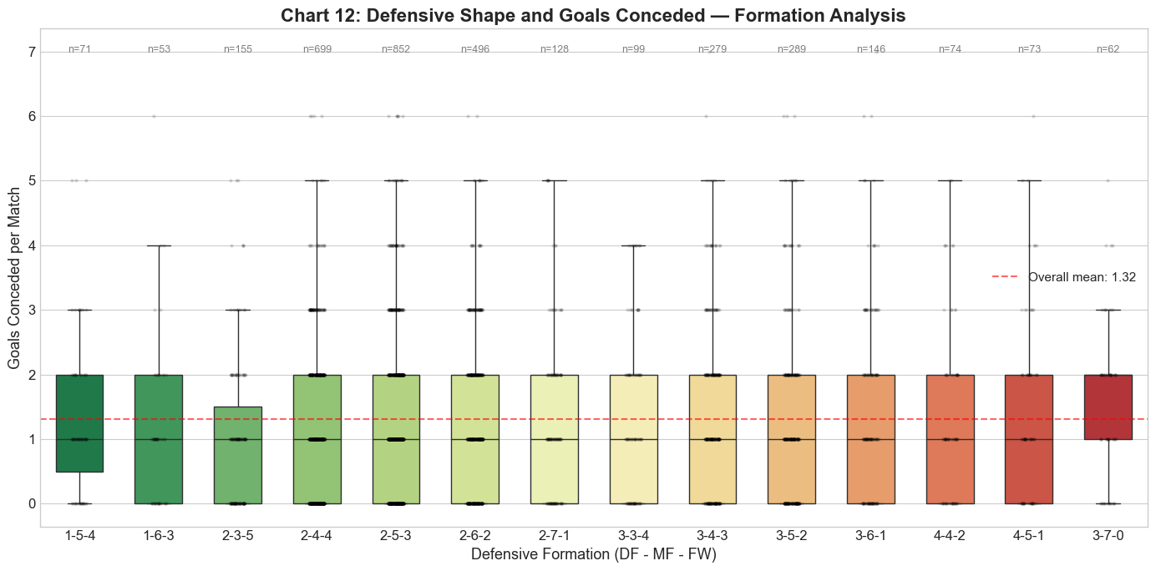
Chart 12 — Goals conceded by formation, sorted from most solid (left) to most vulnerable (right).
4. Reflection
AI Tool Used
The analysis was performed with Claude (Anthropic) operating as an agentic assistant. Claude designed the analysis framework, generated the Python code for data joining, statistics and visualization, and helped interpret the results in plain language.
Advantages
- Conversational iteration: Transforms open-ended search questions ("What patterns lead to goal achievement?") into actionable, implementable analytical steps.
- High-quality code: Powerful software using Pandas, Matplotlib, and Seaborn libraries, capable of handling a 2.3 GB data file by column selection.
- Domain knowledge: Understands and correctly applies specialized concepts (such as SPADL procedure formatting, VAEP goal sequence classifications, and conversion rates).
Limitations
- No visual feedback: Claude cannot see rendered charts, so the human must visually confirm each visualization is correct.
- Data assumptions: the coordinate convention (which goal a team attacks) had to be checked manually; an early version measured distance to the wrong goal.
- Scope of data: the dataset records only on-ball events, so off-ball runs and defensive positioning are invisible to this analysis.
How AI-Generated Results Were Verified
- Cross-checking — Key totals (5,104 goals, 11.1% conversion, 2.63 goals/match) were recomputed directly from the raw data and matched.
- Reproducibility — each headline statistic was recomputed via different filtering paths (zone counts vs. distance bins) and the results agreed.
- Falsification — the popular “speed kills” claim was tested and the data did not back it — tempo barely separates scoring from non-scoring sequences, and the mean and median even disagree — so we reported the honest null result rather than the assumed one.
- Sanity checks — results were checked against football intuition (close-range shots convert more, headers are rarer but efficient).

Full reproducible analysis and all 13 visualizations are provided in the accompanying notebook: soccer_goal_analysis.ipynb

