Ansible Setup on EC2 Instances

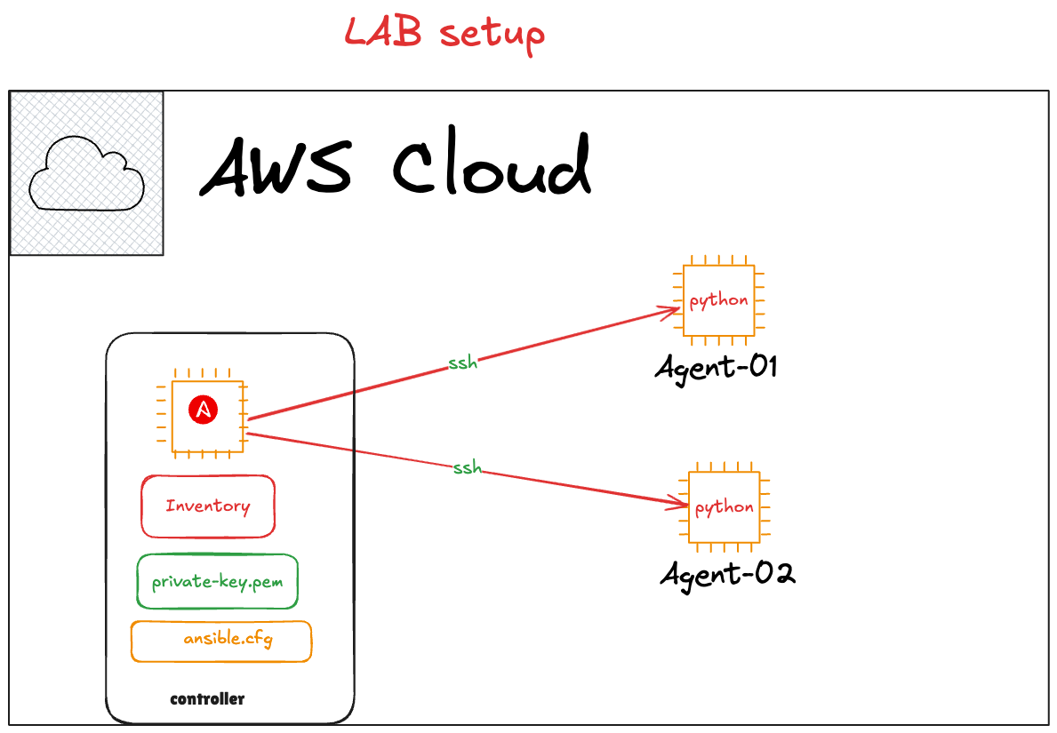

Architecture
• Controller Node: EC2 Instance #1 (Amazon Linux)
• Managed Nodes: EC2 Instances #2 and #3
• All instances use the same SSH key pair ( ansible.pem)

Step 1: Launch 3 EC2 Instances
• OS: Amazon Linux 2 or 2023
• Use the same key pair for all three
• Security group: Allow SSH from your IP and allow intra-group traffic

Step 2: Install Ansible on the Controller Node
1. SSH into the controller node:
ssh -i your-key.pem ec2-user@<controller_public_ip>
2. Install Ansible:
# sudo dnf install -y ansible

Step 4: Create Inventory File
1. Create project folder:
# mkdir ~/ansible-project && cd ~/ansible-project
2. Create a file named 'hosts':
[web]
<node1_ip> ansible_user=ec2-user ansible_ssh_private_key_file=~/ansible-project /your-key.pem
<node2_ip> ansible_user=ec2-user ansible_ssh_private_key_file=~/ansible-project /your-key.pem

Step 5: Set Up SSH Access to Managed Nodes
2. Place your-key.pem inside ~/ansible-project :
chmod 400 ~/ansible-project your-key.pem
3. Test SSH access:
ssh -i ~/ansible-project your-key.pem ec2-user@<node1_ip>

Step 6: Create ansible.cfg (Optional)
[defaults]
inventory = ./hosts
host_key_checking = False

Step 7: Test Connection
Run the following command to ping the nodes:
ansible web -m ping
Expected Output:
<node1_ip> | SUCCESS => { "ping": "pong" }
<node2_ip> | SUCCESS => { "ping": "pong" }

