Graduation Project Proposal

Project Information
Project Title | Department/Faculty/University | Project Field/Discipline
V2X_Collision_Avoidance | Engineering – Electronics and Communication | Embedded System
Advisors’ Names | Advisors’ Mobile Numbers | Advisors’ Email Addresses
Abdallah Mohammed Hassan | 01110279317 | abdallah.mohamed@azhar.edu.eg
Students’ Names | Students’ Mobile Numbers | Students’ Email Addresses
Abdallah AbdelMomen Abdallah | 01501899476 | Shehawey9@gmail.com
Abdallah Saleh Mohamed | 01126740033 | abdallahsalehmohamed393@gmail.com
Ahmad Gamal Ali | 01006872317 | ag5580386@gmail.com
Alaa Hassan Wanas | 01099118093 | alaahassan0591@gmail.com
Amira Atef Roshdy | 01091860768 | amiraatef1572003@gmail.com
Aya Gamal Taha | 01287883101 | ayagamal87eg@gmail.com
Gamila Adel Mohamed | 01207760389 | gamilaelkomy@gmail.com
Asmaa Saad Fouda | 01154756255 | Saaa299187@gmail.com

Is this project part of a mega-project at the same institution? Yes No (If yes, please submit all proposals together.)
If the project is sponsored by or initiated by an ICT company, please state its name:
Motivation
Please write why you chose this project idea, explaining clearly the problem that the project is addressing
We selected the Vehicle-to-Everything (V2X) project because it addresses critical challenges in modern transportation systems, such as traffic congestion and road accidents, by enabling real-time intelligent communication between vehicles and their surrounding environment instead of relying solely on the driver.
The project is integrated with Internet of Things (IoT) technologies, which form the backbone of connected and smart systems. Vehicles, traffic infrastructure, and sensors are treated as intelligent IoT nodes capable of continuously exchanging data across the network.
In addition, Artificial Intelligence (AI) is incorporated to analyze real-time data collected from vehicles and sensors, predict potential risks such as collisions or congestion, and support proactive decision-making by generating early warnings or recommending route adjustments, thereby enhancing road safety and traffic efficiency.
Although 5G networks are theoretically ideal for V2X applications due to their ultra-low latency and high data rates, their practical use requires regulatory permissions for operating on licensed frequency bands. As a result, Wi-Fi is used as a practical alternative to implement the project prototype and validate the system concept. The system is designed in a flexible manner that allows seamless migration to 5G in the future without major architectural changes.
Why do you think your project should be funded? for which the applicants write in a few lines where the help statement should be “Explain in no more than 3 lines the new and innovative aspects in your project that make it worthy of funding.”
The project deserves funding as it aims to reduce traffic accidents through an intelligent system based on V2X communication for real-time data exchange between vehicles and their environment, enabling early warnings and safer decisions. It also integrates Artificial Intelligence and Computer Vision techniques using models such as YOLO to detect vehicles, pedestrians, and obstacles in real time. This integration enhances risk prediction and improves road safety, aligning with Egypt Vision 2030 for smart mobility.

Block Diagram
Please insert the project detailed block diagram below, (Please highlight the parts that will be implemented in different colors than the parts that will be purchased)
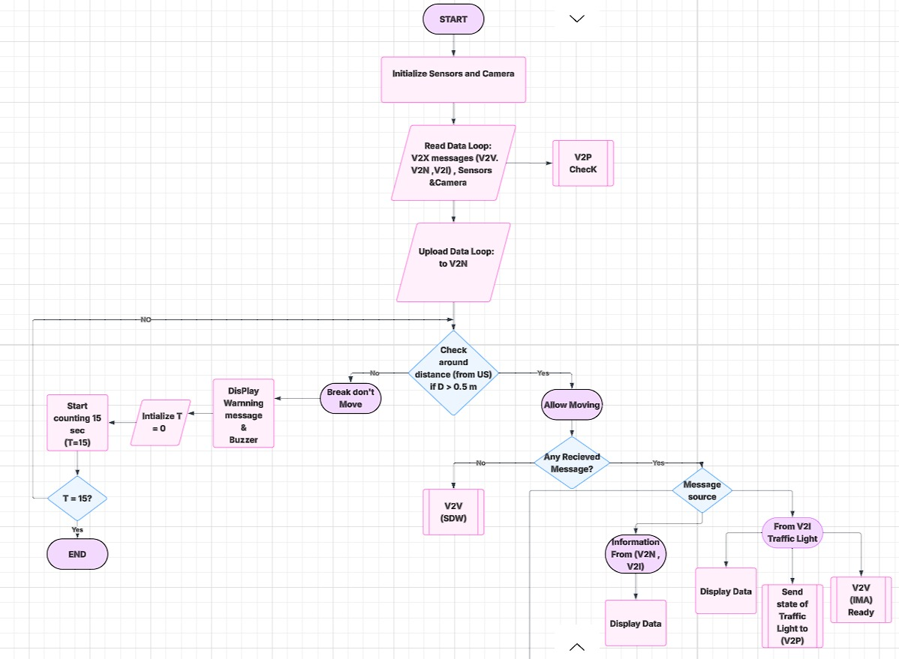

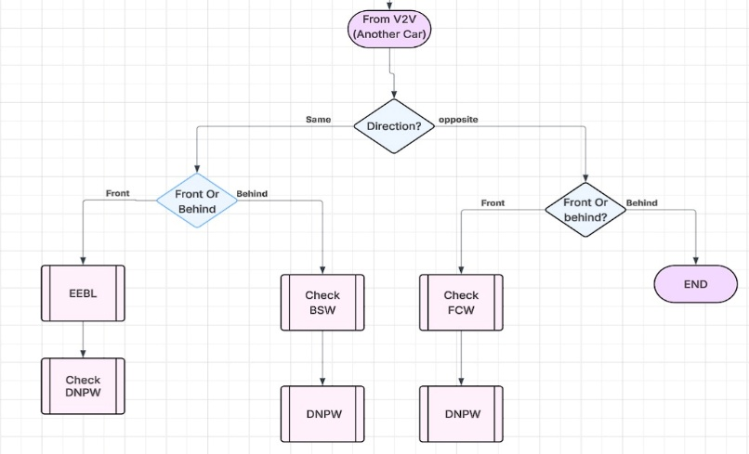
For more details, click here
Prototype Description and Specifications
Please note that ITAC only funds projects that result in a prototype. Include a clear description of how the prototype will operate, explaining a scenario/use case of the operation. Also include the performance metrics you target in the prototype.
Our project focuses on developing a practical prototype of a V2X-based collision avoidance system. The prototype will be installed in a test vehicle and integrates:

Sensors (Ultrasonic, GPS, Speed Sensors)
Microcontrollers (ESP32/STM32)
Wireless communication modules (DSRC / simulated Wi-Fi)
LCD display and buzzer for alerts

🔹 Operational Use Case:
When two vehicles approach an intersection or when a leading vehicle brakes suddenly, the system detects the hazard via sensors and:
Immediately alerts the driver (via LCD message + audible warning)
Transmits a wireless warning to nearby vehicles using V2V communication
If the driver does not respond, the ADAS system automatically intervenes to reduce speed via motor control

🔹 Target Performance Specifications:
Total system response time: < 100 milliseconds (Real-Time Response)
Accuracy in detecting nearby vehicles: ±1.5 meters (with minimal false alarms)
Wireless communication range: Up to 100 meters in open areas
Collision avoidance success rate in simulation: > 90%
System stability: Continuous operation for 4+ hours without failure

🔹 Scalability and Commercial Potential:
The prototype is designed using affordable and readily available components, making it suitable for the Egyptian market. Its modular architecture allows future expansion to support:
Commercial vehicles and buses
Smart infrastructure (connected traffic signals)
As an aftermarket unit installable in existing vehicles
This project supports Egypt’s transition toward smart transportation and sustainable cities, offering a realistic, fundable, and industrially scalable solution.

Project Plan
Please define the approach and phases to deliver the intended project outcome.
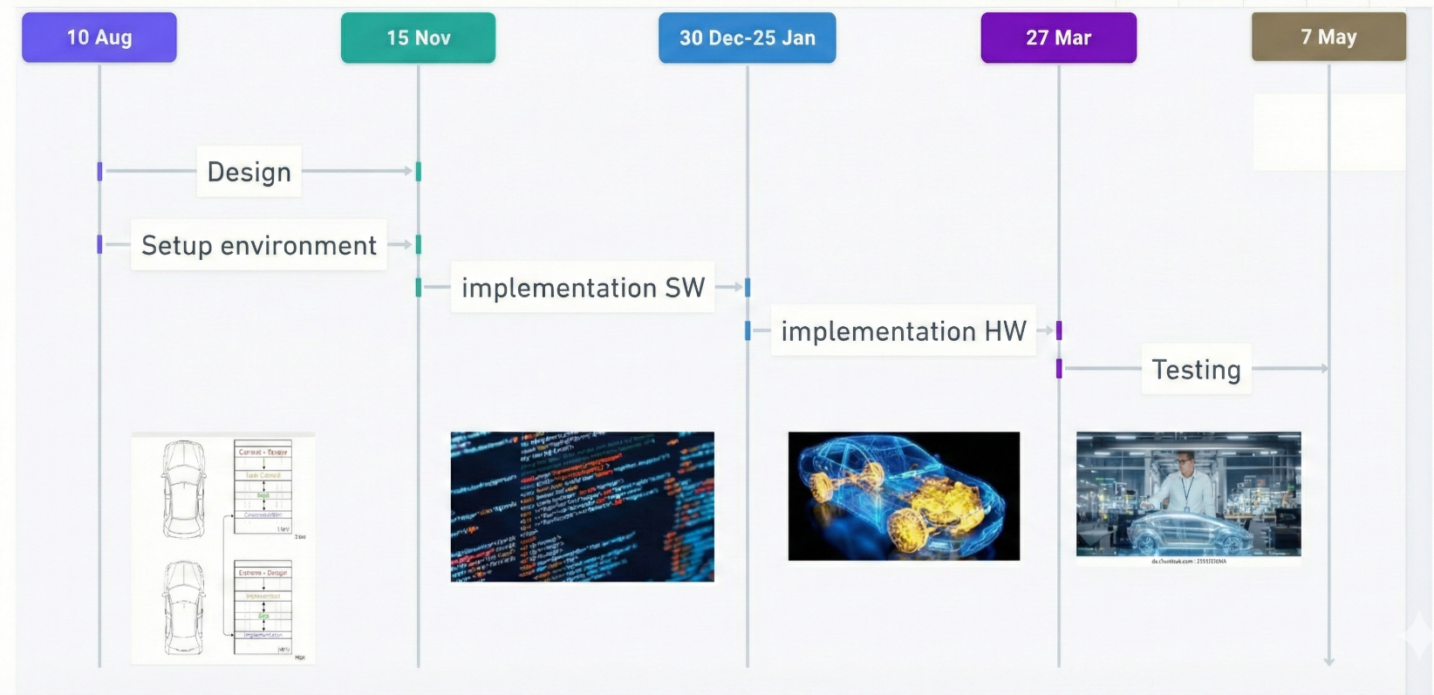

1-Requirements Analysis and Theoretical Study Phase
The project began with a comprehensive theoretical study of Intelligent Transportation Systems (ITS) and Vehicle-to-Everything (V2X) communication Technologies During this phase, the following were carried out:

- Studying the concept of V2X and its various types (V2V, V2I, V2P, V2N).
- Analyzing traffic and accident problems in real-world scenarios, especially in developing countries like Egypt.
- Identifying user needs and system requirements based on these problems.
- Defining the project scope to be a prototype and simulation, rather than a full-scale real-world application.
This phase provided a strong scientific foundation for building the project.

2-System Design and Architecture Phase
After completing the requirements analysis, the project moved to the system design phase, where the following were accomplished:
- Developing the overall design of the V2X system and dividing it into four main subsystems:
Vehicle-to-Vehicle (V2V), Vehicle-to-Infrastructure (V2I),Vehicle-to-Pedestrian (V2P),Vehicle-to-Network (V2N)
- Defining the function of each subsystem and the communication mechanism between them.
- Selecting appropriate hardware and software components.

This phase contributed to transforming theoretical ideas into a clear technical design.

3-Implementation and Development Phase
During this phase, the project systems will be implemented gradually, which will include:

- Developing vehicle safety systems such as:
- Collision warning
Blind-spot monitoring
Maintaining safe distance
- Implementing interaction scenarios with infrastructure, such as smart traffic signals.

- Applying the Vehicle-to-Network (V2N) system using a central server or cloud platform for real-time data exchange.
- Simulating data exchange between vehicles, infrastructure, and the network using appropriate communication protocols.

4-Testing and Performance Verification Phase
- After implementation, the system will be tested to ensure its efficiency and accuracy, through:
Testing each subsystem individually.
- Verifying the correctness of data exchange and response times.
- Emergency situations
Traffic congestion
Collision risks
- Identifying potential issues and improving overall system performance.
This phase will help ensure the achievement of safety and efficiency objectives.
Prototype Prospects
List the Egyptian ICT companies that may be interested in the developed prototype and the end-users/customers (name the specific class of individuals, governmental agencies, ministries … etc. that will benefit from the prototype)
List of ICT Companies:
The developed V2X prototype integrates Embedded Systems, Artificial Intelligence (AI), and IoT, making it relevant to companies operating in intelligent transportation, smart city solutions, automotive technology, and traffic management. Potential Egyptian companies include:
- Link Development – specializes in smart city and IoT solutions.
- Raya Smart Mobility / Raya Group – involved in transportation and mobility solutions.
- ITWorx – provides AI and software integration for smart systems.
- Orascom TMT / VINCI Solutions – focuses on digital transformation and smart infrastructure.
- Valeo Egypt, Si-Vision ,SWIFT-ACT – automotive technology, including advanced driver assistance systems.

Potential End-Users/ Consumers:
The following classes of individuals and organizations in Egypt are expected to benefit from the V2X system:
- Governmental Agencies / Ministries:
- Ministry of Transport – for improving road safety and traffic management.
- Ministry of Interior – specifically traffic police units, for monitoring and reducing accidents.
- Ministry of Communications and Information Technology – for smart city integration and IoT infrastructure support.
- Municipal and City Authorities:
Cairo Governorate and other urban municipalities – for traffic congestion management and infrastructure planning.
- Private Sector and Fleet Operators:
Taxi, ridesharing, and logistics companies – to improve vehicle safety and operational efficiency.
- Individual Road Users:
- Drivers, pedestrians, and cyclists – who will receive real-time alerts and proactive safety measures through the V2V system

** Please fill in the budget form and upload both the proposal & budget forms to the student application form.

