1. *Introduction*

Vehicle-to-Infrastructure (V2I) communication is a crucial component of the V2X ecosystem. It enables vehicles to wirelessly exchange data with traffic lights, road signs, and roadside sensors. This technology helps optimize traffic flow, improve road safety, and assists drivers and infrastructure operators in making better decisions.
Suggested image: A car communicating with a smart traffic signal or roadside sensor.

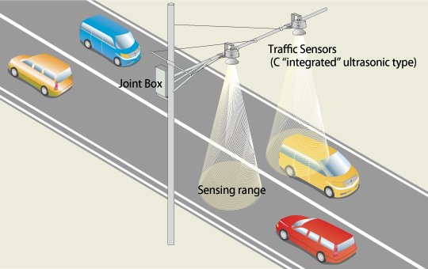

2. *Why V2I? (Previous Challenges)*
Before V2I, vehicles operated mostly in isolation with limited communication capabilities. Drivers relied on:
- Static navigation maps without real-time updates.
- Manual traffic reports or radio announcements for incidents.
- Lack of coordination between vehicles and infrastructure, leading to congestion and slow incident response.

*Problems with previous systems:*
- No real-time traffic awareness.
- Poor emergency response capability.
- Inefficient route planning causing delays.

*How V2I solves these issues:*
- Real-time data exchange through smart infrastructure.
- Instant notifications about hazards and traffic conditions.
- Dynamic route adjustment for optimal travel. 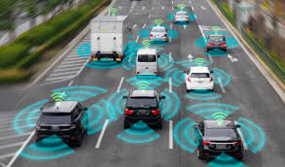
3. *Objectives*
- Enable seamless wireless communication between vehicles and intelligent infrastructure.
- Enhance road safety and reduce accidents via timely warnings.
- Provide drivers with up-to-date information for smarter driving decisions.

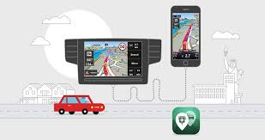
4. *Key Features*

1. *Real-Time Traffic Alerts*
Vehicles receive immediate notifications about accidents or congestion from roadside devices.

2. *Signal Phase and Timing (SPaT)*
Traffic lights communicate their signal cycles directly to vehicles for optimized driving.

3. *Alternative Route Suggestions*
Infrastructure suggests alternative routes dynamically during traffic congestion or roadblocks.

4. *Emergency Broadcasts*
Critical incident alerts are broadcast to all vehicles in affected areas.

5. *Integration with Smart City Systems*
V2I interfaces with broader traffic management and urban infrastructure systems.

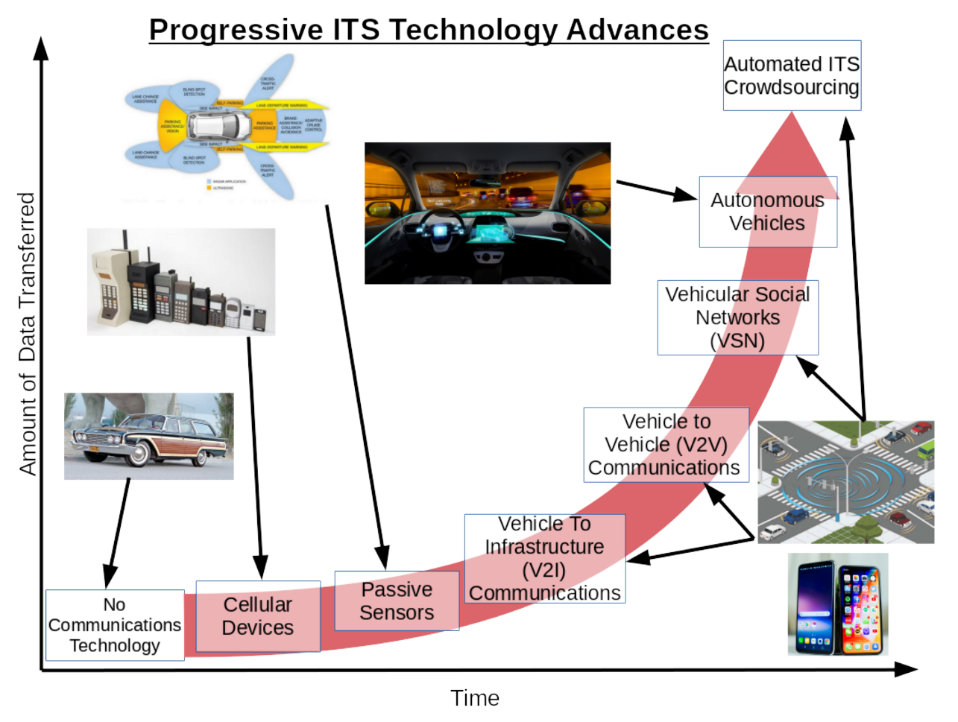
5. *Architecture & Workflow*
*Components:*
- Vehicle On-Board Unit (OBU) for data communication.
- Roadside Unit (RSU) that communicates with vehicles and infrastructure.
- Secure communication channels (Wi-Fi, cellular networks).

*Workflow:*
1. Vehicles send location and status data via OBU to RSUs or central servers.
2. RSUs analyze data to detect congestion or incidents.
3. Alerts are broadcast to all vehicles in the area.
4. Vehicle navigation updates suggested routes or warnings.
5. Continuous monitoring and updates every few seconds.
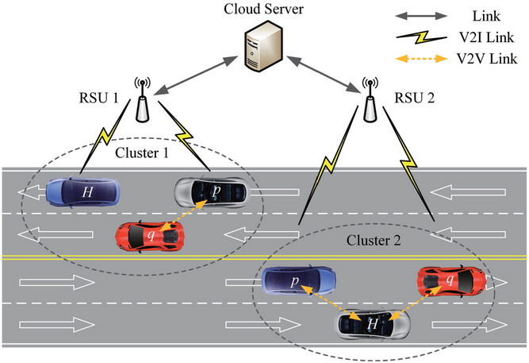
6. *Use Case Example*

A driver sets a destination; the vehicle continuously sends location data to the server. On detecting an accident, the server broadcasts an alert to nearby vehicles and updates their navigation system with alternative routes.
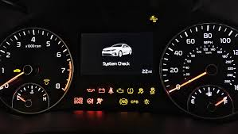

7. *Future Enhancements*

- Integration of 5G for ultra-low latency communication.
- AI-driven traffic prediction for proactive routing.
- Edge computing to reduce latency and cloud dependency.
- Voice-assisted alerts to improve driver response.

