V2P INTRODUCTION:
Vehicle-to-Pedestrian (V2P) communication is considered one of the most promising technologies for enhancing the safety of vulnerable road users. However, relying solely on handheld devices (such as 5G-enabled smartphones or DSRC units) faces practical challenges, since many pedestrians do not consistently carry such devices. To overcome this limitation, recent research has focused on leveraging computer vision and smart sensing technologies to detect and interact with pedestrians in real time.
On one hand, vision-based systems utilizing traffic cameras and deep learning models have been developed to detect pedestrians at signalized intersections and generate Personal Safety Messages (PSMs) with update rates as fast as every 100 milliseconds. These systems demonstrated superior accuracy in estimating pedestrian location and velocity compared to conventional DSRC-enabled handheld devices, enabling the generation of timely alerts to prevent potential collisions.
On the other hand, more advanced frameworks have been proposed that fuse camera data with LiDAR sensors to achieve more robust pedestrian detection and tracking in autonomous driving environments. This approach converts LiDAR streams into depth images and employs deep neural networks to identify pedestrians in both RGB and depth data, while sensor fusion techniques such as the Kalman Filter and optical flow algorithms enable reliable multi-pedestrian tracking with high accuracy.
The findings from these studies indicate that vision-based and multi-sensor fusion approaches provide effective and reliable alternatives for V2P communication, capable of meeting the accuracy and latency requirements of safety applications in connected and autonomous vehicle environments. Ultimately, such systems pave the way for safer and smarter transportation networks.
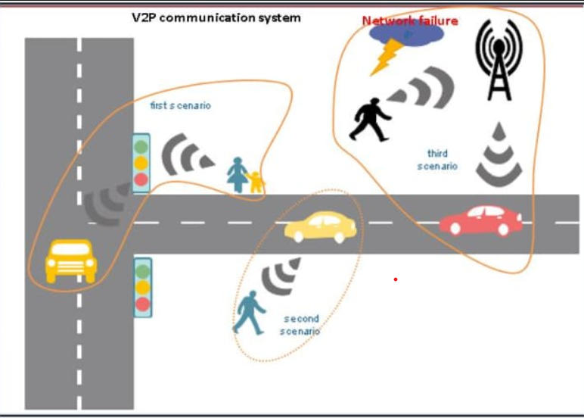

Vehicle-to-Pedestrian (V2P)

Introduction
Vehicle-to-Pedestrian (V2P) systems are designed to enhance the safety of pedestrians by enabling vehicles to detect, track, and predict pedestrian behavior in real-time. Unlike traditional V2P approaches that rely solely on handheld devices, modern systems leverage vision-based technologies, AI algorithms, and sensor fusion (cameras + LiDAR) to detect pedestrians and vehicles, interpret traffic signals, and proactively warn drivers or activate automated safety mechanisms.
Key goals: - Prevent collisions with pedestrians. - Reduce accidents at intersections and high-risk zones. - Support drivers with timely and intelligent decision-making.

Key Features
- Object Detection and Classification
  - Detect vehicles and pedestrians using cameras and AI.
  - Classify objects as moving or stationary.
- Traffic Signal Recognition
  - Detect traffic lights and provide alerts based on red/green signals.
- Pedestrian Intent Prediction
  - AI estimates whether a stationary pedestrian is likely to cross.
  - Adjusts system response based on predicted intent.
- ADAS Integration
  - Automatic braking and speed adjustment if the driver does not react.
  - Alerts to trailing vehicles to prevent rear-end collisions.
- Multi-Sensor Fusion
  - Combines data from cameras, LiDAR, and GPS for robust detection.
- Real-Time Alerts
  - Immediate notifications for drivers when potential hazards are detected.

Challenges
- Detection Accuracy: Detecting pedestrians in crowded or low-light conditions.
- Intent Prediction: Determining if a pedestrian intends to cross the street.
- System Latency: Processing sensor data and sending alerts quickly enough to prevent accidents.
- Driver Inaction: Ensuring safety if the driver ignores warnings.
- Integration Complexity: Coordinating between sensors, AI algorithms, ADAS, and communication modules.

Solutions
- Computer Vision & Deep Learning: For precise pedestrian and vehicle detection.
- Sensor Fusion (Camera + LiDAR): Enhances detection accuracy and reduces false positives.
- Predictive AI Models: Analyze pedestrian posture and movement to predict intent.
- ADAS Integration: Automatically controls vehicle if the driver fails to respond.
- V2X Communication: Alerts other vehicles nearby to prevent secondary collisions.

Architecture & Workflow
Components: - Vehicle On-Board Unit (OBU) - Cameras and LiDAR sensors - ADAS module (braking, alerts, speed control) - V2X communication module
Workflow: 1. System initializes sensors and AI modules. 2. Detect objects ahead: classify as vehicle or pedestrian. 3. Vehicle handling: - Moving: monitor continuously. - Stationary: check traffic signals → alert driver if necessary. 4. Pedestrian handling: - Moving into danger zone → alert driver; if no action, ADAS intervenes. - Stationary → predict intent; if likely to cross, activate pedestrian mode. 5. Update every few milliseconds for real-time response.

Use Case Example
- Pedestrian approaches crosswalk.
- System detects pedestrian, predicts intent to cross.
- Vehicle receives alert; if driver does not act:
  - Automatic braking engages.
  - Alert sent to vehicles behind.
- Collision prevented before pedestrian enters the danger zone.

Future Enhancements
- 5G connectivity for ultra-low latency communication.
- Enhanced AI models for more accurate pedestrian intent prediction.
- Edge computing for faster local processing.
- Integration with smart city infrastructure for coordinated pedestrian and traffic management.

