Cairo University  
Faculty of Computers and Artificial Intelligent

**CS251**

**Software Engineering I**

Project Name

Software Design

Team Names

Month & Year

Contents

Team 3

Document Purpose and Audience 3

System Models 3

I. Class diagrams 3

Important Algorithm 4

II. Sequence diagrams 5

Class - Sequence Usage Table 6

Ownership Report 6

Policy Regarding Plagiarism: 7

# Team

|  |  |  |  |
| --- | --- | --- | --- |
| **ID** | **Name** | **Email** | **Mobile** |
| 20200324 | Abdallah emadeldin abdallah | Abdallahelnabarawy2@gmai.com | 01012035979 |
| 20200598 | Nermin mostafa madbouly | nerminmostafa78@gmail.com | 01207253810 |
| 20200589 | Nada alaaeldin | nadaalaa2909@gmail.com | 01142071128 |

# Document Purpose and Audience

This document describes the vehicle garage management system, and its purpose is to make the vehicles park in the garage in the best way to save space for other vehicles and achieve the greatest gain

# System Models

## I. Class diagrams

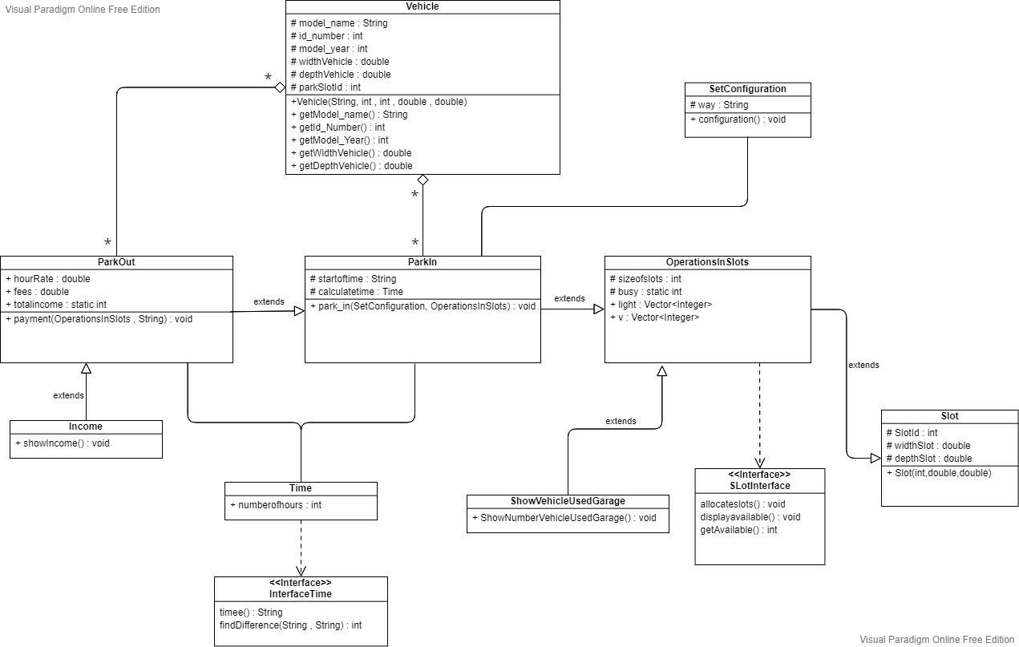

| **Class ID** | **Class Name** | **Description & Responsibility** |
| --- | --- | --- |
| 1 | Vehicle | Saving car info (model name, model year, id number, width, depth) |
| 2 | SetConfiguration | Setting configuration (first come or best fit). |
| 3 | ParkIn | Check if the vehicle can park in garage or not based on the configuration. |
| 4 | ParkOut | Calculate the parking fees based on the time of stay with an hourly rate of 5 EGP. |
| 5 | Income | Calculate and show total income. |
| 6 | Time | Capture time automatically when the user finish park-in and park-out process and calculate the difference. |
| 7 | Slot | Setting slots dimensions and Id. |
| 8 | OperationsInSlots | Allocate slots and check available |
| 9 | ShowVehiclesUserGarage | Show number of vehicles that used garage system. |

### Important Algorithm

## II. Sequence diagrams

**Sequence diagram (1)**

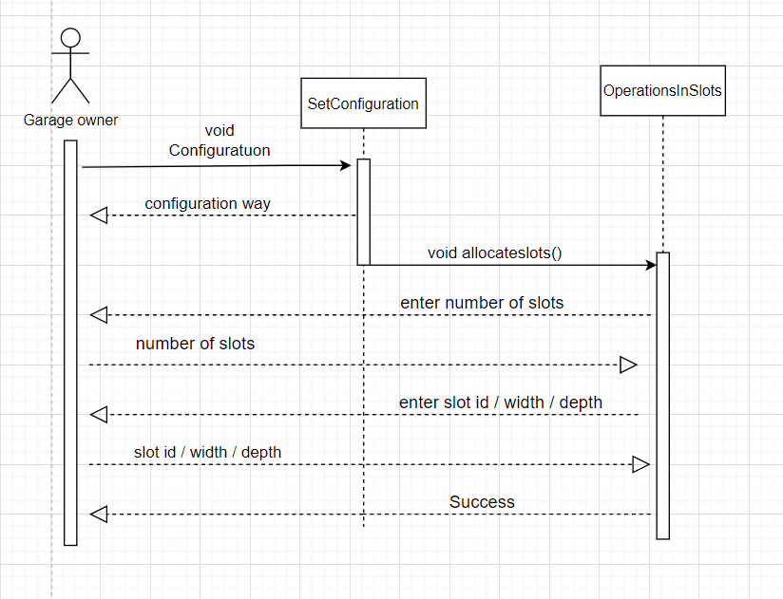

**Sequence diagram (2)**

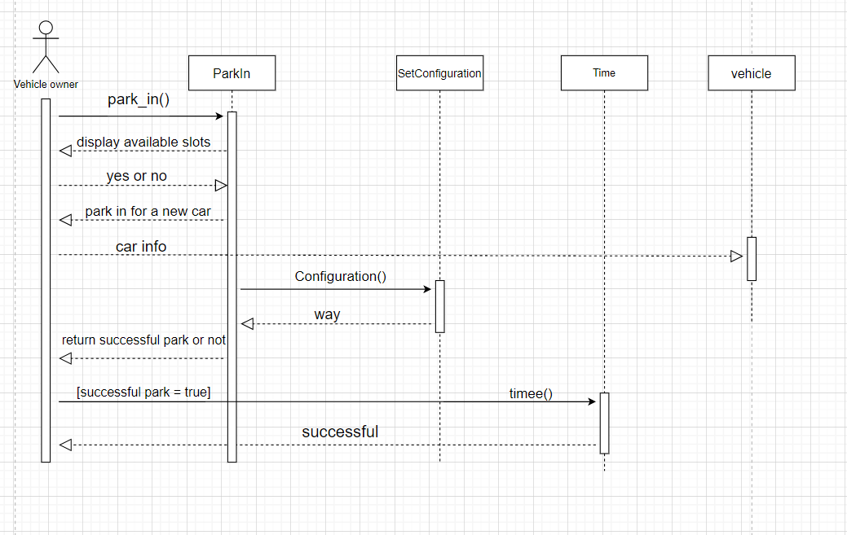

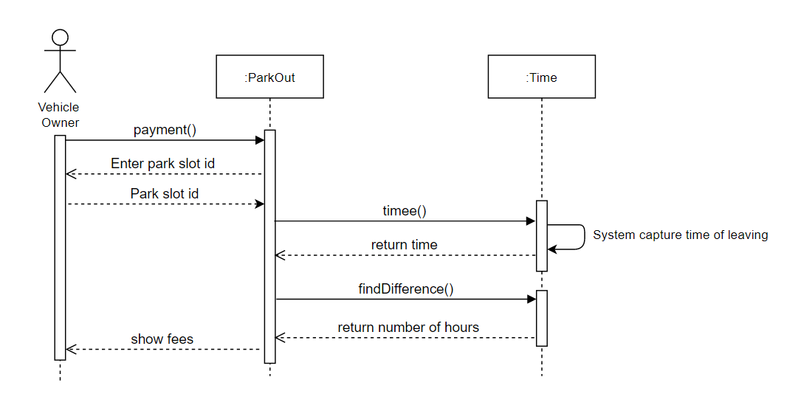**Sequence diagram (3)**

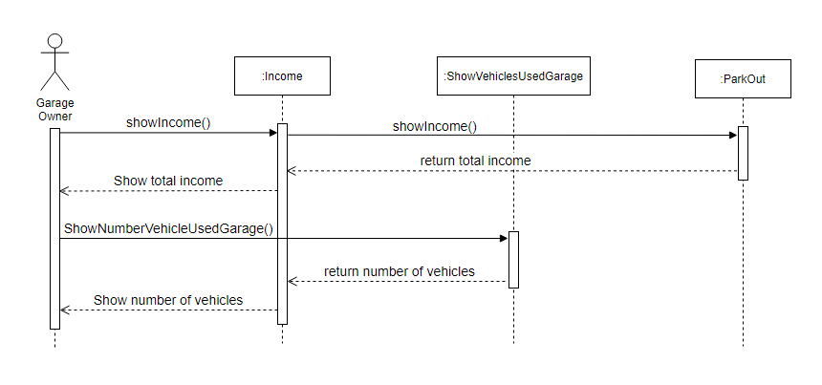

**Sequence diagram (4)**

### 

### Class - Sequence Usage Table

| **Class Name** | **Sequence Diagrams** | **Overall used methods** |
| --- | --- | --- |
| Vehicle | 2 | Vehicle() |
| SetConfiguration | 1,2 | configuration() |
| ParkIn | 2 | Park_in() |
| ParkOut | 3 | Payment() |
| Income | 4 | showIncome() |
| Time | 2,3 | timee()  findDifference() |
| Slot | 1 | Slot() |
| OperationsInSlots | 1 | allocateslots()  displayavailable()  getAvailable() |
| ShowVehiclesUserGarage | 4 | ShowNumberVehicleUsedGarage() |

**Does your class diagram respect or violate SOLID principles?**

The class diagram respects the SOLID principles, as we have focused on making each class responsible for one job/function and it helps to avoid unanticipated side-effects of future changes as well as if something went wrong it doesn't affect the rest of the functions

Such as class ParkOut have one method payment(), class ParkIn have one method ParkIn(),

Class Income have one method shwoIncome(),…etc.

**Does your class diagram contain any design pattern(s), if yes name it and list the names of the classes involved in such pattern(s).**

Yes, Strategy in ParkIn and ParkOut.

# Ownership Report

|  |  |
| --- | --- |
| **Item** | **Owners** |
| Functional requirements, non-Functional requirements, sequence diagram + code | Nada Alaa |
| Use case, use case tables, sequence diagram + code | Nermin Mostafa |
| Class diagram, sequence diagram + code | Abdallah emad |

# Policy Regarding Plagiarism:

**Students have collective ownership and responsibility of their project. Any violation of academic honesty will have severe consequences and punishment for ALL team members.**

1. تشجع الكلية على مناقشة الأفكار و تبادل المعلومات و مناقشات الطلاب حيث يعتبر هذا جوهريا لعملية تعليمية سليمة
2. ساعد زملاءك على قدر ما تستطيع و حل لهم مشاكلهم فى الكود و لكن تبادل الحلول غير مقبول و يعتبر غشا.
3. أى حل يتشابه مع أى حل آخر بدرجة تقطع بأنهما منقولان من نفس المصدر سيعتبر أن صاحبيهما قد قاما بالغش.
4. قد توجد على النت برامج مشابهة لما نكتبه هنا أى نسخ من على النت يعتبر غشا يحاسب عليه صاحبه.
5. إذا لم تكن متأكدا أن فعلا ما يعد غشا فلتسأل المعيد أو أستاذ المادة.
6. فى حالة ثبوت الغش سيأخذ الطالب سالب درجة المسألة ، و فى حالة تكرار الغش سيرسب الطالب فى المقرر.