Driver Manager User Guide
QtrShoe Delivery App

Introduction
Welcome to the Driver Manager Guide.
This document covers everything you need to manage daily delivery operations from monitoring the overview dashboard to assigning orders, tracking drivers, and handling returns.
Note: Driver Manager can also act as a driver yourself and complete deliveries when needed.

Your Role
- Overview - Monitor all orders, delivery stats, and recent activity
- Orders - View, search, and inspect every order in the system
- Operations - Assign unassigned orders to drivers in real time
- Drivers - Review driver performance, earnings, and workloads
- Driver Accounts - Add drivers and manage their account status
- My Deliveries - Manage and complete deliveries assigned to you personally • Map - See all active and unassigned orders on a live map
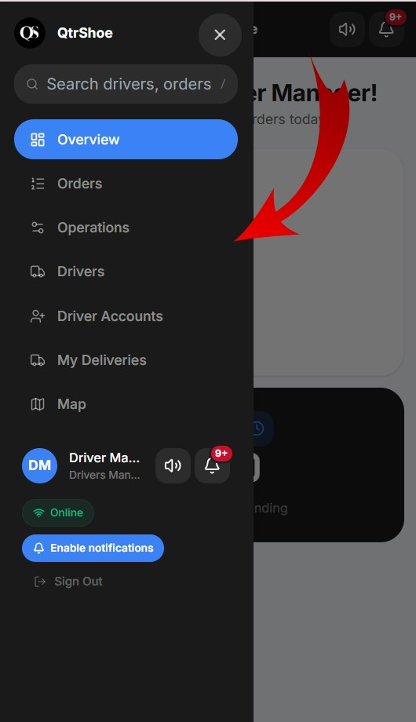

1. Overview
The Overview is your home screen. It shows a live snapshot of today’s operations at a glance.

1.1 Top Stats Cards
Four summary cards appear at the top of the page:
- Total / Done - total orders and how many are completed.
- In Transit - orders currently being delivered by a driver.
- Pending — orders waiting to be assigned or acted on.
- Delivery Rate — percentage of completed deliveries out of total.

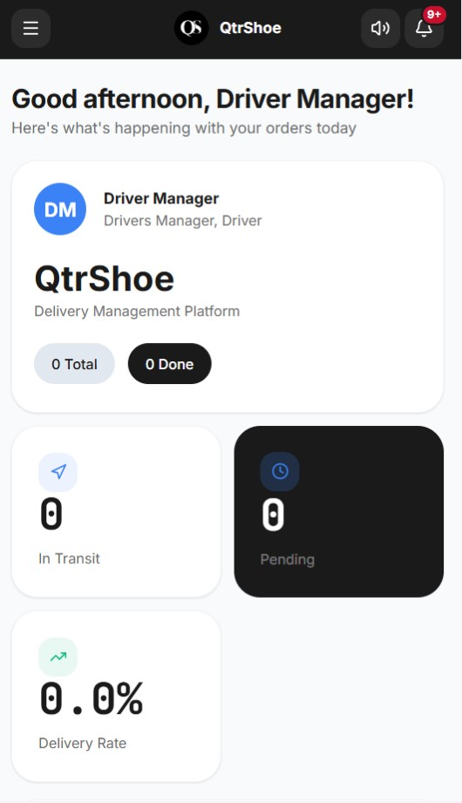

1.2 Order Pipeline
- New - Order just received, not yet confirmed
- Confirmed - Confirmed by admin or customer service
- Cust. OK - Customer confirmed the order is acceptable
- Synced - Synchronised with the ERP system

1.4 Recent Orders Table
The 5 most recent orders with Status, Pipeline stage, Progress bar and Creation date. Use the All / Active / Done tabs to filter.

1.5 WhatsApp & System Panels
At the bottom of the Overview you will find two panels:
- WhatsApp (24h) — Sent, Delivered, and Failed WhatsApp messages in the last 24 hours.
- System — Active Zones, total Drivers, and Total Users on the platform.

2. Orders
The Orders page lists every order, return, exchange, and cancellation. It is your primary tool for monitoring and investigating individual orders.

2.1 Revenue Summary Bar
Four financial figures are always visible at the top:
- Total Revenue - sum of all order amounts (QAR).
- Cash Collected (COD) - cash collected by drivers so far.
- Refunded - total refunded to customers.
- Bank Refunds Outstanding - approved refunds not yet processed.

2.2 Quick Views
Use the bar at the top to jump to common situations instantly:
- Stuck > 24h - orders that have not moved in over a day.
- Returns awaiting approval - return requests needing a decision.
- Exchanges flagged - exchanges that need attention.
- COD unpaid - cash orders where payment has not been collected.
- New today - all orders created today.
- Auto-cancel risk - orders at risk of automatic cancellation.
- Today’s deliveries (map) - map filtered to today.
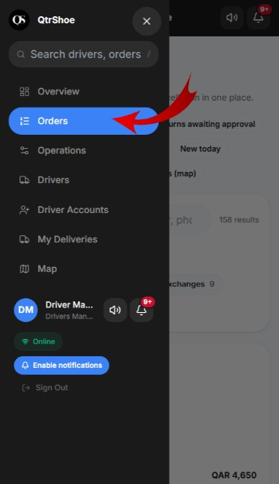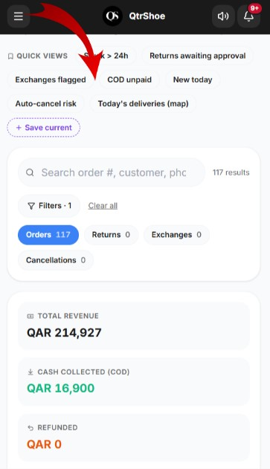

2.3 Order Status Labels
- Pending - Received but not yet assigned to a driver
- Delivered - Successfully delivered to the customer
- Failed - Delivery attempt was unsuccessful
- Requested - A return or exchange has been requested
- Received - Returned item received back at the warehouse

2.4 Viewing an Individual Order
- Timeline - every status change with timestamps.
- Customer - name, phone, city, and delivery address.
- Driver - who is assigned (or “No driver assigned yet”).
- At a glance - item count, returns, tracking views, WhatsApp sent count.
- Customer feedback - rating or comment left after delivery.
- Tabs: Items, Money, Returns/Exchanges, Activity Log — for deeper detail.

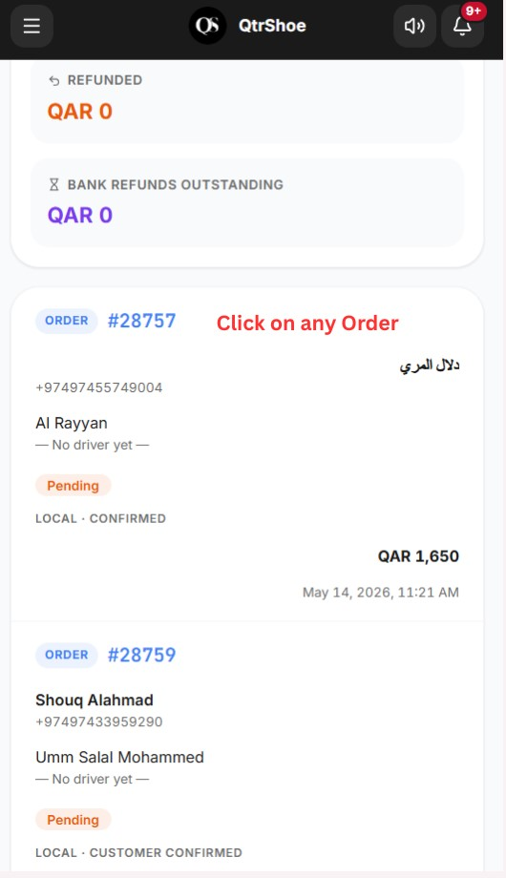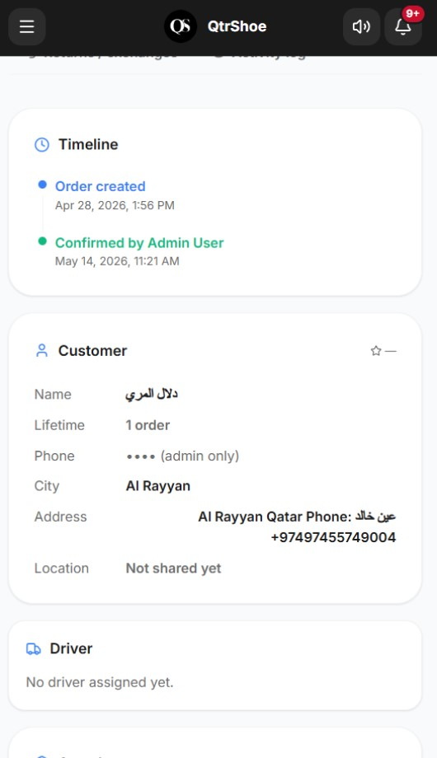

3. Operations
The Operations page is the live dispatch control center. This is where you assign drivers to orders and monitor what is happening right now.

3.1 Live Overview Bar
Real-time counts at the top of the page:
- Total, Pending, Assigned, In Transit, Delivered, Failed — live order counts.
- Drivers - number of active drivers currently online.

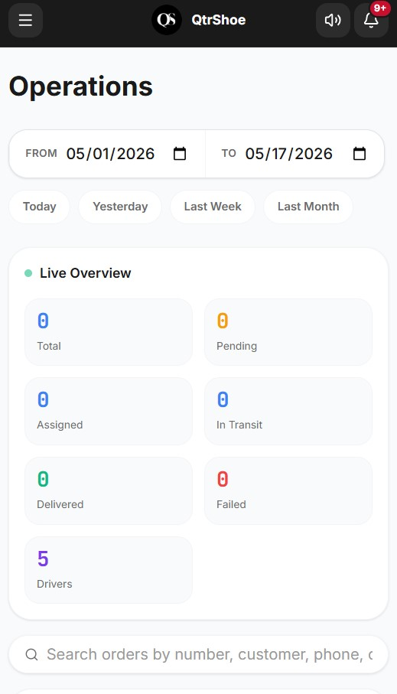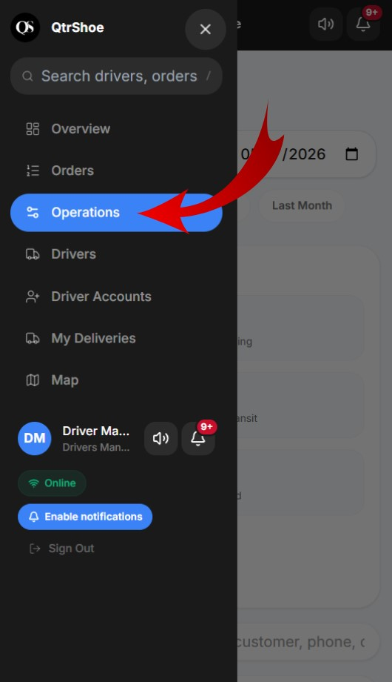

3.2 Unassigned Orders lists orders that do not yet have a driver:
- Moved Over - carried forward from a previous day (badge shows how many times, e.g. Moved over x2).
- Unassigned — new orders ready to assign today.
3.3 How to Assign an Order to a Driver
- Find the order in the Unassigned Orders column.
- Click the blue Assign button next to it.
- Select a driver from the dropdown list.
- Choose the priority: Normal or Urgent.
- Click Confirm to save, or Cancel to discard.
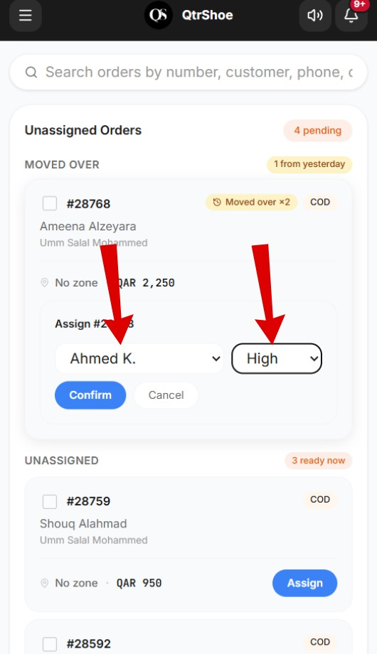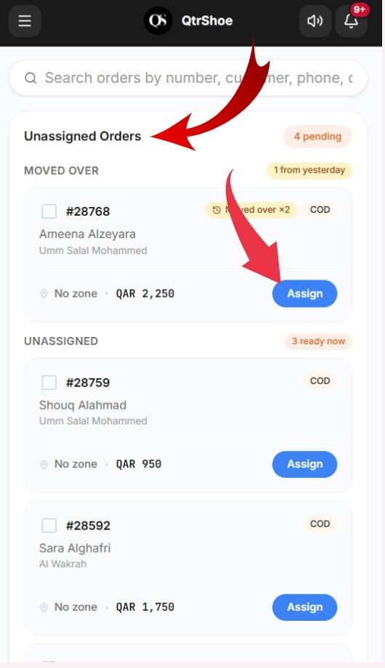
3.4 Active Orders shows orders currently assigned and in progress. Each card shows:
- Order number and customer name.
- Delivery city or area.
- Assigned driver name and order value.
- Re-assign button to change the driver if needed.

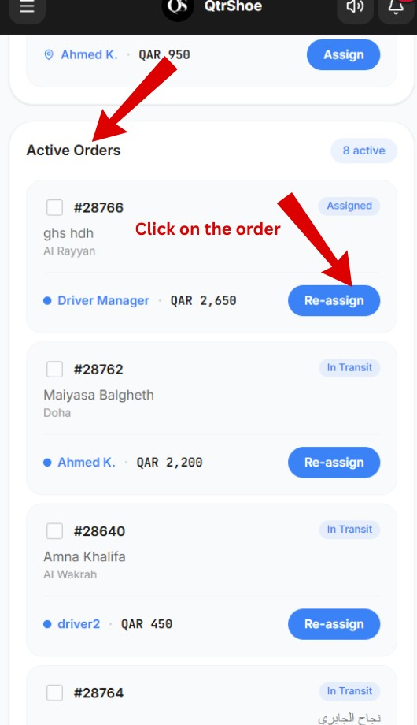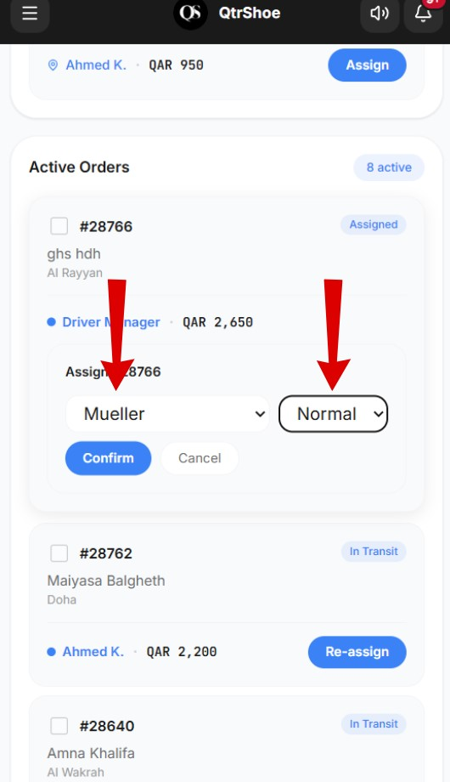

3.5 Returns Awaiting Pickup Driver
returns that need a driver to collect from the customer. Assign a driver the same way as a regular order.

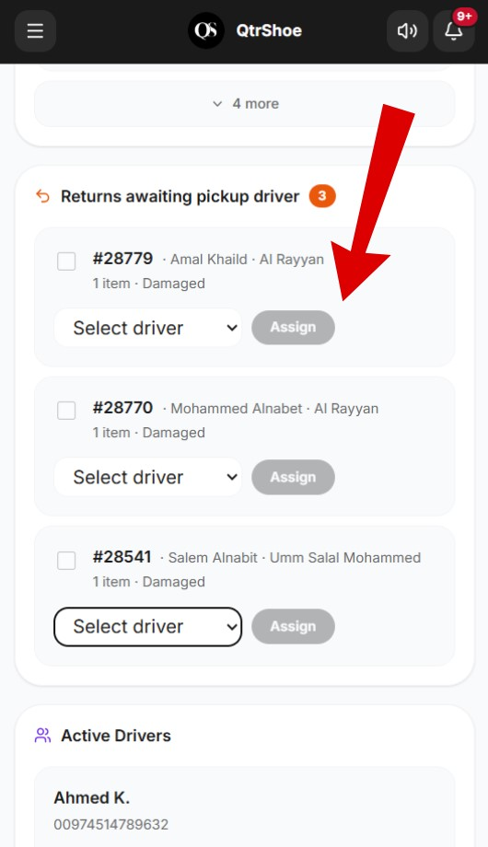

3.6 Active Drivers Panel
At the bottom of Operations, driver cards show each driver’s current order load. Use this to balance workload before assigning new orders.

4. Drivers
The Drivers page shows performance and financial summaries for every driver over a selected date range. Use the date picker or shortcut buttons (Today, Yesterday, Last Week, Last Month) to change the period.

4.1 Outstanding Commission Banner
A banner at the top shows the total cash commission owed to drivers - delivery fees collected from customers via bank that must be paid out.

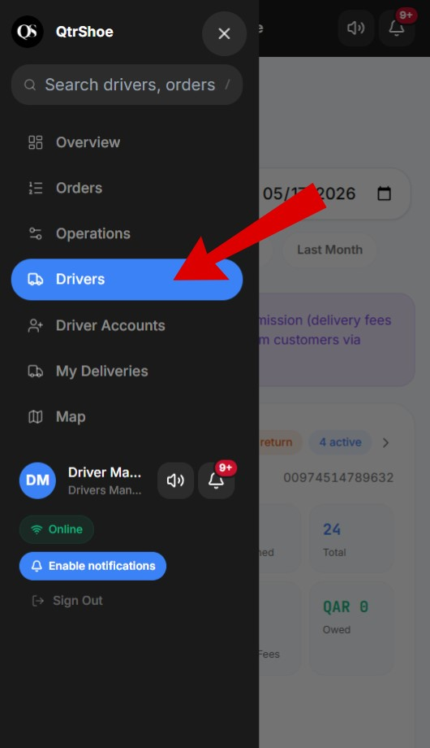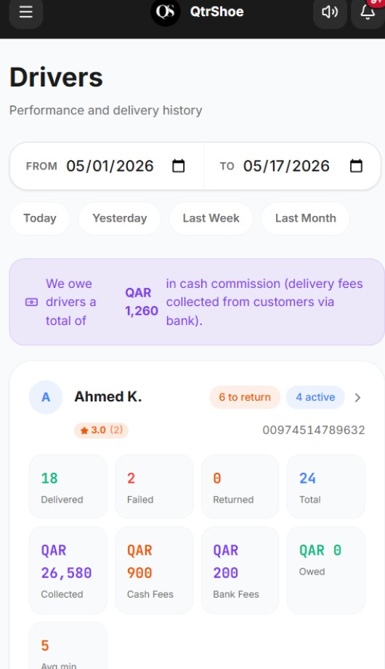

4.2 Driver Cards
Each driver has a card showing:
- Name, star rating, and phone number.
- Delivered / Failed / Returned / Total — delivery counts.
- Collected, Cash Fees, Bank Fees, Owed — financial breakdown.
- Avg min — average delivery time in minutes.
- Active and to return badges — live workload status.
4.3 Financial Fields
- Collected - Total cash the driver collected from customers on delivery
- Cash Fees - Delivery fees paid in cash (driver holds temporarily)
- Bank Fees - Delivery fees paid via bank (must be transferred to driver)
- Owed - Net amount your company still owes the driver

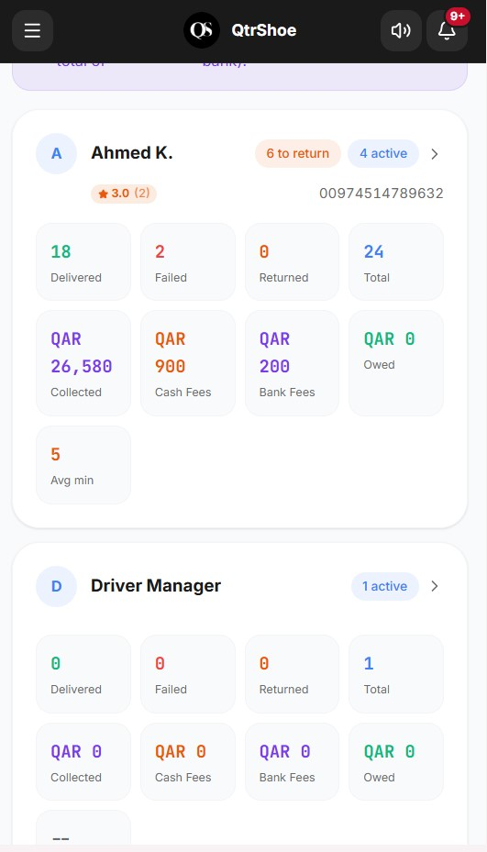

5. Driver Accounts
The Driver Accounts page is where you control who can log in as a driver. Drivers set their own password via a one-time invite link you never see or set it.

5.1 Adding a New Driver
- Click the + Add driver button in the top-right corner.
- A single-use invite link is generated.
- Send the link to the driver via WhatsApp or any messaging app.
- The driver opens the link and fills in their name, email, phone, and password.
- Their account appears in the Drivers list with Active status.

5.2 Managing Existing Driver Accounts
The table shows Name, Email, Phone, Status, and Actions for all registered drivers:
- Edit - update the driver’s name, email, or phone number.
- Disable - deactivate the account so the driver cannot log in. The account is not deleted and can be re-enabled later.

5.3 Pending Invites
Drivers who have been invited but not yet completed registration appear under Pending invites. Once they register, they move to the Drivers table automatically.
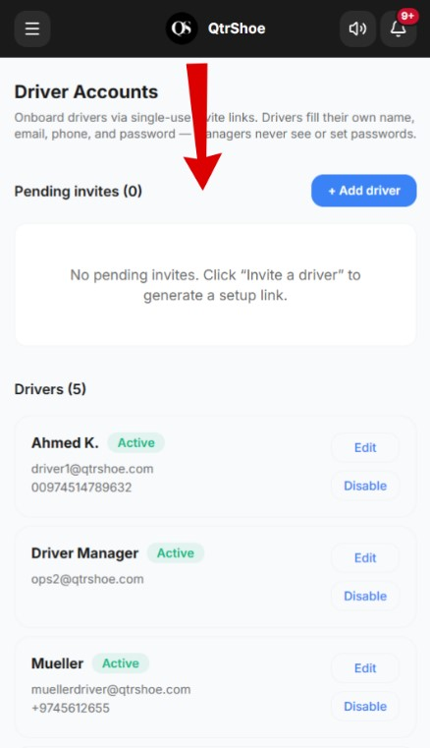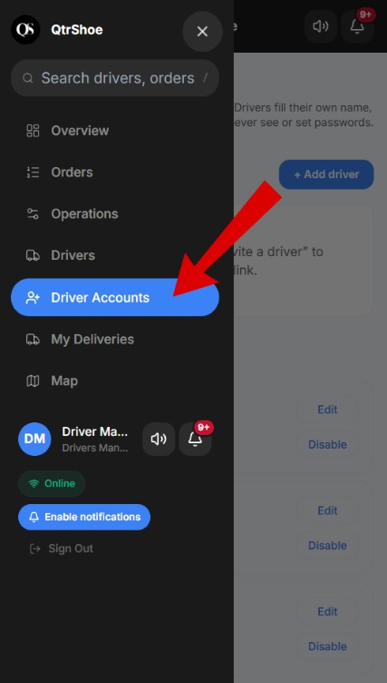

6. My Deliveries
Because Driver Managers are also driver, you have your own My Deliveries section. This is where you manage orders assigned directly to you as a driver.

6.1 Summary Stats
Three counters at the top of the page:
- Assigned - orders assigned to you but not yet started.
- In Progress - orders you are currently delivering.
- Total Active - combined total in your queue.

For more information about the delivery steps, please read the driver quide.

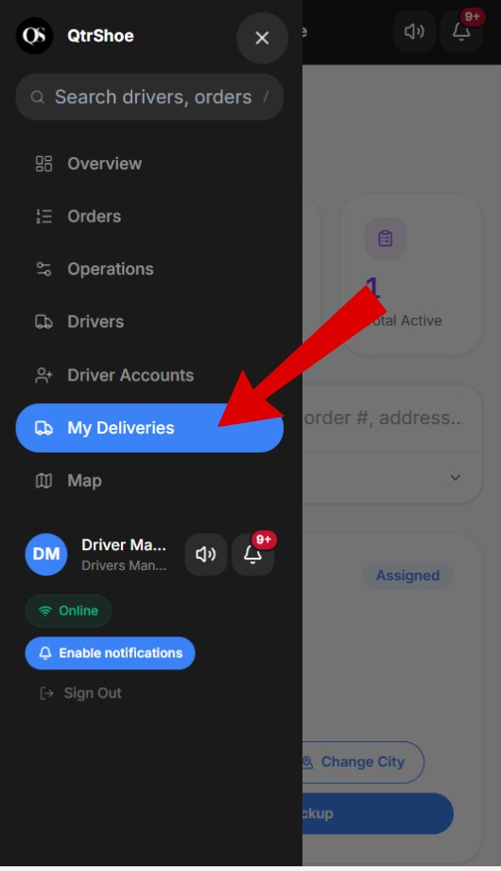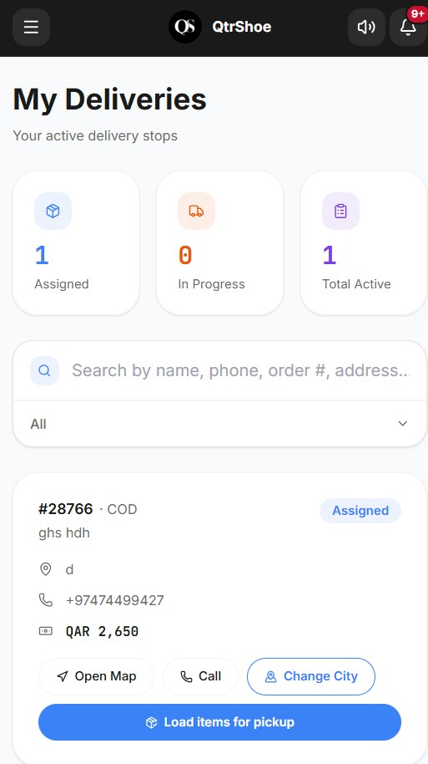

7. Map
The Map page gives a geographic view of all current orders so you can spot coverage gaps at a glance.

7.1 Map Overview
The interactive map shows pins for orders. The right panel lists:
- Total order count - e.g. Orders (11) with active and unassigned breakdown.
- Unassigned orders - highlighted in orange so they stand out.
- Active orders - grouped by delivery zone.
